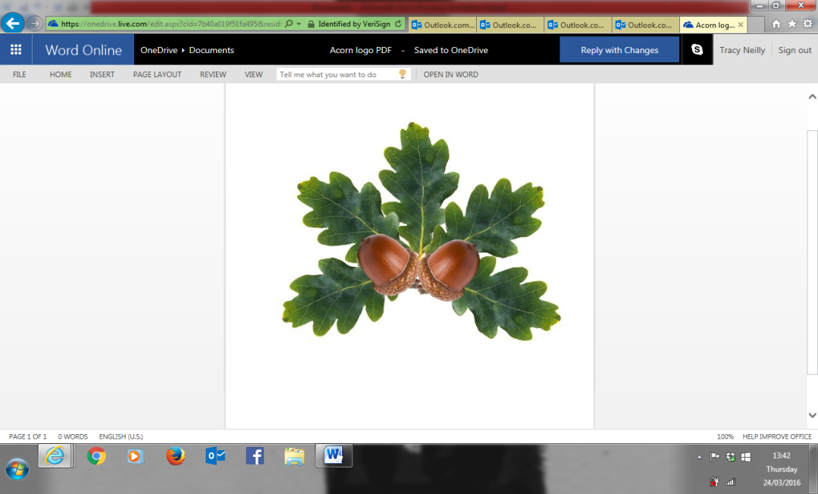 **Little Acorns Pre-School Folkestone CIO**

**Grounds of**

**Folkestone Baptist Church**

**Hill Road**

**Folkestone**

**Kent**

**CT19 6LY**

**Manager: Mrs T. Neilly**

**Tel: 01303 245562**

**Ofsted No:2774263 Mobile: 07879202160**

**Registered Charity No:1204181 E-mail:littleacorns13@hotmail.co.uk**

Safeguarding

Safeguarding is a term which relates to the action taken to promote the welfare of children and protect them from harm. We have procedures in place to ‘Safeguard’ children if we believe intervention is necessary. Safeguarding is defined as:

* protecting children from maltreatment
* preventing impairment of children’s health and development
* ensuring that children grow up in circumstances consistent with the provision of safe and effective care.
* taking action to enable all children to have the best outcomes

If you have any concerns regarding our safeguarding procedures or wrongdoings within them, please do not hesitate to speak to myself. However, you can contact The Local Authority Designated Officer (LADO) Team which deals with allegations against staff who work with children either in education or the wider workforce.  
  
Local Authority Designated Officer contact details:

**LADO Team contact number ;03000 41088.**

**Integrated front door :03000411111(outside office hours 03000419191)**

**Email: kentchildrenslado@kent.gov.uk**

**Kroner house, Eurogate Business Park, Ashford Kent TN248XU**

Please be assured that any issues that are brought to my attention will be dealt with in private and in a confidential manner.

Tracy Neilly  
Pre-School Manager