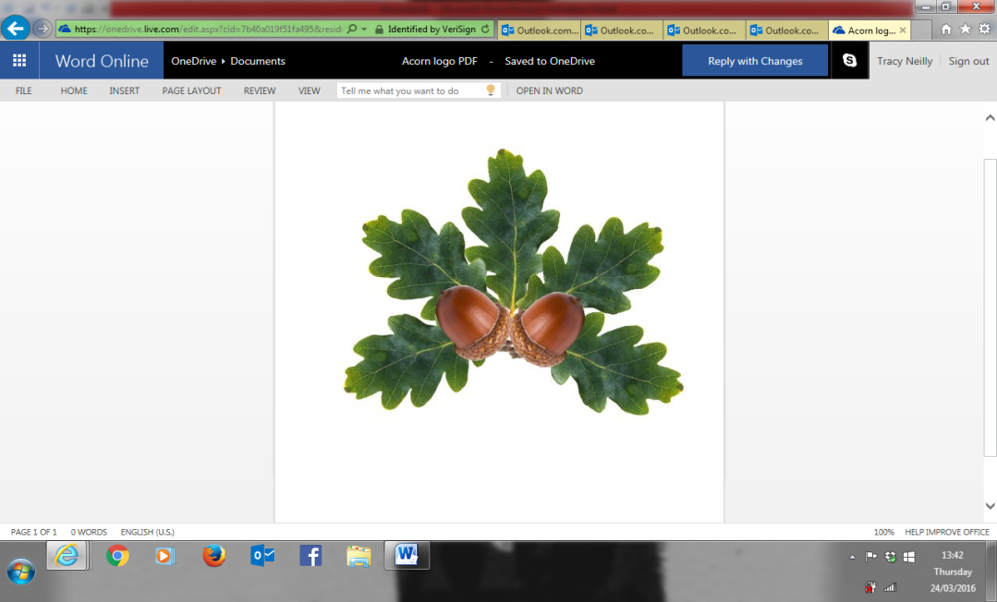 **Little Acorns Pre-School Folkestone CIO**

**Grounds of**

**Folkestone Baptist Church**

**Hill Road**

**Folkestone**

**Kent**

**CT19 6LY**

**Manager: Mrs T. Neilly**

**Tel: 01303 245562**

**Ofsted No:2774263 Mobile: 07879202160**

**Registered Charity No:1204181 E-mail:littleacorns13@hotmail.co.uk**

Privacy Notice

We, Little Acorns Pre-School Folkestone, are a data controller for the purposes of the Data Protection Act. We collect personal information from you and may receive information about you from your previous school and the Learning Records Service. We hold this personal data to:

* Support your learning.
* Monitor and report on your progress.
* Provide appropriate pastoral care, and
* Assess how well we are doing.

Information about you that we hold includes your contact details and personal characteristics such as your ethnic group, any special educational needs and relevant medical information.

***We will not give information about you to anyone without your consent unless the law and our policies allow us to.***

We are required by law to pass some information about you to our Local Authority (LA) and the Department for Education (DfE). If you want to receive a copy of the information about you that we hold or share, please speak to myself, Mrs Tracy Neilly, Pre-School Manager.

If you need more information about how our local authority and/or DfE collect and use your information, please visit:

* Our local authority at:

http://www.kent.gov.uk/about-the-council/contact-us/access-to-information/your-personal-information

Or

* The DfE website at:

https://www.gov.uk/data-protection-how-we-collect-and-share-research-data

If you cannot access these websites, please contact the LA or DfE via the details below:

Information Resilience & Transparency Team

Kent County Council

Sessions House

County Road

Maidstone

ME14 1XQ

Email: dataprotection@kent.gov.uk

Ministerial and Public Communications Division

Department for Education

Piccadilly Gate

Store Street

Manchester

M1 2WD

Email: http://www.education.gov.uk/help/contactus   
Telephone: 0370 000 2288