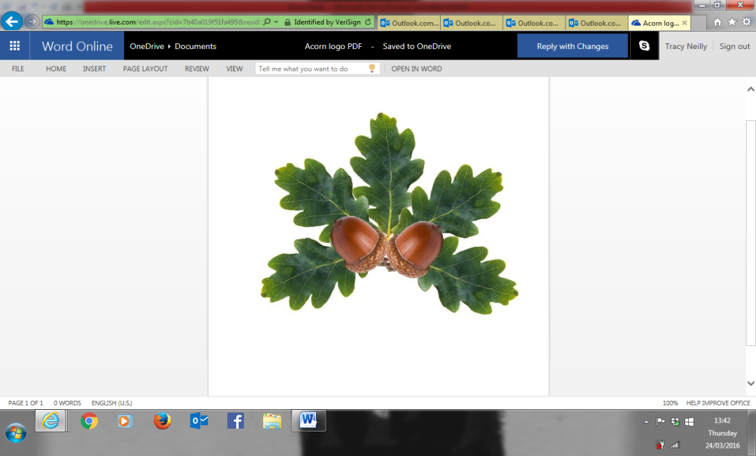 **Little Acorns Pre-School Folkestone CIO**

**Grounds of**

**Folkestone Baptist Church**

**Hill Road**

**Folkestone**

**Kent**

**CT19 6LY**

**Manager: Mrs T. Neilly**

**Tel: 01303 245562**

**Ofsted No:2774263 Mobile: 07879202160**

**Registered Charity No:1204181 E-mail:littleacorns13@hotmail.co.uk**

**Policies**

Times

If your child will be absent on the day they usually attend, please contact the Pre-School on either number, before the session or as soon as possible to let us know. Someone will be within the setting from 8am each morning.

**If you are late collecting your child, you will be charged £10 per 15 minutes your child is in Pre-School after 12:15pm or 15:30pm. These charges apply whether your child is in receipt of Free Early Education or not.**

**Collection**

If for any reason you will not be collecting your child yourself, you must let Pre-School know at the beginning of the session, or as soon as your circumstances change. For your child’s safety and security, if someone other than the nominated people within the enrolment pack are collecting your child, they MUST provide us with the password you write on your enrolment forms.

This person must be over 16 years old.   
It is your responsibility to remember the password.   
The password must be kept on our record, in writing, using the form within the enrolment pack.

**Mobile Phones**

We operate a no mobile zone. This means parents, staff or visitors entering the building cannot use their mobile phone unless in the Manager’s Office. This is also a part of our safeguarding policy. Your child deserves your full attention when collecting them from the Pre-School and will be happy to see you and talk about their day, please engage with them, and encourage this conversation.

**CCTV**

We use CCTV on our premises to protect our staff, children, and the building. It is for safety and security purposes that we use CCTV. Images are used internally only and are protected by The Data Protection Act.

**Medication**

We cannot give your child any medication unless it has been prescribed by a doctor. This includes **Calpol/Nurofen / cough medicine**. If your child is unwell enough to need any of these, they **are NOT well enough to attend the setting.** This is to prevent the spread of any germs, viruses, or illnesses.