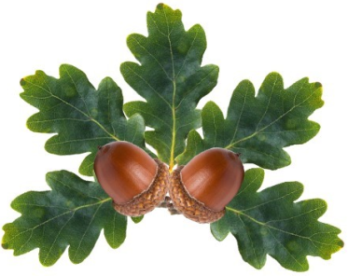

Little Acorns Pre-School Folkestone C.I.O
Grounds of
Folkestone Baptist Church
Hill Road
Folkestone
Kent
CT19 6LY
Manager: Mrs T. Neilly
Tel: 01303 245562
Ofsted No: 2774263 Mobile: 07879202160
Registered Charity No:1204181 E-mail:manager@littleacornspreschoolcio.co.uk

Early Years Pupil Premium

For some years, schools have been given extra funding for some children who meet the free school meal criteria. This money is used to support children’s individual learning. Some children in Early Years groups may also be eligible for this. The funding is called Early Years Pupil Premium, and we may be able to get extra money to spend on your child’s learning if you are on certain benefits or they have been in care.

You can complete the form yourself online at:

www.kent.gov.uk/pupilpremium

You will need this DfE number: 667 951.

If you would prefer, we can complete the form together in my office and would only take 5 minutes. All you need to do is bring your National Insurance Number and the name of the benefit(s) you are on.

Please speak to your child’s key person or me for more information. The money will be used to support your child to have all the skills they will need to be ‘school ready’

Your support is much appreciated.

Thank you

Tracy
Pre-School Manager

