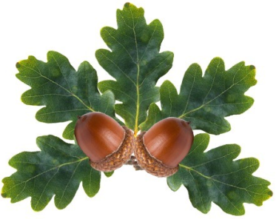

Little Acorns Pre-School Folkestone C.I.O
Grounds of
Folkestone Baptist Church
Hill Road
Folkestone
Kent
CT19 6LY
Manager: Mrs T. Neilly
Tel: 01303 245562
Ofsted No: 2774263 Mobile: 07879202160
Registered Charity No:1204181 E-mail:littleacorns13@hotmail.co.uk
All About me!

My name is ______________ and I am _________ years old
I live at home with ___________________________________________________________________________________________________________________________________________________________________________________________________
My favourite things to play with are

Something I really like watching at home is

When I get sad something that calms me down is

I really enjoy eating and drinking

My favourite people are

Something that makes me laugh is

Something that scares me is

My favourite rhymes, songs and books are

How I eat and drink (in a highchair/drink from a bottle/what I drink ect)

The grown ups at Little Acorns are called:
- Amy
- Ella Rose
- Kim
- Vicki
- Tracy
- Jade
- Louise
- Annette
- Sam
They will use this information to make my time at Little Acorns as enjoyable and as comfortable as possible!

