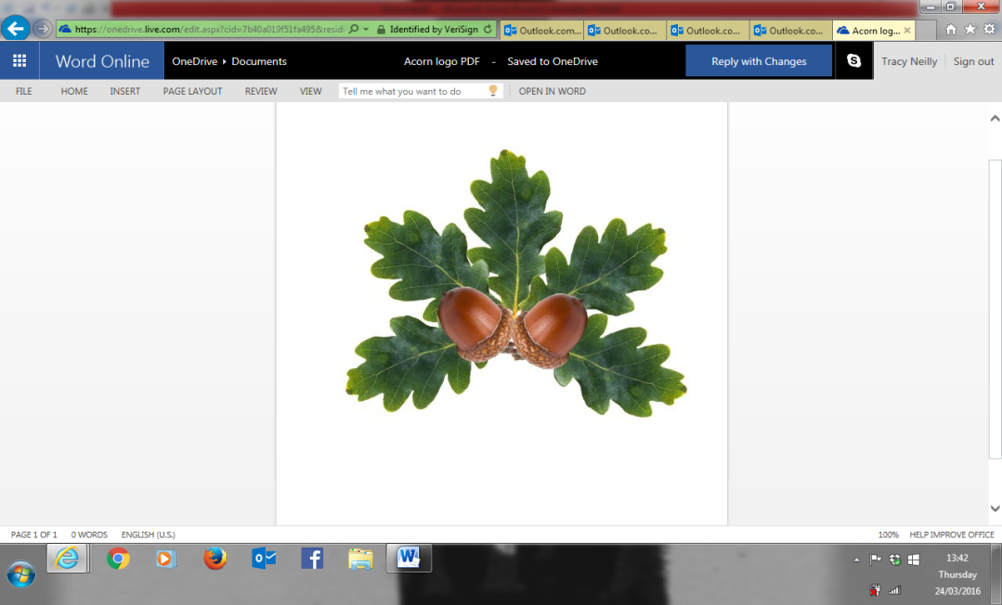

**Little Acorns Pre-School Folkestone C.I.O**

**Grounds of**

**Folkestone Baptist Church**

**Hill Road**

**Folkestone**

**Kent**

**CT19 6LY**

**Manager: Mrs T. Neilly**

**Tel: 01303 245562**

**Ofsted No:2774263 Mobile: 07879202160**

**Registered Charity No:1204181 E-mail:littleacorns13@hotmail.co.uk**

Contract

Our Pre-School offers supporting services. However, parents/carers are the first and most important educators of their young children. The work of the group cannot be fully effective unless Pre-School and parents/carers work together in the child’s interests.

Parents/carers are asked to read and sign the statements below as an expression of this shared commitment.

Shared Record Keeping

I/we will contribute to the record of my child’s development created jointly by parents and the Pre-School, working with the staff to identify and meet the child’s educational, personal, and social needs and to implement decisions taken in the interest of the child. I/we will endure those contributions are made to my child’s personal ‘learning journey’ on a regular basis.

Fees

I/we will pay fees in the amounts and by the times specified by the Pre-School. I/we understand that I/we will pay full fees for time off due to sickness or holiday other than that cancelled by the Pre-School.

Sessions

I/we understand that my child’s sessions cannot be changed unless a terms notice is given and missed sessions can not be swopped/changed

Punctuality

I/we will try not to be late in collecting my/our child at the end of their session and will warn the Pre-School and, if able to, the child, on any occasion when this might happen. I/we understand that I/we will incur a charge of **£10 per every 15 minutes** over the collection time.

Absence

I understand that if my child is absent, I must call/text /email the setting before 10.30am each day and state why they are absent. If this does not happen the setting will contact me, this is in line with ofsted legislation with regards to safeguarding

Signed: _____________________ (Parent/Guardian) Date: _______________________

Signed: _____________________ (Parent/Guardian) Date: _______________________