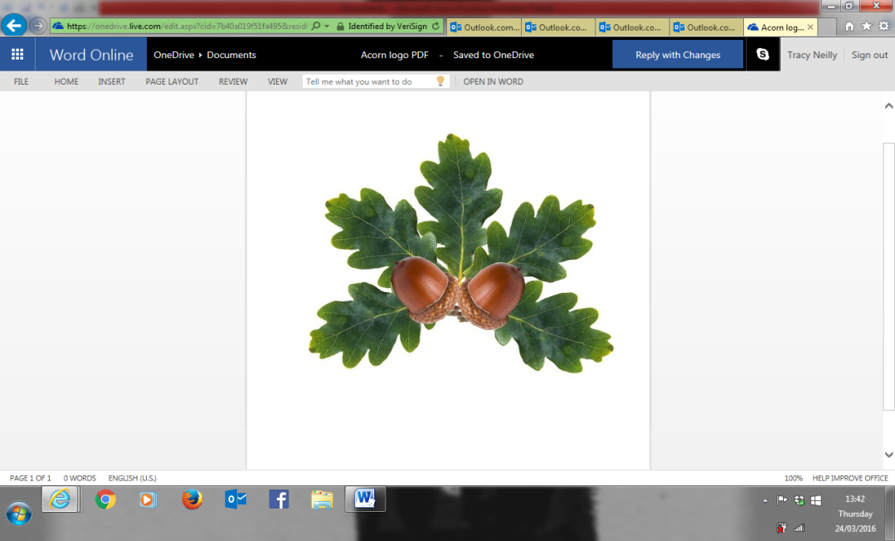

**Little Acorns Pre-School Folkestone C.I.O**

**Grounds of**

**Folkestone Baptist Church**

**Hill Road**

**Folkestone**

**Kent**

**CT19 6LY**

**Manager: Mrs T. Neilly**

**Tel: 01303 245562**

**Ofsted No: 2774263 Mobile: 07879202160**

**Registered Charity No:1204181 E-mail:littleacorns13@hotmail.co.uk**

Consent Forms

All parents/carers should read the following statements carefully and sign the consent form below. It is important that parents/carers are aware of our policies and procedures as they form the basis for how the setting is operated. Please indicate your acceptance to each statement below by ticking the box you agree with.

I have read and understood all Pre-School policies and procedures and accept that the setting will run in accordance with them YES [ ] NO [ ]

In the event of a medical emergency, I give permission to Little Acorns staff to administer any first aid that they are trained in YES [ ] NO [ ]

If the necessity should arise, I give permission to Little Acorns staff to accompany my child to hospital in an emergency vehicle in my absence YES [ ] NO [ ]

I agree to my child being photographed within the setting for use by the Pre-School YES [ ] NO [ ]

I understand that if photographic material is to be used for advertising purposes, I will be notified YES [ ] NO [ ]

I agree to cream being applied to my child at the time of their nappy change by their key person if necessary YES [ ] NO [ ]

I agree to my child taking part in outings and walks to the surrounding areas YES [ ] NO [ ]

I give permission for a Kids Sensitive SPF50+ sun cream to be applied to my child by Little Acorns staff and agree to contribute £1 towards the cost of this YES [ ] NO [ ]

I give permission for plasters to be applied to my child by Little Acorns staff YES [ ] NO [ ]

I will pay fees in the amounts stated and by the time specified by the Pre-School YES [ ] NO [ ]

I understand that all data kept on my child will be used and stored in accordance with the Data Protection Act 1988 YES [ ] NO [ ]

Signed: _____________________ (Parent/Guardian) Date: ___________________