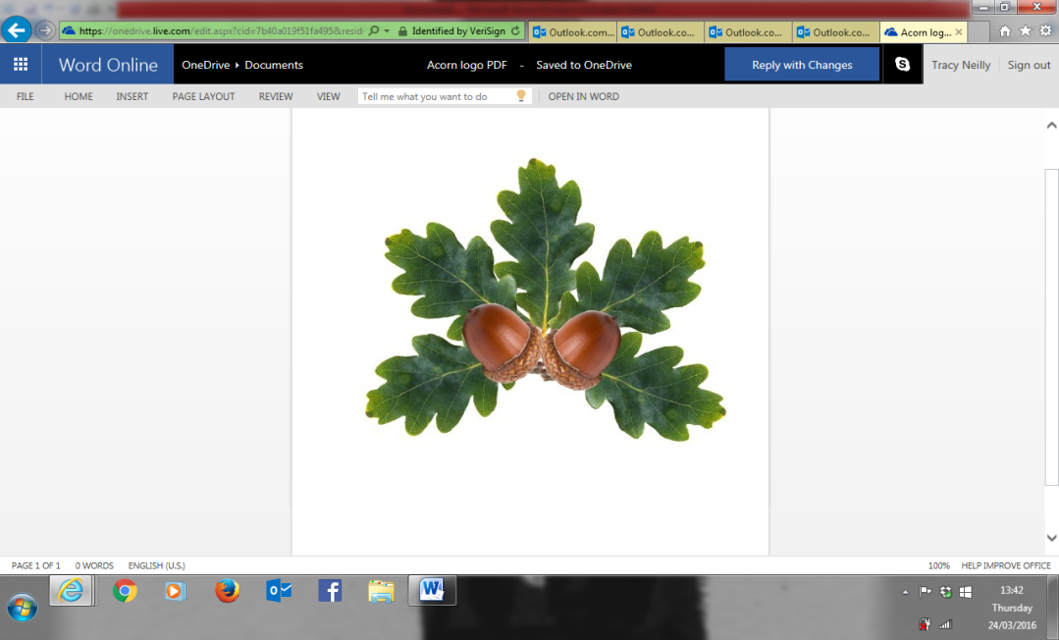 **Little Acorns Pre-School Folkestone CIO**

**Grounds of**

**Folkestone Baptist Church**

**Hill Road**

**Folkestone**

**Kent**

**CT19 6LY**

**Manager: Mrs T. Neilly**

**Tel: 01303 245562**

**Ofsted No:2774263 Mobile: 07879202160**

**Registered Charity No:1204181 E-mail:littleacorns13@hotmail.co.uk**

Sessions and Fees

Early Bird

This session begins at 8:15am and is charged at **£8 a session**. Your child will be provided with breakfast before the start of the Pre-school Day. Early Bird must be booked in advance. *This session does not fall under the free funded hours criteria.*

Early Bird Drop Off

This enables you to drop your child off before the start of the Pre-school Day without the option of breakfast. You can drop your child off anytime between **8:45am & 9:15am, it is £4.00 a day** and can be arranged in the morning by phoning Pre-School. These are handy if you have appointments to get to or other children to drop at schools*. This session does not fall under the free funded hours.*

Late pick up

This is from **3.15pm until 3.45pm** at a fee of **£4.00** and **must be pre booked.**

Children will have access to tabletop activities a drink and a snack, this will be in the kitchen.

There are very limited spaces. If your child is not booked in, and you are late you will be charged the late collection fee of **£10.00 per 15 minutes** over collection time. *This session does not fall under the free funded hours.*

Morning

This session runs 9:15-12:15 and can be used as part of your child’s free hours.

Full Day  
This session runs 9:15-15:15 and can be used as part of your child’s free hours.

We deliver ‘Free For 2’ funding. If your child is eligible, they are entitled to 15 hours free early education to be used flexibly, between 9:15am and 15:15pm a week.

We also deliver working parent entitlement for 2 year olds. They are entitled to 15 hours of childcare per week to be used flexibly within our delivery pattern.

All eligible 3- and 4-year-olds are entitled to 15 hours of free early education to be used flexibly between 9:15am and 3 :15pm a week.

Universal free early education is 570 hours, this equates to 15 hours per week. Your child’s free early education is accessed once your parental declaration is complete. We also require you to bring your child’s birth certificate or passport as proof of age for the eligibility of the Early Years Free Early Education.

We offer 30 hours free education if you meet the criteria. To check if you qualify for any of the above entitlements, please visit:   
  
https://www.childcarechoices.gov.uk/

https://www.kent.gov.uk/education-and-children/childcare-and-pre-school/free-childcare/30-hours-free-childcare

Please circle the sessions you require

**Delivery Pattern**

|  |  |  |  |  |
| --- | --- | --- | --- | --- |
| **Day** | **Early Bird** | **Morning** | **Afternoon** | **Full Day** |
| Monday | 8:15am-9:15am (1 hour) | 9:15am- 12:15pm (3 hours) | 12:15pm- 3 :15pm (3 hours) | 9:15am-3 :15pm (6 hours) |
| Tuesday | 8:15am-9:15am (1 hour) | 9:15am- 12:15pm (3 hours) | 12:15pm- 3 :15pm (3 hours) | 9:15am- 3 :15pm (6 hours) |
| Wednesday | 8:15am-9:15am (1 hour) | 9:15am- 12:15pm (3 hours) | 12:15pm- 3 :15pm (3 hours) | 9:15am- 3 :15pm (6 hours) |
| Thursday | 8:15am-9:15am (1 hour) | 9:15am- 12:15pm (3 hours) | 12:15pm- 3:15pm (3 hours) | 9:15am- 3 :15pm (6 hours) |
| Friday | 8:15am-9:15am (1 hour) | 9:15am- 12:15pm (3 hours) | 12:15pm- 3 :15pm (3 hours) | 9:15am- 3 :15pm (6 hours) |

Any sessions you require outside of your child’s free hours will be charged as set out below:

Each 3-hour session is charged at £18  
Each 6-hour session is charged at £36.

Little Acorns Pre-School is open 38 weeks of the year, term time only.

Sessions can be changed by giving a terms notice.

Fees

Fees for the term will be issued at the beginning of each new term. These can be paid as and when but MUST be paid in full, by the date set by the Pre-School before the end of each term.

Fees are calculated for the whole term for the days your child attends. This means that if your child has time off due to sickness or holiday, you will still be charged. If Pre-School cancels a session, you will not be charged. This is an Ofsted policy.

**If you are late collecting your child, you will be charged £10.00 per 15 minutes your child is in Pre-School after 12:15pm or 3:15pm. These charges apply whether your child is in receipt of Free Early Education or not**