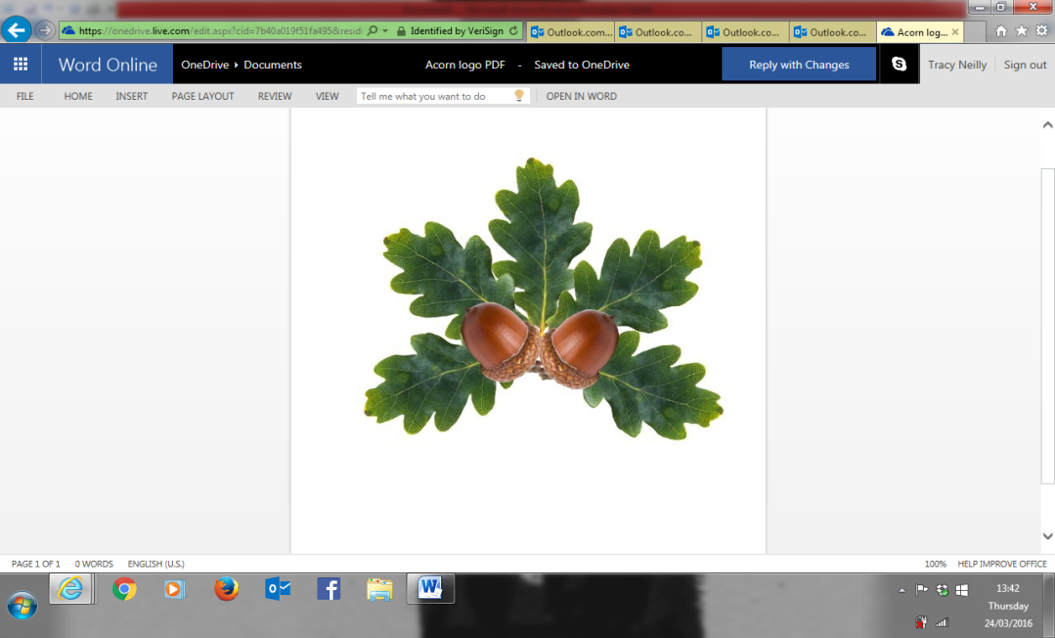
Little Acorns Pre-School Folkestone C.I.0
Grounds of
Folkestone Baptist Church
Hill Road
Folkestone
Kent
CT19 6LY
Manager: Mrs T. Neilly

Tel: 01303 245562
Ofsted No:2774263 Mobile: 07879202160
Registered Charity No:1204181 E-mail:littleacorns13@hotmail.co.uk

Little Acorns Pre-School Folkestone CIO Enrolment Form
Parents and Carers Contact Details

Name of child: ___________________________ Known as: ____________________
Date of birth: ___________________________ Gender: _____________________

Childs address: _______________________________________________________
___________________________________________________________________
Postcode: __________________________________
Home phone number: _________________________________________

Parents the Child Lives With
Parent/Carer 1: _______________________ Relationship to child: _________________
Mobile number: _______________________ Parental responsibility: Yes/No (Please circle)

Parent/Carer 2: ______________________ Relationship to child: _________________
Mobile number: _______________________ Parental responsibility: Yes/No (Please circle)

To be able to use our online learning journey app, Tapestry, we require your email address. Please provide us with it so you can start enjoying seeing what your child gets up to while at Pre-School.

Parent/Carer 1 email address: ______________________________________________
Parent/Carer 2 email address: ______________________________________________
For your child to receive their Free early education entitlement of 15 or 30 hours per week you need to provide us with a parent’s national insurance number and date of birth. For more information on eligibility check online on www.gov.uk.

National insurance number: _______________________

Date of birth: ____________________________

Parents the Child Does Not Lives With
Parent’s name: _______________________ Relationship to child: _________________
Mobile number: ______________________ Parental responsibility: Yes/No (Please circle)

Address: _______________________________________________________
___________________________________________________________________
Postcode: __________________________________

Does this parent have legal access to the child? Yes/No (Please circle)

Emergency Contact Details
Parent 1 Daytime/Work contact number: ____________________________________
Parent 2 Daytime/Work contact number: ____________________________________

Other Emergency Contact Numbers
Name: ____________________________ Contact number: _______________________

Relationship to child: _______________________________________
Name: ____________________________ Contact number: _______________________

Relationship to child: _______________________________________

Persons Authorised To Collect Child (Must Be Over 16)
Name: ____________________________ Contact number: _____________________

Relationship to child: _______________________________________

Name: ____________________________ Contact number: _____________________

Relationship to child: _______________________________________

For your child’s safety and security, we require a password if anyone, other than yourself or the authorised named people above, collect your child from the Pre-School. This person must be over 16 years old.
It is your responsibility to remember the password.
The password must be given in writing.
Password: _____________________________________

Medical Details
Child’s doctor: ____________________________
Surgery address: _______________________________________________________
___________________________________________________________________
Telephone number: __________________________________

Immunisations: Please circle those already received
Diphtheria Tetanus Whooping Cough Meningitis
Polio Doses 1 2 3 M.M.R H.I.B

Has your child ever had a convulsion? Yes/No
Is there a family history of convulsions? Yes/No
If yes, please give details _________________________________________________
_____________________________________________________________________
Does your child require regular medication? Yes/No
If yes, please give details _________________________________________________
_____________________________________________________________________
Does your child have any allergies? Yes/No (Please Circle)
Please include allergies such as food intolerances, colorant, pollen etc.
If yes, please give details _________________________________________________
_____________________________________________________________________
Do you have a health visitor? Yes/No (Please Circle)
Name: ______________________________ Contact number: _____________________
Based at: ___________________________________

Does your family have a social worker for any reason? Yes/No (Please Circle)

Name: ______________________________ Contact number: _____________________
Based at: ___________________________________

Are any other professionals involved with your child? Yes/No (Please Circle)

1 Name: ___________________________ Agency: _____________________________
Role: _____________________________ Contact number: _______________________

2 Name: ___________________________ Agency: _____________________________
Role: _____________________________ Contact number: _______________________

How many children are in the family? _________________________________________
What position is the child in your family? ______________________________________
What is your child’s ethnicity or cultural background? ____________________________
What is the main language spoken at home? ____________________________________
What is the main religion in your family? ______________________________________
Are there any festivals or special occasions celebrated in your culture that your child will be taking part in that you would like to see acknowledged and celebrated while at our setting? _____________________________________________________________________

We are primarily a Christian Pre-School and do celebrate all major Christian events and holidays.
Do you have any objection to this? Yes/No (Please Circle)

You are required to bring your child’s birth certificate or passport as proof of age for eligibility of the Early Years Free Early Education

Please provide any additional information you feel is relevant to your child below:
_____________________________________________________________________

How did you hear about Little Acorns Pre-School?
_____________________________________________________________________

Signed: _____________________ (Parent/Guardian) Date: _______________________

_____________________________________________________________________

Office use only:

Evidence seen: __________________________ Number: ________________________
Checked by: ____________________________ Date: __________________________

Parent declaration completed: Yes/No

Privacy notice information received. Yes/No Date: __________________________

