AYRODYNAMIC TRIATHLON CLUB
MEMBERSHIP 2025

As a member of Ayrodynamic Triathlon Club during 2024, we would like to invite you to renew your membership for 2025. The committee have partnered with JoinIn as a booking and administration system for the Club which makes booking sessions and making payment in a straightforward and manageable basis.

As discussed at our AGM in November 2024, a proposal was passed to increase the annual membership fee to £35 per annum. Additionally, it was proposed and passed to increase session prices slightly to counter the increase in costs of facilities to the Club.

The JoinIn system has been set up to take monthly direct debit payments via London and Zurich of £12 per month which covers the cost of attendance at all swimming and track sessions during the month. Alternatively, members can pay for each session on a pay as you go basis at £4 per session.

At the moment ONLY annual membership and monthly direct debits will be taken via Joinin. The online booking system for sessions will be available in April. If you intend to proceed via PAYG for sessions, please continue to make bank transfers to the club account of £4 per session.

To use the JoinIn system to renew your membership, you require to go to the following link.

https://app.joinin.online/#/app/joinin/organisation/shop/09dc0ffe-70b2-4294-a1ab-b908102f8555

This will take you to the Club shop where you can purchase your annual membership. There follows information on how to purchase annual membership and set up your monthly direct debit. Please refer to these instructions for assistance. Once you have started the process of purchasing your annual membership, you will be asked to create an account. Once your account has been created, you can login for future purchases at https://app.joinin.online/#/app/joinin/login

Information on how to book sessions will be provided once this element is available.

We look forward to welcoming all our members to sessions and activities thoughout the year.

Happy training

Ayro Committeee
ANNUAL MEMBERSHIP PURCHASE

To purchase the annual membership, please follow the following instructions:-

- Click Membership

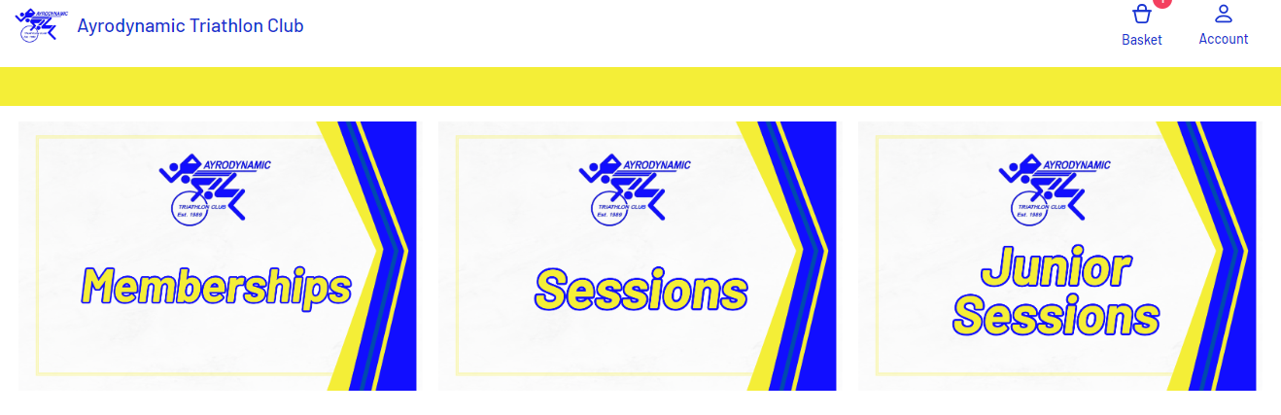

- Pick either “Annual Joining Fee” or “Annual Joining Fee Junior” (please note that for juniors, an adult requires to create the JoinIn account and then select the junior membership and complete the details of the junior)
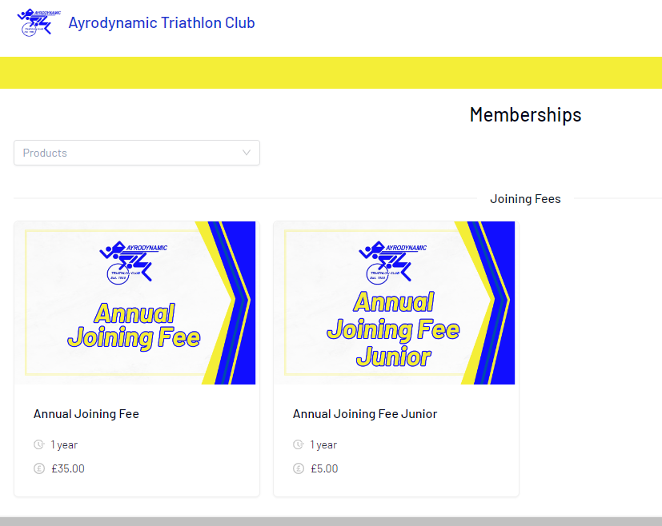

- Once you have selected the appropriate Joining Fee, add to basket, then close the window with the “X” in the top right corner of the joining fee pop up.

- Click “Basket” in the top right hand corner of the main screen.

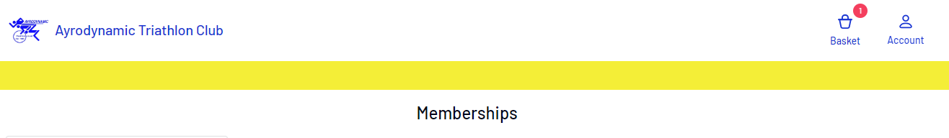

- Click “Proceed to checkout” in the bottom right hand corner of the main screen.

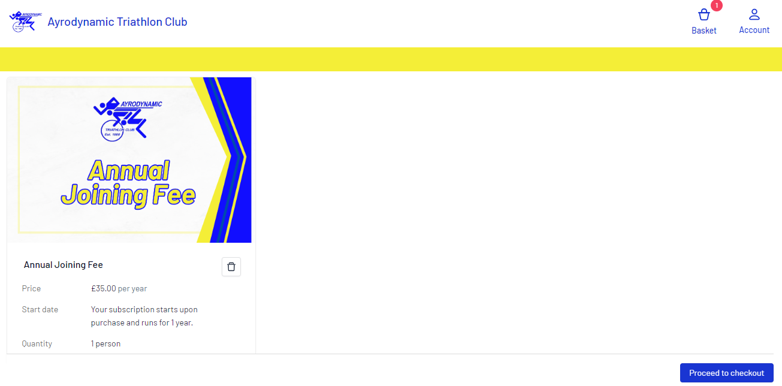

- Then select the person for whom the membership is being purchased. For senior members, this will be yourself. The system for junior members is slightly different and information on this follows.

- Follow the instructions and complete the various questions.

- Once all questions have been answered (which are required by Triathlon Scotland to gather anonymous information regarding our diversity of membership), proceed to make payment as you would for any purchase. Prior to proceeding to the checkout, you can also include your monthly direct debit purchase for all sessions within the month. Instructions on how to include that monthly direct debit purchase follow below.

You will receive a confirmation email from JoinIn so please keep an eye on your junk box for any emails.

MONTHLY DIRECT DEBIT PURCHASE

To set up your monthly direct debit of £12 per month to cover all of your training session, please follow the following instructions. Please note you can only purchase a monthly direct debit once you have purchased your annual subscription:-

- Login to JoinIn via the following link:

https://app.joinin.online/

- Enter your email and password to login

- Click “Shop” on the menu on the left hand side of the screen

- Click “Ayrodynamic Triathlon Club”

- Click Membership

- On the Memberships page scroll down to the “Monthly Unlimited Class Pass”

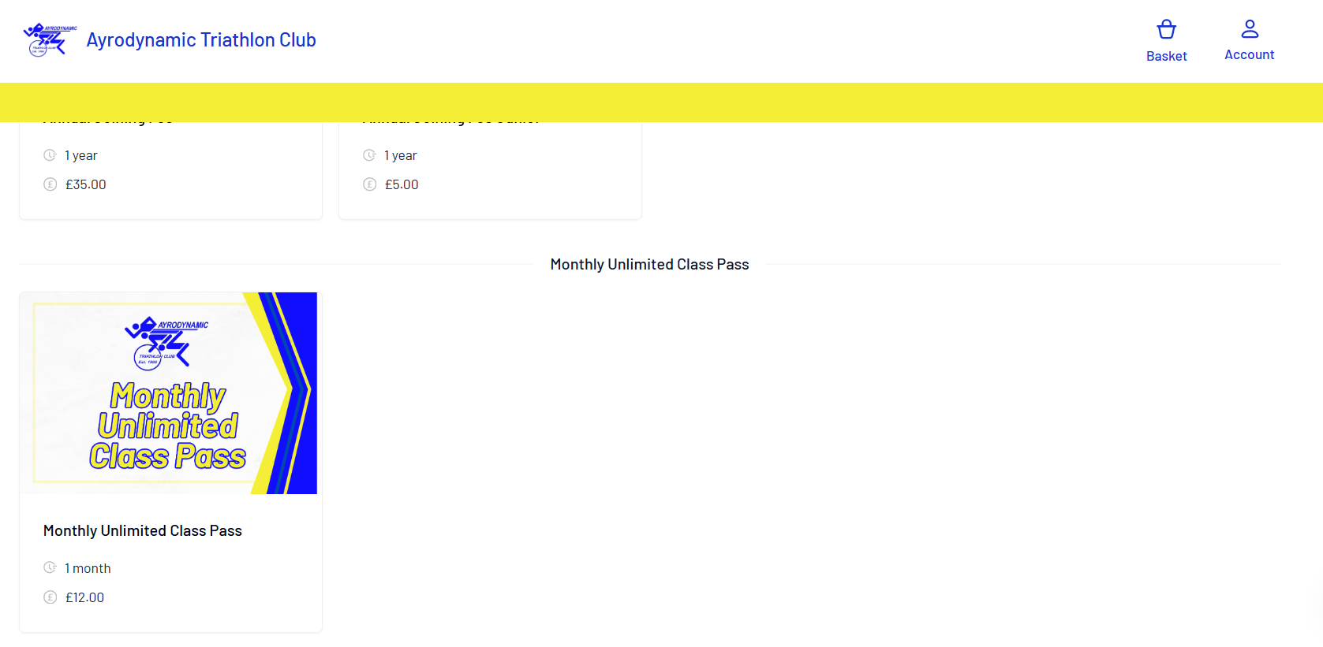

- This will take you to the following screen

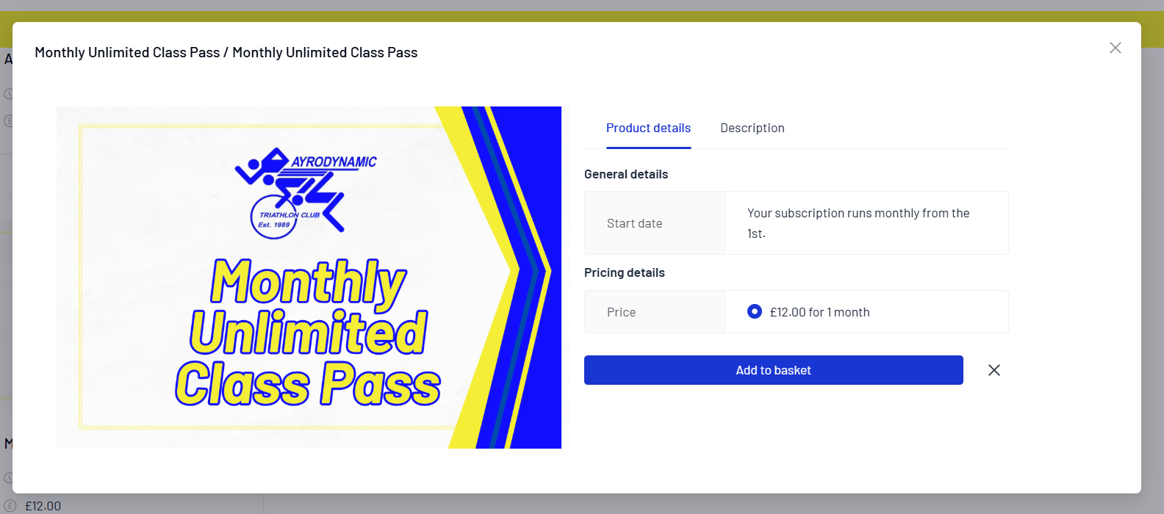

- Click add to basket

- Go to basket and check out in the normal manner.

You will receive a direct debit mandate from London & Zurich. Please keep an eye on your junk inbox in case it goes there.

ANNUAL MEMBERSHIP JUNIOR PURCHASE

To purchase membership for a junior member, the adult requires to create an account at the JoinIn login page at the following link:

https://app.joinin.online/

Once the adult has created their account, go to the left hand menu and click “Friends and Family”

Then click “New Person”

Then complete the details of your young person.

To take out members, follow the guidance for “Annual Joining Fee” above however click on “Annual Joining Fee Junior”

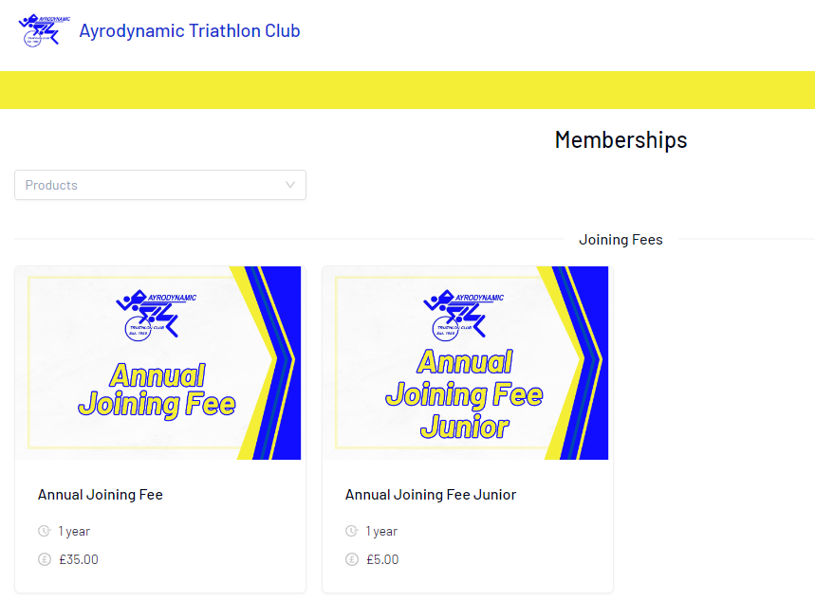

Click “Add to Basket”

Click the “X” in the top right hand corner of the pop up

Click “Basket” on the main page

Click “Proceed to Checkout”

At this point, where above it mentions completing your own information to take out membership, click on the name of your young person and then complete their medial information, emergency contact information etc. Then proceed to checkout in the same manner as for membership purchase.

A junior monthly direct debit purchase can also be made at the same time. To do this, follow the instructions above in relation to senior monthly direct debit however click “Junior Unlimited Class Pass” and follow the rest of the instructions as for seniors above.

