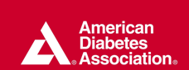

American Diabetes Association

Self-paced Learning
for the Glycemic Method and
the Carbohydrate Counting Method

Completed in Spring of 2011 by:

Kathy Ekorikoh

Susi Schmidt

Sue Ellen Simon


Table of Contents

Introduction 3
Welcome! This training is for you 3
What this training can do for you 3
What you need to complete this training 3
How this training works 4
Pre-Assessment 5
Unit One: The Glycemic Index Method 8
What you will be able to do after completing Unit 1 8
How using the Glycemic Index Method Looks 9
Step-by-Step How to use the method 9
Unit Two: The Carbohydrate Counting Method 30
What you will be able to do after completing Unit 2 30
How using the Carbohydrate Counting Method Looks 31
Carbohydrate Budget 31
Step-by-Step How to use the method 32
Maintaining a Low Carbohydrate Lifestyle 39
Course Summary 42
Practice Exam 42
Final Exam 45
Choose a method 52
Pre-Plan other situations 52
How to sustain using the method 52
Summary 53
Appendices 54
Appendix A: Practice Exam Answer Key 55
Appendix B – Final Exam Answer Key 57

Design notes for Dr. Stepich:
- There is a slight modification of instructional materials from the detailed instructional plan in that we added steps in the conclusion to select one method and then do additional planning. The instructional plan called for integration of the method in each unit which was not essential for each when the request was for them to choose one method to start with.
- Based upon feedback on the instructional plan, modifications were made to add diminished coaching.
- This section will be removed prior to sharing with the client or the learners.

Introduction

Welcome! This training is for you

This training is for you if you are a patient with diabetes and are looking to control your blood glucose levels through healthy food choices. Although other factors influence your diabetes, following these methods may positively affect the management of your diabetes.

Always work with your health care provider or diabetes educator for primary guidance on managing your diabetes. This training is not a substitute for health advice from your doctor.

What this training can do for you

The goal of this training program is to learn two methods of controlling blood glucose levels so that you can select foods and build recipes that will help you control your blood sugar levels.

The two methods you will learn are the Glycemic Index Method and the Carbohydrate Counting Method. These are two commonly recognized nutritional methods in diabetes management.

What you need to complete this training

In order to complete this training, you will need:
- This learning guide.
- A pen or pencil to write in the guide.
- The ADA food journal provided by the Tucson Office
- A list of suggestions for online journals is listed in the reference section.
- Computer access. If you do not have access to a computer, you may check with your local library or your local ADA office.
- A calculator if you wish to use one for adding.
- One or two of your own recipes.

How this training works

This training is at your own pace. You can start and stop the training in segments that work best for you. It is recommended that you provide yourself with a quiet location to work through this guide.

We know that you already make allot of food choices today. You probably also have a number of recipes and meals that you like and want to keep. Who wants to give up their favorite meals? You won’t need to but you probably will modify your recipes.

During this training, you will practice both the glycemic index and carbohydrate counting methods, using recipes provided and then one of your own. After learning each method, you will then choose one method and pre-plan for additional situations where you will use that method. You may switch methods at any time so you are free to practice and change based upon what method works best for you.

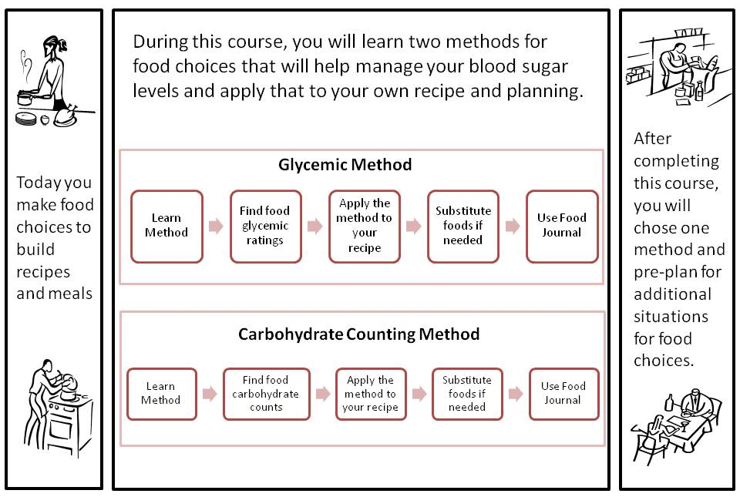

Like any journey, it is helpful to know where we start and end. We will start with you taking a pre-assessment. Please fully complete the assessment. You are not expected to know this material but you will upon completion of the learning units. After the course you will take a practice test and a final exam. By looking at all of these, you will be able to see the progress you have made and, if there are any missed questions, you may go back to the material to review. So let’s get started.

Pre-Assessment Directions
Carefully read through these instructions and proceed with the pre-assessment
- Take the assessment in an area where you can concentrate and remain uninterrupted for 15 minutes
- Read each question thoroughly
- Answer each question as best as you can
- After completing the pre-assessment go to unit one: glycemic index

Estimated Time: 10-15minutes

Pre-Assessment
- ___________ foods quickly raise the blood glucose.
  - High GI
  - Low GI
  - Medium GI
  - Both B and C
  - Don’t know

- Meal planning with GI involves choosing foods that are_____________.
  - Medium GI
  - High GI
  - Low
  - Low and Medium GI
  - Don’t know
- Choose which food item has a higher GI
  - Yam
  - Spinach
  - Pineapple
  - All of the above
  - Don’t know

- Carbohydrate counting involves setting a limit for your maximum amount to eat. True or False

- Total carbohydrate on a nutritional label includes
  - Sugar
  - Starch
  - Fiber
  - All of the above
  - Don’t know

- Which ingredient is higher in carbohydrates?
  - Beef hot dog
  - Hot dog bun
  - Garden green salad
  - 2 boiled eggs
  - Don’t know

- Home recipes can be made healthier by food substitution. TRUE or FALSE
- Documenting your daily food intake is a resourceful tool for
  - Meal planning
  - Disease management
  - Controlling carbohydrate
  - All of the above
  - Don’t know

- Having diabetes means having the same food day after day. TRUE or FALSE

Great! Now that you have completed the pre-assessment, you can get started on learning about the first method in unit one.
Unit One: The Glycemic Index Method

What you will be able to do after completing Unit 1

Upon completing this self-paced module, you will be able to:

- Accurately find the glycemic index for a food using a reference manual or on-line resource.

- Accurately list glycemic ratings of high, medium or low for each ingredient in a home recipe, using a reference manual or on-line resource.

- Substitute all high glycemic ingredients in the recipe for low/medium glycemic ingredients, using a reference manual or on-line resource.

- Accurately document every ingredient and food consumed during the day, and the ingredient’s glycemic index rating, in a manual or web-based journal.

You currently make food choices and build recipes using a multiple of ingredients.

In this training, you will be asked to identify, and have available for use, one of your favorite recipes that will be used throughout the unit.

Through this section of the program, you will learn about the glycemic index method for choosing foods that will help regulate your blood sugar level. You will then be able to apply what you have learned using this method to your own recipes.

Here is what you will be covering in Unit 1:

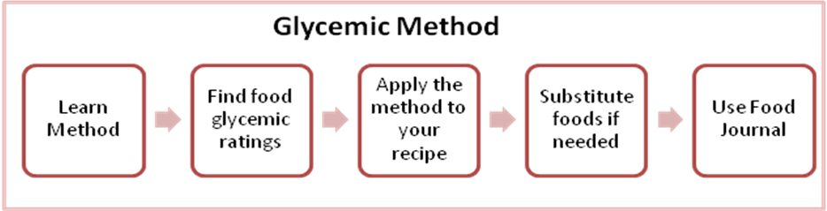

How using the Glycemic Index Method Looks

Mary is a 35 year old female who has been recently diagnosed with Diabetes and has been told by her doctor that she needs to start making healthier eating choices. In order to start making these healthier food selections, Mary needs to learn what the glycemic index is and how she can use the different glycemic index ratings for foods to help her make these decisions. Once Mary learns how to find the glycemic index rating for foods, she can then start replacing her current foods she is eating with healthier food choices. She can then record the food choices she makes as well as the glycemic index ratings for each of these foods in a journal on a daily basis to help her understand how these foods and their glycemic index ratings can help her control her blood sugar levels.

Step-by-Step How to use the method

In order to determine what the glycemic index rating (GI) for foods are, you will need to understand the basic concept of the glycemic index. The basic idea behind the glycemic index is that foods are given a specific number based on how quickly these foods raise blood sugar levels. These numbers are then grouped into a rating system based on three different categories of high, medium or low. The idea is to switch high rated foods you are currently eating to either low or medium rated foods.
For example, a slice of white bread has a high glycemic index rating of 71. However, a slice of whole grain bread has a low glycemic index rating of 49. A glycemic index rating chart is listed on the top of the next page.

Glycemic index rating chart:

High GI = 70 and above | Medium GI = 56-69 | Low GI = 55 and under

In order to know how to look foods up in either an online database, glycemic index book or chart it is important that you understand what a carbohydrate is. A carbohydrate is a type of food that raises blood sugar levels which your body uses for energy. There are two different types of carbohydrates which are simple and complex carbohydrates. Simple carbohydrates raise blood sugar quickly which can be very problematic for diabetes. These simple carbohydrates are often high on the glycemic index. Complex carbohydrates also give the body energy, but raise blood sugar levels at a much slower rate and tend to be in the medium to low categories on the glycemic index. Examples of both types of carbohydrates are listed below:

Simple carbohydrates: sugar, fruit juices, soft drinks, cakes, cookies, white breads and other sweets.
Complex carbohydrates: bran, whole grain foods, vegetables, fruits, whole grain breads

One important thing to consider is that you will only focus on the carbohydrate foods when you are using your recipes to find the glycemic index ratings for foods within your recipes. For example, if your recipe has a meat item, a dairy item, a bread item and a fat item such as butter, you will only need to be concerned about the bread item because that is the item that will raise your blood sugar.
With that being said, let’s get started looking up the glycemic index of foods. Proceed to the next page.

Step 1: you will need to log on to the World Wide Web and type in the following address: www.glycemicindex.com. An image of the website is shown at the top of the next page.

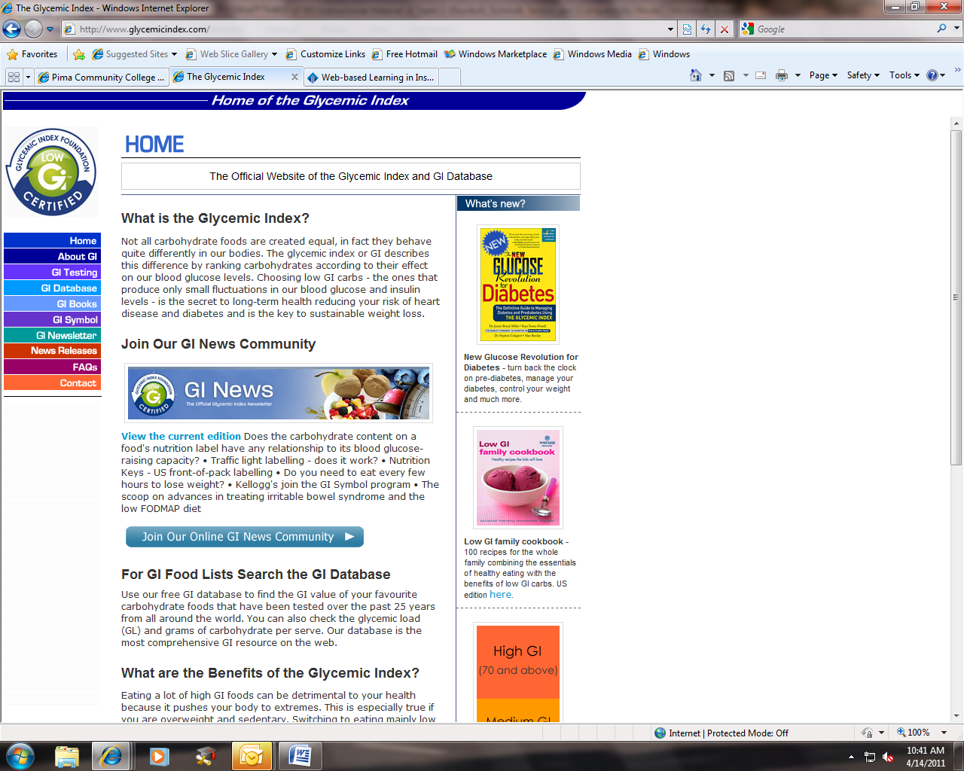

Step 2: you will then click on the tab that says GI database on the left hand side of the screen. An image is listed below with a red arrow pointing to the GI database tab.

Step 3: Once you have clicked on the GI database tab, you will then look up the food of your choice leaving all the fields as they appear. See the image of the database search fields below:

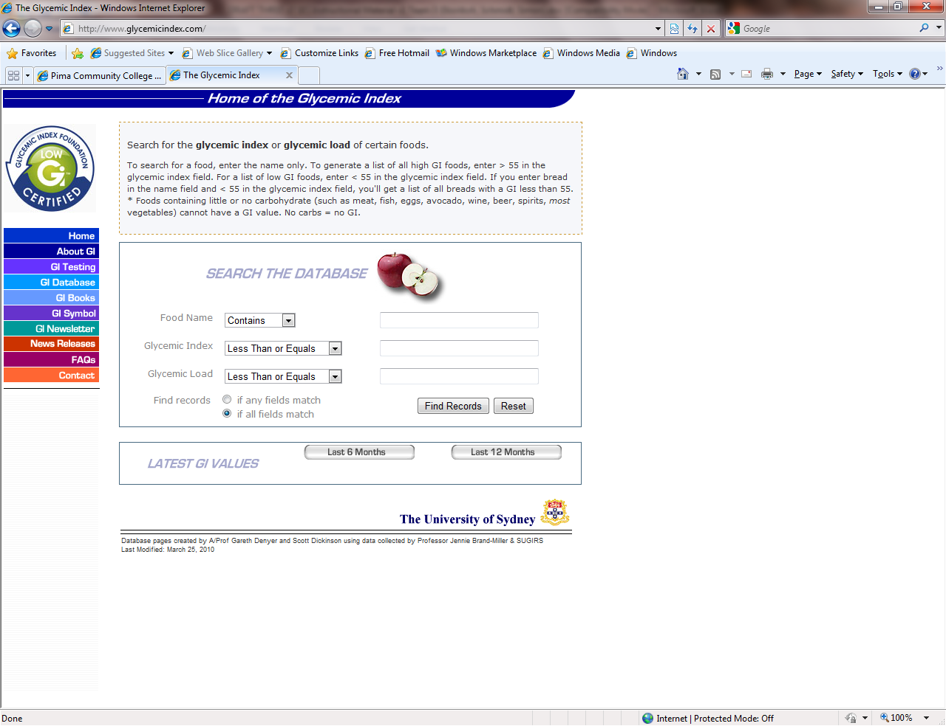

Step 4: Once you have the search field in front of you, you can now enter a food into the database. Let’s try it…
Let’s use carrots as an example food to look up. You will need to type in carrots into the box marked “food name”. An image with a red arrow is shown below:

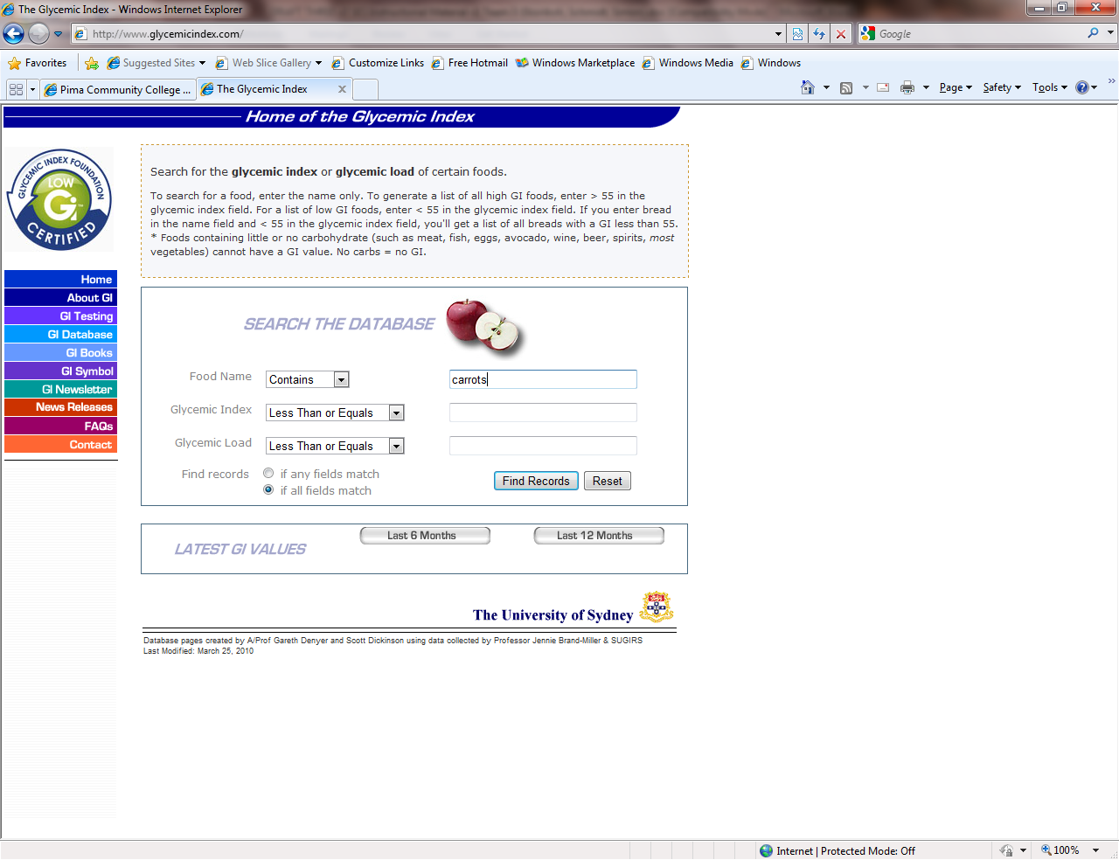

Step 5: once you have entered the food “raw carrots” into the search box named “food name”, you will now click the button titled “find records”, as seen in the previous image. Once this step is completed, you will see an image like the one below:

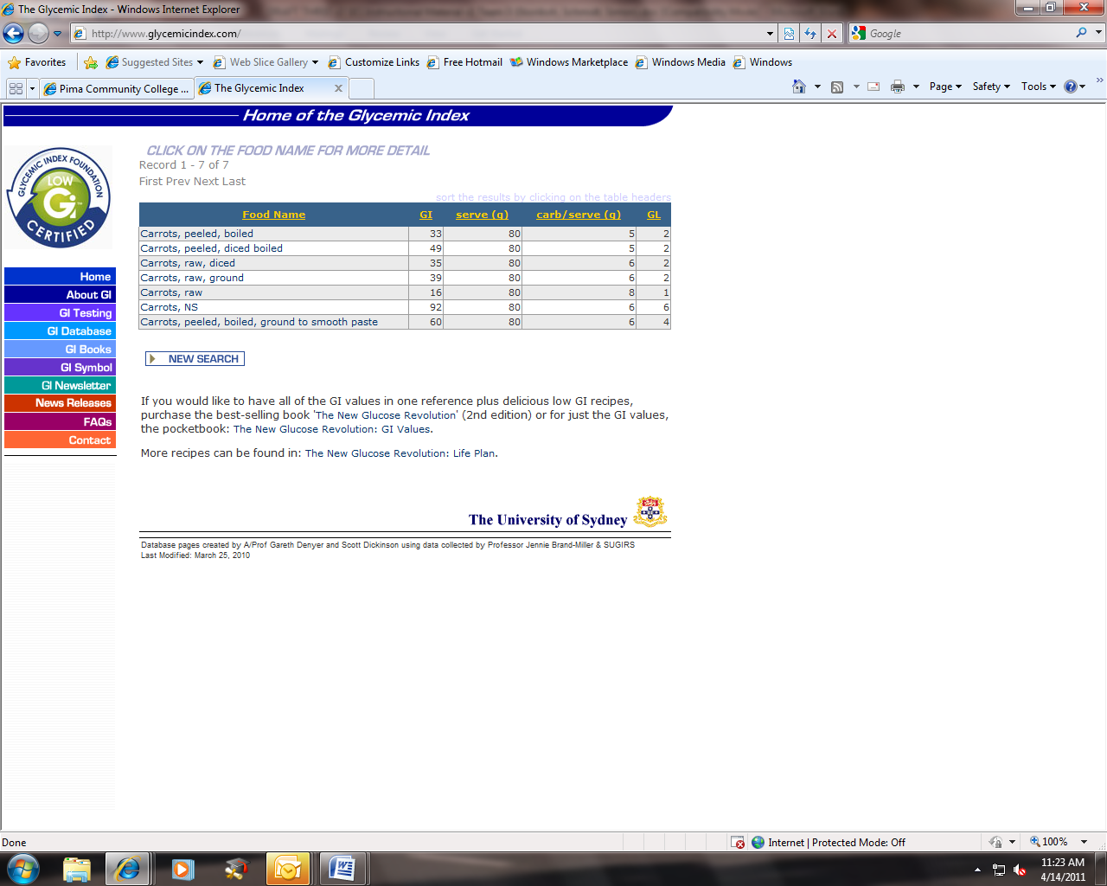

Step 6: As you can see from the image above, 80 grams of raw carrots have a GI of 16, which is considered low on the glycemic index.
Now that we have reviewed how to look up a food using the website database, it is your turn to try and look up a food. Try looking up “raw strawberries” and once you get your results list, look for a serving size of 120 grams.

When looking up “raw strawberries”, follow the steps that were just reviewed above in steps 1-6 using carrots as an example. The bullets listed below will provide reminders on what to do:
- List the food
- Look up the food
- Write down the glycemic index rating here________ and then list what category of the glycemic index it falls into (high, medium or low) here ________________.

Did you complete the task of looking up the glycemic index of “raw strawberries? If so, remember to write down above in the blanks given, what the GI rating was for the strawberries and also what category the fall into.

Let’s move on to how to look up the GI ratings of foods using a GI chart of basic foods. Review the GI rating chart for basic foods listed on the following two pages.
Breakfast Cereal  Staples | Bread  Snacks & Sweet Foods  Legumes (Beans) | Vegetables  Fruits  Dairy
  Low GI
  All-bran (UK/Aus) | 30
  All-bran (US) | 50
  Oat bran | 50
  Rolled Oats | 51
  Special K (UK/Aus) | 54
  Natural Muesli | 40
  Porridge | 58
  Medium GI
  Bran Buds | 58
  Mini Wheats | 58
  Nutrigrain | 66
  Shredded Wheat | 67
  Porridge Oats | 63
  Special K (US) | 69
  High GI
  Cornflakes | 80
  Sultana Bran | 73
  Branflakes | 74
  Coco Pops | 77
  Puffed Wheat | 80
  Oats in Honey Bake | 77
  Team | 82
  Total | 76
  Cheerios | 74
  Rice Krispies | 82
  Weetabix | 74
  Low GI
  Wheat Pasta Shapes | 54
  New Potatoes | 54
  Meat Ravioli | 39
  Spaghetti | 32
  Tortellini (Cheese) | 50
  Egg Fettuccini | 32
  Brown Rice | 50
  Buckwheat | 51
  White long grain rice | 50
  Pearled Barley | 22
  Yam | 35
  Sweet Potatoes | 48
  Instant Noodles | 47
  Wheat tortilla | 30
  Medium GI
  Basmati Rice | 58
  Couscous | 61
  Cornmeal | 68
  Taco Shells | 68
  Gnocchi | 68
  Canned Potatoes | 61
  Chinese (Rice) Vermicelli | 58
  Baked Potatoes | 60
  Wild Rice | 57
  High GI
  Instant White Rice | 87
  Glutinous Rice | 86
  Short Grain White Rice | 83
  Tapioca | 70
  Fresh Mashed Potatoes | 73
  French Fries | 75
  Instant Mashed Potatoes | 80
  Low GI
  Soya and Linseed | 36
  Wholegrain Pumpernickel | 46
  Heavy Mixed Grain | 45
  Whole Wheat | 49
  Sourdough Rye | 48
  Sourdough Wheat | 54
  Medium GI
  Croissant | 67
  Hamburger bun | 61
  Pita, white | 57
  Wholemeal Rye | 62
  High GI
  White | 71
  Bagel | 72
  French Baguette | 95
  Low GI
  Slim-Fast meal replacement | 27
  Snickers Bar (high fat) | 41
  Nut & Seed Muesli Bar | 49
  Sponge Cake | 46
  Nutella | 33
  Milk Chocolate | 42
  Hummus | 6
  Peanuts | 13
  Walnuts | 15
  Cashew Nuts | 25
  Nuts and Raisins | 21
  Jam | 51
  Corn Chips | 42
  Oatmeal Crackers | 55
  Medium GI
  Ryvita | 63
  Digestives | 59
  Blueberry muffin | 59
  Honey | 58
  High GI
  Pretzels | 83
  Water Crackers | 78
  Rice cakes | 87
  Puffed Crispbread | 81
  Donuts | 76
  Scones | 92
  Maple flavoured syrup | 68
  Low GI
  Kidney Beans (canned) | 52
  Butter Beans | 36
  Chick Peas | 42
  Haricot/Navy Beans | 31
  Lentils, Red | 21
  Lentils, Green | 30
  Pinto Beans | 45
  Blackeyed Beans | 50
  Yellow Split Peas | 32
  Medium GI
  Beans in Tomato Sauce | 56
  Low GI
  Frozen Green Peas | 39
  Frozen Sweet Corn | 47
  Raw Carrots | 16
  Boiled Carrots | 41
  Eggplant/Aubergine | 15
  Broccoli | 10
  Cauliflower | 15
  Cabbage | 10
  Mushrooms | 10
  Tomatoes | 15
  Chillies | 10
  Lettuce | 10
  Green Beans | 15
  Red Peppers | 10
  Onions | 10
  Medium GI
  Beetroot | 64
  High GI
  Pumkin | 75
  Parsnips | 97
  Low GI
  Cherries | 22
  Plums | 24
  Grapefruit | 25
  Peaches | 28
  Peach, canned in natural juice | 30
  Apples | 34
  Pears | 41
  Dried Apricots | 32
  Grapes | 43
  Coconut | 45
  Coconut Milk | 41
  Kiwi Fruit | 47
  Oranges | 40
  Strawberries | 40
  Prunes | 29
  Medium GI
  Mango | 60
  Sultanas | 56
  Bananas | 58
  Raisins | 64
  Papaya | 60
  Figs | 61
  Pineapple | 66
  High GI
  Watermelon | 80
  Dates | 103
  Low GI
  Whole milk | 31
  Skimmed milk | 32
  Chocolate milk | 42
  Sweetened yoghurt | 33
  Artificially Sweetened Yoghurt | 23
  Custard | 35
  Soy Milk | 44
  Medium GI
  Icecream | 62
The GI chart for basic foods lists some of the most common foods and is broken down by food groups and the different GI ratings of high, medium and low. You will not find all foods listed here, rather it is meant to be a reference for basic foods, or foods you may not be able to find within the GI database which was reviewed earlier.

Using this GI chart, find the GI ratings for the following foods and list them in the given spaces given next to the food:

- White rice _______
- Soy milk _______
- Ice cream _______
- Lettuce _______
- Watermelon _______
- Wheat tortilla _______

OK, now that you have learned how to find the glycemic index of many different foods, using both an electronic database and a GI rating chart, Let’s move on to applying what you have learned to recipes. For this next section, a few different examples of recipes will be given to help you practice what you have learned and also apply this new knowledge to your own home recipes. The first recipe given will show each carbohydrate listed and the GI rating for each one. The second recipe will have half of the carbohydrate foods with the GI ratings given and the other half of the carbohydrate foods will be blank and you will need to look them up using the electronic database or the GI ratings chart we went over earlier. The third recipe will be a recipe you can choose from home and you will be required to look up all the GI ratings and list them in the space provided.

Let’s get started.....

The first recipe listed below has all GI ratings listed for each carbohydrate.

Recipe #1

Ingredients: GI rating based on each
- 1 pint strawberries - cleaned, hulled and sliced (GI=40/low)
- 1 pound seedless grapes, halved (GI=43/low)
- 3 kiwis, peeled and sliced (GI=58/medium)
- 3 bananas, sliced (GI=51/low)
- 1 cup watermelon (GI-80/high)
- 1 can peaches in juice (GI=45/low)

Directions

In a large bowl, combine the strawberries, watermelon, grapes, kiwis, and bananas. Gently mix in peaches. Chill for 1 hour before serving.
Below you will see a chart that lists the carbohydrate ingredients of this recipe, the GI rating for each of these ingredients and the category of high, medium or low on the glycemic index.
Ingredient | Glycemic rating/category
1 pint strawberries - cleaned, hulled and sliced | GI=40, low
1 pound seedless grapes, halved | GI-43, low
3 kiwis, peeled and sliced | GI=58, medium
3 bananas, sliced | GI=51, low
1 cup watermelon | GI=80, high
1 can peaches in juice | GI=45, low
Ok, now that we have reviewed how to list the carbohydrates and the GI ratings for them, it is time for you to try and practice these same steps with some help. Listed below is another examples recipe that has parts of it filled in for you. The next step is for you to identify which items are carbohydrates and then you will need to find the GI rating for these items either using the online GI database or the given GI rating chart shown on pages 19-20.
Try filling in the GI ratings as well as the category of each of the carbohydrate items from the recipe listed below.
Recipe #2
Ingredients: GI rating based on each
- 2 slices white bread

- 2 teaspoons (10 ml) reduced-fat mayonnaise

- 1 teaspoon (5 ml) prepared mustard (optional)

- 2 ounces (60 g) sliced deli turkey ham

- 1 small apple, cut in half, cored, and thinly sliced

- 1 lettuce leaf, washed and drained on paper towels
- 4 dates served on the side of the sandwich
- Lay bread slices on a cutting board. In a small bowl, combine mayonnaise and mustard, if using
- Spread the mayonnaise mixture on the top side of each bread slice.
- Fold each turkey ham slice into quarters and place on 1 slice of bread. Arrange the apple slices on top of the turkey ham. Cover with the lettuce leaf.
- Place the second slice on top of the lettuce, mayonnaise side down.
- Serve at once, or cut into half or quarters and serve.
For the chart listed below, fill in the blank spots for only the carbohydrates listed in this recipe. One of the carbohydrate items for this recipe has already been filled in for you.
Ingredient | Glycemic rating/category
White bread | GI=70, high

Now that you have practiced how to apply what you have learned using the glycemic index ratings of foods, it is now time for you to practice listing out the carbohydrates of your own recipe using the online glycemic index database or the glycemic index rating chart given on pages 19-20. Use the table listed on the next page to fill in the carbohydrates.

Now let’s use your recipe. Write your recipe in the space below.

Now list your ingredients and the GI ratings for your recipe:

Ingredient | Glycemic rating/category

OK—now you have had practice learning how to find the glycemic index of common foods of a given recipe and one of your own recipes. Now, we will work on substituting those foods that are in the high and medium categories for foods that are in the low categories. For the purpose of this exercise, we will substitute all foods with a high or medium GI rating for those in the low category if possible. Remember, this will not always be possible, so having foods in the medium category will be acceptable.

In this exercise, you will be given the same recipes as in the last section, however, this time, you will be substituting the foods that have already been identified as having high or medium GI ratings for low GI rated foods.

Let’s get started….

Recipe #1

Ingredients: GI rating based on each
- 1 pint strawberries - cleaned, hulled and sliced (GI=40/low)
- 1 pound seedless grapes, halved (GI=43/low)
- 3 kiwis, peeled and sliced (GI=58/medium)
- 3 bananas, sliced (GI=51/low)
- 1 cup watermelon (GI-80/high)
- 1 can peaches in juice (GI=45/low)
Directions
In a large bowl, combine the strawberries, watermelon, grapes, kiwis, and bananas. Gently mix in peaches. Chill for 1 hour before serving.
Below you will see a chart that lists the carbohydrate ingredients of this recipe, the GI rating for each of these ingredients and the category of high, medium or low on the glycemic index.
Ingredient | Glycemic rating/category
1 pint strawberries - cleaned, hulled and sliced | GI=40, low
1 pound seedless grapes, halved | GI-43, low
3 kiwis, peeled and sliced | GI=58, medium
3 bananas, sliced | GI=51, low
1 cup watermelon | GI=80, high
1 can peaches in juice | GI=45, low

As you can see from the example on the previous page, the carbohydrate foods listed are highlighted in yellow and notated with a red arrow. These same foods are also highlighted in yellow in the table above. We will now show how to go about substituting the foods that are in the high/medium categories with foods from the low categories.

Let’s try substituting the following foods outlined as high or medium from the previous page.

Ingredient | Glycemic rating/category
1 pint strawberries - cleaned, hulled and sliced | GI=40, low
1 pound seedless grapes, halved | GI-43, low
3 kiwis, peeled and sliced | GI=58, medium
3 bananas, sliced | GI=51, low
1 cup watermelon | GI=80, high
1 can peaches in juice | GI=45, low

As you can see from the table listed on the previous page, the high/medium GI rated foods have been highlighted in yellow. Our job now is to find other foods that have a low glycemic index rating that we can substitute instead. The foods you choose will be up to you as an individual. For example, for the table above, you can look up an orange and see what the glycemic index rating is and see if that will work.

Let’s try looking up an orange in the electronic GI database and see what the GI rating is:

Follow the steps discussed earlier in the lesson in order to look up a food. In this case, we are looking for an orange.

The GI rating for an orange is 47. See the screenshot of the GI database on the top of the next page that shows the GI rating of 47.

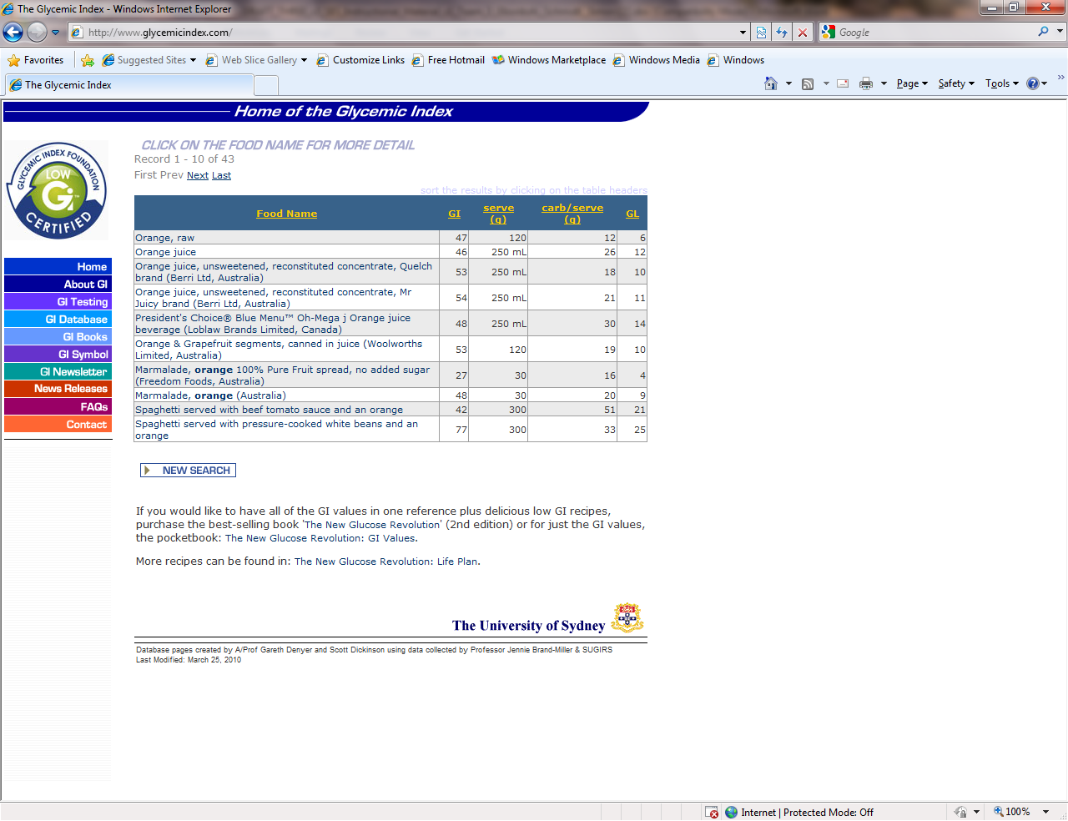

As you can see from the table listed on the next page, we have replaced the high GI rated food of watermelon that had a GI rating of 80, with an orange, which has a low GI rating of 47. You can choose another low GI rated food to replace the kiwis with a medium rating or you can leave them in the recipe since it is only one medium rated food among low foods.

Ingredient | Glycemic rating/category
1 pint strawberries - cleaned, hulled and sliced | GI=40, low
1 pound seedless grapes, halved | GI-43, low
3 kiwis, peeled and sliced | GI=58, medium
3 bananas, sliced | GI=51, low
1 orange | GI=47, low
1 can peaches in juice | GI=45, low

Let’s try another example of replacing high GI rated foods with low/medium rated foods. Another recipe that was used in the previous section is again used below. You will need to fill in the GI ratings in this table just as you did for the previous section. After the GI ratings are completed, you will then need to substitute all high GI rated foods with low or medium rated foods as we did in the example above. Remember, you will only need to list and substitute carbohydrate foods.
Recipe #2
Ingredients: GI rating based on each
- 2 slices white bread

- 2 teaspoons (10 ml) reduced-fat mayonnaise

- 1 teaspoon (5 ml) prepared mustard (optional)

- 2 ounces (60 g) sliced deli turkey ham

- 1 small apple, cut in half, cored, and thinly sliced

- 1 lettuce leaf, washed and drained on paper towels
- 4 dates served on the side of the sandwich
- Lay bread slices on a cutting board. In a small bowl, combine mayonnaise and mustard, if using
- Spread the mayonnaise mixture on the top side of each bread slice.
- Fold each turkey ham slice into quarters and place on 1 slice of bread. Arrange the apple slices on top of the turkey ham. Cover with the lettuce leaf.
- Place the second slice on top of the lettuce, mayonnaise side down.
- Serve at once, or cut into half or quarters and serve.

Ingredient | Glycemic rating/category
White bread | GI=70, high

In this next section, you will continue practicing substituting high GI rated foods for low to medium GI rated foods by using your own recipe as you did in the previous section. For this exercise, use your own recipe that you used in the last section and write down all the GI ratings for all carbohydrate foods. You will identify all high GI rated foods by circling all foods that have a high GI rating. You will then substitute all high GI rated foods for low to medium GI rated foods. A table is given for you to complete this exercise below.

Now let’s use your recipe……

Recipe #3 (write down your own recipe)

Ingredient | Glycemic rating/category

Now that you have learned how to find the glycemic index rating for foods as well as how to substitute high rated foods for low to medium foods, it is not time to review how to monitor these numbers on a daily basis.

Keeping a daily journal of glycemic index ratings on a daily basis, will help you to keep track of the ratings for the foods you eat for each meal. This will help you understand how the new habits you have learned of substituting high glycemic rated foods for low to medium rated foods will help you reduce your blood sugar levels.

Keeping this journal will allow you to track the progress of your new healthy eating habits as well as your daily blood sugar levels. Doing this, will allow you to monitor these levels on a daily basis and will allow you to take control of your Diabetes.

We will now review how to complete the glycemic index journal, which you will find at the top of the next page. The journal on the next page will have the foods from the first recipe listed with the GI ratings next to each carbohydrate food in the breakfast column. The AM snack column will be left blank since we did not have an AM or PM snack in this lesson. One of the foods from recipe #2 will be entered in the lunch column. You will fill out the rest of the lunch column with the foods and GI ratings from recipe #2. The dinner column foods along with the GI ratings will be filled using the recipe you have chosen throughout the lesson.

Let’s get started….

As you can see, the breakfast column is already filled out for you. The lunch column has one food already filled out and you will need to fill out the rest of the foods using recipe #2.

Have you completed the foods in the lunch column from recipe #2? If so, you are ready to move on to the dinner column using your own recipe you chose throughout the lesson. You are now ready to fill in the dinner column by writing down all the carbohydrate foods and the GI ratings from each food from the recipe you chose earlier in the lesson.

Glycemic Index Journal:

Meal | Food | GI rating
Breakfast
1 pint strawberries - cleaned, hulled and sliced |  | GI=40, low
1 pound seedless grapes, halved |  | GI-43, low
3 kiwis, peeled and sliced |  | GI=58, medium
3 bananas, sliced |  | GI=51, low
1 orange |  | GI=47, low
1 can peaches in juice |  | GI=45, low
Lunch
White bread |  | GI=70, high
PM snack
Dinner

Now that you have filled in all the columns for the day in your daily glycemic index tracker, take a moment to review all of the GI ratings for all the foods you listed. Do all the carbohydrate foods have a GI rating of low to medium? If so, you are on the right track already! If not, go back and review the foods in the high GI rating category and use the steps taught in the substitution section of this lesson to substitute any high rated foods for low to medium rated foods.

Unit Two: The Carbohydrate Counting Method

What you will be able to do after completing Unit 2

Upon completing this self-paced module, you will be able to:

- Accurately identify the carbohydrate target for a meal.

- Accurately list the carbohydrate counts for each ingredient used in a home recipe, using a reference manual, and on-line resource or a food label.

- Substitute all high carbohydrate ingredients in the recipe for lower carbohydrate ingredients, using a reference manual, food label or on-line resource, to stay within your target carbohydrate count for a meal.

- Accurately document every ingredient and food consumed during the day, and the ingredient’s carbohydrate count, in a manual or web-based journal.

Here is what you will be covering in Unit 2:

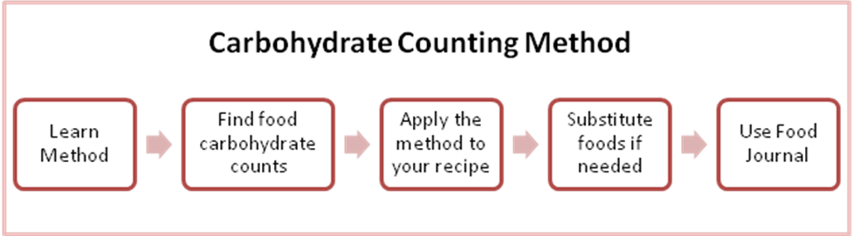

How using the Carbohydrate Counting Method Looks
Lena has been overweight for a few years. She is 52 years old, and she found out that she has type 2 diabetes 1 year ago. She has been seeing a nurse at her physician’s office for nutrition information, and the nurse has referred her to a registered dietitian (RD) in the outpatient clinic at the nearby hospital. Lena brings her food records to her initial visit with the RD. The RD reviews the records, which consist only of Lena’s food choices with no portion sizes or amounts consumed listed. The RD recommends that Lena consider weighing and measuring her portion sizes and writing them down along with her food choices. The RD provides Lena with a copy of the American Diabetes Association (ADA) basic carbohydrate counting pamphlet and uses food models to demonstrate appropriate portions of the foods Lena might select. During the ensuing 3-month period, Lena works with a carbohydrate budget for each meal, uses the basic carbohydrate counting pamphlet, and pays attention to her portion sizes. She loses some weight, improves her glycemic control, and becomes more motivated to continue.

Carbohydrate Budget
Carbohydrates are the body's most important and readily available source of energy. Most of the foods you eat—from milk and fruit to breads and grains—contain carbohydrates. There is no way to avoid them, and you probably would not want to. The trick is to avoid eating too many carbohydrates in one day or at one sitting because carbohydrates raise blood sugar.

Controlling your carbohydrate intake is vital for self-managing diabetes. One way to do it is assessing how many carbohydrates you can have throughout the day along with carbohydrate counting. Knowing and following those guidelines consistently every day—will set your blood sugar levels on an even keel, make you feel more energized, and help you avoid complications of diabetes.

A good place to start is at about 45-60 grams of carbohydrate per meal. If you have not already established a carbohydrate budget with your physician, dietician, or diabetic nurse educator use 50 grams of carbohydrates as your carbohydrate budget. Record this number in an accessible location as you will be referring to 50 grams as your carbohydrate budget throughout this course.

You may need more or less carbohydrates at meals depending on how you manage your diabetes so, make sure that you and your health care team figure out the right amount for you. Once you know how much carb to eat at a meal, choose your food and the portion size to match.

Step-by-Step How to use the method

There are two ways to count carbs, the simple way and the more advanced method. With the simple method, you work within your carbohydrate budget to plan meals and snacks. In order to determine the carbohydrate count for foods, you will need to know how to look foods up in either an online database, glycemic index book or chart. For this training, you will be shown how to look up foods in an online database and a carbohydrate food chart.

Once again, only focus on carbohydrates! And, with that being said, let’s get started counting carbs

Step 1: you will need to log on to the World Wide Web and type in the following address http://tracker.diabetes.org/explore/. An image of the website is shown below.

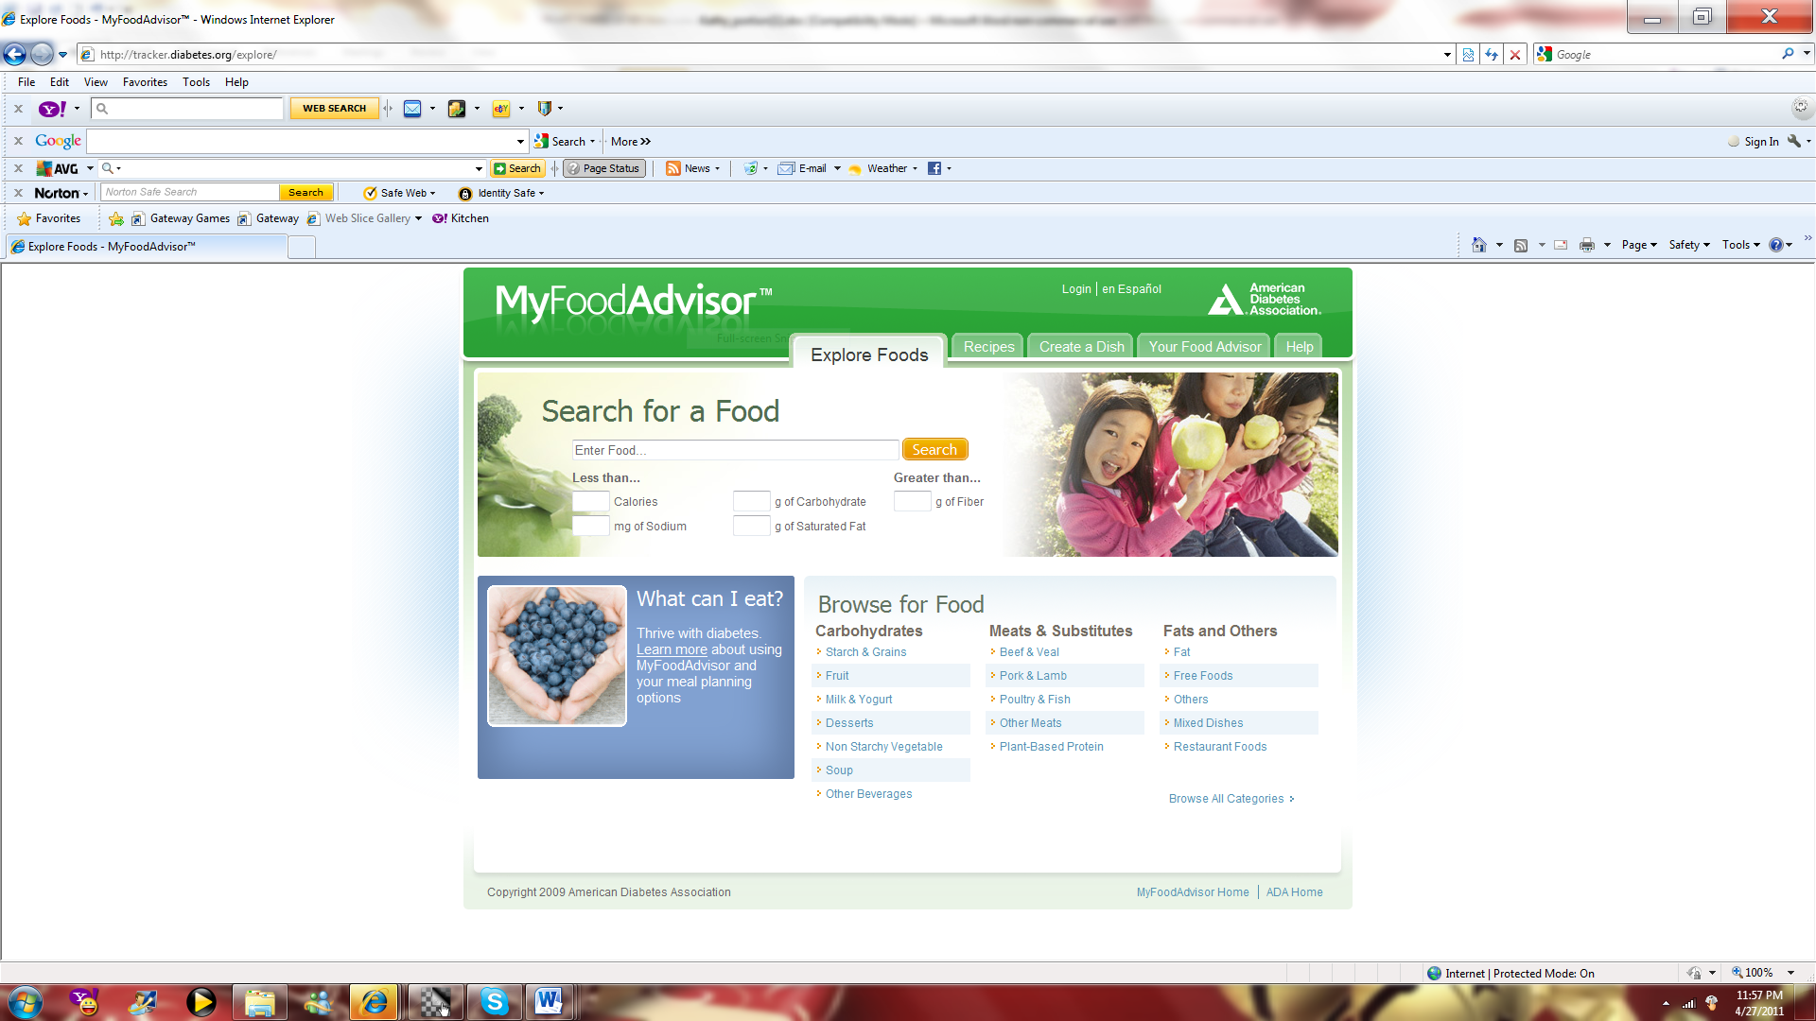

Step 2: type “carrots” in the search box and then click on the “search” icon. An image is listed below with a red arrow pointing to the search box.

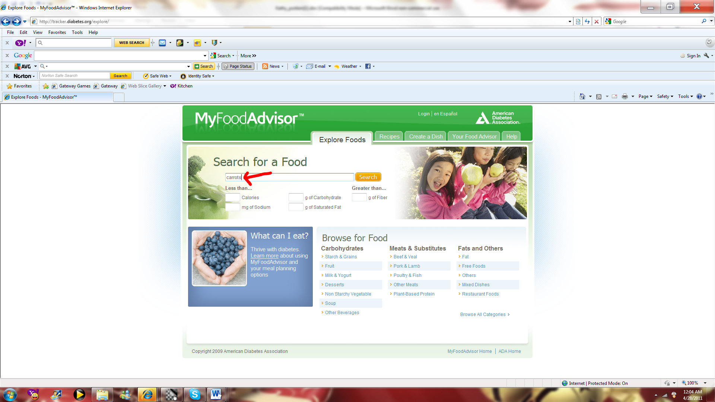

Step 3: Review all Search Results and click on “raw carrots”. An image is listed below with a red arrow pointing to the search results.

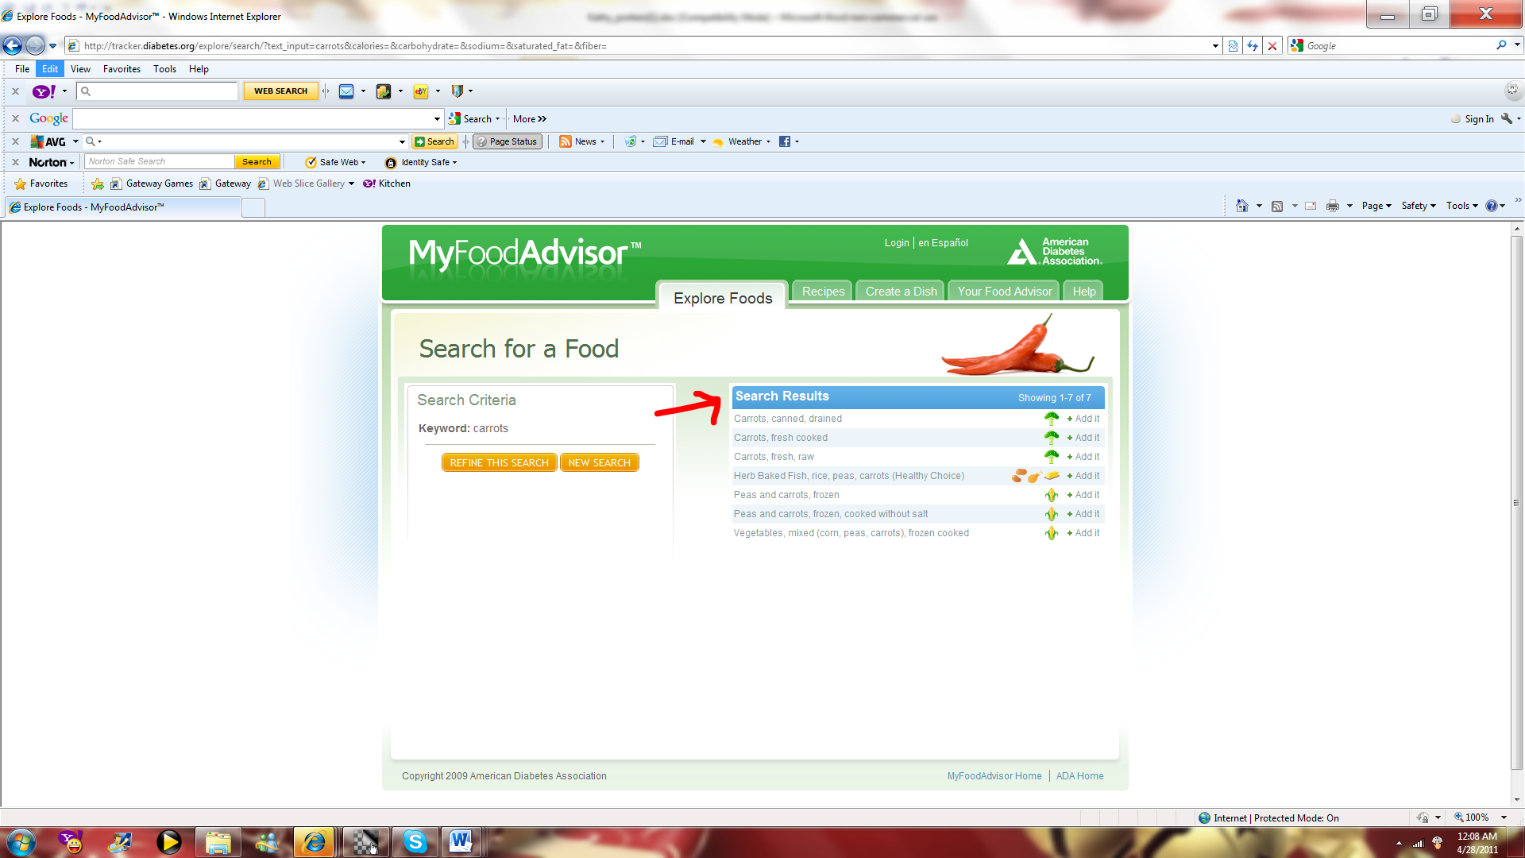

Step 4: Your carbohydrate count results for “raw carrots”. An image is listed below with a red arrow pointing to the carbohydrate count.

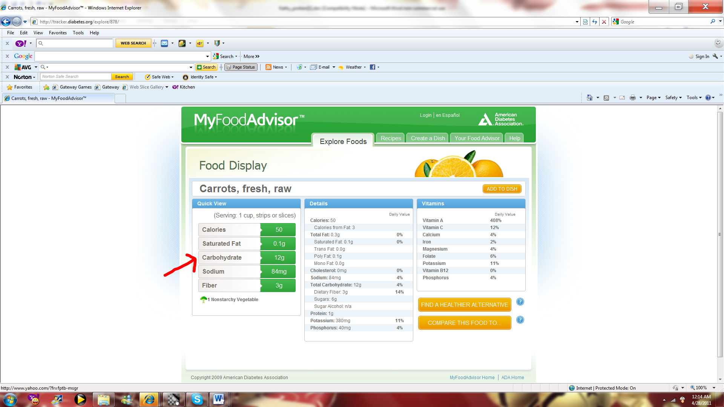

Step 5: As you can see from the image above, 1 cup of raw carrots equals 12 grams of carbohydrates.

Now it is your turn to try. Using the database, find the carbohydrate count for the following: (1 serving)
Raw spinach ________
Apple _________
Brown rice _______

Now that we have reviewed how to look up carbohydrates using the website database, it is your turn to try and look up a food using a carbohydrate food chart.
Food (100g) | Energy(Calories) | Protein(g) | Fat(g) | Carbo(g)
Salad Cream | 300 | 2 | 27 | 15
Salad Cream Weight Watchers | 145 | 1.2 | 8.2 | 17.4
Salmon steamed | 200 | 20 | 13 | 0
Sardines canned in oil | 220 | 24 | 14 | 0
Sardines canned tomato sauce | 180 | 18 | 12 | 0.5
Satsumas peeled | 35 | 1 | 0 | 8
Sauce brown | 100 | 1 | 0 | 25
Sausages beef grilled | 270 | 13 | 17 | 15
Sausages pork grilled | 320 | 13 | 25 | 12
Sausage - Herta | 335 | 12 | 31 | 2
Scampi fried in breadcrumbs | 320 | 12 | 18 | 29
Scones | 370 | 7.5 | 15 | 56
Sherry dry | 115 | 0 | 0 | 1.4
Sherry sweet | 140 | 0 | 0 | 7
Shredded wheat cereal | 320 | 10.5 | 3 | 68
Sorbet Blackcurrent | 118 | 0.3 | 0 | 30.7
Spaghetti boiled | 120 | 4 | 0.3 | 26
Spaghetti canned tomato sauce | 51 | 1.7 | 0.2 | 10.5
Spaghetti tin, weight watchers | 51 | 1.7 | 0.2 | 10.5
Spirits - whisky, Gin etc | 220 | 0 | 0 | 0
Sponge pudding | 340 | 6 | 16 | 46
Spring greens boiled | 10 | 1.7 | 0 | 1
Squash undiluted | 122 | 0.1 | 0.1 | 32.2
Squash Undiluted - sugar free | 5 | 0.1 | 0 | 1.2
Steak stewed canned | 180 | 15 | 13 | 1
Strawberries fresh | 25 | 0.5 | 0 | 6
Sugar | 390 | 0 | 0 | 100
Sugar puffs cereal | 350 | 6 | 0.8 | 84
Sultanas | 250 | 2 | 0 | 65
Swede boiled | 20 | 1 | 0 | 4
Sweetcorn | 124 | 4.1 | 2.3 | 22.8
Sweets boiled | 330 | 0 | 0 | 87
Food (100g) | Energy(Calories) | Protein(g) | Fat(g) | Carbo(g)
Tangerines peeled | 36 | 1 | 0 | 8
Toffees | 430 | 2 | 17 | 71
Tomato juice | 12 | 0 | 0 | 3
Tomato Ketchup | 97 | 1 | 0 | 24.9
Tomato Puree | 89 | 5.6 | 0.4 | 16.4
Tomatoes canned | 23 | 1 | 0 | 5
Tomatoes raw | 15 | 1 | 0 | 3
Trout steamed | 140 | 24 | 4.5 | 0
Tuna canned in oil | 280 | 25 | 22 | 0
Turkey roast | 140 | 29 | 3 | 0
Turnips boiled | 10.8 | 0.7 | 0 | 2
Food (100g) | Energy(Calories) | Protein(g) | Fat(g) | Carbo(g)
Veal fillet roast | 230 | 32 | 12 | 0
Venison roast | 200 | 35 | 6 | 0
Food (100g) | Energy(Calories) | Protein(g) | Fat(g) | Carbo(g)
Walnuts | 530 | 11 | 52 | 5
Watercress | 14 | 3 | 0 | 0.7
Weetabix cereal | 340 | 11.5 | 3.5 | 70
Wine red | 70 | 0 | 0 | 0
Wine white dry | 65 | 0 | 0 | 0.6
Wine white sweet | 10 | 0 | 0 | 6
Food (100g) | Energy(Calories) | Protein(g) | Fat(g) | Carbo(g)
Yogurt flavoured - low fat | 41.6 | 4.6 | 0.1 | 5.5
Yogurt natural | 55 | 5.9 | 1.2 | 5.6
Yorkshire puddings | 222 | 7 | 10 | 26
Table adapted from: Food Tables, A.E. Bender D.A. Bender

Using, the food nutritional chart above, try looking up “raw strawberries”.
If you are correct, you have noted that one serving of strawberries contains 25 grams of carbohydrates.

Using the nutritional chart, locate the carbohydrate count for the following:
Tomato juice___________
Sugar_________________
Roast turkey___________
Tangerine______________
Sweet white wine________
Now that you have practiced how to look up the carbohydrate count using manual and electronic methods, let’s advance to applying what you have learned to recipes.
For this next section, you will use the same recipes provided in the glycemic index section in order to practice identifying carbohydrate values as well as comparison of the two different methods.
Once again, the first recipe given will show each carbohydrate listed and their corresponding carbohydrate count in grams. The second recipe will have half of the carbohydrate foods with the carbohydrate count given and the other half of the carbohydrate foods will be blank and you will need to look them up using the electronic database or a manual carbohydrate food chart. The third recipe will be chosen from your collection of recipes and you will be required to look up all the carbohydrate count and list them in the space provided. In other words, you will begin the process of meal planning.

Recipe #1
Ingredient | Carbs
1.25 cups strawberries - cleaned, hulled and sliced | 40
17 grapes, halved | 15
2 kiwis, peeled and sliced | 22
1 bananas, sliced | 23
1.25 cups watermelon | 14
1 can peaches in juice | 17
Total | 131

Note: The recipe totals 131 carbohydrates but remember to divide this by the number of servings.

Ok, now that we have reviewed how to list the carbohydrates, it is time for you to try and practice these same steps with just a little help. For recipe #2, the first carbohydrate count has been filled in for you. Please fill in the carbohydrate count for the remaining of the recipe.
Recipe #2
Ingredients | Carbs
 |  | 48
  - slices white bread
2 teaspoons (10 ml) reduced-fat mayonnaise

1 teaspoon (5 ml) prepared mustard (optional)

2 ounces (60 g) sliced deli turkey ham

1 small apple, cut in half, cored, and thinly sliced

1 lettuce leaf, washed and drained on paper towels

Now let’s use your own recipe……
Instructions: Using one of your favorite recipes, list each carbohydrate ingredient and its corresponding carbohydrate count. Feel free to use as much space as you need.

Ingredients | Carbs

Maintaining a Low Carbohydrate Lifestyle

How are food diaries helpful? Well, one factor is that many diabetic patients have labeled food journaling as the key to diabetes self-management. There are many others that absolutely loathe the idea of having to keep track of everything they eat in a day however, by recording every bite you eat in a journal, you will get an eye-opening, accurate view of what types of foods you are consuming on a daily basis. This will allow you to see seemingly hidden sources of insulin increasing foods that are secretly seeping into your diet and affecting your blood glucose level. In addition, food diaries can be helpful in preventing binge eating because you will be a lot less likely to consume a massive quantity of food if you know that you are going to have to physically record it in your journal at the end of the day. As a result, food journaling can help you to choose foods based on whether you are really, truly hungry or are just eating out of emotion.

The following steps are recommend for accurate and complete food diaries both intended for the use of the glycemic index or the carbohydrate counting method.

Step 1: Complete a food journal of everything you eat for a week. Be honest and include three columns that specify the food item; serving size; and carbohydrates or glycemic index. It is also a good idea to keep track of fats, fiber and proteins once you have become comfortable incorporating journal in your disease management regiment.

Step 2: Isolate all of the carbohydrates or the glycemic index from your food journal into one column and write down the number of grams of carbohydrates.

Step 3: Total your carbohydrate intake or glycemic index for the week and note where you've gone astray. Establish consistency in your meals

Let’s take a look at a food diary that list carbohydrates.

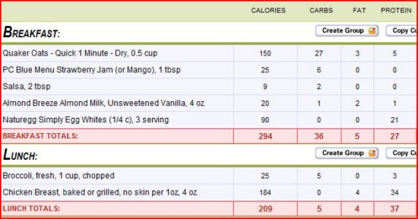

No matter how you keep your food diary or what method you decide to use, consistency is the key to accuracy.

Now you try journaling a single day on your own using the following scenario accurately list all food consumption in the food journal provided.

Lisa awoke around 6:00 AM. She began her morning with a toasted bagel with cream cheese. On her drive to work she consumed a 16 oz. serving of orange juice. Trying to avoid the mid-morning burnout, she decided to drink a 20oz coffee. She ritually drinks her coffee black with a splash of whole milk but, decided to have it with a splash of skim milk and a tbsp. of sugar. Around 12:30 she indulged herself with a 6” roast beef & swiss cheese sub sandwich w/ mayo, 20 oz. diet Pepsi. The afternoon was especially boring and Angie found herself snaking on a 13 oz. bag Hershey miniature chocolate bars until they were complete. After making home, her dinner consisted of ½ box macaroni & cheese (made w/ 2% milk), 3 beef hot dogs on buns. Rewarding herself for a hard day work she enjoyed every bit of a 1 ½ cup of vanilla ice cream

TIME | SERVING  SIZE | CALORIES | GI | CARBS

Course Summary

Learner’s Post-training Instruction:
- After completing all of the modules, proceed to the practice exam located on page
- After completing the practice exam, verify your answers with the answer key located on page
- Compare your pre-assessment with your practice exam
- For any missed question, re-read the section in the module that contains the subject matter
- When you are ready, complete the final exam

Practice Exam Directions
- Carefully read through these instructions and proceed with the practice exam
- Take test in an area where you can concentrate and remain uninterrupted for 15 minutes
- Read each question thoroughly
- Answer each question

Estimated Time: 10-15minutes

Practice Exam
- Home recipes can be made healthier by food substitution. TRUE or FALSE

- The Glycemic Index (GI) measures how ________________ raises blood glucose.
  - Protein
  - Fat
  - Carbohydrates
  - Fiber

- Meal planning with GI involves choosing foods that are_____________.
  - Medium GI
  - High GI
  - Low
  - Low and Medium GI

- Choose which food item has a higher GI
  - Yam
  - Spinach
  - Pineapple
  - All of the above

- Carbohydrate counting involves setting a limit for your maximum amount to eat. True or False

- Documenting your daily food intake is a resourceful tool for
  - Meal planning
  - Disease management
  - Controlling carbohydrate
  - All of the above

- ___________ foods quickly raise the blood glucose.
  - High GI
  - Low GI
  - Medium GI
  - Both B and C

- Having diabetes means having the same food day after day. TRUE or FALSE

- Total carbohydrate on a nutritional label includes
  - Sugar
  - Starch
  - Fiber
  - All of the above

- Which ingredient is higher in carbohydrates?
  - Beef hot dog
  - Hot dog bun
  - Garden green salad
  - 2 boiled eggs

Final Exam

- The Glycemic Index (GI) is a scale that ranks
  - Fat
  - Fiber-rich foods
  - Carbohydrate-rich foods
  - Protein-rich foods

- Foods with a high GI tend to quickly raise your body's blood sugar levels TRUE OR FALSE.

- The GI is categorized as high, medium, or low; what are their corresponding reference range
Low = ______--- ______
Medium = ________---_______
High = ___________---_________

- Meal planning with the GI involves choosing foods that have ____________
  - A low GI
  - A high GI
  - A medium GI
  - Both A and C

- Choosing Low GI foods may help you to:
  - Control and stabilize your blood glucose levels
  - Control your cholesterol levels
  - Control your appetite
  - All of the above

- Using a manual Glycemic Index reference, determine the GI for each food item.
FOOD ITEM | GI
Frozen Sweet Corn
Raw Carrots
Boiled Carrots
Broccoli
Cabbage

- Using an online GI database of your choice, determine the GI for each food item.

FOOD ITEM | GI
Refined white sugar
Whole milk
2% milk
Honey
Organic Agave Cactus Nectar

- Using your preferred glycemic index reference, arrange the following food items according to their GI value range of Low (L) 55 or less; medium (M) 56 - 69, or high (H) 70 or more.
Example: orange juice, tomato juice, cranberry juice cocktail
Answer: (L) tomato juice (M) orange juice (H) cranberry juice cocktail

  - Papaya, watermelon, apple = (L)___________ (M)__________ (H)_________________
  - Parsnips, beets, broccoli = (L)___________ (M)__________ (H)___________________
  - White rice, wild rice, couscous = (L)___________ (M)__________(H)_______________
  - Potato chips, peanuts, pretzels = (L)___________ (M)__________ (H)_______________
  - Hamburger bun, French baguette, Pumpernickel = (L)________ (M)________(H)_______

- What is the GI for the following recipe?
  - (L) Low
  - (M) Medium
  - (H) High

INGREDIENTS
1/3 pound(s) sweet potatoes
Salt and pepper
1 teaspoon(s) olive oil
1/4 bunch(es) (about 6) green onions, each cut into 1-inch pieces
1/4 (3 1/2 to 4 pounds) chicken, cut into 8 pieces with skin
1/4 tablespoon(s) jerk seasoning
Jamaican Jerk Chicken with Sweet Potatoes

- Which Breakfast has a higher glycemic index? ___________
  - Old-fashioned oatmeal with skim milk and peaches; 100% stone-ground wholewheat toast and no-sugar-added Fruit Spread
  - Coffee (decaf); Corn flakes with skim milk; English muffin with jelly; • Coffee (regular)

- Which lunch is better for a low glycemic diet?___________
  - Turkey sandwich on white bread with lettuce and tomato; Watermelon; Iced tea (regular, sweetened)
  - Turkey sandwich on 100% stone-ground whole-wheat bread with lettuce and tomato; Apple; Iced tea (decaf, diet)

- Using the following recipe, substitute 2 ingredients for lower glycemic index alternatives.
Pineapple Cream Pie
INGREDIENTS | SUBSTITUTION
Graham cracker Crust
16-oz. can sweetened crushed pineapple
4-oz. package vanilla pudding
Small tub of whipped topping
8-oz. Carton sour cream

- According to the American Diabetes Association, carbohydrate counting is another acceptable method for controlling blood glucose level. TRUE OR FALSE

- Using your preferred carbohydrate reference, determine the carbohydrate count for 1 serving of the following food items:

FOOD ITEM | CARBOHYDRATE COUNT (grams)
Coke (regular)
Apple juice
Mango
American cheese
Cabbage
Tomatoes
Whole wheat bread
Couscous
Taco Shells
Boiled egg

- Using the following nutritional label, how many grams of carbohydrates are contained per serving?
  - 375 grams
  - 300 grams
  - 38 grams
  - 6 grams
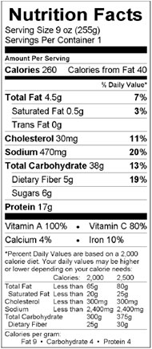

Baked Macaroni and cheese
1 1/2 tablespoon(s) plain dry breadcrumbs
1/2 teaspoon(s) extra-virgin olive oil
1/8 teaspoon(s) paprika
1/2 package(s) (16-ounce or 10-ounce) frozen spinach, thawed
7/8 cup(s) whole milk, divided
1 1/2 tablespoon(s) all-purpose flour
1 cup(s) shredded extra-sharp Cheddar cheese
1/2 cup(s) cottage cheese
teaspoon(s) ground nutmeg
1/8 teaspoon(s) salt
Freshly ground pepper, to taste
ounce(s) (2 cups) whole-wheat elbow macaroni or penne

- Using the following recipe, how can the carbohydrate count be reduced?

  - Substitute low-fat cottage
  - Eliminate breadcrumbs
  - Substitute 2% milk
  - Any or all of the above

- Which of the following breakfast meal has a lower carbohydrate count?
  - Pancakes with butter and maple syrup
  - Spinach omelet without cheese
  - Western omelet
  - 2 cups of frosted flakes with whole milk
- Using the following scenario, accurately list all food consumption in the food journal.

BREAKFAST: LUNCH: DINNER
___________________ ___________________ ________________
___________________ ___________________ ________________
___________________ ___________________ ________________
___________________ ___________________ ________________
___________________ ___________________ ________________

AFTERNOON SNACK PM SNACK
___________________ ____________________
___________________ ____________________
___________________ ____________________

- Answer the following question, using the scenario located at the bottom of the exam
Which of Angie’s meal had the lowest glycemic index value?
  - Breakfast
  - Lunch
  - Dinner
  - PM snack

- Which meal contained the lowest carbohydrate count?
  - Breakfast
  - Lunch
  - Dinner
  - Afternoon Snack

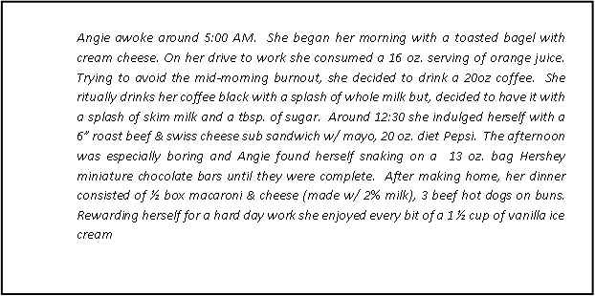

Choose a method

Now that you have tried both methods, it is up to you to choose one that works best for you. You may use your final exam results to guide you to the method that you knew the most thoroughly as well as your comfort level using each method through the practice session. You may change and try another method at any time.

As a starting point, indicate which method you will begin with:

Glycemic Method

Carbohydrate Counting Method

Pre-Plan other situations

Now that you have chosen your method, begin thinking about how you will apply the method to other situations other than your personal recipes.

Dining out | I will choose foods that….
Grocery Shopping | I will choose foods that….

How to sustain using the method

Making changes can be challenging and it helps to have the help of others. Here are some ideas which will help you find support in making your changes:

- Identify a friend or family member to ask you if you have used your chosen method for all ingredients and foods consumed for at least one week.
- Join a support group or participate in an online discussion thread

Summary

You’ve done it! Remember to check in with your health care provider regularly and keep your journal. You are now ready to start using your chosen method!

Appendices

Appendix A: Practice Exam Answer Key
Appendix B: Final Exam Answer Key

Appendix A: Practice Exam Answer Key
- Home recipes can be made healthier by food substitution. TRUE

- The Glycemic Index (GI) measures how ___ Carbohydrates____ raises blood glucose.
  - Protein
  - Fat
  - Carbohydrates
  - Fiber

- Meal planning with GI involves choosing foods that are Low and Medium GI.
  - Medium GI
  - High GI
  - Low
  - Low and Medium GI

- Choose which food item has a higher GI Pineapple

  - Yam
  - Spinach
  - Pineapple
  - There all the same

- Carbohydrate counting involves setting a limit for your maximum amount to eat. True

- Documenting your daily food intake is a resourceful tool for All of the above
  - Meal planning
  - Disease management
  - Controlling carbohydrate
  - All of the above

- _____ High GI ___ foods quickly raise the blood glucose.
  - High GI
  - Low GI
  - Medium GI
  - Both B and C

- Having diabetes means having the same food day after day. FALSE

- Total carbohydrate on a nutritional label includes All of the above

  - Sugar
  - Starch
  - Fiber
  - All of the above

- Which ingredient is higher in carbohydrates? Hot dog bun

  - Beef hot dog
  - Hot dog bun
  - Garden green salad
  - 2 boiled eggs

Appendix B – Final Exam Answer Key

Final Exam Answer Key

- Carbohydrate-rich foods

- TRUE

- Low = _55 or less
Medium = _55-69_
High = __70 and above
- D) all of the above
- Choosing Low GI foods may help you to:
D All of the above

FOOD ITEM | GI
Frozen Sweet Corn | M
Raw Carrots | L
Boiled Carrots | L
Broccoli | L
Cabbage | L

- Using an online GI database of your choice, determine the GI for each food item.

FOOD ITEM | GI
Refined white sugar | M
Whole milk | M
2% milk | M
Honey | M
Organic Agave Cactus Nectar | L

- Papaya, watermelon, apple = (L)_APPLE__ (M)___PAPYA_(H)___WATERMELON_____
  - Parsnips, beets, broccoli = (L) BROCCOLI_ (M) BEETS (H)_PARSNIPS_
  - White rice, wild rice, couscous = (L)__COUSCOUS_ (M)_WHITE RICE (H) WILD RICE
  - Potato chips, peanuts, pretzels = (L)_PEANUTS (M) PRETZELS (H) POTATO CHIPS
  - Hamburger bun, French baguette, Pumpernickel = (L)__PUMPERNICKEL (M)_HAMBURGER BUN_(H)_FRENCH BAGUETTE

- (L) Low

- _____A______Coffee (decaf); Corn flakes with skim milk; English muffin with jelly; • Coffee (regular)

- B____ Turkey sandwich on 100% stone-ground whole-wheat bread with lettuce and tomato; Apple; Iced tea (decaf, diet)

INGREDIENTS | SUBSTITUTION
Graham cracker Crust
16-oz. can sweetened crushed pineapple | UNSWEETENED CRUSHE PINAPPLES
4-oz. package vanilla pudding | NON-FAT VANILLA PUDDING
Small tub of whipped topping | NON FAT WHIPPED TOPPPING
8-oz. Carton sour cream | FAT-FREE SOUR CREAM

- TRUE

FOOD ITEM | CARBOHYDRATE COUNT (grams)
Coke (regular) | 38
Apple juice (UNSWEETENED) | 29
Mango | 35
American cheese | .5
Cabbage | 1.9
Tomatoes | 5.7
Whole wheat bread | 12.9
Couscous | 20.8
Taco Shells | 8.1
Boiled egg | .6

- C-- 38 GRAMS

- D--Any or all of the above

- B--Spinach omelet without cheese

17.
BREAKFAST: LUNCH: DINNER
___________________ ___________________ ________________
___________________ ___________________ ________________
___________________ ___________________ ________________
_________________ ___________________ ________________
___________________ ___________________ ________________

AFTERNOON SNACK PM SNACK
___________________ ____________________
___________________ ____________________
___________________ ____________________

- C—Dinner

- Breakfast

- Breakfast

