**Rugby St. Andrews RFC Annual General Meeting**

**Minutes 2025**

# Welcome

Chairman welcomed all attendees – **47** in attendance and registered, although there were other attendees outside

# Apologies

* Nigel Headley
* Simon & Sharon McAusland
* Craig Jones
* David & Anita College

# 2024 Minutes

The 2024 Minutes were approved without comment

# Chairman’s Speech

Chairmans AGM Report

Good evening, everyone, and welcome to the 24/25 Club AGM – or as we like to call it: "That One Night a Year Where We Pretend to Be Serious Adults."

The minutes and all the important paperwork have been pinned to the notice board, posted on the website, and flung across social media like confetti. Hopefully, you’ve all had a quick scroll while pretending to read them thoroughly.

We’ll be using some slides tonight – not just because it looks professional, but because they stop me from rambling too far off track. And yes, a draft P&L has been handed around – try not to fall asleep just yet.

Now, onto the rugby.

We finally had a full, uninterrupted season! A rare and beautiful thing. The club had a chance to breathe, get stuck in, and run a full calendar of events without last-minute chaos.

First Team – battled like warriors. There were games where Andrews looked certain to win… right up until the last 10 minutes. Then, well… let’s just say our fitness and decision-making made things “interesting.”

Refereeing? Let’s just say there were moments when both teams were equally baffled. One game ended with players from both sides asking, “What sport are we even playing here?”

Despite all that, we secured a glorious 9th place and thought, “Job done, no relegation!” But then the league gods reshuffled the deck and demoted! Welcome to Counties 3 M East South Northwest Midlands Extra Sauce Division, now featuring our old frenemies, Rugby Welsh.

Massive thanks to Ian and Max – not just for their hard work, but for not spontaneously combusting from the stress. We appreciate you. And yes, we know – it was sometimes painful to watch.

Second Team – absolute legends this year. Loads of fixtures home and away, powered by returning players (some of whom we thought had retired into a life of pipe-smoking and slippers). Huge thanks to Bill, Huggy, and the gang for pulling ex-players off the sofa and back onto the field. You’re staying in the Warwickshire Merit 2 league, with the aim to push into the league system in 26/27 – fingers crossed and limbs unbroken.

The Colts – coached by Aaron, Ian, and Griff – had a cracking season. Then the players discovered jobs and real life in April, which made fielding a team… tricky. Still, they’ve got talent, heart, and terrible haircuts. Looking forward to seeing them graduate to senior rugby.

Speaking of transitions: Ian Skeen is stepping into a new role as Senior Forwards Coach. He’s traded his whistle for… a louder whistle. Aaron heads off to coach Newbold 2nds, and Griff is focusing his efforts on the M&J side. Legends, all three I mean 2.

Ladies Team – booming! Numbers are up, enthusiasm is high as I’ve been reliably informed by Elaine and Jenny Barnes, Great work all round – the team’s going strong mid-season and showing no signs of slowing.

Minis & Juniors – numbers are up another 20%, which is another huge success. Huge thanks to Emma (Chair – soon retiring at the end of the upcoming season), Ed (who has stepped down from fixtures but now coaching Fosses Falcons), Pin (accounts), and Chris & Dan (Vice Chairs). You’re all legends. And of course, a big shoutout to our safeguarding queen Kirsty Telford – who’s had a very busy year, which is probably a worrying sign…

Now, onto money. The world’s still mad, inflation is still doing backflips, and our electricity bill has basically become a second mortgage. We’re talking £1500 per month on electric and £500 on gas since November. Barry will take you through the numbers – I recommend a strong drink beforehand.

Sponsors – thank you to Rob Ward (Current Live), Lord Clarke, and Dave from Rugby Engineering, plus everyone who sponsored kit, donated money, or said, “Put me down as anonymous!” You keep this place going.

Volunteers – this club would fall apart without you. Seriously. You make the magic happen, whether it’s coaching, cooking, or calming down a group of sugar-fuelled under-10s. Massive appreciation and a few cheeky gifts tonight:

Anita – club shop: flowers & wine

Kirsty – safeguarding: flowers & wine

Barry – Treasurer/Ballbuster: bottle

Martin D – Club Secretary: bottle

Tommy – Part-Time Vice Chairman/Bar Manager: bottle

Billy B – President and full-time raconteur: bottle

Thank you

# Treasurers Report

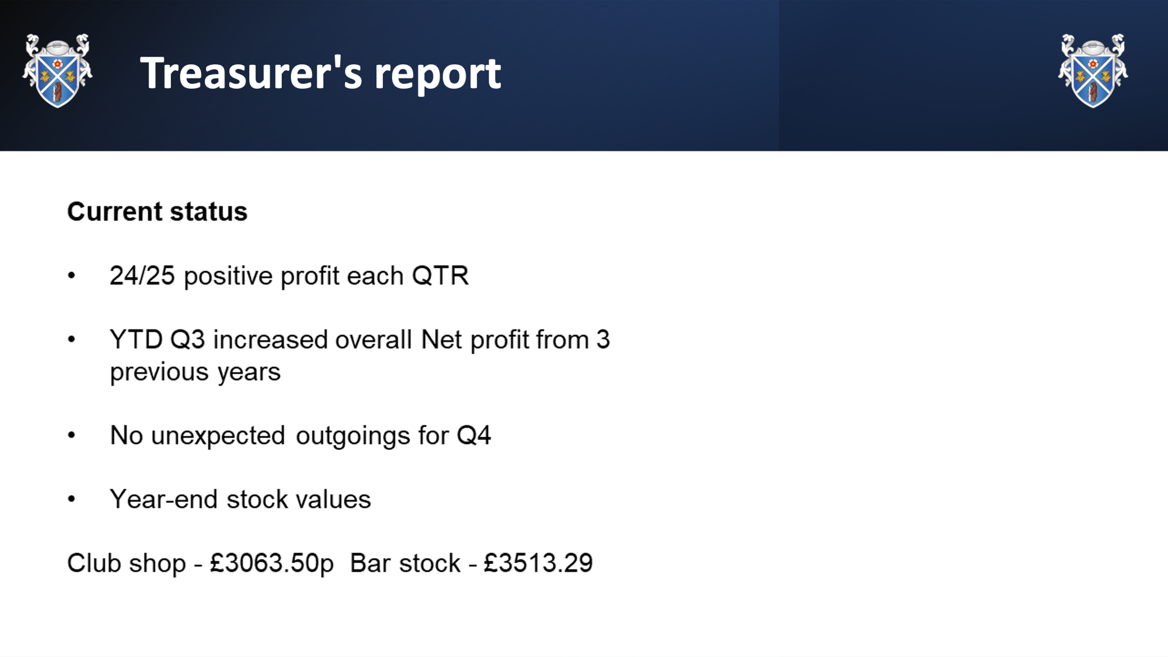

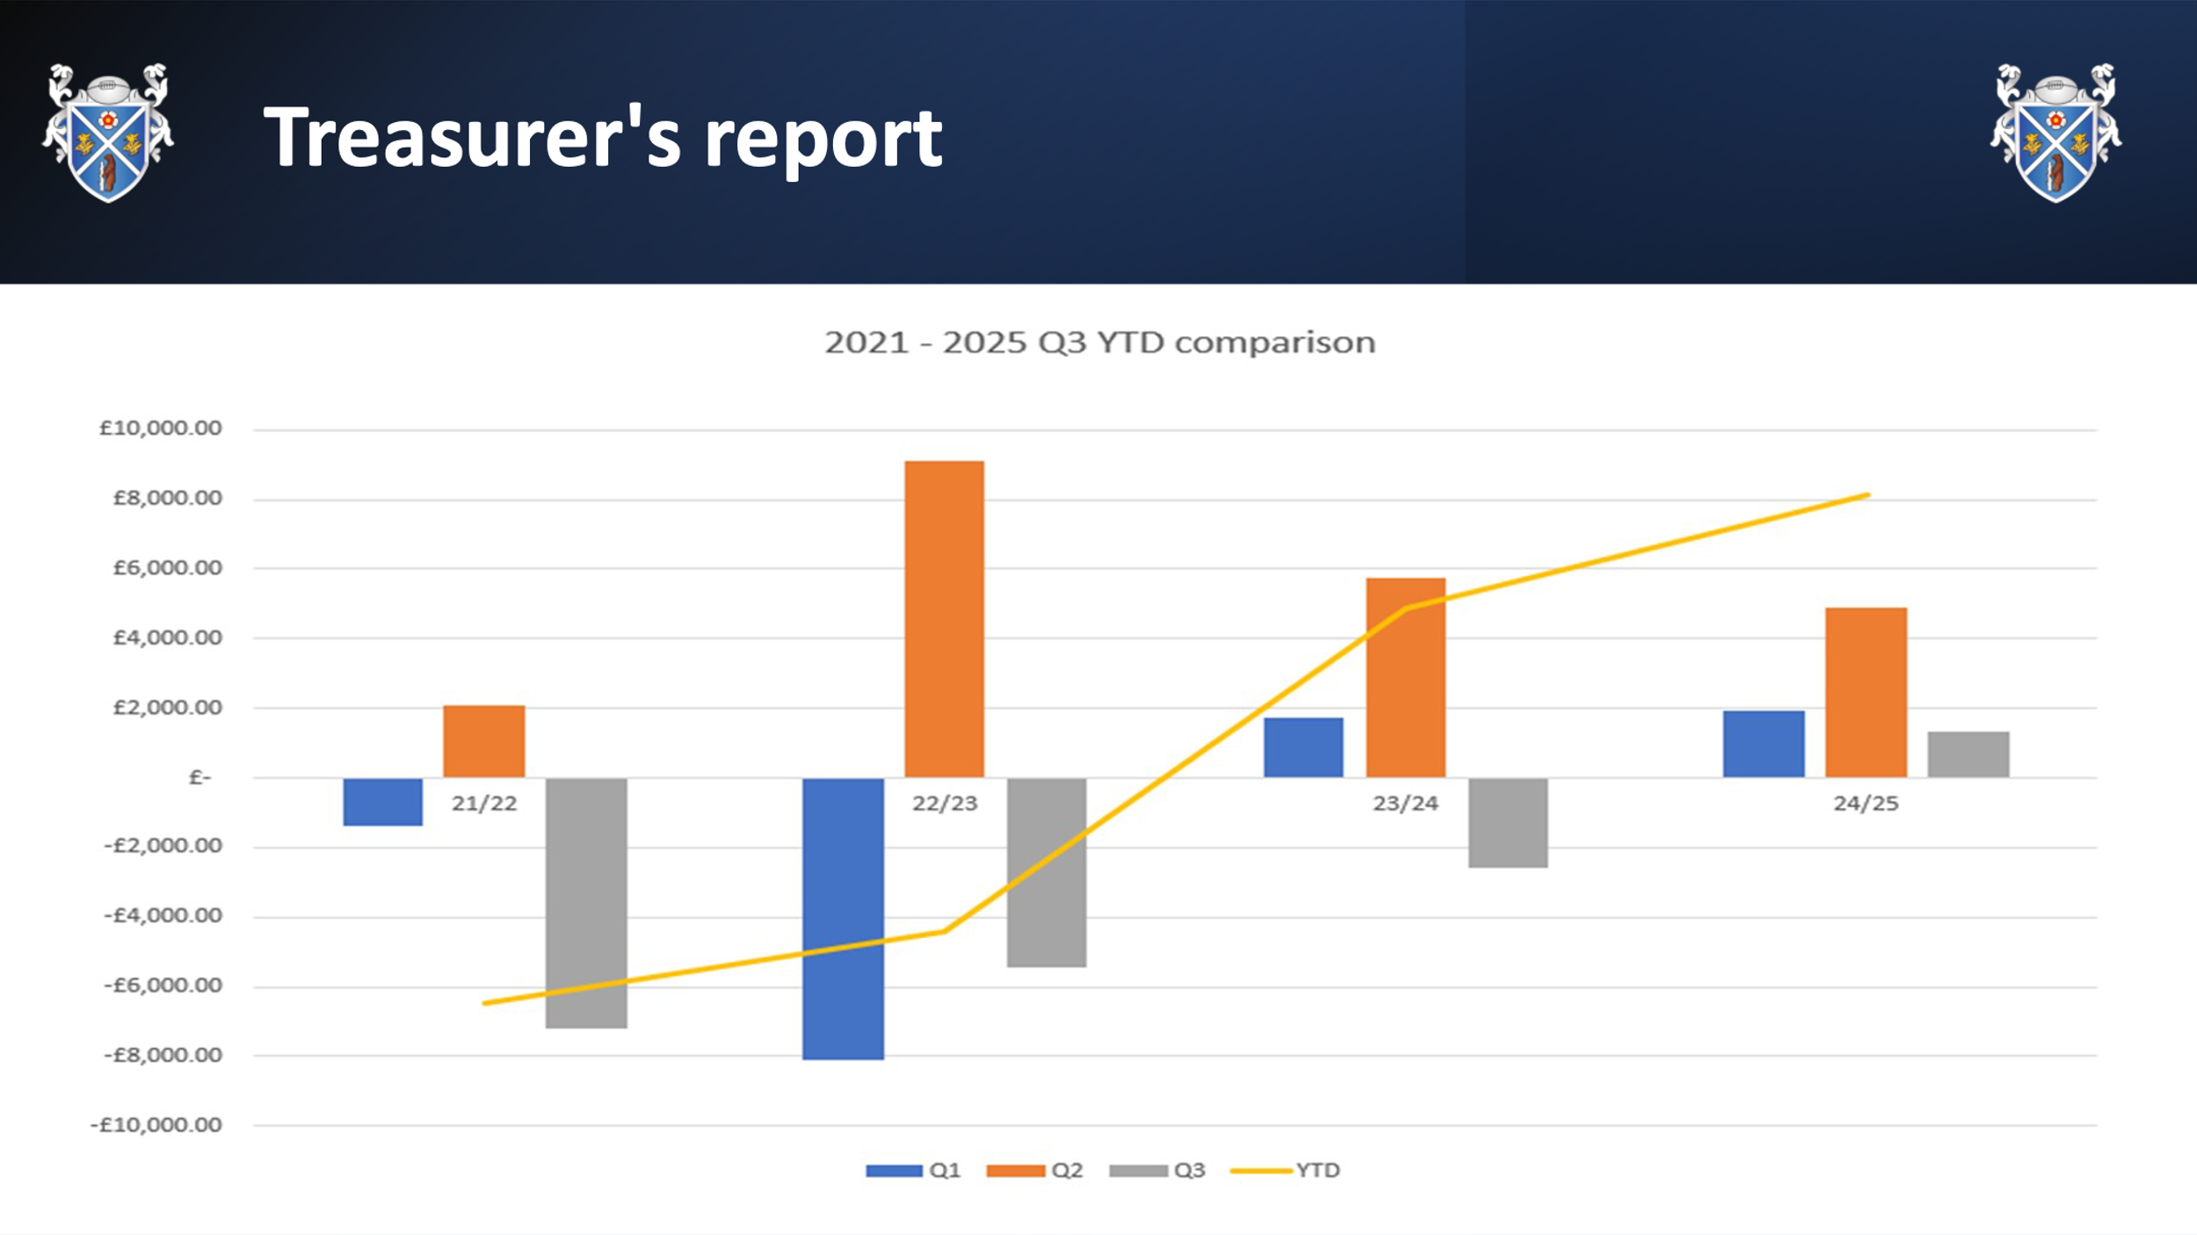

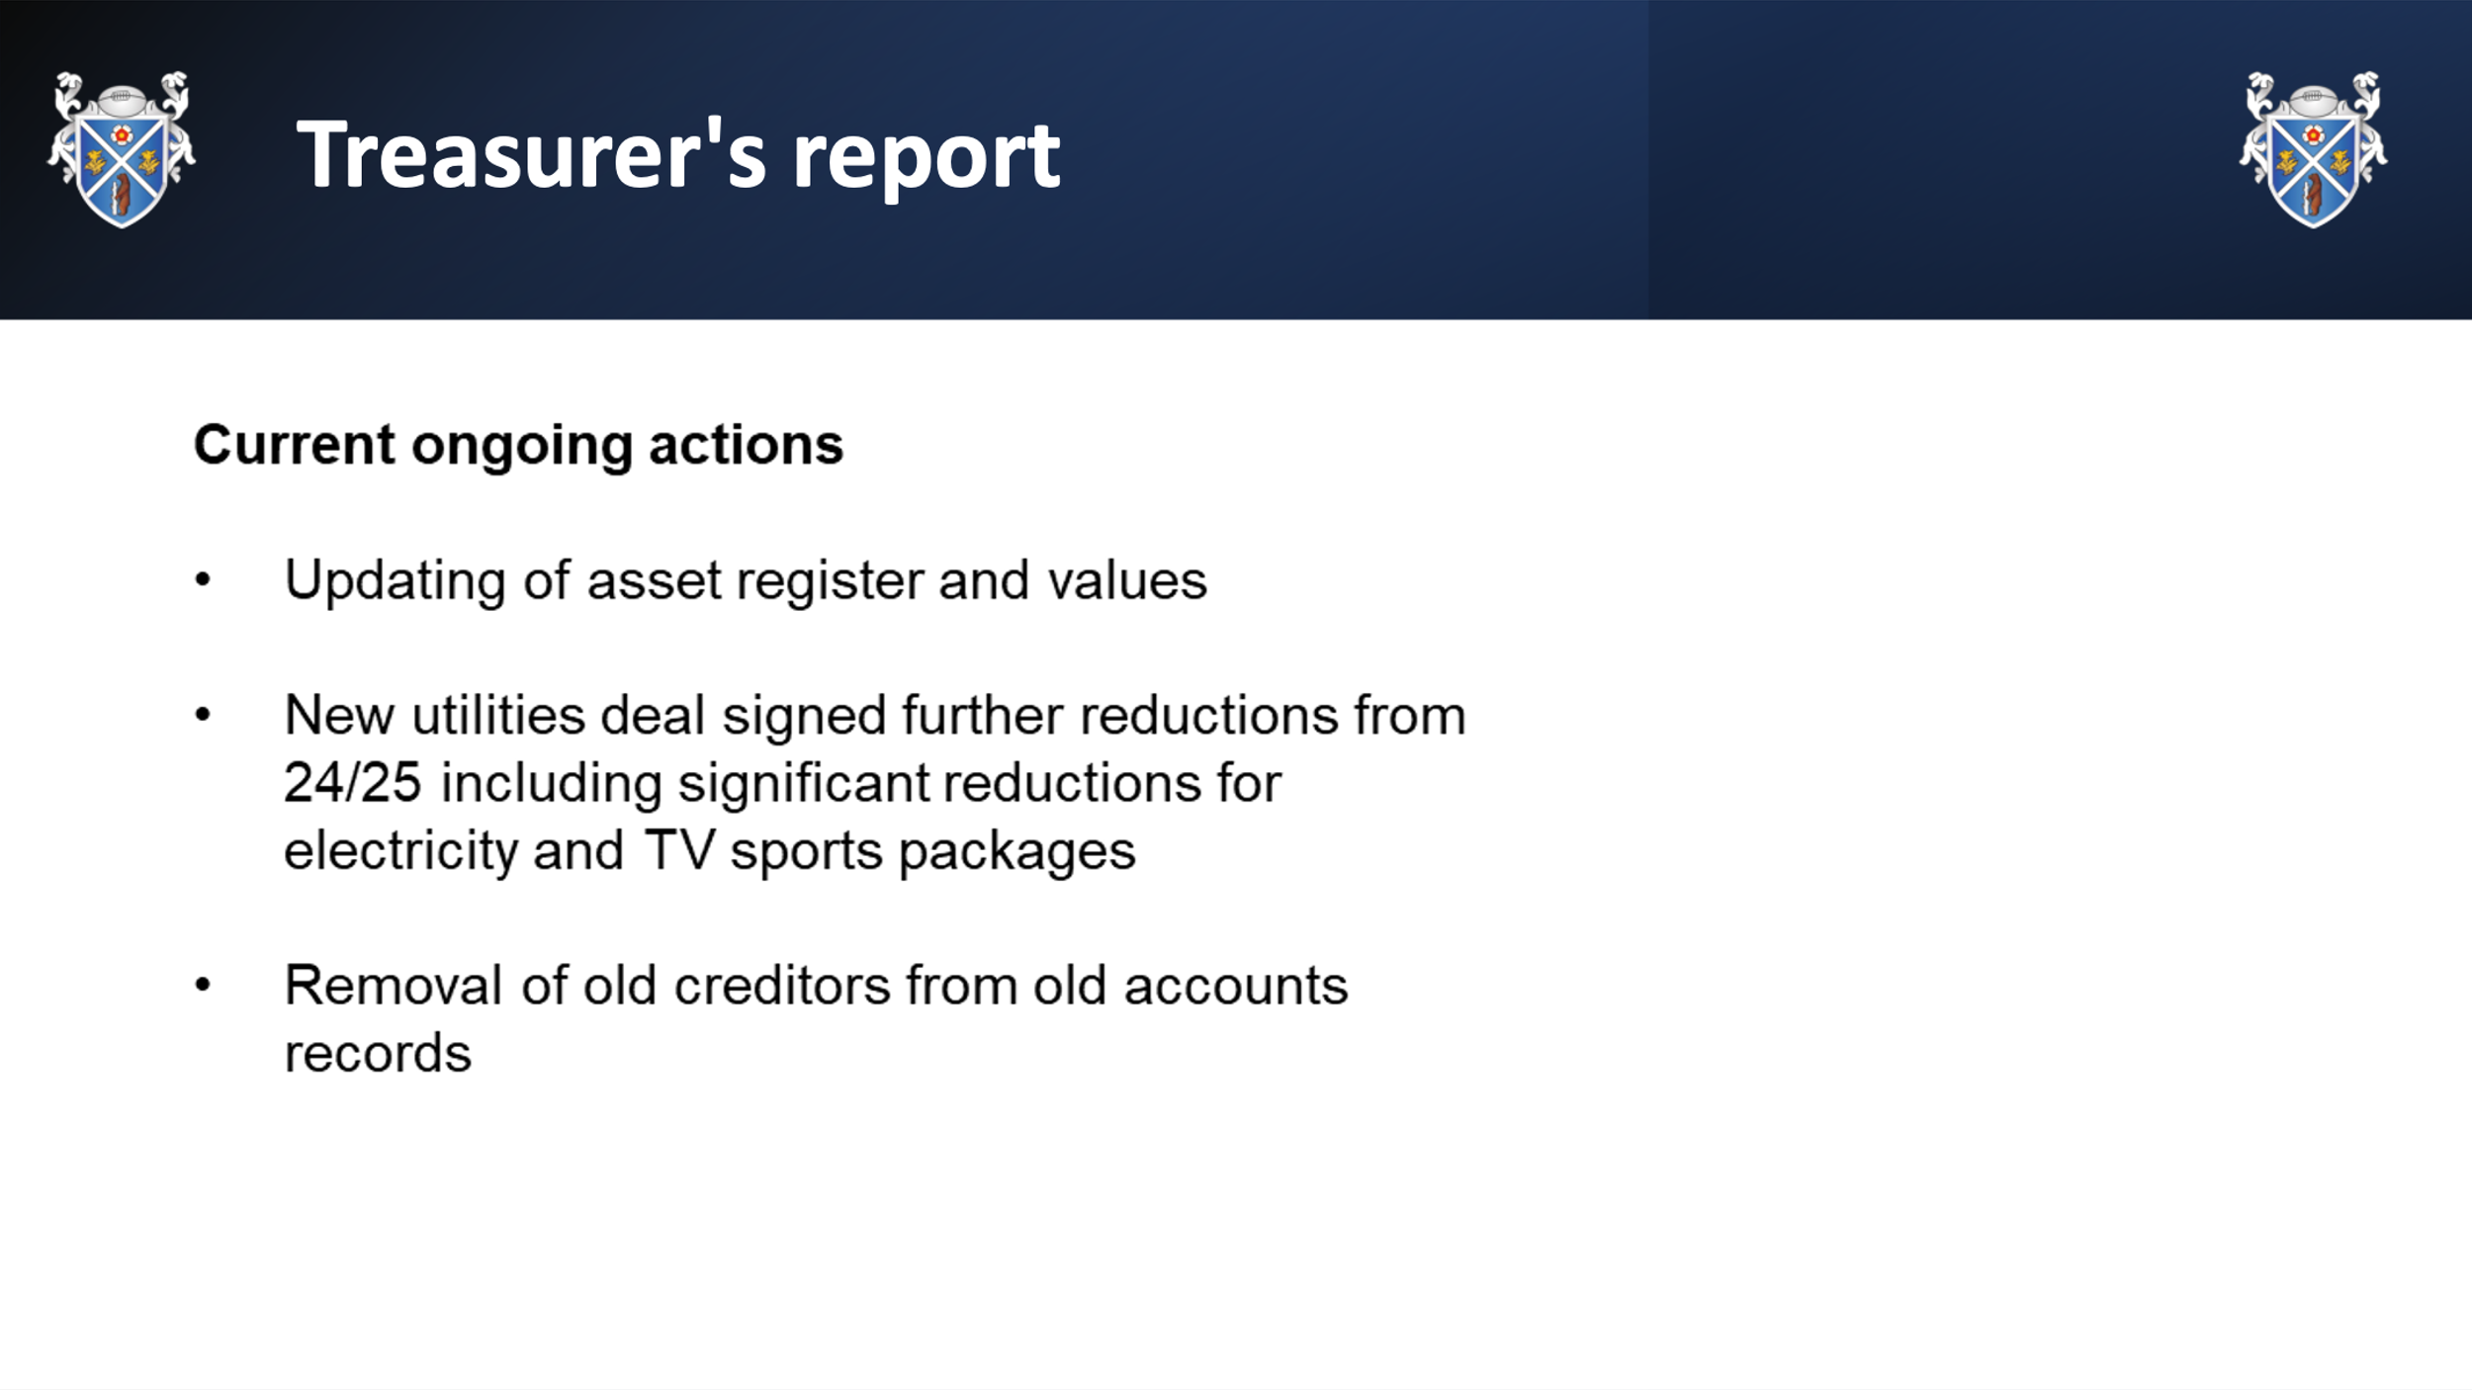

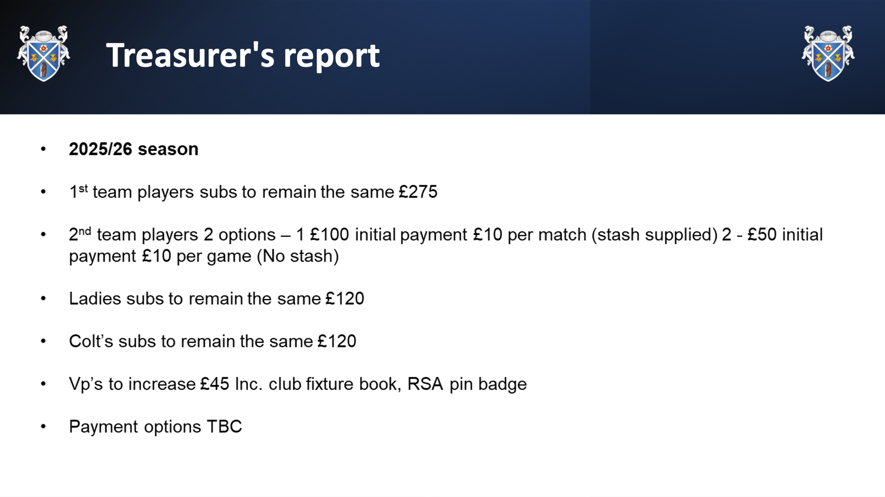

#### Further notes to report.

* To note, ***figures provided including comparison are Q3 figures*** as Q4 figures will not be available for a few weeks from the Club Accountant
* Club has moved from:
  + £7k loss in 21/22
  + £4.5k loss in 22/23
  + £4.5k profit in 23/24, to
  + £8k profit in £24/25.
* The updating of the asset register should improve figures again; given that the current set of assets reflects assets we no longer hold and not the ones that we do!! E.g. Floodlights; kitchen equipment; Training equipment
* The Club is working with RBC to resolve the issues over the Clubhouse lease. This will additionally have a positive impact upon the Club finances; given that it has been shown to have depreciated in value over the last few years; although there is a rising market in land and asset values.

**Questions taken**

Rod Blinko asked what the current cash holding within the Club Bank account was. This was verbally provided on the evening, including the figures held by the Ladies section and to cover international tickets.

#### Subs 2025/26

Kalum, Barry and Ian ‘Spanner‘ Spencer will discuss 2025/26 subs with the Directors, identifying player ‘stash‘ and options, including ‘pay as you play‘ for non first team players.

***To note***: VPs Subs will be announced at the same time, although there is likely to be a small increase

# Election of Club Officials

#### Directors

All Directors are still within their current 3 year tenure.

* David Godfrey Eaton
* Nigel Headley
* Craig Jones
* Paul Bostock
* John Parsons

Unfortunately, Alan Parish will be unable to return to the Club due to illness and has been stood down as Director.

***Ted Mawby*** has been nominated as a replacement Director, seconded by Mark Hughes (Huggy)

Elected unanimously.

#### Committee Positions

* President (Director) – Election required
  + Matthew (Billy) Butlin (holder)
  + Tommy Helliwell (nominated)
  + **Billy won the election by 21 votes to 7 and duly elected**
* Chairman (Director) – **Kalum Goodfellow** – relected without opposition and accepted
* Vice Chairman – Election required
  + Tommy Helliwell (holder)
  + Nick Thompson (nominated)
  + **Tommy won the election by 25 votes to 11 and was duly elected**.
* Treasurer (Director) – **Barry Rees** – relected without opposition and accepted
* Secretary (Director) – **Martin Donnelly** – relected without opposition and accepted
* M&J Lead – **Emma Williams/Goodfellow** – no election required
* Ladies Section Leads – **Jenny Barnes & Elaine Mold** – relected without opposition and accepted
* Club Shop – **Anita Colledge** – relected without opposition and accepted
* Safeguarding Lead – **Kirsty Telford** – relected without opposition and accepted
* GMS Mgr – **Dan Rainbow** – relected without opposition and accepted
* Head Coach – **Ian ‘Spanner‘ Spencer** – relected without opposition and accepted
* Fixtures Secretary – **Steve Kettleborough** - relected without opposition and accepted
* Coaching Co-ordinator – not elected
* Sponsorship, Marketing & Fundraising lead – not elected

***First XV Captain for 2025/26 will be announced by the Coaching Team closer to the start of the season***

***Captain for the Rugby St. Andrews 7’s team for Hamplified Festival 2025 is George Headley***.

# AOB

#### Pitches

Rod Blinko asked about the state of the pitches and plans for improvements

* KG response over the Club receiving the Ground Maintenance Grant from the RFU. The pitches been seeded and spiked (April 2025); however due to hot spell this has not had the improvements required. The GM Team will be back in 4 weeks (July) to re-assess next steps
* No Training from any teams will be done on RF1
* There are further Ground Maintenance Grant Monies received for 2026/27 and 27/28

#### Developments

Club Entrance & other Developments update asked by Roger Willis

* KG advised that BR and himself have been chasing RBC over the lease amendments with regards the red boundary and had a verbal agreement from an RBC Officer that the lease red line will be extended further than initially considered – out towards the substation, rather than just the edge of the patio.
* A meeting between KG, BR and Tom Kittendorff of RBC is planned for shortly
* Once the lease is updated, we can reassess the club assets and finances. Then apply for planning and begin fundraising properly.