Example Business Analysis Approach

Project ID

Planning Approach

The project will use the Quality With Agile Process. This is an agile methodology that is based on Scrum and SAFe

There are various planning methods used across perspectives, industries, and enterprises. Many planning methods fit somewhere along a continuum between predictive and adaptive approaches.

Regardless of the approach, planning is an essential task to ensure value is delivered to an enterprise. Planning typically occurs more than once on a given initiative as plans are updated to address changing business conditions and newly raised issues. The business analysis approach should describe how plans will be altered if changes are required.

Adaptive approaches focus on rapid delivery of business value in short iterations in return for acceptance of a higher degree of uncertainty regarding the overall delivery of the solution. These approaches tend to be preferred when taking an exploratory approach to finding the best solution or for incremental improvement of an existing solution.

Different approaches may be used within the same initiative. Among other factors, the business analyst may consider the organization’s standards, tolerance for uncertainty, and previous experience with different approaches when planning for business analysis activities.

Predictive approaches focus on minimizing upfront uncertainty and ensuring that the solution is defined before implementation begins in order to maximize control and minimize risk. These approaches are often preferred in situations where requirements can effectively be defined ahead of implementation, the risk of an incorrect implementation is unacceptably high, or when engaging stakeholders presents significant challenges.

Formality

Requirements will be in the form of user stories with acceptance criteria. Stakeholder requirements, business needs and objectives are specified in the form of, ‘As a .. I want .. So that..‘. Transition and solution requirements are of the form, ‘Given .. When .. Then ..’.Goals and business rules are specified with plain text. Business rules are referenced user stories where applicable. Goals are traced to user stories.

When defining the business analysis approach, consider the level of formality that is appropriate for approaching and planning the initiative. Predictive approaches typically call for formal documentation and representations. Business analysis information may be captured in a formal document or set of representations following standardized templates. Information is captured at various levels of detail. The specific content and format of business analysis information can vary depending on the organizational methodologies, processes, and templates in use. Adaptive approaches favour defining requirements and designs through team interaction and gathering feedback on a working solution. Mandatory requirements representations are often limited to a prioritized requirements list. Additional business analysis documentation may be created at the discretion of the team, and generally consists of models developed to enhance the team’s understanding of a specific problem. Formal documentation is often produced after the solution is implemented to facilitate knowledge transfer. Business Analysis Planning and Monitoring Plan Business Analysis Approach. Other considerations that may affect the approach include:

· the change is complex and high risk,

· the organization is in, or interacts with, heavily regulated industries,

· contracts or agreements necessitate formality,

· stakeholders are geographically distributed,

· resources are outsourced,

· staff turnover is high and/or team members may be inexperienced,

· requirements must be formally signed off, and

business analysis information must be maintained long-term or handed over for use on future initiatives.

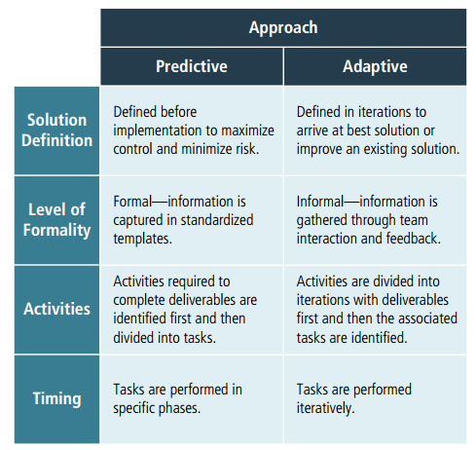

Business Analysis Deliverables

The process will produce all artifacts described in the BABOK. This is so that an example of each is delivered with this project.

A business analysis approach provides a description of the types of activities that the business analyst will perform. Frequently the organization’s adopted methodologies influence the activities that are selected.

Integrating business analysis activities in the business analysis approach includes:

· identifying the activities required to complete each deliverable and then breaking each activity into tasks,

· dividing the work into iterations, identifying the deliverables for each iteration, and then identifying the associated activities and tasks, or

· Predictive Tasks are performed in specific phases.

Tasks are performed iteratively. Solution Definition Level of Formality Activities Timing Activities required to complete deliverables are identified first and then divided into tasks. Activities are divided into iterations with deliverables first and then the associated tasks are identified. Formal—information is captured in standardized templates. Informal—information is gathered through team interaction and feedback. Defined before implementation to maximize control and minimize risk. Defined in iterations to arrive at best solution or improve an existing solution. Adaptive Approach using a previous similar initiative as an outline and applying the detailed tasks and activities unique to the current initiative.

Timing Of Business Analysis Work

Activities require the following resources and stakeholders:

* Business Analysis Planning and Monitoring tasks
* Elicitation and Collaboration
* Requirements Life Cycle Management
* Strategy Analysis
* Requirements Analysis and Design Definition
* Solution Evaluation

Business analysts determine when the business analysis tasks need to be performed and if the level of business analysis effort will need to vary over time. This type of planning includes determining whether the business analysis tasks performed within the other knowledge areas will be performed primarily in specific phases or iteratively over the course of the initiative.

The timing of business analysis activities can also be affected by:

• the availability of resources,

• priority and/or urgency of the initiative,

• other concurrent initiatives, or

• constraints such as contract terms or regulatory deadlines.

Complexity and Risks

The project will impact the following business areas to the extent described:

The following list of risks should be considered during planning of the project;

The complexity and size of the change and the overall risk of the effort to the  
organization are considered when determining the business analysis approach. As  
complexity and risk increase or decrease, the nature and scope of business  
analysis work can be altered and reflected in the approach.  
The approach may also be altered based on the number of stakeholders or  
business analysis resources involved in the initiative. As the number of  
stakeholders increases, the approach may be adjusted to include additional  
process steps to better manage the business analysis work.  
Other factors that can impact complexity include:  
• size of the change,  
• number of business areas or systems affected,  
• geographic and cultural considerations,  
• technological complexities, and  
• any risks that could impede the business analysis effort.  
Factors that can impact the risk level of a business analysis effort include:  
• experience level of the business analyst,  
• extent of domain knowledge held by the business analyst,  
• level of experience stakeholders have in communicating their needs,  
• stakeholder attitudes about the change and business analysis in general,  
• amount of time allocated by stakeholders to the business analysis activities,  
• any pre-selected framework, methodology, tools, and/or techniques imposed by organizational policies and practices, and  
• cultural norms of the organization.

Acceptance

Acceptance is described in Test Build chapter of the Quality With Agile Process

The business analysis approach is reviewed and agreed upon by key stakeholders. In some organizations, the business analysis process may be more structured and require key stakeholders to sign off on the approach to ensure all business analysis activities have been identified, estimates are realistic, and the proposed roles and responsibilities are correct. Any issues raised by stakeholders when reviewing the approach are documented by the business analyst and resolutions are sought. Stakeholders also play a role in reviewing and accepting changes to the approach as alterations are made to accommodate changing conditions across the initiative.