Hat Quest
A Stylish Word Search Adventure

James W McKinzie

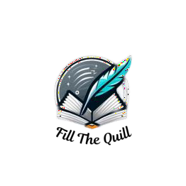
Published by Fill The Quill Fillthequill.com

Introduction
Hat Quest: A Stylish Word Search Adventure presented by Fill The Quill. Dive into the world of headwear with our meticulously designed puzzles, each celebrating a different style of hat. From the dapper Fedora to the elegant Cloche, our puzzles will take you on a fashionable journey through the history and variety of hat styles.
Sharpen your vocabulary and discover fun facts about these iconic accessories that have adorned heads for centuries.
Overview
Embark on a stylish quest with our word search puzzles centered around the diverse and fascinating world of hats. Each puzzle highlights a different hat style, from the casual Beanie to the sophisticated Panama, and everything in between. Whether you're a fashion aficionado or a puzzle enthusiast, these challenges are perfect for you. With varying levels of difficulty, these puzzles cater to all skill levels, ensuring that everyone can enjoy the fashionable adventure of "Hat Quest."

Instructions
Select Your Style: Choose a puzzle that piques your interest from our diverse collection of hat-themed challenges.
Hat Hunt: The hidden words can be found in all directions—horizontal, vertical, diagonal, or reversed. Use the provided word list as your guide. Spot the Styles: Encircle the words in the grid as you would spot stylish hats in a crowd, revealing each unique headpiece.
Log Your Finds: After your stylish search, ensure that all the hidden words have been marked and no fashionable terms are left undiscovered.
Race the Trend: Challenge yourself to complete the puzzle in record time or invite friends to join in a fun, competitive word search showdown.
With “Hat Quest: A Stylish Word Search Adventure,” you’re not only diving into the world of word searches but also exploring the fascinating history and variety of hat styles. Begin your fashionable journey and happy hat-hunting!

Learn the Answers and Explore Hat Styles
Once you've tested your skills with our captivating puzzles, don't miss the chance to check your solutions and learn more about each hat style! Right after the puzzles, you'll find a section with comprehensive solutions for every word search. Plus, intriguing descriptions accompany each hidden word, providing deeper insights into the world of hats you've been exploring. This turns your puzzle-solving experience into an enriching educational journey.
Get ready for an exciting voyage into the world of fashion as you uncover words hidden within the grids. You'll sharpen your mind, possibly compete with fellow puzzle enthusiasts, and enhance your knowledge of hat history. Look forward to piecing together the stories behind each hat style as you embark on this stylish adventure.

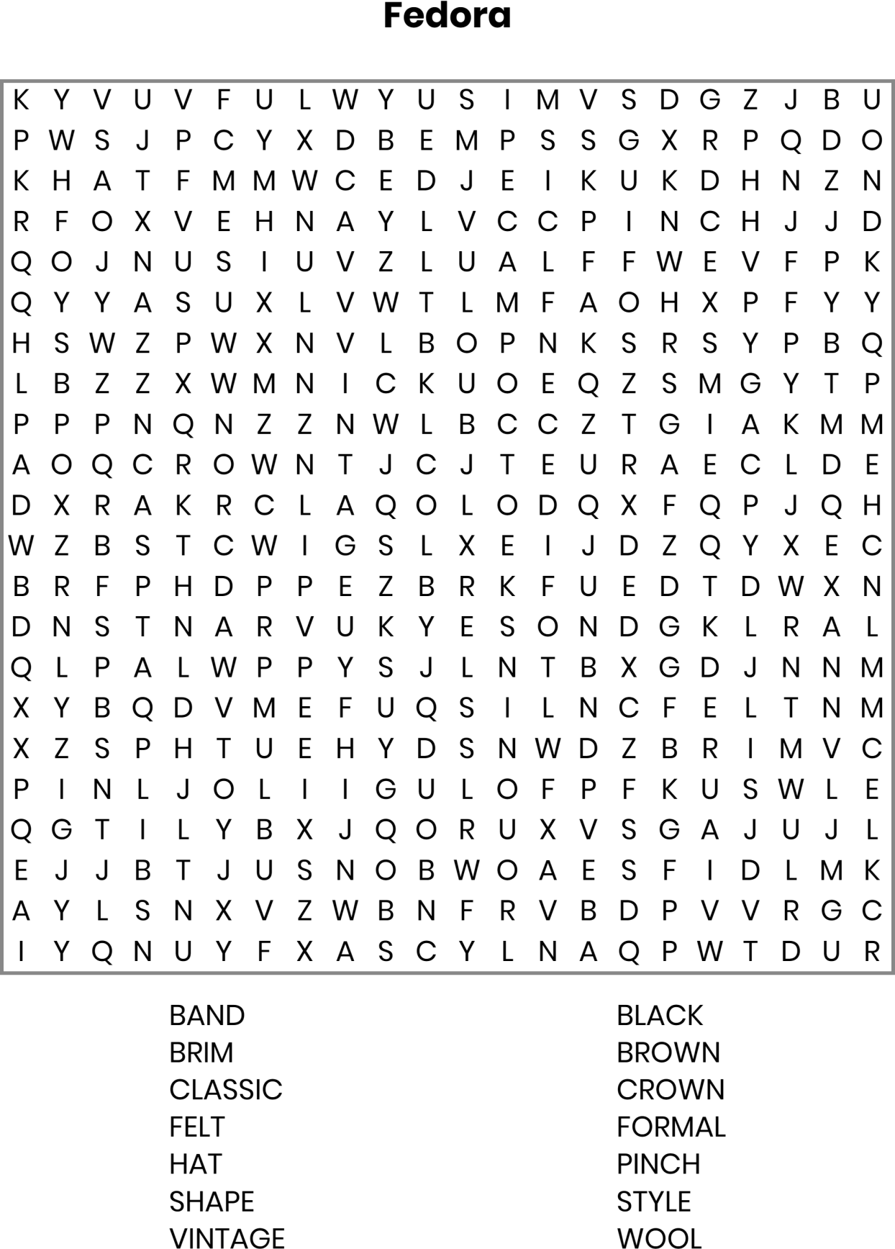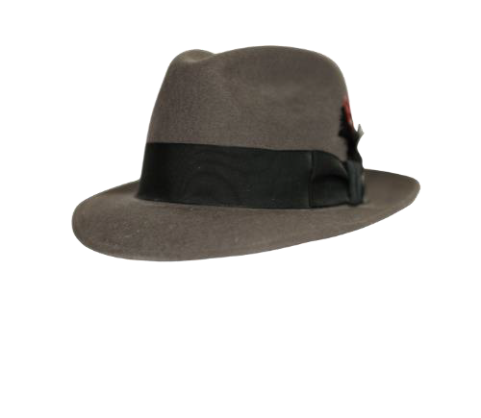

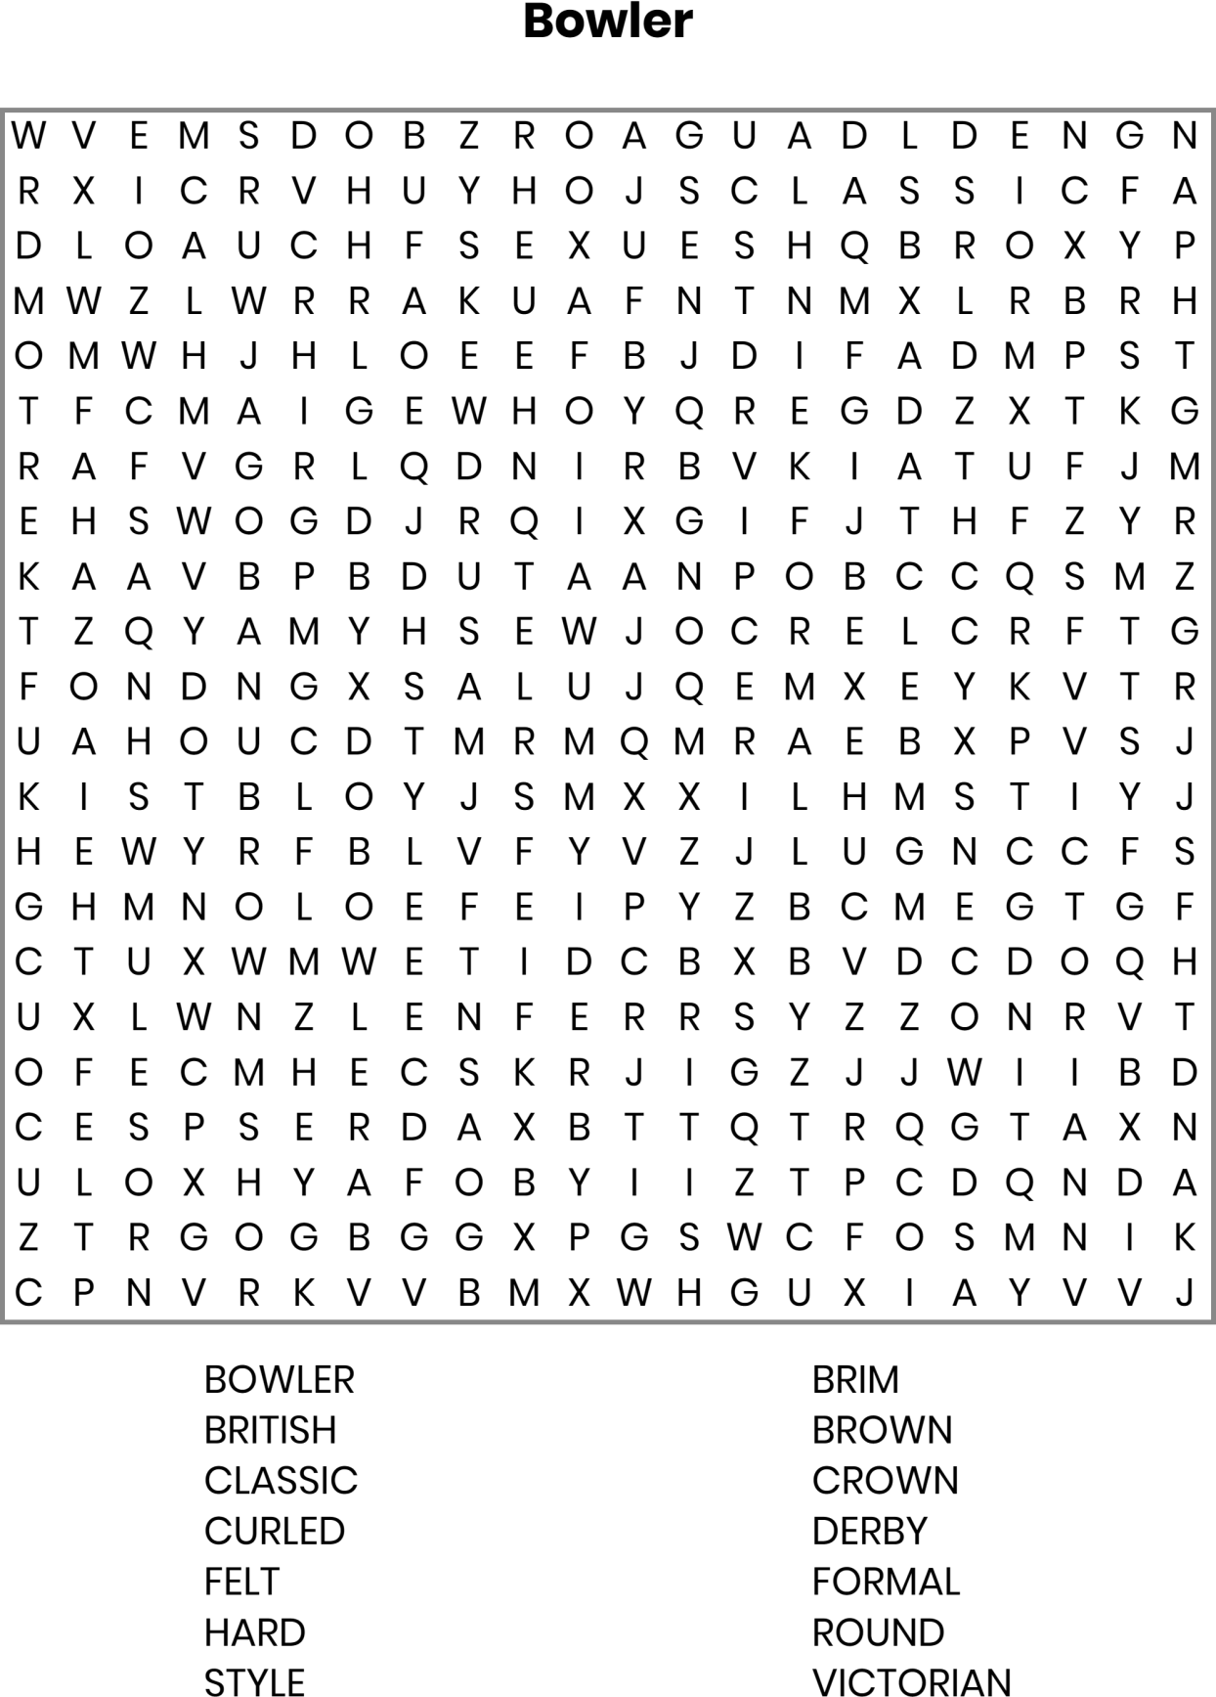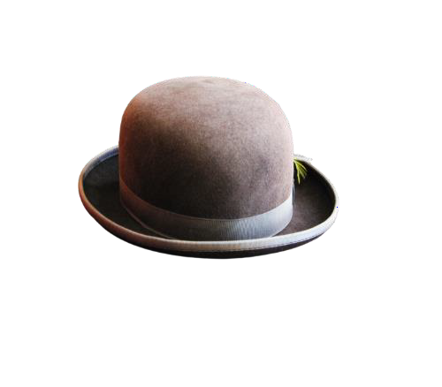

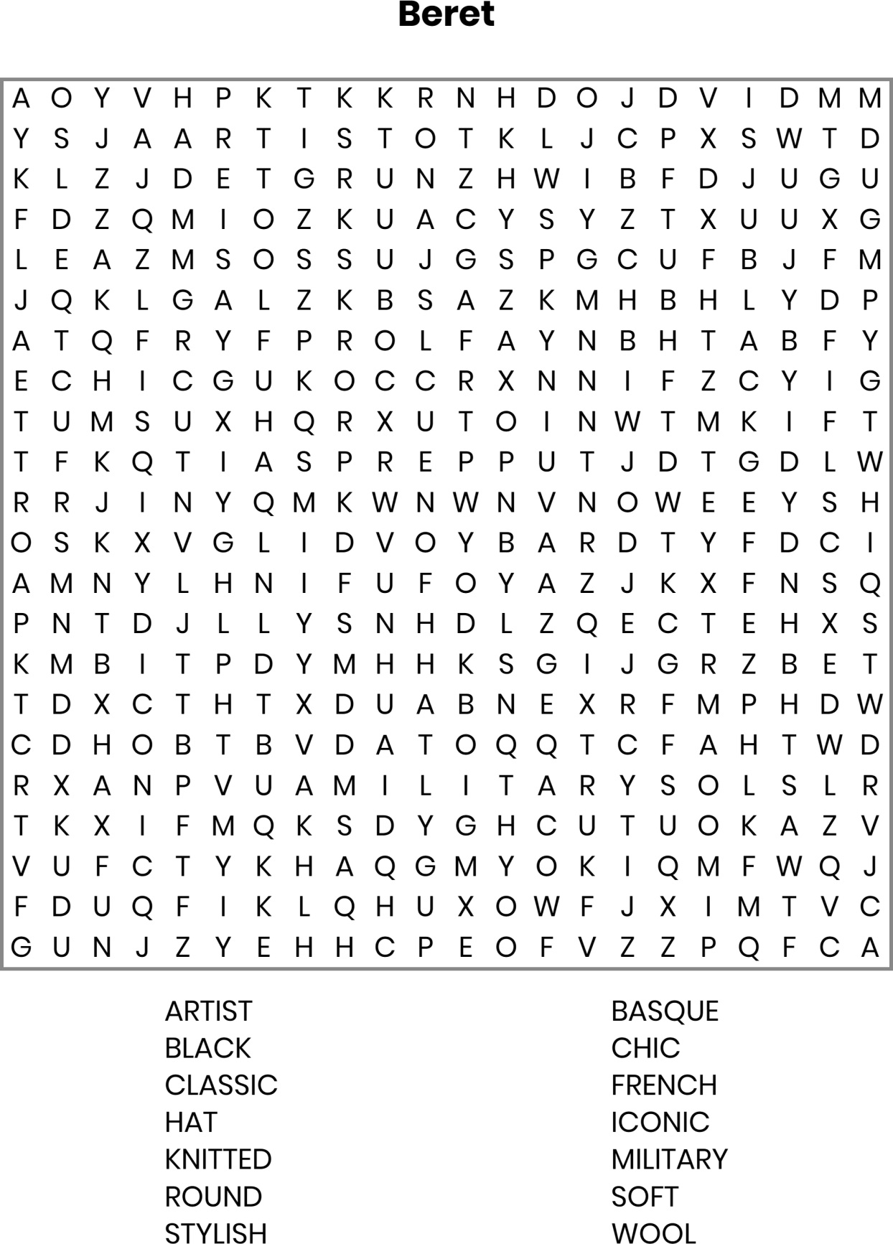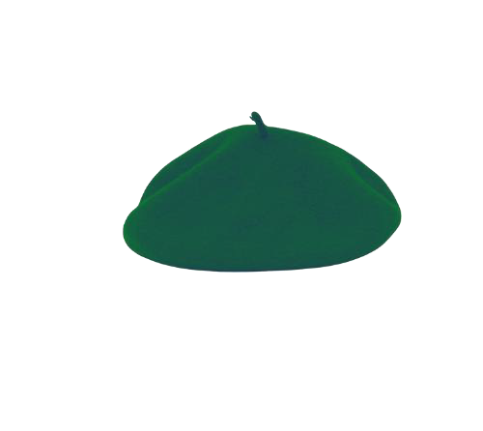

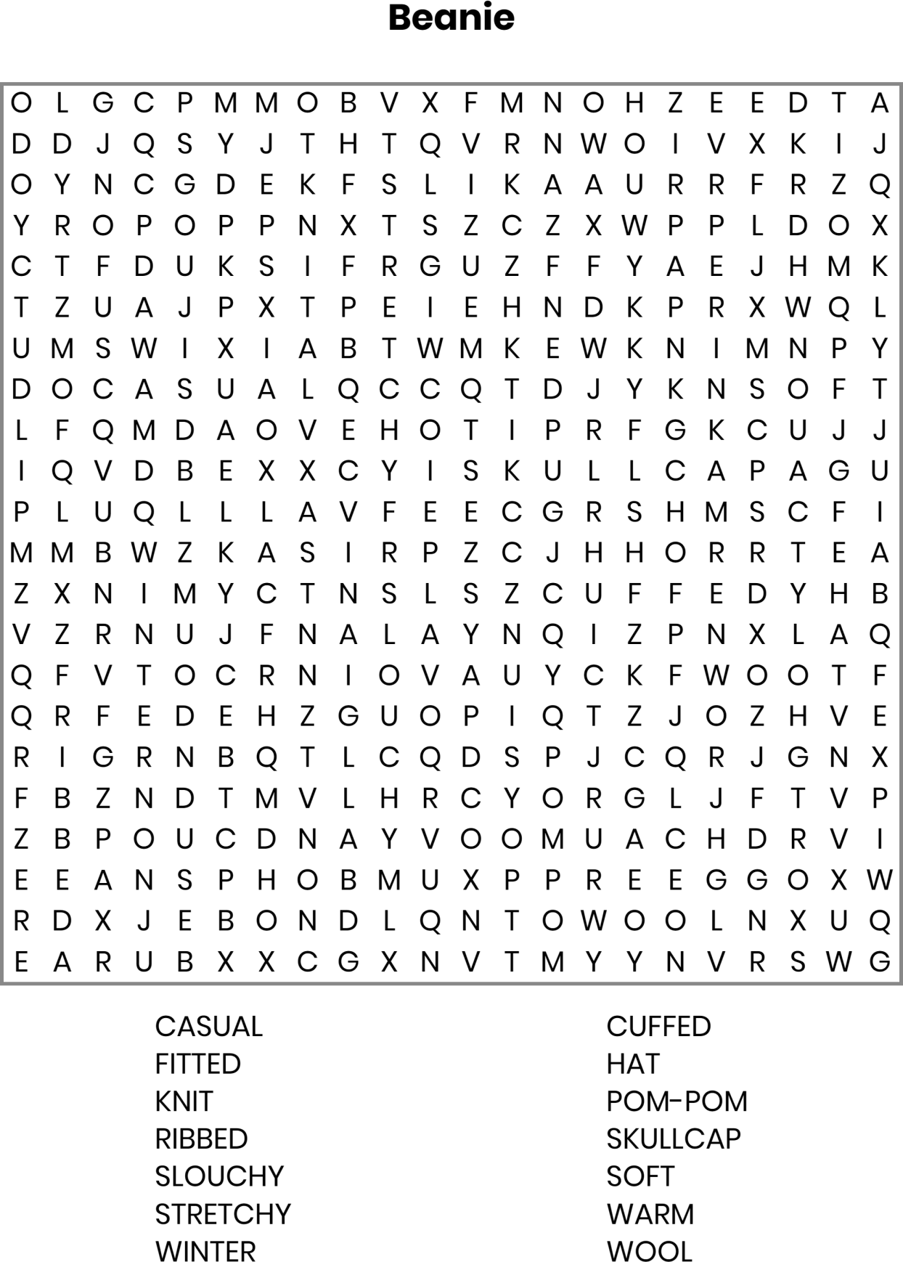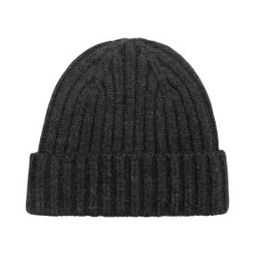

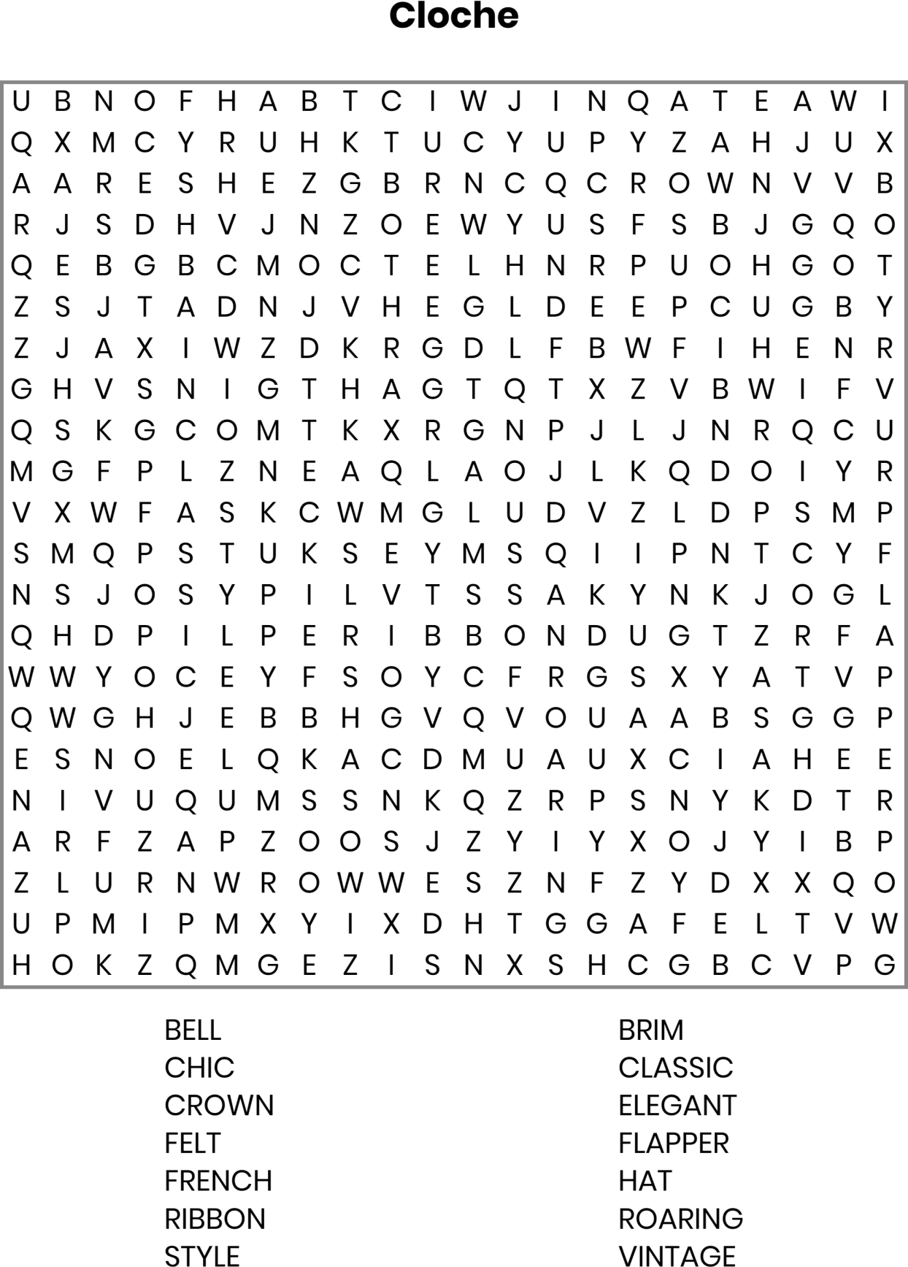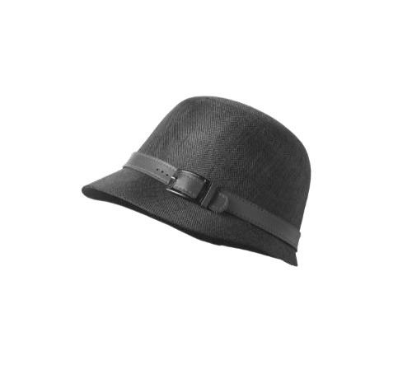

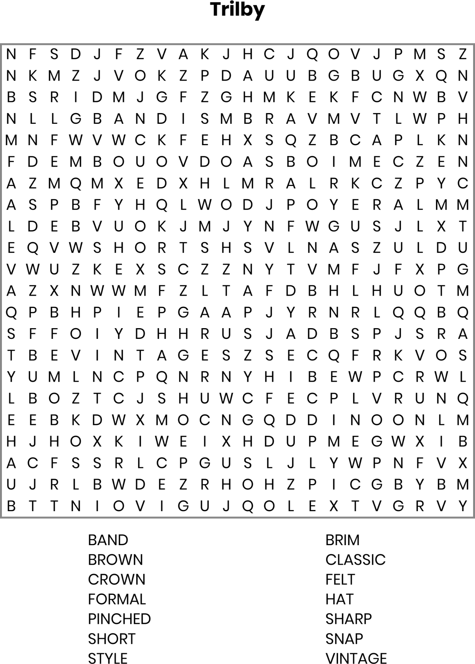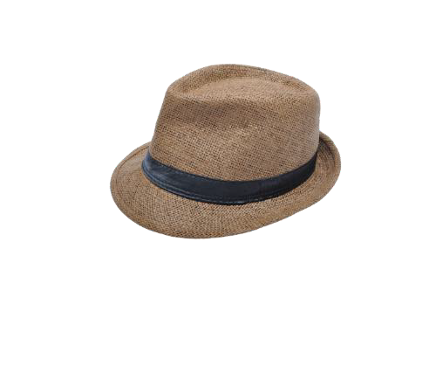

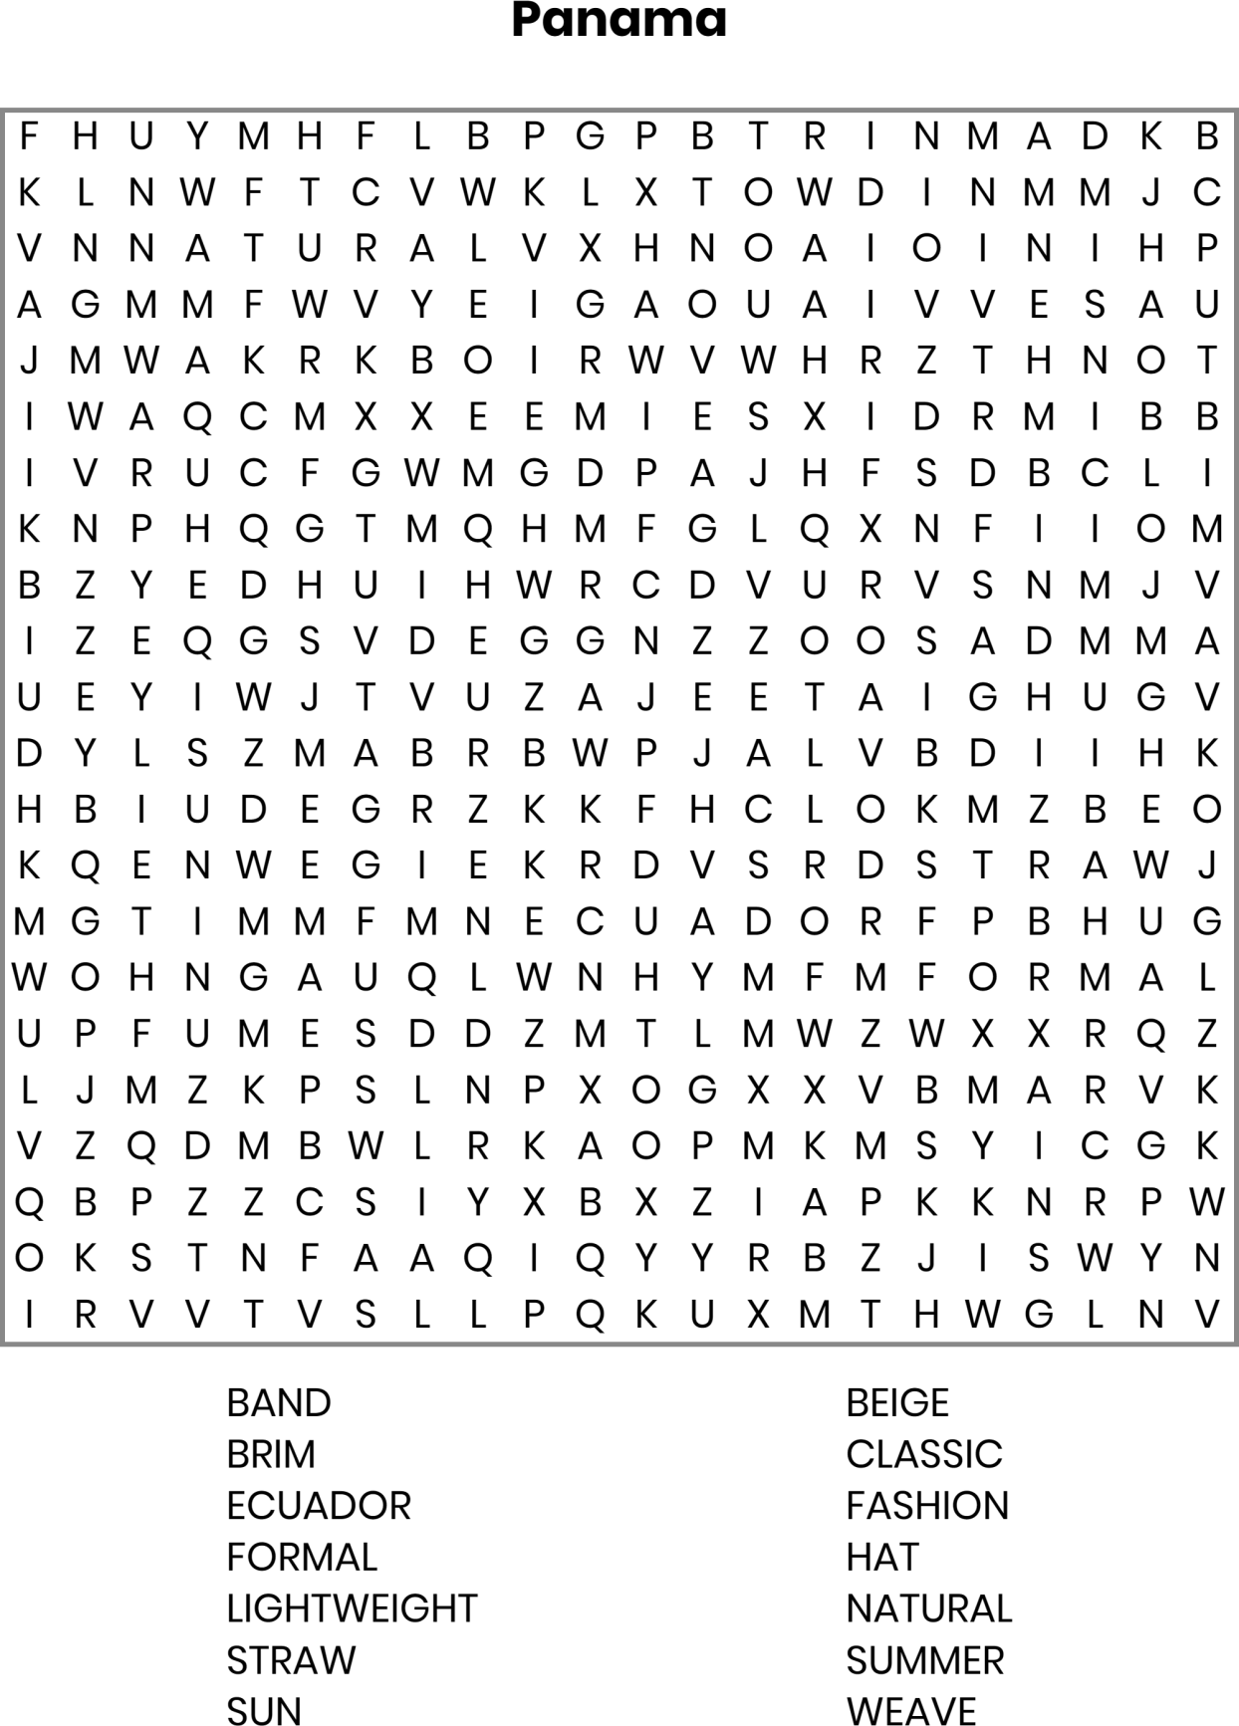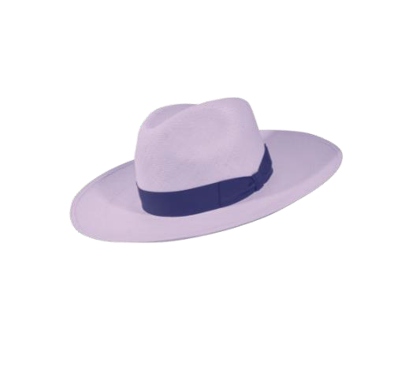

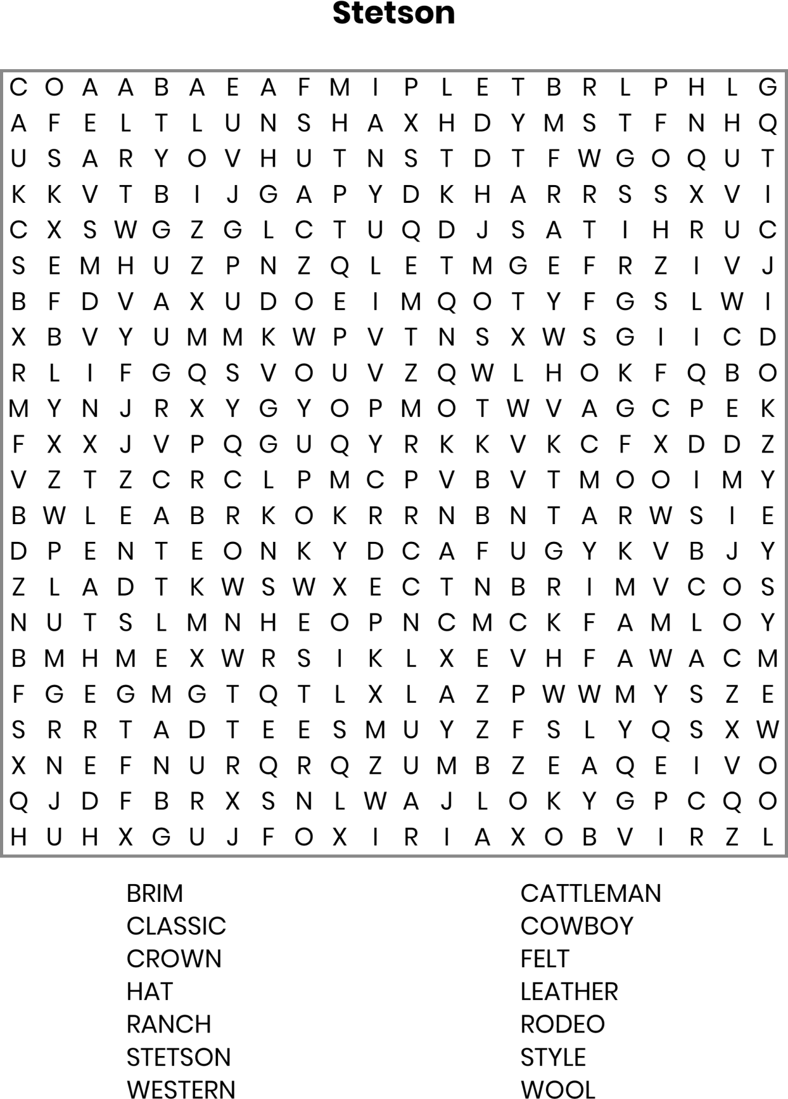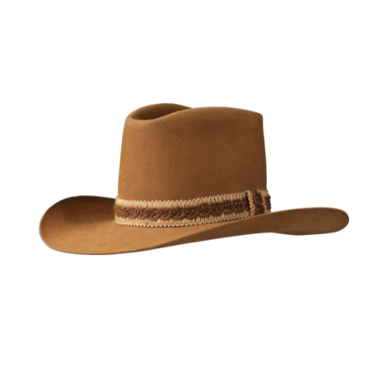

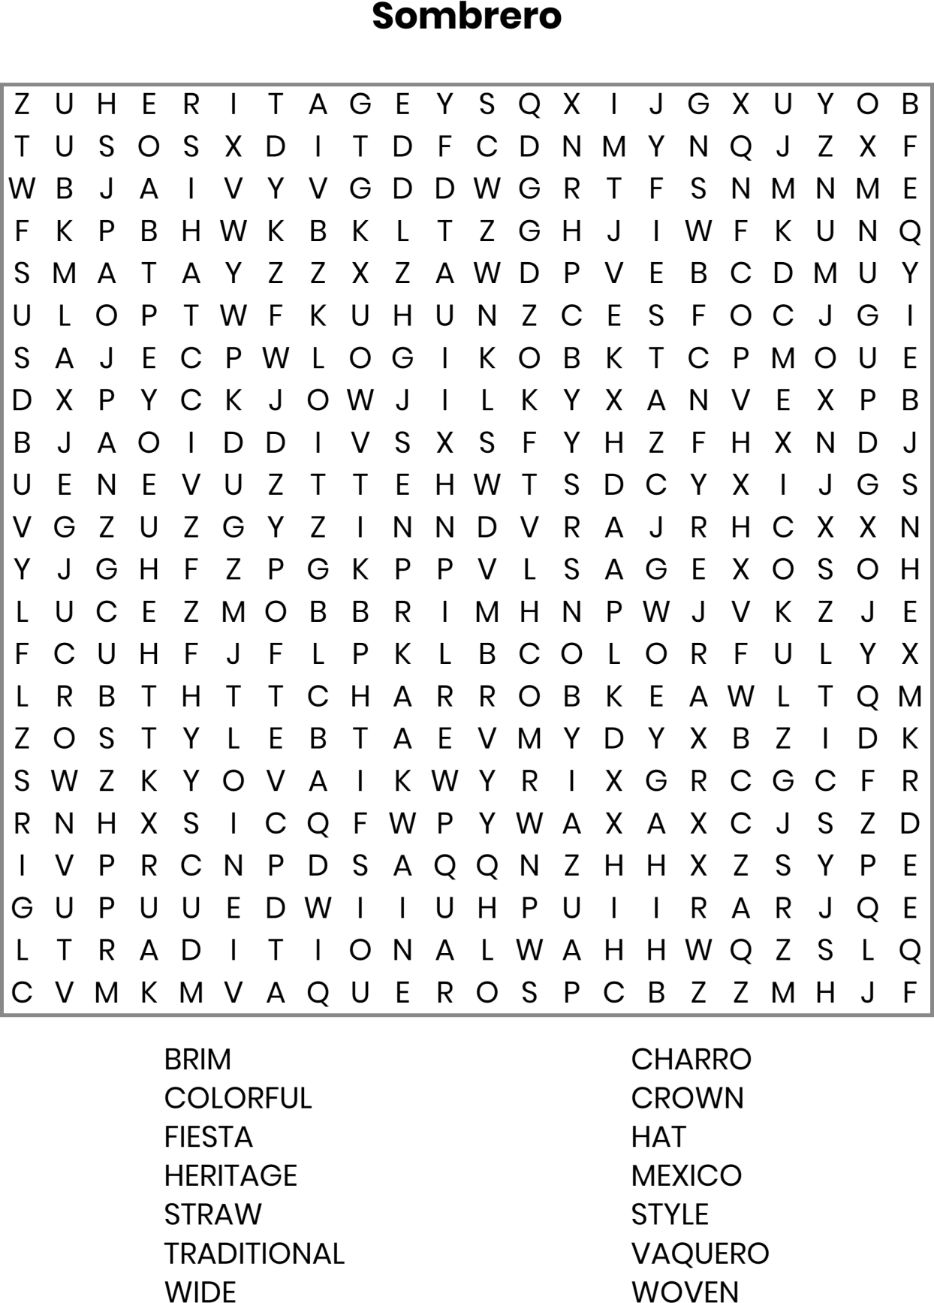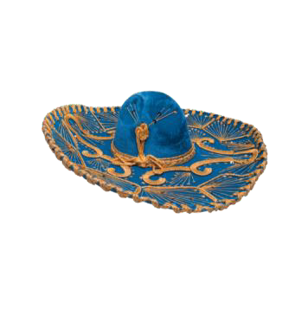

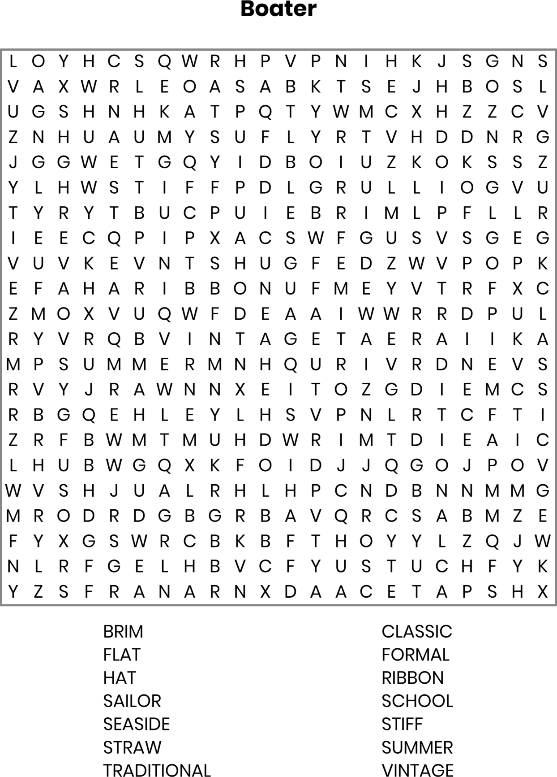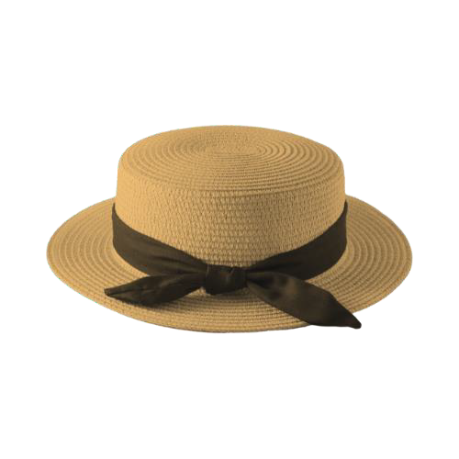

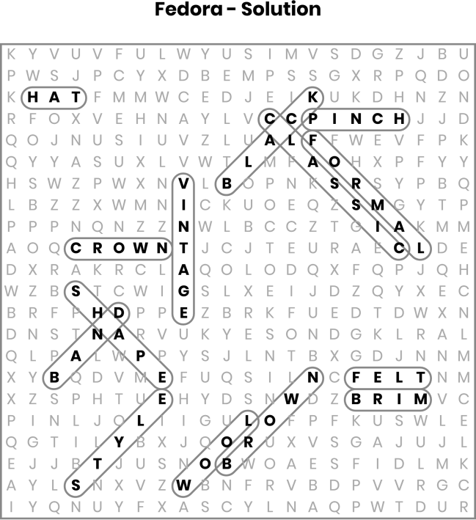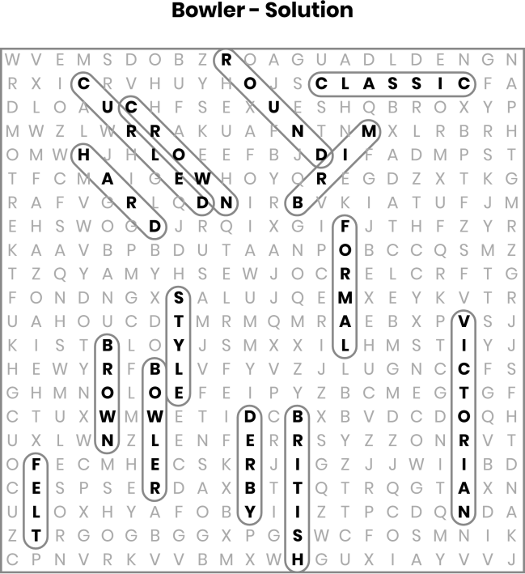

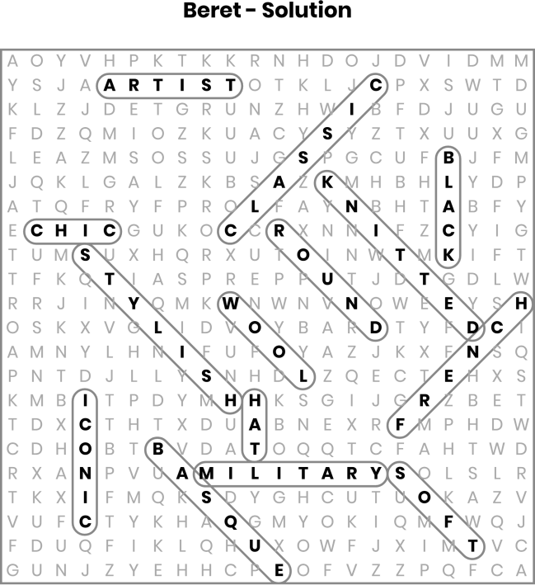
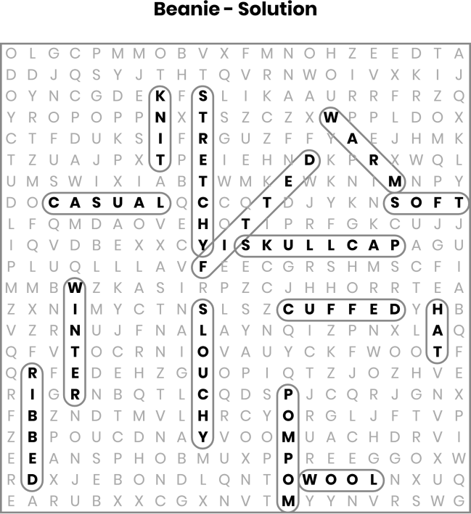

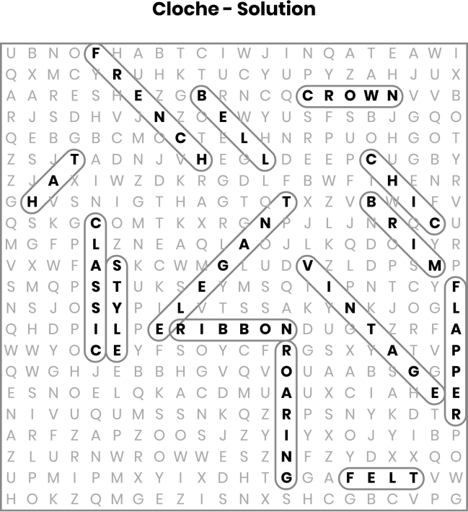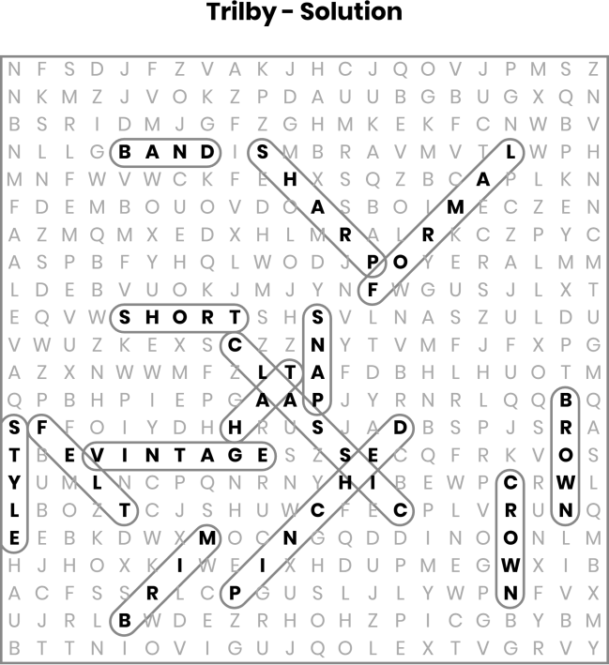

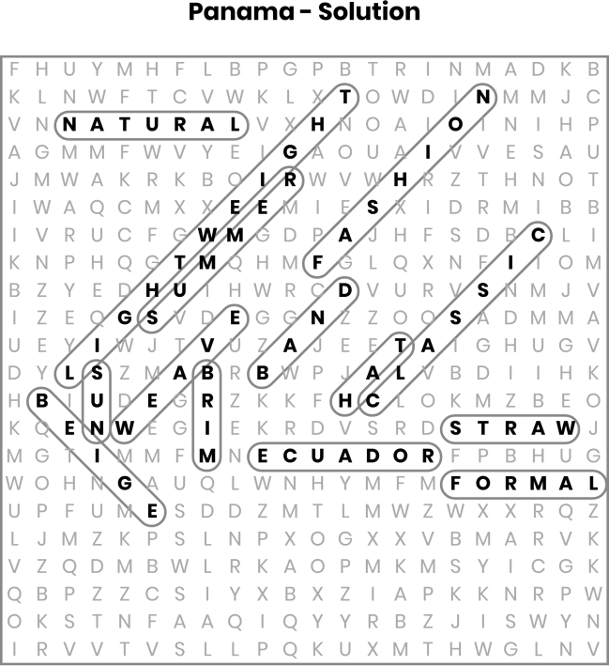
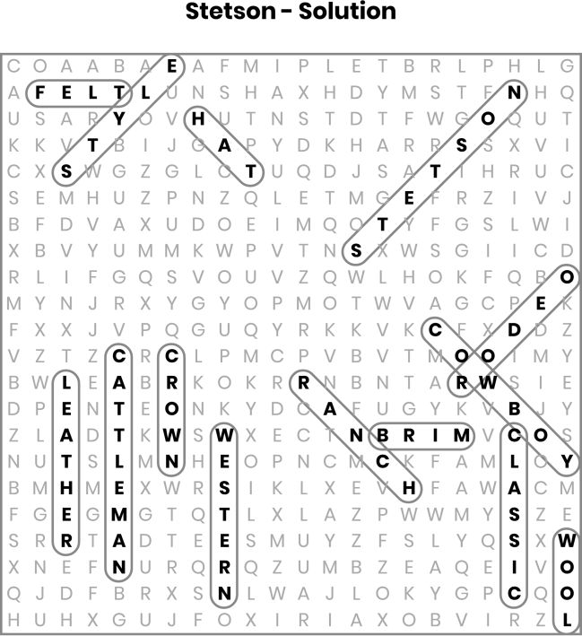

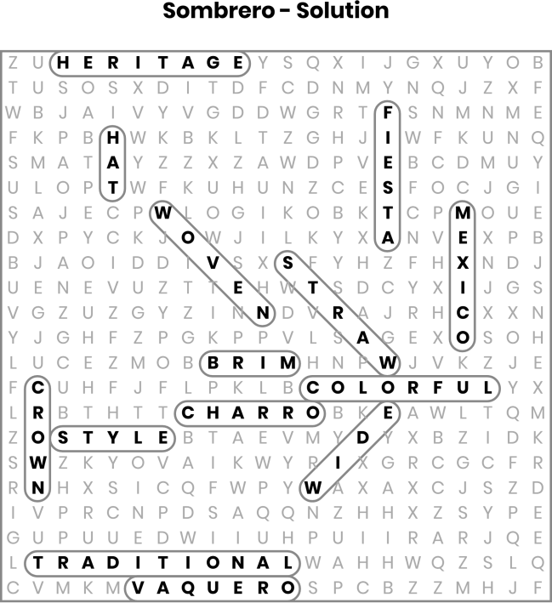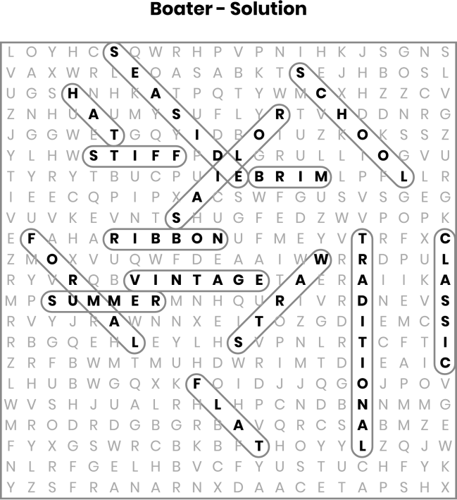

Fedora
Band: The ribbon or fabric around the base of the hat's crown. Black: A common color for Fedoras, often seen in formal settings. Brim: The part of the hat that extends outward from the crown, providing shade.
Brown: Another popular color for Fedoras, suitable for both casual and
formal wear.
Classic: The Fedora is considered a timeless and traditional style of hat.
Crown: The top part of the hat, which can be shaped in various ways. Felt: A common material used to make Fedoras, typically from wool or fur.
Formal: Fedoras are often worn in formal or semi-formal settings.
Hat: The general category that Fedoras belong to.
Pinch: The indentation at the front of the crown, characteristic of many Fedoras.
Shape: The distinctive form of a Fedora, including the crown and brim.
Style: Refers to the Fedora's fashionable appeal and versatility. Vintage: Fedoras have a historical and retro appeal, often associated with past eras.
Wool: A material frequently used in the construction of Fedora hats.

Bowler
Bowler: The name of the hat style itself, also known as a Derby hat.
Brim: The narrow edge that is typically curled up on a Bowler hat. British: The Bowler hat is closely associated with British culture and history.
Brown: A common color for Bowler hats, alongside black.
Classic: The Bowler hat is considered a timeless and traditional style. Crown: The rounded top part of the hat, a distinctive feature of Bowlers.
Curled: Describes the typical upward curl of the Bowler hat's brim. Derby: Another name for the Bowler hat, particularly in the United States.
Felt: A common material used in the construction of Bowler hats,
usually made from wool.
Formal: Bowler hats are often worn in formal or semi-formal settings.
Hard: Refers to the stiff, structured construction of the Bowler hat. Round: Describes the overall shape of the hat, especially the crown. Style: Refers to the Bowler hat's fashionable and recognizable design. Victorian: The era during which the Bowler hat became popular, reflecting its historical significance.

Beret
Artist: The beret is often associated with artists and creative individuals.
Basque: The region in France and Spain where the beret originated. Black: A common color for berets, symbolizing its classic and versatile nature.
Chic: The beret is known for its stylish and fashionable appearance.
Classic: The beret is a timeless and enduring style of hat. French: The beret is closely associated with French culture and fashion.
Hat: The general category that berets belong to.
Iconic: The beret is easily recognizable and has a distinctive look. Knitted: Some berets are made from knitted materials, providing a soft texture.
Military: Berets are worn by various military forces around the world.
Round: Describes the overall shape of the beret.
Soft: The beret is typically made from soft materials like wool or felt.
Stylish: The beret is considered a fashionable accessory.
Wool: A common material used in the construction of berets, known
for its warmth and softness.

Beanie
Casual: Beanies are often worn in relaxed, informal settings. Cuffed: Some beanies have a folded-over edge, adding extra warmth and style.
Fitted: Beanies are designed to fit snugly on the head.
Hat: The general category that beanies belong to.
Knit: Beanies are typically made from knitted fabric, often wool or acrylic.
Pom-pom: A decorative ball of fabric sometimes found on top of beanies.
Ribbed: A type of knit pattern that adds texture and elasticity to the beanie.
Skullcap: Another name for a beanie, emphasizing its close fit to the
head.
Slouchy: A style of beanie that is longer and looser, creating a relaxed look.
Soft: Beanies are usually made from soft, comfortable materials. Stretchy: The knit fabric of beanies allows them to stretch and fit various head sizes.
Warm: Beanies are designed to provide warmth, especially in cold weather.
Winter: Beanies are commonly worn during the winter season for warmth.
Wool: A popular material for beanies, known for its insulating properties.

Cloche
Bell: The cloche hat has a bell-shaped design that fits closely to the head.
Brim: The narrow brim of the cloche hat often curves downward. Chic: The cloche is known for its stylish and fashionable appearance. Classic: The cloche is considered a timeless and iconic style of hat. Crown: The top part of the cloche hat, which is typically rounded.
Elegant: The cloche hat is associated with refined and sophisticated fashion.
Felt: A common material used to make cloche hats, providing structure and shape.
Flapper: The cloche hat was popularized during the 1920s, often worn
by flapper girls.
French: The word "cloche" means "bell" in French, and the style originated in France.
Hat: The general category that cloche hats belong to.
Ribbon: Decorative bands or ribbons are often added to cloche hats for embellishment.
Roaring: Refers to the Roaring Twenties, the era when the cloche hat
became fashionable.
Style: Refers to the distinctive and fashionable design of the cloche hat.
Vintage: The cloche hat is often associated with vintage fashion from the early 20th century.

Trilby
Band: The ribbon or fabric around the base of the crown, often used for decoration.
Brim: The short, narrow edge of the Trilby, usually angled down at the front and up at the back.
Brown: A common color for Trilby hats, though they come in various
colors.
Classic: The Trilby is considered a timeless and traditional hat style. Crown: The top part of the hat, typically indented or pinched in Trilby designs.
Felt: A common material used in making Trilby hats, usually from wool or fur.
Formal: Trilby hats are often worn in formal or semi-formal settings.
Hat: The general category that Trilby hats belong to. Pinched: Refers to the indentation at the front of the crown, characteristic of the Trilby.
Sharp: The Trilby's design is often associated with a sharp, stylish appearance.
Short: Describes the length of the brim, which is shorter than that of a
Fedora.
Snap: Refers to the snapped brim, which can be worn up or down.
Style: Refers to the Trilby's fashionable and versatile design.
Vintage: The Trilby has a retro appeal, often associated with mid-20th- century fashion.

Panama
Band: The ribbon or fabric around the base of the crown, often used for decoration.
Beige: A common color for Panama hats, reflecting their natural straw material.
Brim: The wide edge of the Panama hat, providing shade from the sun. Classic: The Panama hat is considered a timeless and traditional style.
Ecuador: The country where Panama hats originate, specifically from the towns of Montecristi and Cuenca.
Fashion: The Panama hat is a stylish accessory, often worn for both casual and formal occasions.
Formal: Panama hats can be worn in formal settings, adding a touch
of elegance.
Hat: The general category that Panama hats belong to. Lightweight: Panama hats are known for their light and breathable construction.
Natural: Refers to the natural straw material used to weave Panama
hats.
Straw: The primary material used in making Panama hats, usually from the Toquilla palm.
Summer: Panama hats are popular in the summer due to their breathable and cooling properties.
Sun: The wide brim of the Panama hat provides protection from the sun.
Weave: Refers to the intricate hand-weaving technique used to create
Panama hats.

Stetson
Brim: The wide edge of the Stetson hat, designed to provide shade and protection.
Cattleman: A popular crown shape for Stetson hats, featuring a crease down the center and dents on either side.
Classic: The Stetson is considered a timeless and iconic style of hat. Cowboy: The Stetson is famously known as the cowboy hat, associated with Western culture.
Crown: The top part of the Stetson hat, which can come in various shapes, including the cattleman.
Durable: Stetson hats are known for their long-lasting and sturdy construction.
Felt: A common material used in making Stetson hats, typically from
wool or fur.
Hat: The general category that Stetson hats belong to.
Leather: Sometimes used for hatbands or in the construction of some Stetson hats.
Ranch: The Stetson hat is often worn by ranchers and those working
outdoors.
Rodeo: Stetson hats are popular in rodeo events and Western shows. Stetson: The brand name and synonymous with quality cowboy hats. Style: Refers to the distinctive and fashionable design of the Stetson hat.
Western: The Stetson hat is closely associated with Western and cowboy culture.

Sombrero
Brim: The wide and often upturned edge of the sombrero, providing ample shade.
Charro: A style of sombrero worn by traditional Mexican horsemen. Colorful: Sombreros are often decorated with vibrant colors and intricate designs.
Crown: The top part of the sombrero, which can be tall and sometimes elaborately decorated.
Fiesta: Sombreros are commonly worn during celebrations and festivals in Mexican culture.
Hat: The general category that sombreros belong to.
Heritage: The sombrero is an important symbol of Mexican cultural
heritage.
Mexico: The country where sombreros originated and are most closely associated with.
Straw: A common material used to make sombreros, providing lightness and breathability.
Style: Refers to the distinctive and recognizable design of the
sombrero.
Traditional: Sombreros are a traditional part of Mexican attire. Vaquero: The Mexican cowboy, who traditionally wore sombreros while working outdoors.
Wide: Describes the broad brim of the sombrero, which is designed to offer sun protection.
Woven: Many sombreros are intricately woven from straw or other
materials.

Boater
Brim: The stiff, flat edge of the boater hat, providing a structured look.
Classic: The boater hat is considered a timeless and traditional style.
Flat: The boater hat has a distinctive flat crown and brim.
Formal: Boater hats are often worn in formal or semi-formal settings, such
as garden parties or regattas.
Hat: The general category that boater hats belong to.
Ribbon: A decorative band, often made of grosgrain, that encircles the base of the crown.
Sailor: The boater hat is sometimes associated with nautical and sailor attire.
School: Traditionally worn as part of school uniforms in some British
schools.
Seaside: Boater hats are often worn in seaside and coastal areas, reflecting their nautical heritage.
Stiff: Boater hats are made from stiff straw, giving them their rigid structure.
Straw: The primary material used in the construction of boater hats. Summer: Boater hats are commonly worn during the summer months for their lightweight and breathable nature.
Traditional: The boater hat is a traditional part of certain uniforms and dress codes.
Vintage: The boater hat has a retro appeal, often associated with early 20th-century fashion.

