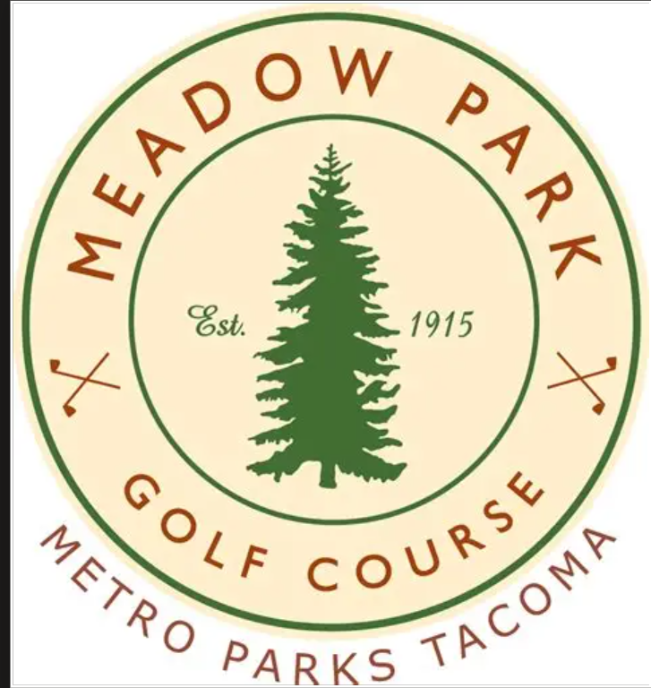



Job Listing
https://www.governmentjobs.com/careers/parkstacoma/jobs/5295747/golf-industry-explorer-maintenance-assistant-i?keywords=golf&pagetype=jobOpportunitiesJobs

Chris Goodman
General Manager, Meadow Park Golf Course
Parks & Recreation Department
Office (253) 473-3033/ Mobile (253) 448-4831
7108 Lakewood Dr. W., Tacoma, WA 98467

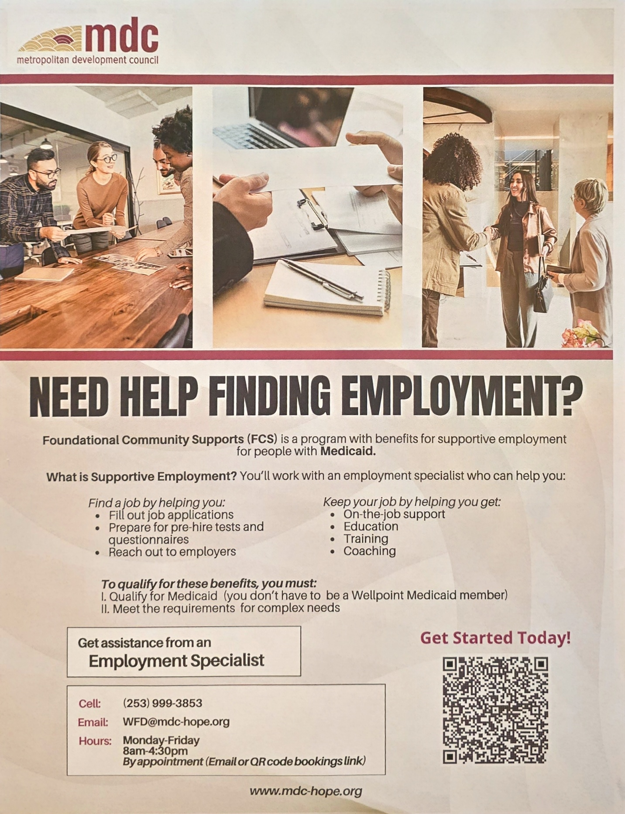



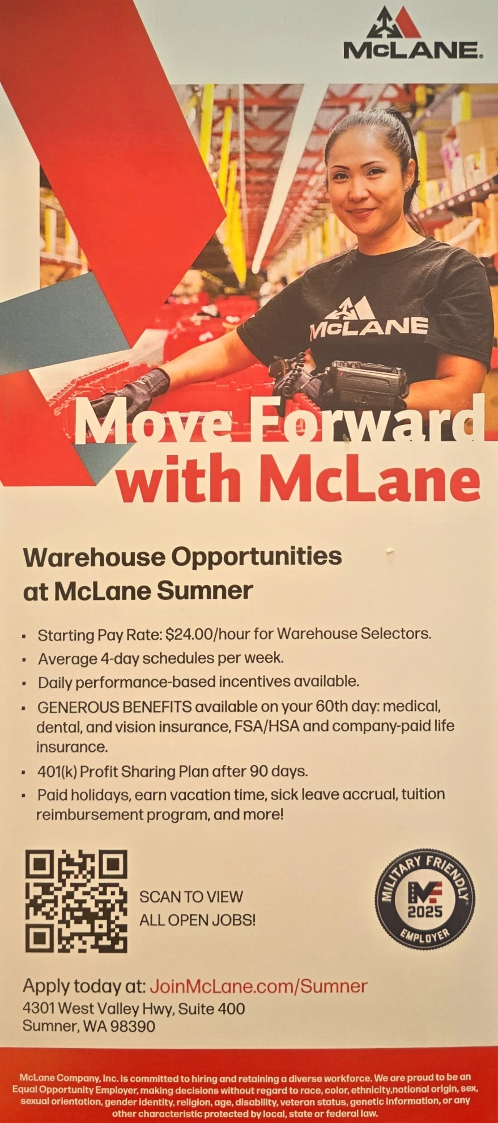
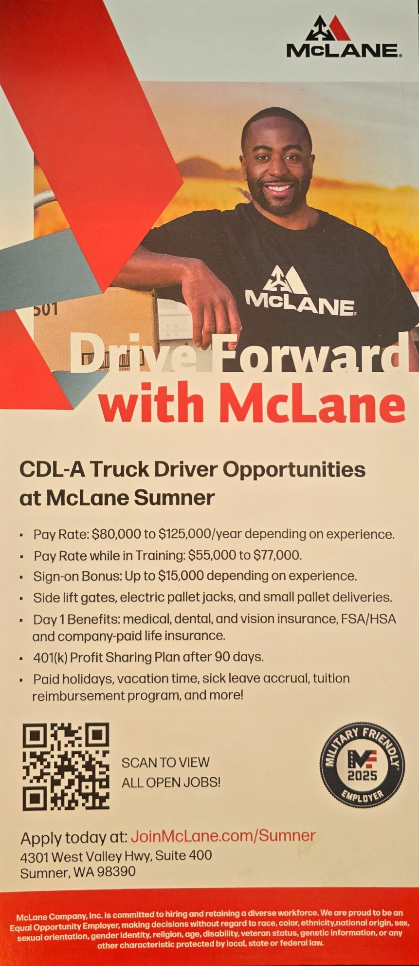

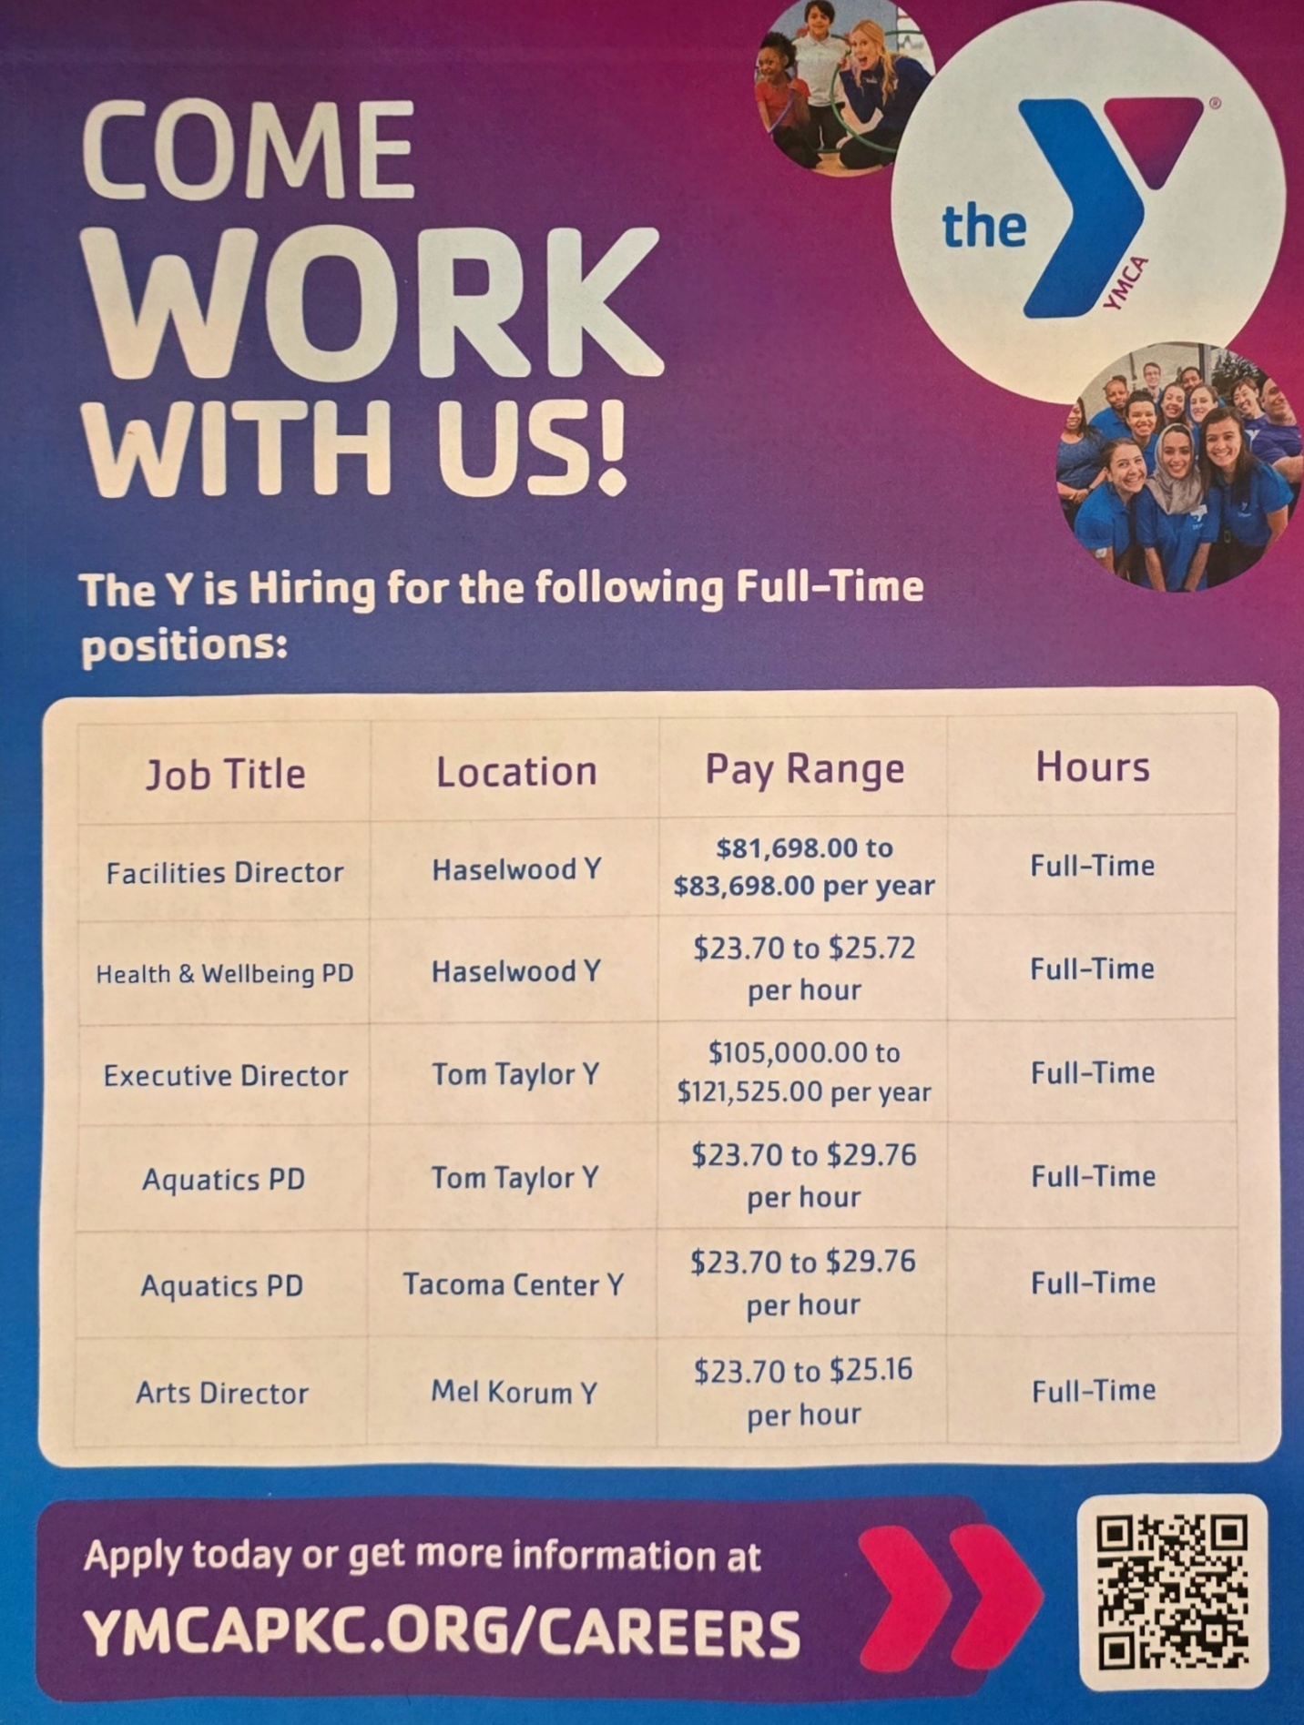

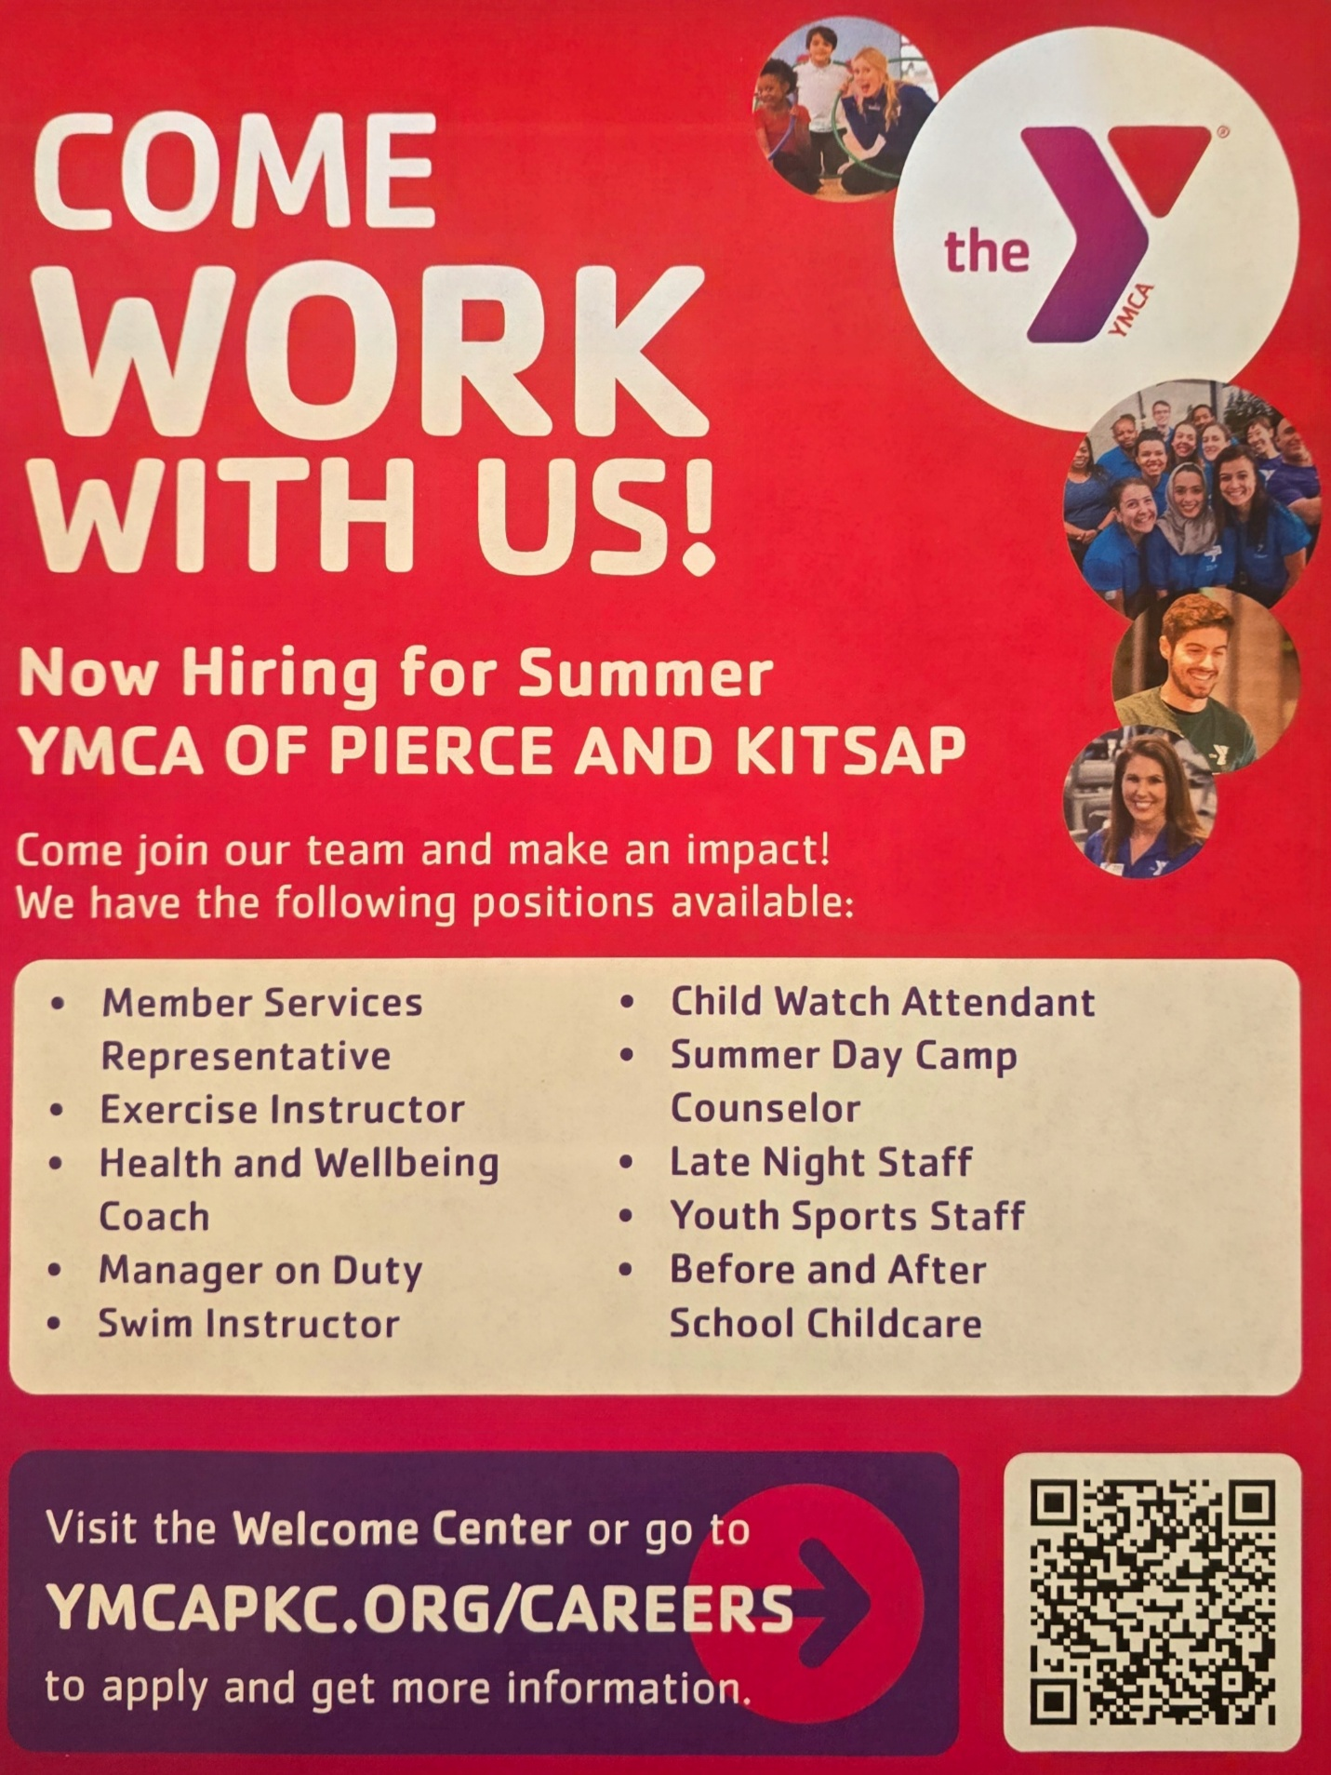

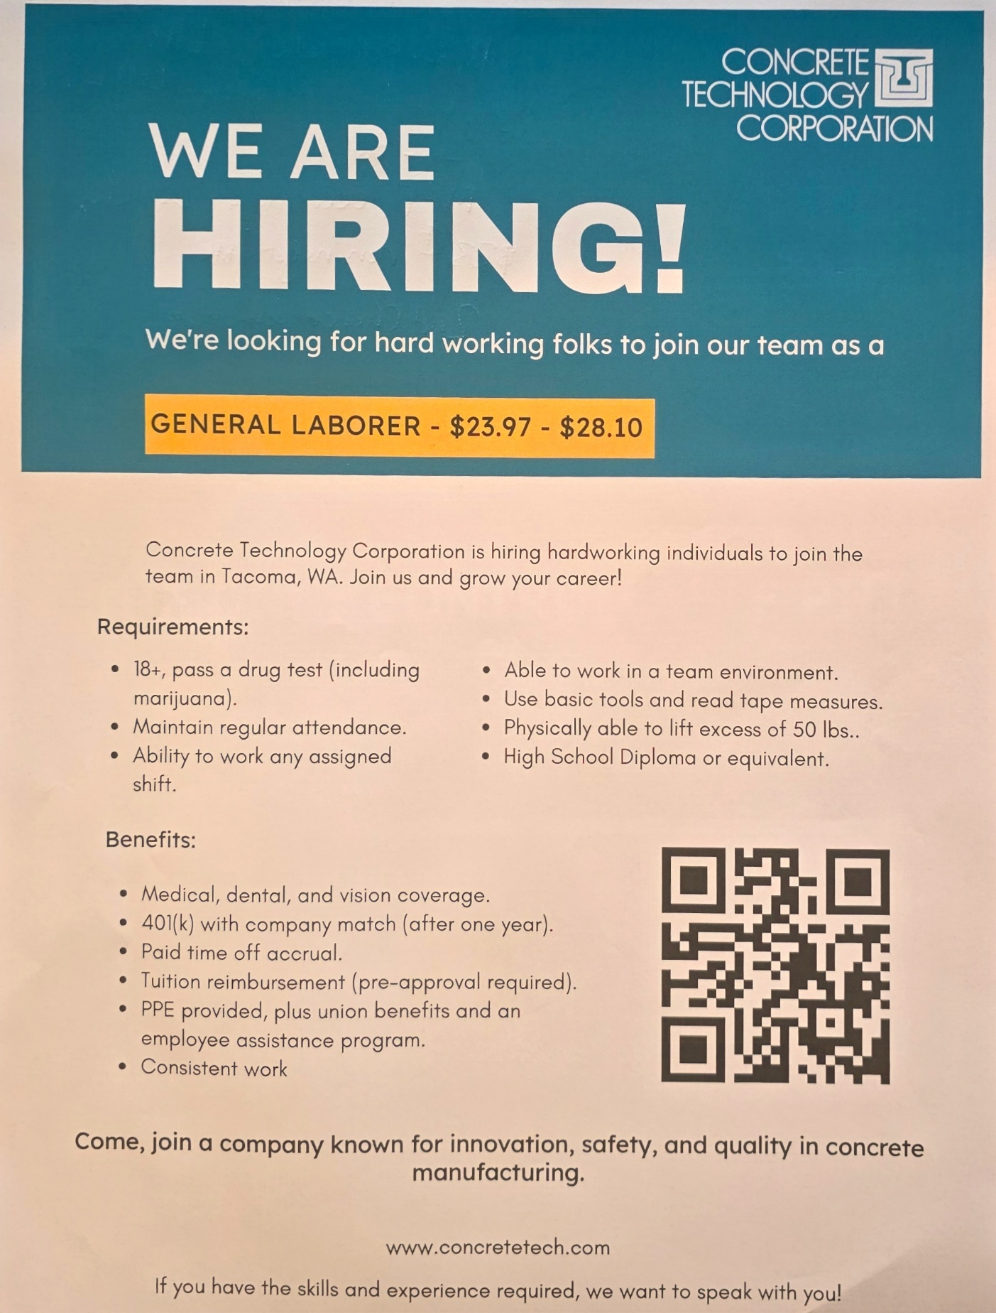
2nd Chance Employer

Union Local 252
No set schedule
Start Times between 3am - 8am
M-F Occasional Saturday
$23.97 non-negotiable

Kevin Johnson Jr
HR Recruiting and Training Coordinator 253-404-2221 (Direct) & 253-383-3545 (Main)

