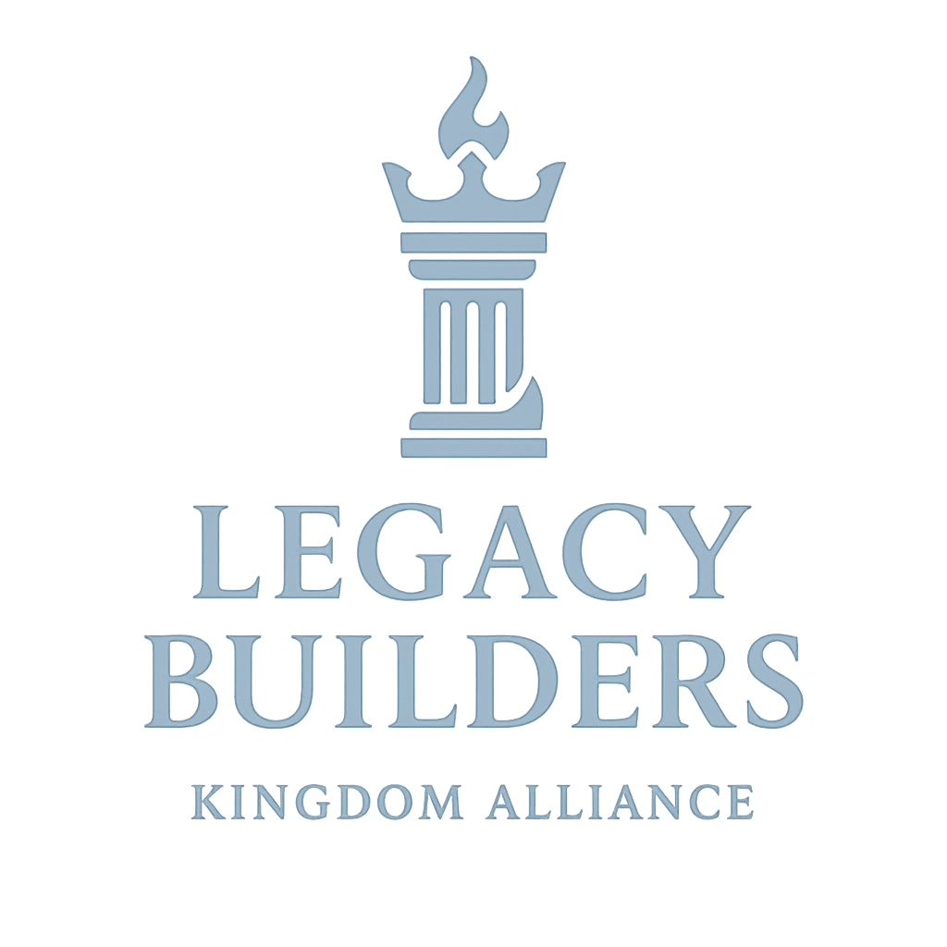

Legacy Builders Kingdom Alliance Application & Questionnaire
Welcome to the Movement.
Thank you for your interest in partnering as an Ambassador with Legacy Builders Kingdom Alliance — a chamber of influence for Kingdom-minded entrepreneurs, ministry leaders, professionals, and marketplace influencers. This application will help us align vision, values, and assignment as we build a Kingdom ecosystem together.

PART 1: PERSONAL & CONTACT INFORMATION
1. Full Name: ______________________________
2. Email: _______________________________
3. Phone: _______________________________
4. City & State: _______________________________
5. Date of Birth: _______________________________
6. Marital Status: _______________________________
7. Website/Social Media (if applicable): _______________________________
8. Preferred Method of Communication: ☐ Phone ☐ Email ☐ Text ☐ WhatsApp

PART 2: PROFESSIONAL & MINISTRY BACKGROUND
1. Are you currently involved in… ☐ Business ☐ Ministry ☐ Workforce ☐ All Three ☐ Other (please explain): _______________________________
2. Business/Ministry Name: _______________________________
3. Role/Title: _______________________________
4. Years in Operation: _______________________________
5. Briefly describe what you do professionally:
______________________________________________________________________________
6. What sector(s) of society are you currently involved in? ☐ Faith ☐ Business ☐ Education ☐ Government ☐ Media ☐ Arts/Entertainment ☐ Family ☐ Other: ____________
7. What sector(s) of society do you desire to influence and impact? ☐ Faith ☐ Business ☐ Education ☐ Government ☐ Media ☐ Arts/Entertainment ☐ Family ☐ Other: ____________

PART 3: KINGDOM ALIGNMENT & VISION
1. What does the term “Legacy Builder” mean to you personally?
______________________________________________________________________________
2. Why do you want to join the Legacy Builders Kingdom Alliance?
______________________________________________________________________________
3. What do you feel your Kingdom assignment is at this moment?
______________________________________________________________________________
4. Are you currently under spiritual covering (Connected with a Spiritual leader?) If yes, please share the name and relationship.
______________________________________________________________________________
5. What does Apostolic Alignment mean to you?
____________________________________________________________________________________________________________________________________________________________

PART 4: PARTNERSHIP & ENGAGEMENT
Please check the ways you would like to engage with Legacy Builders:
☐ Ambassador Partner (Membership)
Join as a committed member and Kingdom investor in the movement—receiving covering, training, and collaboration opportunities within the Legacy Builders ecosystem.
☐ Active Volunteer
Serve in key areas of administration, events, media, or outreach to help advance the mission and vision of Legacy Builders on the ground.
☐ Speaker/Trainer
Use your expertise to equip and empower others through teaching, workshops, and leadership development sessions aligned with Kingdom principles.
☐ Ecosystem Collaborator
Partner strategically through your organization, business, or ministry to create sustainable impact and resource-sharing across the Kingdom network.
☐ Regional Representative
Lead and represent Legacy Builders within your city or region, expanding the movement’s reach and influence through local activations and partnerships.
☐ Other: ____________
Which of the following areas would you be interested in contributing to?
☐ Leadership Development ☐ Wealth Strategies ☐ Marketplace Mobilization ☐ Kingdom Collaboration ☐ Apostolic Governance ☐ Innovation & Strategy ☐ Youth & Legacy Empowerment
What resources, relationships, or experience can you bring to this alliance?
____________________________________________________________________________________________________________________________________________________________

PART 5: THE ELLII CODE AFFIRMATION
The Legacy Builders Kingdom Alliance operates according to the ELLII Code of ELOHIM, which represents the divine blueprint for Kingdom builders to lead, govern, and expand Heaven’s influence on earth. Each principle of the ELLII Code defines how we live, lead, and leave a lasting impact in every sphere of culture and commerce.
• Excellence – Heaven’s Standard
I commit to operate in excellence as the reflection of Heaven’s order on earth, understanding that mediocrity misrepresents the King I serve.
• Leadership – Heaven’s Government
I embrace my call to lead with wisdom, humility, and divine authority.
• Leverage – Heaven’s Strategy
I will seek divine strategies and innovative solutions to steward influence and resources for Kingdom expansion.
• Influence – Heaven’s Voice
I affirm my role as a Kingdom voice—speaking truth, releasing vision, and shaping culture through prophetic wisdom.
• Impact – Heaven’s Footprint
I dedicate my life, business, and ministry to create measurable, sustainable impact that leaves a legacy of transformation for generations to come.
☐ I affirm my commitment to embody the ELLII Code of ELOHIM in my business, ministry, and leadership.
By this affirmation, I declare my decision to become an Ambassador of the Legacy Builders Kingdom Alliance.
Signature: ________________________________ Date: ________________________________ Printed Name: _____________________________

CONFIDENTIALITY & AGREEMENT
By submitting this application, I understand that this information is used for alignment, stewardship, and equipping purposes only. I affirm that all information is accurate to the best of my knowledge.

FOR OFFICE USE ONLY
Date Received: _______________________
Reviewed By: _______________________
Status: ☐ Approved ☐ Pending ☐ Follow-up Required
Notes: _____________________________________________________________

