**Clarifying the Problem: Collaborative Discussion**

**Assess Digital Learning Instruct (EDLD-5315-D21)**

In this discussion, I will connect my action research planning to my innovation plan about implementing a blended learning model for second-grade literacy. As highlighted in my innovation plan, integrating face-to-face instruction with digital tools such as iReady and Schoology aims to increase student engagement and motivation while strengthening reading and writing skills. Using the “5 Why Process” and reflecting on Chapters 4–6 of Mertler (2019), I have been able to narrow my focus and identify a core problem of practice: the need to transform hybrid learning from a content-centered model into a meaningful, motivating, and immersive experience for bilingual second-grade students. This alignment between my innovation plan and my action research design ensures that my study is relevant, feasible, and directly connected to improving literacy outcomes in my classroom.

***Innovation Planning as a Guiding Path***The planning of my innovation, focused on implementing a thematic blended learning environment called Explorers of the Forest of Reading and Writing to strengthen reading and writing in second grade, has been essential in narrowing the focus of my action research. At first, my concern was broad—improving literacy in a bilingual context—but reflective analysis of my practice helped me identify the true core of the problem: fostering my students’ motivation to read and write. This methodological clarity aligns with Mertler’s (2019) view of action research as a cyclical process that begins with clearly defining a problem of practice. Likewise, as Fink (2013) emphasizes, significant planning connects students’ interests with authentic learning experiences; in my case, this means weaving narrative, play, and technology to spark curiosity. Thus, planning has not only guided the selection of my research topic but also ensured that the evidence I collect will be meaningful, engaging, and transformative for my students.

***Topic, Purpose, and Research Questions***

*The topic* of my action research focuses on examining how the implementation of a thematic blended learning environment, *Explorers of the Forest of Reading and Writing*, can strengthen Spanish literacy development among second-grade students in a bilingual context.

*The purpose* of my study is to understand how the combination of digital resources and face-to-face experiences influences students’ motivation and academic outcomes in reading and writing. My intention is to demonstrate that blended learning not only expands access to content but also serves as a driver of enthusiasm and active participation, thereby enhancing both reading comprehension and written production.

*The fundamental question* guiding this study is:  
What effect does the implementation of *Explorers of the Forest of Reading and Writing* have on the motivation, reading comprehension, and written production in Spanish of second-grade students within a bilingual blended learning environment?

***Problems of a Poorly Developed Research Question and How to Address Them***When a research question is not well developed, several issues may arise. The study may become too broad or vague, making it difficult to determine what data to collect and how to analyze it, which limits the usefulness of the findings for teaching practice. A poorly defined question may also lead to the use of inappropriate instruments, thereby compromising the validity and reliability of the results. Ultimately, if the question is not aligned with the actual needs of the classroom, the research loses relevance and fails to have a meaningful impact on educational improvement (Mertler, 2019). To prevent these problems, it is essential to use strategies such as conducting a “why” analysis, reviewing previous literature, consulting with colleagues, and narrowing the focus to a specific, observable, and measurable issue. In my case, limiting the research to the effect of blended learning activities on the motivation and Spanish literacy of second graders ensures that the data collected is meaningful and actionable. In short, a well-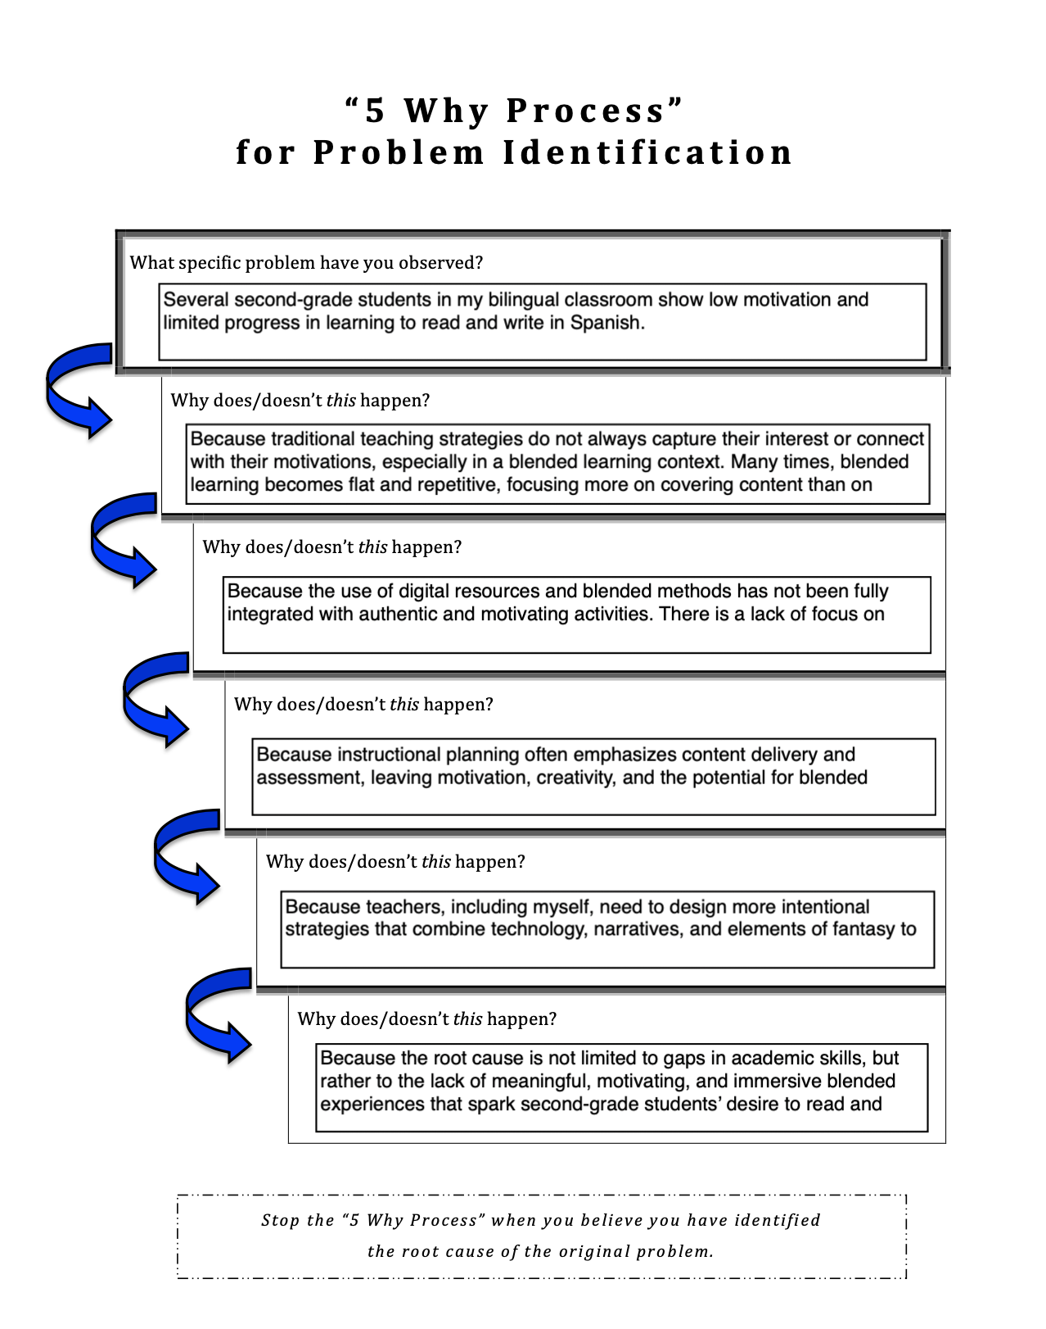formulated question not only gives direction to the study but also ensures that the results contribute to improving teaching practice and student learning.

***Research Design Guided by the Question***When analyzing my research question—What effect does the implementation of the Explorers of the Forest of Reading and Writing project have on the motivation, reading comprehension, and written production in Spanish of second-grade students in a bilingual blended learning environment?—and drawing on Table 4.1 from Mertler (2019), I conclude that the most appropriate design is a mixed-methods approach. On one hand, quantitative data is necessary to measure progress in reading comprehension and written production through diagnostic and post-tests, analytic rubrics with numerical scores, and fluency records. These represent observable and comparable results (lag measures). On the other hand, qualitative data is needed to capture how blended activities influence students’ motivation, using Likert-type surveys, classroom observations, digital portfolios, and anecdotal notes (lead measures). As Mertler (2019) explains, a mixed design is most suitable when the research seeks to address both measurable outcomes and subjective processes. In my case, this approach ensures a comprehensive understanding by showing not only whether students improve in literacy skills, but also how and why the blended environment fosters their interest and desire to learn.

***Most Appropriate Type of Data for the Research***The most appropriate type of data for my action research is mixed methods, since my goal is to gain a comprehensive understanding of the effect of the *Explorers of the Forest of Reading and Writing* project on Spanish literacy and student motivation in a bilingual blended learning environment. Quantitative data will allow me to measure progress in reading comprehension and written production through diagnostic and post-tests, analytic rubrics with numerical scores, fluency records, and digital platform analytics such as iReady (time on task, frequency of access, and progress achieved). At the same time, qualitative data will provide insights into students’ experiences and perceptions through Likert-type surveys adapted to second grade, classroom observations, digital portfolios, and anecdotal notes on enthusiasm or frustration. As Mertler (2019) highlights, combining both types of data strengthens validity and enables triangulation. In this way, quantitative evidence will capture objective results and participation, while qualitative evidence will reveal students’ voices, emotions, and experiences, offering a holistic view of how the blended environment transforms both their learning and their desire to learn.

**Specific Data and Measurement Instruments**  
In my action research, I will collect mixed data that address both academic outcomes and motivational or participation processes. For **motivation**, I will administer Likert-type perception surveys adapted to second grade at three points (pre, mid, and post), conduct structured observations, and keep anecdotal notes on enthusiasm, persistence, and attitudes toward reading and writing. I will also analyze digital portfolios (Schoology, ClassDojo) and physical portfolios (notebooks and folders) that show voluntary participation, quality of entries, and feedback. For **reading comprehension**, I will use diagnostic and post-tests of literal and inferential comprehension, reading fluency records (WCPM), and analytics from platforms such as iReady and Amplify Reading, focusing on time on task, lessons completed, and level achieved. Regarding **written production**, I will collect Spanish writing samples at baseline and at the end of the project, evaluate them with analytic rubrics (ideas, organization, vocabulary, conventions), and review evidence in both digital and physical portfolios. Finally, for **participation and bilingual strategy transfer**, I will analyze platform data (Schoology, iReady, Amplify, ClassDojo), use participation checklists for class and hybrid activities, and employ observation protocols to identify the use of cognates, inferences, and predictions between English and Spanish. As Mertler (2019) highlights, this multimodal and triangulated approach ensures that the collected data capture both academic achievement and students’ motivational experiences in a valid and comprehensive way.

Importance of Anticipating Data Collection and Aligning the Research Plan  
Anticipating data collection and other steps of my research plan is essential because it ensures that all components of the design remain properly aligned. According to Table 4.2 in Chapter 4 (Mertler, 2019), there must be a clear correspondence between the research problem, the guiding questions, the selected design, the type of data to be collected, the measurement instruments, and the analysis strategies. Without this alignment from the beginning, there is a risk of collecting irrelevant or insufficient data that fails to address the research question. For instance, if my focus is on motivation toward reading and writing in Spanish within a blended environment but I do not prepare instruments to measure attitudes or participation, my study would remain incomplete.

In my case, anticipating data collection allows me to choose appropriate tools in advance (rubrics, surveys, fluency records, digital platform analytics) and schedule specific moments for their application (diagnostic, monitoring, post). It also enables me to plan how I will analyze the information to provide clear and coherent answers to my research questions. In short, anticipating and aligning each step ensures that the process is rigorously planned, feasible in practice, and valid in its results, which strengthens the credibility and usefulness of my action research both in my classroom and in the academic work required in EDLD 5320.

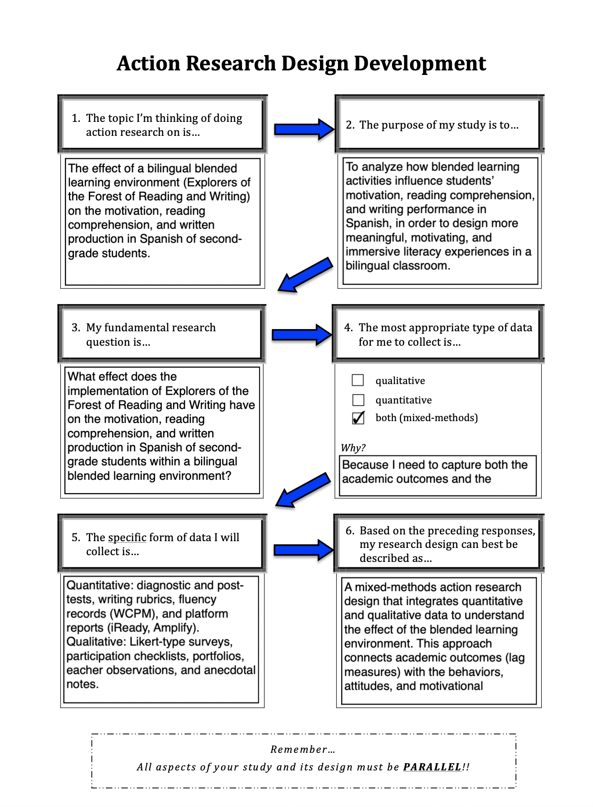

***References***Fink, L. D. (2013). Creating significant learning experiences: An integrated approach to

designing college courses (2nd ed.). Jossey-Bass.  
Mertler, C. A. (2019). Action research: Improving schools and empowering educators (6th ed.).

SAGE Publications.