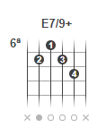
CAPOTRASTE
Money Talks
J.J. Cale
Am E7/9+
Money talks, it'll tell you a story
Money talks, says strange things
Money talks, very loudly
C D F G
You'd be surprised the friends you can buy
With small change
Am E7/9+
They say it's the root of all evil
They say gold is the king
Money talks, you'd better believe it
C D F G
All that gold don't mean a thing
SOLO
Am E7/9+
Rich people, hear those pockets jingle
Spare change, hear the down-and-outers cry
Money talks, tip-toe up behind you
C D F G
Steal what they can, off the cuff or on the sly
Money talks
Money talks
Money talks
Money talks

