Detroit – A lesson for us all
Posted on August 30, 2015 by Sandy Muir
In asset management we frequently discuss the balance of funding services and infrastructure. It is a balancing act that needs to be managed with caution. Many people consider that the theory is just that and then there was the City of Detroit.
Detroit declared Chapter 9 bankruptcy July 17, 2013. But this did not happen overnight; it was a long-term affair.
At one time Detroit was the 5th largest city in the United States. With the support of the motor industry the city was performing well. In 1950 the population was 1.85 million but even in the late 1950’s there were signs of strain. Post Second World War there were two conflicting events that occurred:
- Suburbanisation (Urban Sprawl); and
- Deindustrialisation (Pressure from foreign competition).

The population steadily declined until 2010 when the population had dropped 60+% to 714,000. But what was really going on?
There were numerous issues that were never addressed during the population decline. They all contributed to what I will call “the sinkhole effect”. In summary:
- As the population declined, revenue declined, and properties were abandoned.
- The leaders of Detroit created new taxes and failed to cut expenses.
- The leaders of Detroit also gifted workers and retirees with generous bonuses.
- They failed to cut health care benefits.
- In the 1990s the city added approximately 1,100 employees even though the population was in decline.
- Between 1998 and 2012 the state of Michigan withheld $172million from the city.
- Detroit borrowed for cash flow purposes and ended up with $18 – 20 billion in debt with unfunded pension and health care liabilities.
- Between 1950 and 2010 revenue hovered between $1.3 Billion and $2.9 Billion settling back to $1.3 Billion in 2009.
- Debt fell from $4 Billion in 1972 to $1.4 Billion in 1985 and then exploded to $9 Billion in 2004.
- Increased taxes were introduced to increase revenue, but this drove people away even more.
- The city downsized too little, too late. As revenue fell 77% the city only cut its workforce by 28%.
- Between 1985 and 2008 the city handed out $1 Billion in bonuses from the two pension funds to retirees and active city workers.
- Between 2000 and 2012 spending on retiree health care rose 46% while revenue fell 20%.
- Around 2000 to close budget holes and build infrastructure the city borrowed more than doubling debt to $8 Billion.
- Mayor Kilpatrick borrowed $1.44 Billion to restructure pension fund debt. The deal could cost $2.8 Billion over the next 22 years.

Prior to declaring bankruptcy, the breakdown of the debt was approximately:
- $2.9 Billion Government debt
- $5.9 Billion Water and Sewerage department debt.
- $3.5 Billion Unfunded pension liability
- $5.7 Billion Unfunded retiree health care liability



What happened to the services and Infrastructure?
I implore you to Google Detroit Bankrupt and search on images to see the devastation of Detroit’s infrastructure. Words could not describe what has happened to Detroit. Examples of service reduction include:
- Approximately 78,000 houses empty.
- Thousands go without water as Detroit cuts service.
- Bus services reduced.
- 72 parks closed and not maintained by city.
- Average response to emergency 58 minutes.
- Only one third of ambulances were in service in first quarter of 2013.
- 40 percent of the city’s street lights were not functioning in first quarter of 2013.
- Backlog of complaints was more than 3,300 long.
- Only 8.7 percent of crimes were solved.
- 160 buses considered outdated.
- Computer systems and I.T are antiquated. Many of the systems are no longer supported with software upgrades.
- Many of the city’s parks lack regular maintenance, while needing serious repairs.
- Unacceptable long delays in court cases with backlog of fine payment.
- Many of the garbage trucks in need of repair
- Garbage pickups days late
- Reduction in bulk garbage pickup from monthly to three times a year
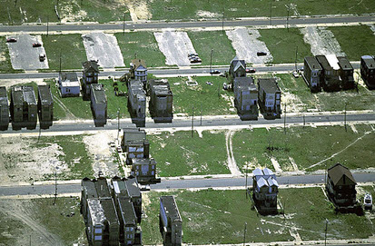

But did the Detroit Leaders learn anything?
In screwed news…The city of Detroit is in turmoil. That city is broke – and its residents are struggling to get by. And – Detroit retirees are facing steep pension cuts. So naturally – despite all this despair – a compensation committee has recommended that the members of the Detroit City Council get raises. Yup – you heard that right. As you can imagine – this move isn’t going over too well with the people of the Motor City.
– Published on YouTube, 3 Apr 2015”.
Could this happen again? Could another large city fall into bankruptcy? What about a country? Oh, wait a minute and then there was Greece. But that’s another story.
For further details, please refer to websites below:
- http://archive.freep.com/interactive/article/20130915/NEWS01/130801004/Detroit-Bankruptcy-history-1950-debt-pension-revenue
- http://www.washingtonexaminer.com/top-10-reasons-detroit-went-bankrupt/article/2533299
- https://www.youtube.com/watch?v=BeH_1_YyJqQ (The Big Picture)
- http://www.foxnews.com/us/2013/07/16/detroit-dire-but-private-groups-citizens-keep-motor-city-running/
- http://www.wsj.com/articles/SB10001424127887324263404578614290110229034
- http://archive.freep.com/article/20140221/NEWS01/302220027/city-services-and-plan-of-adjustment

Using Apps for Building Data Collection
Posted on October 6, 2017 by Sandy Muir
We have just completed the Building data collection App as I write this post. You can use this App to collect data on the buildings, rooms, assets and works for your ten year plans. Condition data can be collected based on the NAMS Property Manual.
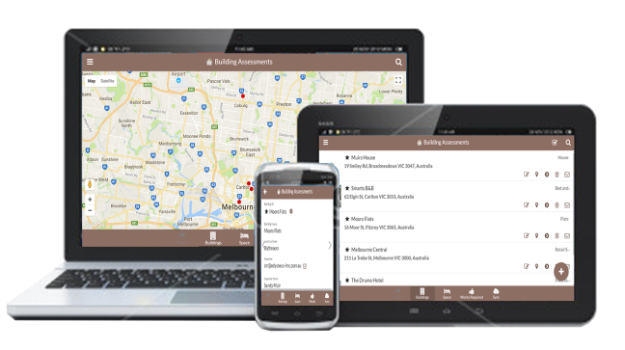
For those of you contemplating data collection for your properties then this App is for you. Take photos while collecting data and store them in the cloud. Use the dashboard as the Project Manager to monitor the contractor’s progress live. Identify issues before the project ends not after you receive the data.
For contractors tendering for projects, use the App as a differentiator from other tenderers. Give the client the comfort in knowing the data is being collected to their requirements and the quality of data is being provided. We will guide you during data collection to ensure the data quality is of a high standard.
Use your smartphones and tablets in the field and use the web browser on your desktop in the office to monitor progress. Have comfort in knowing the data can be monitored by us and is secure in the cloud.

Bridges at Risk now includes Level 2 Assessments
Posted on September 25, 2017
As part of our mobile App suite we have enhanced Bridges at Risk to include the ability to record Level 2 assessments. If your assessors are assessing the bridges on paper and potentially losing the original data, then they should be using the App to record all information in the cloud for future use by you and themselves.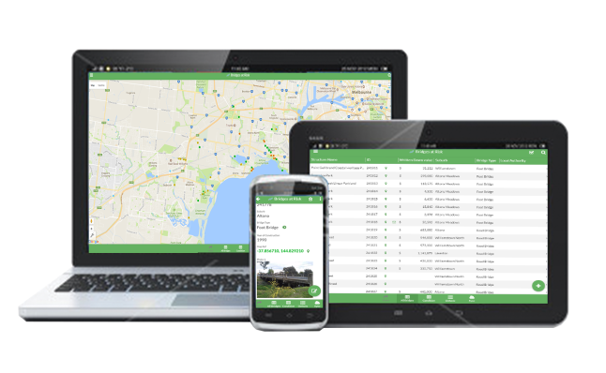

Performance Dashboards – Are they what the future holds for Asset Management?
Posted on September 18, 2017 by Sandy Muir
Approximately 15 years or so ago I watched a documentary on television about the milk industry. While it was fascinating, the one thing that caught my eye was the use of a dashboard that monitored the health of each and every cow while they were being milked. The dashboard recorded such items as quantity of milk, quality of milk, health of the individual cow e.g. body temperature, blood pressure etc. It then dawned on me that our clients should be using such tools to monitor the performance of our assets and therefore the business.
Of course in the engineering world life runs slowly and as such it has only been in recent years that I have seen a small percentage of clients using dashboards for anything at all. Recently I have seen asset management systems providing the dashboard functionality but few clients using them. It has only been in the last week where I have seen the results of one client taking the initiative and producing a near complete dashboard that their own people can use and monitor the performance of the assets.
Don’t get me wrong the client’s vision has been there for many years but a significant push in the past few years has seen the dashboard become real, functional and extremely powerful. The dashboard combines data from a number of software applications in a format that provides the user the ability to interrogate the data in a way they can drill down and seek further information.
As a simple example, imagine you are the Project Manager on a condition inspection project and have sent people out to collect the condition data for bridges.

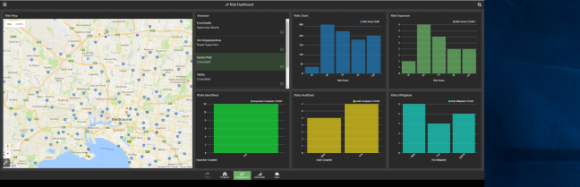Why wait the weeks or months it will take to collect the data and provide the reports before you can analyse it? Why not monitor the progress at your desk and at the same time analyse the live data as it is entered into mobile devices? Why not build the bridge strategy as the data is collected and complete the strategy not long after the data is collected?
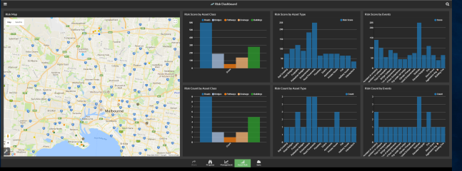
The above example is the same for any asset type where the data will take time to collect e.g. sewers, buildings, roads, drains, etc.
Odysseus-imc has built similar dashboards into its Apps so the the data can be interrogated live. If you wish to see an example or know the detail call us. We are happy to assist.

Improve Asset Management Capability through Smart Mobile Applications
Posted on August 21, 2017 by Sandy Muir
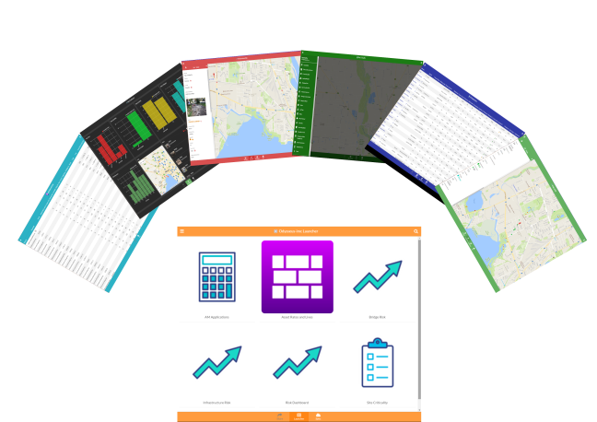
Odysseus-imc has been busy the past few months producing low cost, high quality apps to assist authorities to manage their infrastructure to a much higher standard than before. Consider this, for an up-front fee starting from AUS$1,000 per app per licence and an ongoing fee starting from $1,000 for annual maintenance per licence you can have an app on your mobile phone or tablet that operators and inspectors can use in the field to collect data, assign criticality and risk to your infrastructure. Complete with dashboards your managers or supervisors can use the power of the dashboard to view live data as the operators collect the data in the field.
Use the mobile applications to supplement your asset management systems, collect the data in the cloud , managed by Odysseus-imc and present the outcomes of the collection on dashboards. Simple to use, intinuitive and mobile and fills a huge gap in the market. Extremely simple to learn means minimal training. Most of all supported by a team of experts in Asset Management as well as other fields with total experience exceeding 100 years.
Streamlined application management means no need for you to worry about the management as we will do it for you. As apps are upgraded all you have to do is press the icon and sync the app from the cloud. That’s all there is to it.
Remember all application upgrades are free with the annual fee.
The Apps will work on Android, IOS, Windows smart phones and select web browsers making them ideal for field and desktop use.
Current applications include:
- Odysseus Launcher
Initial Cost: free with apps
Ann. Maint. Fee: $50 per licence p.a.

- Bridges at Risk
Initial Cost: $1,000 per licence
Ann. Maint. Fee: $2,000 per licence p.a.
- Infrastructure Risk & Dashboard
Initial Cost: $2,500 per licence
Ann. Maint. Fee: $2,000 per licence p.a.
- Asset Rates and Lives
Initial Cost: $2,000 per licence
Ann. Maint. Fee: $1,000 per licence p.a.
- Site Criticality
Initial Cost: $1,000 per licence
Ann. Maint. Fee: $2,000 per licence p.a.
- AM Systems Catalogue
Initial Cost: $2,000 per licence
Ann. Maint. Fee: $1,000 per licence p.a.
In the next few months, we will be introducing:
- Pathways at Risk
- Stormwater at Risk
- Buildings at Risk
If you have an idea let us build the app for you. We welcome inquiries from AM software Vendors.

