**Reflection**

Here we go, reflecting! Not always easy, but interesting to do. Just a few important points:

1. It won't go well right away, that's okay;
2. Use a specific situation that you can write down very specifically. A good situation would be where you would react like: “Yes, but I normally never act like that”, these are probably precisely the situations where you can best implement your points for improvement;
3. It is easier to reflect on a situation with 1 other person than with a group. A group would immediately makes it much more complex;
4. Also try to see the fun in this, it can be fun to be busy with yourself in addition to being stressful!

Reflection is about becoming aware of our own behavior and trying to improve on this within who we are. If we take ownership of our own behavior, this means that we want to work on it and improve it. Becoming aware of our behavior by analyzing is the next step. By means of reflection & development plans for ourselves, we can ensure that we grow in an authentic way. Growing based on who we are instead of picking up learned behavior. This also ensures that we continue to take ownership (and perhaps take more) and thus continue to grow.

On principle, any situation is good to analyze, but the best is a situation where you either felt very good afterwards OR had a feeling that something is not right. This can mean that you remained angry or just had a bad feeling, but also an “intuition” that something is not right.

You can use the following scheme for analysis. It is further explained step by step below. You can remove the explanation step by step and use this format for your own first reflection.

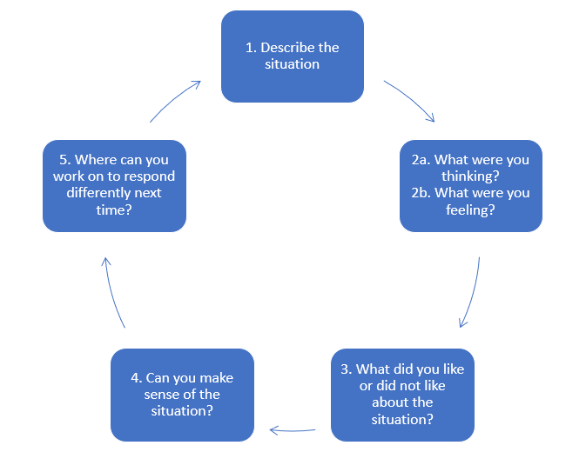

|  |
| --- |
| **Describe the situation** |
| Factually describe what happened. No interpretation yet of your own thoughts or emotions or of the behaviour of the other person. Purely what you can see from the outside based on observation. Do not try to value your own behaviour or the behaviour of the other person. |
| **What were you feeling and thinking?** |
| First try to describe your own thoughts in this situation. What were you thinking at the time. If this is difficult, try to remember as much details from the situation. Where were you, who were present, what were you doing or trying to discuss, when was it? The more details you remember will actively help you to make the memory better. We are very good at interpreting rather than remembering, so try to really focus on the moment rather than how you thought of it later.  Secondly try to focus on your own emotions. If you have difficulty with this, try to use one of the following emotions:   * Joy * Fear * Love. * Sadness. * Angry.   Other emotions can often be related to these, and they often follow each other up. For people who spend a lot of times thinking about emotions rather than feeling (They would often say during this exercise: I think I felt) it can help to close your eyes and go back to the moment. See what your body is telling you. |
| **What did you like or did not like about the situation?** |
| Describe what you liked about the situation and what you didn’t like. What felt right and what did not feel right.  Try to make it as specific as possible and try to narrow it down to a sentence that somebody said or a feeling that you got from such a remark. If you come to: He/she made me feel like X, you have not analysed it enough yet. When and why did he/she make you feel like this, and why did you react this way?  In a positive scenario with joy or love also try to find the underlying reasons why you feel like this. It can help you to find things that you enjoy in life or the type of people you should hang around with more often. |
| **Can you make sense of the situation?** |
| Can you connect what you liked or didn’t like to earlier situations in your life, to your norms & believe system or your personality type?  Can you relate it to your strengths of improvement points or perhaps to your motives & desires in life? The point here is to find where in the iceberg you are not aligned or where you find the joy in this situation. When you find this you can start working on this segment. |
| **Where can you work on to respond differently next time?** |
| This is usually the toughest part. We have found where the issue is but to work out where to work on is usually much more difficult. For example:  You get angry at a person because he/she is too late for work. One of your norms is that you show up on work on time and you have connected it to being a good competent employee for yourself. You live your live mostly based on norms & values that you uphold dearly and this person in your opinion does not. It does not mean you cannot expect the person to come on time or even that it should be upheld but getting angry probably just creates more issues for yourself then the other (funny video of an example: <https://www.youtube.com/watch?v=qlGlMRQbNik> – watch out for rough language).  Because it is an example it is difficult to go in the underlying reasons, but a usual “what to do next time” I hear in this situation is: “Next time I won’t get angry”. If this would work so easily you probably already would not have gotten angry this time.  Working on this particular issue probably requires you to develop something else then a norm & value standpoint or to work on your communication. So really try to look into your own blind spots that you have learned through your personality tests or which you understand through your norms & values.  Try to make your action as clear as possible. In this case it could be a sit down with the employee to ask him or her how she is doing first (work on empathy/heart), to set out the rules more clearly (communication) and to make a plan for yourself how you will react if it would happen again. It still might go wrong a few times but in this way you will have started the learning process. |