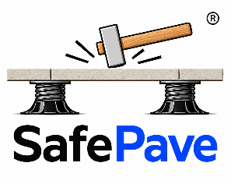

SafePave® Capability Statement

Reinforcement Systems for Raised Pedestal Flooring
Company: CBP117 Pty Ltd trading as SafePave
Brand: SafePave®
Location: Moorebank, NSW, Australia
Website: www.safepave.com.au
Email: info@safepave.com.au
Phone: 0425 288 812

Company Overview
SafePave® is a world first, Australian-developed product range created to improve the safety, strength, and reliability of raised pedestal flooring systems used on balconies, rooftops, podium decks, terraces, landscaped roof areas, and commercial pedestrian spaces.
Raised pedestal systems provide excellent drainage, service access, and installation flexibility, but they also create unique structural risks. Tiles are commonly supported only at their corners, which can lead to bending stress, underside tensile stress, cracking, impact failure, vibration, and wind uplift concerns. SafePave systems are designed to address these risks by reinforcing the underside of brittle paving materials and converting them into bonded composite assemblies.

Core Capability
SafePave designs and supplies bonded reinforcement systems for porcelain, ceramic, and natural stone pavers used in suspended or pedestal-supported flooring applications.
Our systems improve:
- Tile and paver safety
- Crack containment
- Breakthrough resistance
- Load distribution
- Point load performance
- Impact performance
- Tile stability
- Vibration and acoustic behaviour
- Wind uplift resistance when used as part of an engineered system
SafePave products are installed using a simple peel-and-bond process, with no specialist equipment required for standard applications.

Product Range

1. SafePave® Reinforcement Tape 300 — SPRT
SPRT is a fibreglass-reinforced adhesive tape designed for crack containment and safety reinforcement of brittle tiles and pavers. It uses a 300 g/m² woven fibreglass reinforcement layer with a modified acrylic pressure-sensitive adhesive system. It is less than 1mm thick meaning no change to pedestal height in an existing installation
Best suited for:
- Retrofit reinforcement of existing tiles
- Safety upgrades to existing pedestal systems
- New tile reinforcement where crack containment is required
- High-traffic areas
- Porcelain, concrete, ceramic, and natural stone surfaces
Key capability:
SPRT is primarily a safety and containment system. It helps hold cracked tiles together and reduces the risk of breakthrough, but it is not intended to replace structural backing systems such as SSS or SSS-E.

2. SafePave® Structural Support — SSS
SSS is a bonded structural backing system for raised pedestal flooring. It combines a structural GFRP backing layer with SafePave® reinforced bonding technology to improve tile stiffness, impact performance, and load distribution.
Best suited for:
- Natural stone pedestal tiles
- Large-format porcelain tiles
- Commercial pedestrian areas
- Balconies and terraces
- Podium decks
- Projects requiring increased structural capacity
Key capability:
SSS creates a rigid structural backing that distributes loads across pedestal supports, improves impact resistance, and reduces the risk of cracking or breakthrough.

3. SafePave® Structural Support Elite — SSS-E
SSS-E is SafePave’s premium engineered composite system. It combines GFRP skins, a structural PET foam core, reinforced bonding layers, and mechanical restraint integration for high-performance pedestal flooring applications.
Best suited for:
- High-rise balconies
- Rooftop decks
- Wind-exposed environments
- Premium architectural installations
- High-traffic commercial areas
- Projects requiring improved system stability
Key capability:
SSS-E provides maximum load distribution, significant reduction in tile deflection, improved impact and dynamic load resistance, enhanced structural stability, and integration with mechanical wind uplift restraint systems. It also incorporates anti-vibration with thermal and acoustic insulation.

Applications
SafePave® systems are suitable for:
- Rooftop terraces
- Balconies
- Podium decks
- Landscaped roof areas
- Commercial external floors
- High-traffic pedestrian areas
- Strata and remedial works
- Retrofit safety upgrades
- New pedestal tile installations
- Natural stone and porcelain pedestal systems
SafePave® systems are compatible with porcelain, concrete, granite, limestone, sandstone, and travertine, subject to project-specific verification.

Technical Capability
SafePave® products are developed around the principle of bonded composite action. By bonding reinforcement to the underside of the tile or paver, the tile and reinforcement work together to improve performance under bending, impact, and point loading.
SafePave systems can assist with:
- Reducing tensile stress at the underside of tiles
- Improving bending stiffness
- Distributing loads across the tile assembly
- Reducing breakthrough risk
- Containing cracked fragments
- Improving system reliability
- Maintaining pedestal system compatibility
As SafePave uses the tile itself as an integral part of the composite system, final performance will vary depending on the tile used. SafePave will provide its core benefits, including reinforcement, crack containment, load distribution, and improved safety; however, the degree of improvement will depend on factors such as tile material, thickness, size, pedestal spacing, installation quality, surface preparation, and applied load conditions.

Testing and Quality Approach
SafePave products are supported by material-level and system-level testing, including adhesion, tensile performance, crack containment, impact behaviour, and load distribution assessment. Testing is ongoing as part of product development.
The systems are designed for repeatable installation using controlled materials, pressure-sensitive adhesive systems, GFRP reinforcement, fibreglass reinforcement, microcellular foam layers, and structural composite panels.

Installation Capability
SafePave systems are designed for practical site use and scalable project deployment.
Typical process:
- Clean and prepare tile underside
- Remove release liner
- Align SafePave product to the tile
- Apply uniform pressure across the surface
- Install reinforced tile assembly onto pedestal system
No mechanical fixings, wet adhesives, or specialist trades are required for standard peel-and-bond applications.

Differentiation
SafePave is not simply a loose tray, mat, or generic panel system. It is a bonded reinforcement system specifically developed for brittle pedestal-supported tiles and pavers. The reinforcement is bonded directly to the tile underside, allowing the tile and backing to act together as a composite assembly rather than as separate components. When correctly bonded and installed, this composite action improves load distribution, increases resistance to cracking and breakthrough, and provides a more controlled failure response than loose or independent support components.
This gives SafePave a strong point of difference in applications where tile breakage, breakthrough, impact failure, and long-term pedestal system reliability are key concerns.

Warranty and Support
SafePave products are covered by a Limited Product Warranty when installed in accordance with SafePave guidelines. SPRT has a 10-year warranty, while the broader SafePave system has a 25-year warranty.
SafePave provides technical assistance, specification guidance, product selection support, and project-specific advice.

Patent Position
SafePave® is based on a patent-pending reinforcement system for tiles and pavers in suspended flooring applications. The system is focused on bonded composite reinforcement of brittle pedestal-supported tiles, full-area underside reinforcement, retrofit reinforcement capability, and integrated uplift-resistant system design where required.

Summary Statement
SafePave helps make raised pedestal flooring stronger, safer, and more reliable.
By reinforcing the underside of porcelain and natural stone tiles, SafePave improves crack containment, impact resistance, load distribution, and long-term system performance while preserving the advantages of pedestal flooring systems.


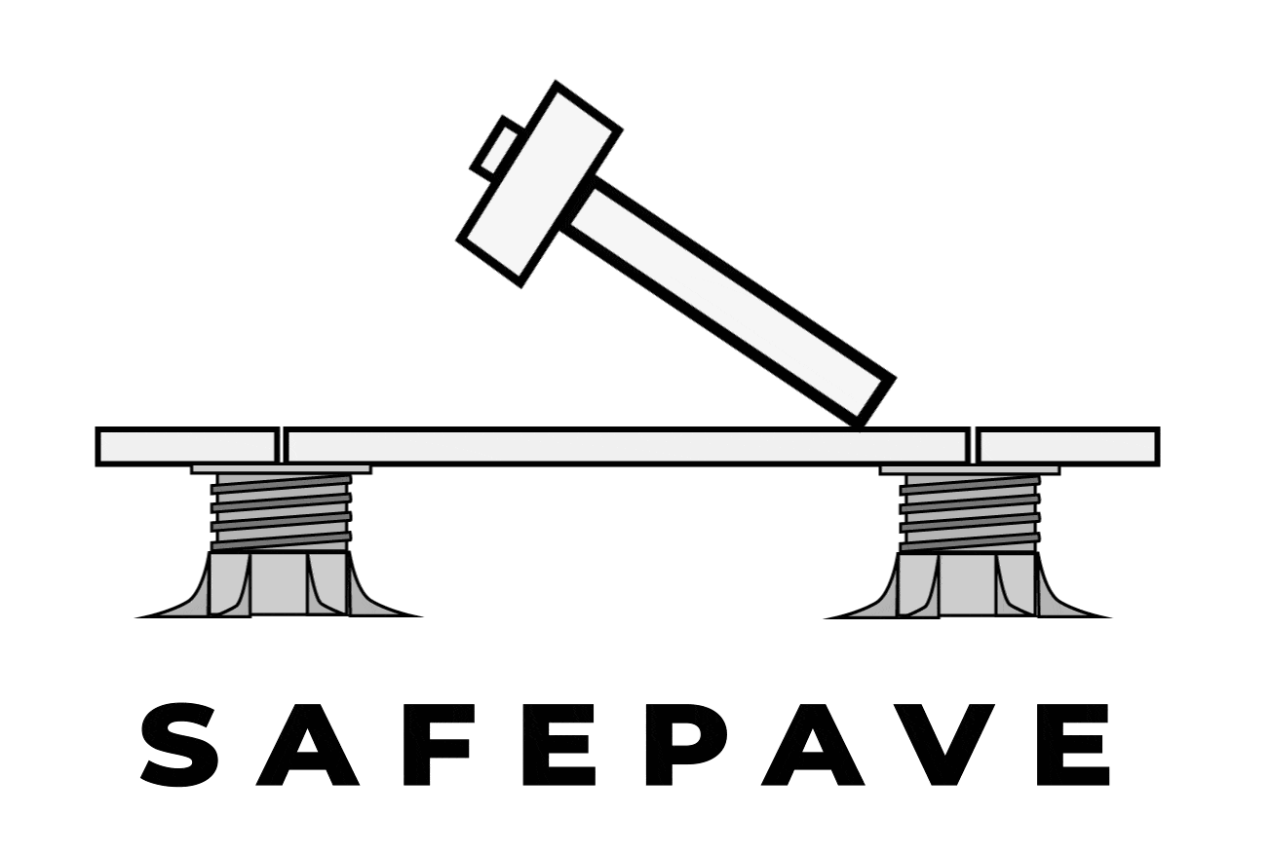
SafePave®
Safer Raised Floors
Making pedestal paving stronger, safer and more reliable.

