

Women’s Empowerment Workshop in Encinitas
Thursday July 16th 6:30-8:00PM

This workshop is facilitated by Jaclyn Deilgat, Ph.D. (Licensed Clinical Psychologist; PSY27879). Jaclyn has extensive training in depth psychology which is a unique approach to understanding the human experience. Depth psychology is where psyche and soul meet mind and body, the bridge between conscious and unconscious realms. Depth psychology also recognizes the role society, family, and the collective human experience can have on individual functioning.

“Why a Women’s Empowerment Workshop?”

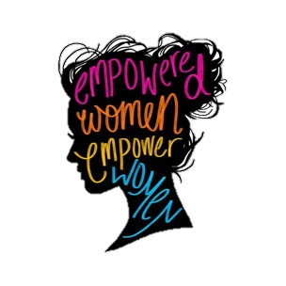
Around 14 years of age, girls’ self-esteem plummets and this trend often continues into adulthood. Unhealthy romantic relationships, body image issues, victimization, sexual harassment, corporate glass labyrinths, societal inequities, and the double-shift burden of working and providing childcare are just a few of the innumerous and complex issues women face that subtly reinforce the notion that women are inferior. Given these unique challenges women face, Jaclyn wants to help more women:

- Believe in, and advocate for, themselves
- Feel confident in speaking their truth without fear of repercussion
- Know and command their worth
- Develop skills to negotiate and effectively communicate
- Build self-esteem and self-confidence
- Make strides in prioritizing themselves

If you think you could use support in these areas, you are not alone. Now is a prime opportunity to become more self-empowered and work on that self-esteem that for many of us took a dive at 14 years old.

*Please call/text 760-688-6761 or email therapy@jddphd. com to get signed up today. Space is limited. $50 per person.

