How Does the Differing Concentration of Contact Lens Solution Affect the Refractive Index?

PHYSICS STANDARD LEVEL INTERNAL ASSESSMENT

NOV22

# **THE REFRACTIVE INDEX OF CONTACT LENS SOLUTION**

## **1. Introduction**

My sister uses contact lenses for some time now, and she says that it is the best decision she ever made. When I tried contact lenses, I hated it. My eyes felt so itchy and my vision was blurry. This experience made me a big fan of the traditional eyeglass, and I decided to prove my sister that contact lenses are not the best. In my Physics SL class, we learned about the refractive index and its effects on how we see our surroundings. A quick research leads me to the importance of a good contact lens solution, since a small amount of the solution is directly in contact with the eye[1]. Additionally, previous papers have revealed that contact lens solution has an effect on the eye sight[2]. The purpose of this paper is to examine how does the differing concentration of contact lens solution affect the refractive index.

## **2. Background Information**

Refraction refers to the direction change of light when passing from one medium to another, due to the difference in its speed. Refractive index is determined by the speed of light in a vacuum divided by the speed of light in a medium, which is given by the equation

$$n=\frac{c}{v} (Equation 1)$$

where *n* is the value for refractive index of the medium, *c* is the value for the speed of the light in vacuum, which is known to be 300 000 kilometers per second and *v* is the specific value of speed of the light in a given medium.

Willebrord Snellius discovered that the sin of the angle of the incidence to the sin of the angle of refraction is constant for the given pair of media. This relationship is known as the Snell’s Law:

$$n_{1}sinθ_{1}=n_{2}sinθ_{2} (Equation 2)$$

where n1 and n2 indicates the respective first and the second medium in which the light travels through, sinθ1 represents the angle of refraction and sinθ2 represents the angle of refraction. The constant value found refers to the refractive index of the second medium with respect to the first one.

**Figure 1.**  Illustration of the refraction of the light (drawn by me using Google Drawings Software)

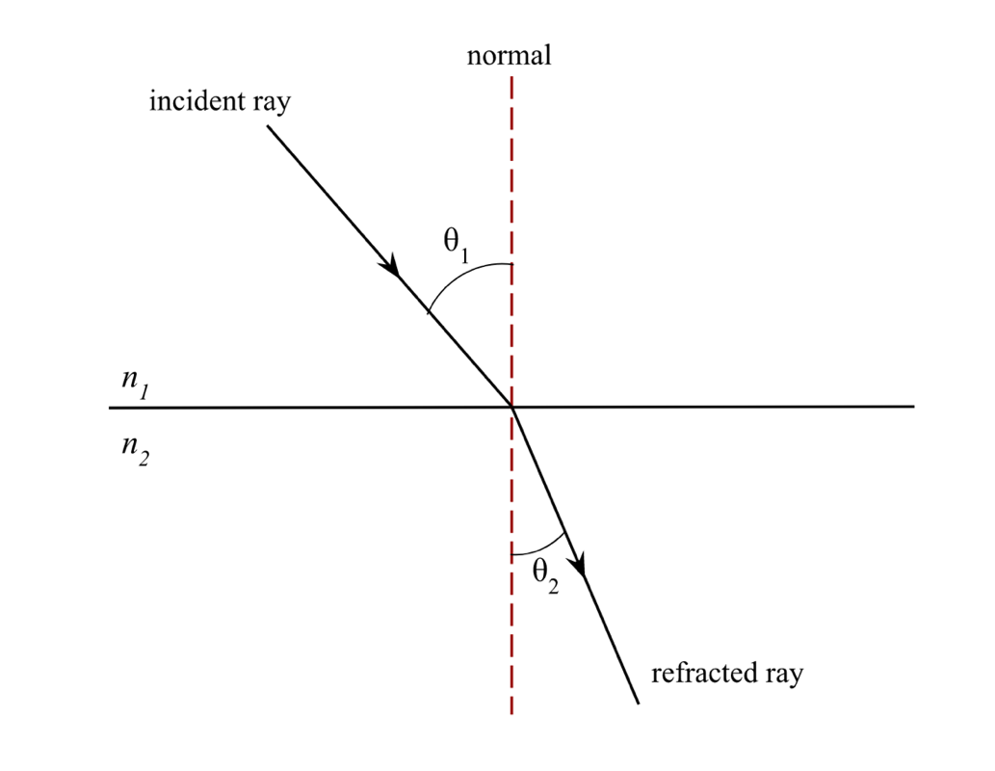

The refractive index is technically only defined for one wavelength and governed by the permittivity and permeability of a material. Pure water has an index of refraction of 1.334[3] and aqueous humor which is the liquid covering the front part of the eye, has an index of 1.336 (Patel, S. and Tutchenko, L., 2019)[4]. Thus, an ideal contact lens solution should have an index of between abovementioned values.

Further research enabled to find the common chemicals used in a usual contact lens solution, which are namely hydrogen peroxide, sodium chloride and sodium phosphates. It can be deduced that the salinity levels in contact lens solutions are high. It was known that “the refractive index increases with increasing salinity[5].” Thus, the contact lens solution is expected to have a higher refractive index than water.

**3. Research Question**

How does the differing concentration of contact lens solution affect the refractive index of the solution?

**4. Hypothesis**

Increasing the concentration of a contact lens solution (with respect to water) decreases the refraction angle and thus, increases the refractive index.

Since the solute concentration in contact lens solution is greater than distilled water (which is assumed to be zero), if the amount of contact lens solution in the experiment group increases, the light beam is expected to refract more, resulting in a smaller refraction angle.

## **5. Variables**

**Table 1.** A table showing the variables in the experiment

|  |  |  |  |
| --- | --- | --- | --- |
| **Variables - Units** | | **Impact upon the investigation** | **How the variable will be changed/ measured/controlled** |
| **Independent Variable** | Concentration of contact lens solution (mol/dm3) | Dissolving any substance in water would change the refraction angle of the laser beam, thus change the refractive index. | The volume of the contact lens solution is determined with a graduated cylinder. Sensitive pipettes are used to dilute the solution. |
| **Dependent Variable** | Refraction angle  *(θr)* [degree] | According to the Snell’s Law, the refractive index of a solution is determined by the angle of refraction. | A paper is placed on the wall and stabilized with a washi tape. Each point that the laser hit on the paper is marked with a pen. Values are obtained from the points, and angle of refraction is calculated accordingly. |
| **Controlled variables** | Temperature of the solution | A changing temperature leads to a changing refractive index[6]. | A thermometer is used before taking each reading. |
| Wavelength | A changing wavelength leads to a changing refractive index6. | The same laser pointer is used in each trial. |
| Incidence angle | According to the Snell’s Law, a changing incidence angle leads to a changing refractive index. | A plain paper is placed under the experiment set up. The exact locations of laser and glass cuvette is traced with a pencil to prevent a possible location change. |

## **6. Diagram**

**Figure 2**. A diagram showing the experiment setup (drawn by me using Google Drawings Software)

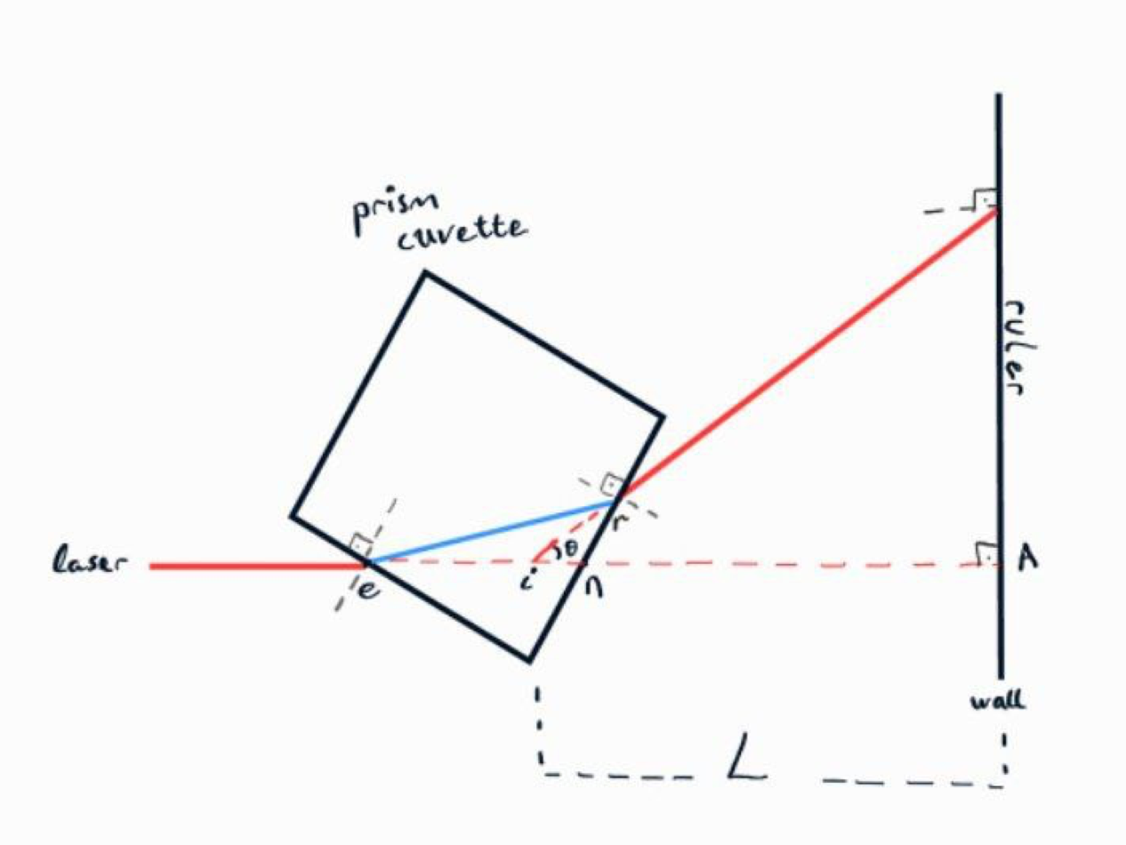

$θ_{md }$: $angle of minimum deviation$

$A : the point that the laser pass through the empty cuvette$

$e : the point that laser beam enters the prism$

$i : the point of intersection$

$L : the distance between the point of intersection and the wall$

$n : the point that laser beam normally exits the prism (in case of no refraction)$

$r :the point that refracted laser beam exits the prism$

## **7. Apparatus**

* A laser pointer
* 25 ml Contact lens solution
* 25 ml Distilled water
* 30 cm Ruler (±0.1)
* 5 ml Sterile Pipette (±0.01)
* Prism (Glass) Cuvette
* Thermometer
* A4 Plain paper
* Washi tape

**8. Preliminary Experiment**

Conducting a set of preliminary experiments is beneficial in terms of determining the scope of the actual experiment. The main purpose of the preliminary experiment was to find the distance between the laser pointer and the wall for observable results. Different trials were attempted with distances range between 30 centimeters to 2 meters. Best results were obtained with 2 m distance. After that, a method was required for processing the data.

After the exploration of different methods in the academic literature, a “novel method” developed by the scientists in the Kathmandu University (2006)[7] was adapted for this investigation. The original method includes a hand spectrophotometer to determine the angle of minimum deviation and refractive index. Since the experiment carried out in a high school laboratory, spectrophotometer is replaced with a ruler to enable the manual calculations of desired values. After these findings and arrangements, method is designed as explained below.

## **9. Method**

1. A glass cuvette is placed in front of the laser and they located 2 meters away from the wall, which is covered with a white plain paper.
2. The laser pointer and the glass cuvette are traced with a pen to ensure all the components in this experiment maintain a constant relative position and achieve consistency of the measurements.
3. To measure the angle of minimum deviation, the point on the paper which is formed by the laser pass through the empty cuvette is marked (Point A).
4. Ruler is attached on the wall using the washi tape. The point that the laser hits on the wall is matched with the 0 on the ruler.
5. The cuvette is then filled with 5 ml of distilled water at 25°C and the point where laser hits the paper against the wall is marked.
6. The cuvette is rotated until the laser beam hits the zero on the ruler.
7. The water is drained, the cuvette is filled with 5 ml of contact lens solution at 25°C and carefully placed on the paper within the traced line. The point is marked on the paper, and its distance from the Point A is recorded.
8. This measurement is recorded for each experiment group of contact lens solution with different dilutions.

**Figure 3.**  Experimental setup

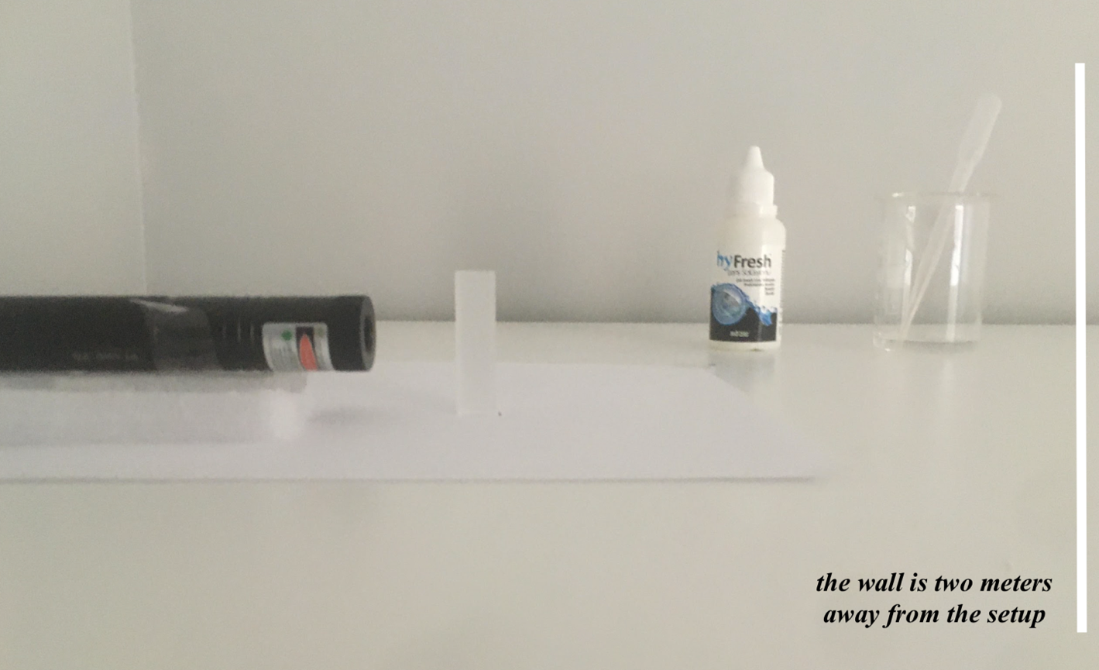

## **10. Safety Considerations**

Even laser pointers with minimum power can damage the eye. Wear protective glasses and do not expose your or someone else’s eye to the laser directly. If possible, use a Class 2 laser, which is considered as the safest laser type to use[8].

**11. Raw Data**

|  |  |  |  |  |  |  |
| --- | --- | --- | --- | --- | --- | --- |
| **Table 2.** The measured lenght between the point where light beam hits the wall and the Point A | | | | | | |
| **Solution** | **Concentration (mol/dm3)** | **Length from the Point A (*mm*) $$∓ 0.05 mm$$** | | | | |
| **Trial 1** | **Trial 2** | **Trial 3** | **Trial 4** | **Trial 5** |
| **1** | 20% | 3.6 | 3.6 | 3.5 | 3.6 | 3.6 |
| **2** | 40% | 3.8 | 3.7 | 3.7 | 3.8 | 3.8 |
| **3** | 60% | 3.9 | 4.0 | 3.9 | 4.6* | 3.9 |
| **4** | 80% | 4.3 | 4.2 | 4.2 | 4.3 | 4.2 |
| **5** | 100% | 4.5 | 4.6 | 4.6 | 4.6 | 4.5 |

|  |  |  |  |  |  |  |
| --- | --- | --- | --- | --- | --- | --- |
| **Table 3.** The distance between the the intersection of incident ray and emergent ray and the wall | | | | | | |
| **Solution** | **Concentration (mol/dm3)** | **Distance from the intersection point to the wall (mm) $$∓ 0.5 mm$$** | | | | |
| **Trial 1** | **Trial 2** | **Trial 3** | **Trial 4** | **Trial 5** |
| **1** | 20% | 1780 | 1780 | 1790 | 1760 | 1790 |
| **2** | 40% | 1830 | 1820 | 1850 | 1850 | 1840 |
| **3** | 60% | 1880 | 1890 | 1870 | 1890 | 1890 |
| **4** | 80% | 1940 | 1930 | 1950 | 1960 | 1940 |
| **5** | 100% | 1990 | 1980 | 2000 | 1980 | 1990 |

**12. Calculations**

In order to calculate the refraction index, it is required to find the angle of minimum deviation for each trial. The points labelled in *Figure 2* define the angle of minimum deviation. As suggested by Zhang and Luo (2020), when *the length from the Point A* in which the laser beam hits the wall is divided by the length *L*, the answer would be the tangent of the $θ_{md }.$ Thus, the formula can be written as following:

$$\tan^{-1}\left(\frac{the length from the Point A}{the length from intersection point to the wall (L)}\right)$$

$$Equation 3$$

## Since the light waves passes through two different mediums, Snell’s Law (Equation 1) should be applied twice to find the index. Since the prism cuvette is equilateral, trigonometric identities can be used to calculate the refractive index of a given solution.

$$Refractive Index of the Solution=Refractive Index of Air x\frac{sin[0.5(θ_{md}+ θ_{apex })]}{sin(0.5 x{ θ}_{p })}$$

The angle between the sides of the prism is called apex angle. The cuvette used in the experiment is square- based, thus the angle of apex is 90°.

* Substituting the apex angle and refractive index of air ($n=1.00028$)
$$n_{solution}= 1.00028 × \frac{sin[0.5(θ_{md}+90°)]}{0.5}$$

* Carrying out simplification for obtaining the final equation

$$n_{solution} = 2.00056 ×\sin\left[0.5\left(θ_{md}+ 90°\right)\right]$$

$$Equation 4$$

### Sample Calculations

The refractive index of solution 1, which consists of 20% contact solution and 80% of distilled water, is calculated as an example. This sample calculation not only portrays an example on how to apply the formula, but also enables to check the accuracy of the experimental setup. Since the majority of the solution is distilled water, value is expected to be close to 1.334 which is the refractive index of water.

* Employing *Equation 3* to find the angle of minimum deviation for distilled water:
$$\tan^{-1}\left(\frac{ average length from the Point A}{average distance L}\right)= \frac{2.98 mm}{1738 mm}=0.0993°$$

* Substituting $θ_{md}=22.47°$ in the *Equation 4*

$$n_{distilled water }= 2.00056 ×\sin\left[0.5\left(9.93°+ 90°\right)\right]= 1.416$$

The refractive index of 20% contact lens solution is $1.416$, which yields a numerical difference of 0.082 when the refractive index of water is subtracted from it. Apparently, refractive index is close to but different (due to the solute concentration) that of water’s refractive index.

Calculating Uncertainties

Uncertainties of solutions can be calculated by the following equation:

$$\frac{∆c}{c}= \frac{∆m}{m}+ \frac{∆v}{v}$$

where *m* is the amount of contact lens solution and *v* is the total volume when distilled water is added. The uncertainty of the concentration of *solution 1*, which consists of 20% contact solution and 80% of distilled water, is calculated as a sample calculation below.

$$\frac{∆c}{c}= \frac{0.1}{20}+ \frac{0.01}{5}$$

$$∆c=0.07\%$$

## **13. Processed Data**

|  |  |  |  |  |  |
| --- | --- | --- | --- | --- | --- |
| **Table 4.** Average lenght from Point A and the distance L, calculated Angle of Minimum Deviation and Refractive Index values | | | | | |
| **Solution** | **Concentration**  **(mol/dm3)** | **Average Length from the Point A $$(∓ 0.05 mm)$$** | **Average Distance L $(∓ 0.05 mm)$** | **Angle of Minimum Deviation**  **(degree)** | **Index of Refraction** |
| **1** | 20% | 2.980 | 173.8 | 0.0993 | 1.416 |
| **2** | 40% | 3.580 | 178.0 | 0.1152 | 1.420 |
| **3** | 60% | 3.760 | 183.8 | 0.1172 | 1.427 |
| **4** | 80% | 3.930 | 188.4 | 0.1195 | 1.431 |
| **5** | 100% | 4.240 | 194.4 | 0.1249 | 1.440 |

## **14. Graph**

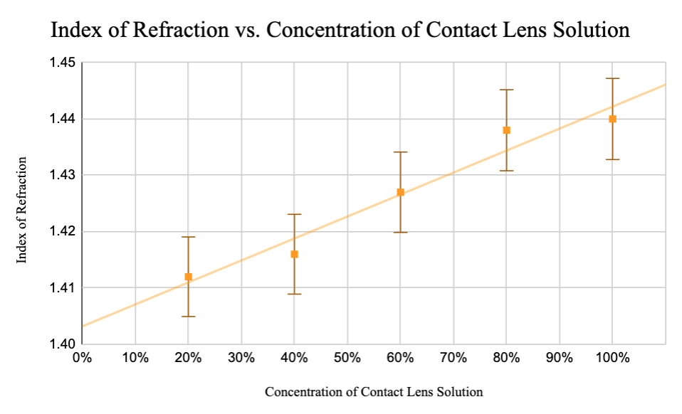

## **15. Observations**

When assessed qualitatively, it was observed that the laser beam bends more with increasing concentration, which increases the distance between the point where the refracted laser beam hits the wall and Point A. The nature of this experiment does not require any major observation. One minor addition to note might be that the apparatus is susceptible to any changes in terms of their position. Any small disposition can drastically affect the refraction angle. This is further discussed in the analysis section.

## **16. Analysis**

## The best fit line on the Graph 1 indicates a positive correlation between the contact lens solution concentration and the index of refraction. A small difference is apparent in successive data points, as the refractive index differs only a few decimal places. The y-intercept of the line is interpreted as the refractive index of the 0% concentration (pure solvent). The value of the y-intercept is between 1.400 and 1.405, which is close but different than the refractive index of water. This can be explained by the interference of the refractive index of the prism cuvette. Since this interference is constant in all measurements, it does not significantly affect the results.

The points on the graph scatter around the best fit line equally and with a small deviation. Two points are below the line and two points are above the best fit line. One point, which is the median value is exactly on the best fit line as expected, since the contact lens solution and distilled water are almost equal in solution 3 (with a slightly higher amount of contact lens solution). This implies that the results of this investigation are graphically significant and thus, reliable.

However, there is one anomaly in the obtained data. As seen in the *Table 2.* The reading of trial 4 (which is 4.6 mm) disrupts thepattern, as all other values are around 4 mm. This caused by a slight change in the location of the prism, which changed the incident angle and thus, refraction angle. At the beginning of the experiment, the base of the prism was traced with a pen on the plain paper. This made it possible to return the prism to its original location. Eventually, human error is reduced and more trials are carried out. The extremum value was not included in the calculations to prevent a possible misleading of the results.

## **17. Conclusion**

The investigation has allowed to conduct an experiment to answer the question of “how does the different concentrations of contact lens solution affect the refractive index?” In this study, it was assumed that increasing the concentration of a contact lens solution decreases the refraction angle due to its high solute concentration and thus, increases the refractive index. The hypothesis is supported by the results of the experiment and small uncertainty. In addition to this, only one major outlier was observed as there were minor changes in the position of the apparatus, which was corrected to reduce the human error.

**18. Evaluation and Improvements**

The experiment designed for this investigation requires high precision as the refractive index differ slightly. Despite the apparatus was chosen according to the smallest uncertainty possible, more accurate results were still obtainable. Limitations of this experiment and possible improvements are stated in *Table 5* below.

**Table 5**. Limitaions and Possible Improvements

|  |  |
| --- | --- |
| **Limitations** | **Improvements** |
| The solution may not have been distributed evenly throughout the distilled water. This would change the angle of refraction. | Shake the prism slightly to keep the solution at maximum homogeneity. |
| Even though the temperature of the solution was checked before each trial, there might be some changes until the readings were taken. | The experiment can be carried out in an insulated tank. This would reduce the possible systematic error caused by temperature change. |
| The uncertainty for the ruler (∓ 0.001 m) was not enough to precisely measure the length from Point A. | A digital measuring tool can be used for more precision. |
| Other light sources may affect the readings on the ruler and may cause random error. | Carry out the experiment in a dark environment. |
| There are some anomalies in the data,  getting a more accurate result is needed. | Carry out the experiment with 10 repeats |

## **19. References**

* "Refractive Index Of H2O (Water) - Daimon-21.5C".Refractiveindex.Info, 2022, <https://refractiveindex.info/?shelf=main&book=H2O&page=Daimon-21.5C>. Accessed 5 Jan 2022.
* "Seawater - Optical Properties". Encyclopedia Britannica, 2022, <https://www.britannica.com/science/seawater/Optical-properties>. Accessed 5 Jan 2022.
* “Contact Lens Care Systems & Solutions.” Centers for Disease Control and Prevention. 10 Aug. 2021, Accessed from: <https://www.cdc.gov/contactlenses/care-systems.html>.
* Belay, Abebe and Gonfa Tesfaye Assefa. “Concentration, Wavelength and Temperature Dependent Refractive Index of Sugar Solutions and Methods of Determination Contents of Sugar in Soft Drink Beverages using Laser Lights.” Journal of Lasers, Optics & Photonics 05 (2018): 1-5.
* Patel, Sudi, and Larysa Tutchenko. "The Refractive Index Of The Human Cornea: A Review". Contact Lens And Anterior Eye, vol 42, no. 5, 2019, pp. 575-580. Elsevier BV, doi:10.1016/j.clae.2019.04.018. Accessed 7 Oct 2021.
* Smalley, Penny J. "Laser Safety: Rısks, Hazards, And Control Measures". Laser Therapy, vol 20, no. 2, 2011, pp. 95-106. International Phototherapy Association, doi:10.5978/islsm.20.95. Accessed 20 Oct 2021
* Subedi, Deepak. (2006). Study of temperature and concentration dependence of refractive index of liquids using a novel technique. Kathmandu Unıversıty Journal of Scıence, Engıneerıng and Technology. Vol.Iı. 1-7.
* Zhang, Qiuzhang, and Tianshu Luo. "The Influence Of Absorption On The Refractive Index Determination By The Minimum Deviation Method". *Optik*, vol 223, 2020, p. 165439. *Elsevier*, doi:10.1016/j.ijleo.2020.165439. Accessed 5 Oct 2021

1. “Contact Lens Care Systems & Solutions.” Centers for Disease Control and Prevention. 10 Aug. 2021, Accessed from: <https://www.cdc.gov/contactlenses/care-systems.html>.
2. Pearson, Richard M. "The Refractive Index Of Contact Lens Saline Solutions". Contact Lens And Anterior Eye, vol 36, no. 3, 2013, pp. 136-139. Elsevier BV, doi:10.1016/j.clae.2012.12.004. Accessed 4 Oct 2021.
3. "Refractive Index Of H2O, D2O (Water, Heavy Water, Ice) - Daimon-21.5C". Refractiveindex.Info, 2022, https://refractiveindex.info/?shelf=main&book=H2O&page=Daimon-21.5C. Accessed 5 Jan 2022.
4. Patel, Sudi, and Larysa Tutchenko. "The Refractive Index Of The Human Cornea: A Review". Contact Lens And Anterior Eye, vol 42, no. 5, 2019, pp. 575-580. Elsevier BV, doi:10.1016/j.clae.2019.04.018. Accessed 7 Oct 2021.
5. "Seawater - Optical Properties". Encyclopedia Britannica, 2022, <https://www.britannica.com/science/seawater/Optical-properties> . Accessed 5 Jan 2022.
6. Belay, Abebe and Gonfa Tesfaye Assefa. “Concentration, Wavelength and Temperature Dependent Refractive Index of Sugar Solutions and Methods of Determination Contents of Sugar in Soft Drink Beverages using Laser Lights.” Journal of Lasers, Optics & Photonics 05 (2018): 1-5.
7. Subedi, Deepak. (2006). Study of temperature and concentration dependence of refractive index of liquids using a novel technique. KATHMANDU UNIVERSITY JOURNAL OF SCIENCE, ENGINEERING AND TECHNOLOGY. VOL.II. 1-7.
8. Smalley, Penny J. "Laser Safety: Rısks, Hazards, And Control Measures". Laser Therapy, vol 20, no. 2, 2011, pp. 95-106. International Phototherapy Association, doi:10.5978/islsm.20.95. Accessed 20 Oct 2021.