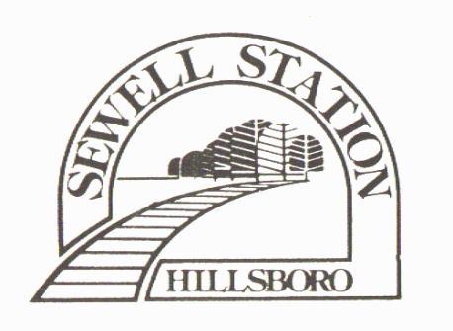May 1, 2025

In October of 2024, PGE and Asplund Tree Service accessed the RV Center for routine maintenance. Both of these vendors reported back to the City of Hillsboro that the SSHOA RV Center was in “deplorable condition”. This reporting stimulated a series of events that involved a threat of fines from the city of Hillsboro for having a “junk yard without a permit” within the city limits of Hillsboro with numerous toxic and biohazard violations. The SSHOA Board has been working diligently with the City of Hillsboro to clean up the RV Center in order to avoid any fines and/or repercussions from the City of Hillsboro and Washington County Health Department. Since October of 2024, several volunteers have completed the following:

1. Removed 10 large bags of garbage and aerosol cans.
2. Removed 49 tires.
3. Removed 4 propane tanks.
4. Removed 2 gas cans and 2 large buckets of oil/oil products.
5. Removed several large metal items laying on the ground.
6. Removed 1 old, dry fire extinguisher.

The SSHOA Board is happy to announce that Brian Hylland will be taking over as the new RV Center Manager starting immediately. The SSHOA Board is updating and requiring the vehicle RV & Long-Term Parking Registration Form to be used by all RV Center users by June 30th, 2025 (Please see enclosed Form). Vehicles not represented on RV Registration forms will be towed starting August 15th, 2025. Vehicles that do not have paid in full RV parking fees within 45 days of billing June 30th, 2025 will be towed starting August 15th, 2025.

As you can see the RV Center user fee will be increasing. This money will go directly back into the RV Center maintenance. The first task will be to remove all the vehicles, clean the lot and then carry out further enhancements. As vehicles are allowed back in to the RV Center, spaces will be assigned. After vehicles are allowed to return to the RV Center Parking, RV Center users using someone else’s assigned space, not following all the rules, blocking others from using their assigned spaces and/or blocking the PGE power pole will be towed by Hillsboro Towing within 72 hours of placement of a Private Party Impound Tow Authorization Form.

On May 17th, Private Party Impound Tow Authorization Forms obtained from Hillsboro Towing will be placed on all vehicles within the RV Center. The Private Party Impound Tow Authorization Forms will be removed on an individual basis by a SSHOA Board Member only after the RV & Long-Term Parking Registration Form has been successfully completed by each user, returned to Brian Hylland and past due parking fees have been paid in full. Any vehicle that is not identified and registered by the owner and/or back RV Parking fees are not paid in full, will be towed by Hillsboro Towing per ordinances, ORS 98.830, ORS 98.810 and/or ORS 98.812 starting August 15th, 2025.

Thank you for your time and immediate attention to this serious matter,

Tammy LaBeck- SSHOA Secretary / Treasurer