- In this Issue  July August 2025  Community Life Support- 2025  . Board of Directors and Officers: David Smith, Tanya Lipinski, Debra Barton, Dawn Knauss, Deanna Rohloff  President- Lynne Hardy  Vice-President Elizabeth Baker  Secretary- Heather Fronckowiak  Finance Secretary- Sharon Kosowsky  Business Manager- Sue Pritt  Treasurer- Ted Wright  Christmas Around the Corner- November 15, 2025- 10- 2 pm Hoosic Valley Hish School Gym.  The Schaghticoke Food Pantry : How will the changes in funding effect our pantry and our ability to serve our communities?  Greater Hoosic Valley Community Business Alliance: directory work  Community Center Initiative: Survey work continues. See stats so far.  Community Health and Wellness-  - Email: clsteam12154@gmail.com  - Email: ebaker50@yahoo.com;  - lenhardyny@gmail.com  - Website: clsschaghticoke.com  - ghvcba.com  - Facebook: Schaghticoke Food Pantry, Community Life Support,  - Greater Hoosic Valley Community Business Alliance.  Get Involved! Your support is crucial to our mission. Here’s how you can help:  • Donate: Every contribution, big or small, makes a difference. Visit this link on Give Butter for CLS support: https://givebutter.com/b1XrKv to give.  • Spread the Word: Share our mission with friends and family. Follow us on social media:  • Facebook: Community Life Support; Website: CLSSchaghticoke.com  Thank You! We are grateful for your support and commitment to making our community a better place. Together, we can achieve great things! For more information, visit our website at CLSSchaghticoke.com or contact us at lenhardyny@gmail.com | Community Life Support Inc. 2019  Mission Statement:  - Community Life Support, Inc.’s mission is to provide multiple approaches in the communities it serves to encourage healthy lifestyles through education, services, and opportunities. Community Life Support, Inc.’s desires to build community capacity through volunteer opportunities, activities, events, and services. Together, we are making a difference in the villages and towns of Schaghticoke, Pittstown and around the northern Rensselaer and Washington County. Community Life and all its branches are hosted at the Presbyterian Church. Contact Liz Baker 518- 461-2155 for further info or to help, speak with anyone on the Board of Directors or to volunteer for any of our programs or the Food Pantry.  Have an idea you would like to see- use this survey to let us know what you are looking for: Some current being considered:  1. Investment club- learn about stocks/investing.  - Cooking Clubs/Baking Club/Bread Club  - Club that teaches about the difference between government and politics.  - how to tell truth from fake news.  - class on Writing a book.  - Variety of genres for a Book Club  - Making your own mixed soup, brownie mixes-  https://docs.google.com/forms/d/1REja7FlmDbr53PVymXU1MUkyBsYlv9EnNmZubXLgH4s/edit#responses  A Brief History: CLS evolved from a ‘community builders’ group’ in 2017- 18. It began with 4 people and expanding as our mission to provide opportunities to bring the community together grew. In 2019 it became Community Life Support Inc. Our logo is a tree with multiple branches to represent the many branches of our work: The Schaghticoke Food Pantry, Health and Wellness, Community Center Initiative and the Greater Hoosic Valley community Business Alliance.  Our annual meeting August 13, 2025 at 6:30 pm is upon us. It is a meeting open to the public. We will elect board members and officers, meet new board members, review our past year, review our budget and our goals for 2026 will be discussed and formatted. Team leaders please provide your reports to Lynne by August 1 for our book. Please be on time and prepared to discuss. Minutes and agenda with the annual report will be provided by email prior to the meeting.  In Our Spotlight: Strawberry Festival June 14, 2025 at the Schaghticoke Fairgrounds. We want to share about the Success of the Strawberry Festival. Liz Baker and her team outdid themselves with 140 vendors and children’s activities. Parking was well done and controlled. Food vendors were great. Weather held out and a good time was had by all.  The Schaghticoke Food Pantry: The Food Pantry is open every Monday 9- 11 am (except for any holiday or snow school day is closed); Thursday 4-6 pm.  Food Pantry Team meets on odd months on the 2nd Wednesday of the month in the dining room of Presbyterian Church. September 10, 2025 at 6:30 pm. We will begin our holiday planning for baskets for Thanksgiving and Christmas. Food Pantry Team Meeting volunteers gather to hear reports, share issues, ideas, and concerns.- open to all.  In early June our freezer in the pantry died. Service was impossible as the part we needed was unobtainable. A decision was made to purchase a new freezer – it arrived on July 14 and is in the pantry. Thanks to all who had a hand in getting it to where it needed to be in a fine fashion. Special Thanks to Tim and Mike and the crew who supplied the coordination and all for the successful orchestration.  We continue to explore the trialing of a community shoppers program- monthly shoppers who purchase items for the pantry- dish soap, snack food. You may sign up for an item for the month. We would reimburse you for your purchases and we will pay you $5.00 for the effort.  Items that are often needed by the pantry and not always available from The Regional Pantry who supplies us:  Dish Detergent, laundry detergent, personal care items like deodorant, shower soap, toilet paper, paper towels, healthy snacks, coffee, cleaning supplies, feminine supplies, bread, rolls for hot dogs and or burgers.  We place our order monthly in the last week of the month and the delivery comes usually the first Friday of the month. There is a limited list of items which are available to order from. We pay for anything we order- of course at a reduced cost- but that cost is going to go up. Currently we can still get frozen hamburg, some chicken, fish sticks, occasionally hotdogs and pork, frozen sandwich meat, butter, cheese, juices, canned veggies and fruits, condiments when available, and boxed sides, cereal, pancake mix and soup.  We luckily have a vendor who supplies us with pet food on a monthly basis, and we have supporters who donate eggs to us on a regular basis. We had been working with Valley Falls and The Hoosic Valley school to have a share of veggies from their gardens- but as of now we are not able to supply volunteers for the community garden, and it is unclear if the school will host a garden. We do have several local farmers who bring use their veggies to share with the clients of the pantry- and we are ever grateful for their support. Any thoughts or questions or if you want to set up a tour please contact us @ ebaker50@yahoo.com.  The Food Pantry welcomes all who would like to volunteer their time. Reach out to Liz Baker for further info and to schedule a visit to the pantry to see if you are a good fit for what we do. Want to volunteer for a program, we would love to hear about it. Liz Baker or lenhardyny@gmail.com are your resource and contacts.  Volunteer Opportunities in Our Community: Volunteer Need: We have learned from some folks of the community have a need for transportation for health and business appointments. We are not on the Flex Route yet- though I keep asking and poking for it- but if there are any folks with some free time and a willingness to help, please let me know- at 207-319-5307 and I will help to coordinate the needs. Thank you.  Health and Wellness currently coordinates 4 classes that are open to the community-  Walking Group: Monday 11- 12  Yoga with Kelsey Richards - Monday Evenings- on these dates: 7/14,7/28, 8/11, 8/25. – pay instructor  Yoga With Sharon Gavitt - Wednesday 10- 11 am- No classes for the Summer and possibly resume in September.  Living with Cancer Support Group with Ted Wright- 3rd Monday of month calls 240-595-4511 to contact.  GHV CBA- our business alliance designed to gather all our cottage industries and service businesses together to support local small businesses through a membership that benefits them with advertising and advocacy and education. Information can be found at GHV.CBA.com. We are also listed as part of clsschaghticoke.com as well as our Facebook page. We are hoping the local businesses will participate and reap the benefits of an alliance in our area of Rensselaer County.  Introducing our newest service: GHV-CBA Business Directory 2025  The directory will include contact information and a brief description. It will be available digitally via a scannable QR code or active link on CLS and community websites.  Printed Directories will be available locally at libraries, schools, Post Offices, and member businesses. Please consider joining us in strengthening our business community.  We acknowledge and thank our early adopters and committee members. If you would like to become more involved in the Community Business Alliance Initiative, please do not hesitate to contact any of our Committee Members.  Elizabeth Baker Debra Barton Alisha Chase Viola Peggy Gray Paul Strasser Dawn Knaus Tanya Lipinski Lynne Hardy  How to get listed in the GHVCBA Directory  Your Next Steps:  Listing  Each listing may include a business name, website, phone  number, and description (up to 3 lines/150 characters).  Pricing- Annual subscription - $50  • Prorated subscriptions available- $5/month- Not to exceed annual rate ($50)  Distribution- Completed registration and appropriate paid subscription fee is needed to be included in the printed directory. Distribution will be available online by link once completed. We can always amend the online version so don’t hesitate to register.  Notice • CLS GHVCBA reserves the right to refuse or reject any entry at any time.  Options for Payment and Registration  Payable at Give Butter Registration: https://givebutter.com/tQYPIq  Or scan the code to join the Greater Hoosic Valley Community Business Alliance    To be included in the Business Directory, complete the registration form by clicking the link below.  https://docs.google.com/forms/d/e/1FAIpQLSd_Detb0EZ5L3QI_U3S3FECMqvJ1h9RCGdNYeLyCl1ADyeWnw/viewform?usp=header  Community Center Initiative est. 2024- the team meets at the Hoosic Valley High School – next meeting will be in early September after the survey is completed. CCI is a grass roots group from the northern Rensselaer County with the central focus on preparing for the future of the Schaghticoke area. We are currently in the survey phase and meeting to discuss the data we are getting and then move to the next steps. A survey for the community can be found at the link below. Surveys are distributed through Parents Space and to high school students 7- 12th grade through their social studies class. We want every voice to be heard. Besides the survey work CCI is interested in seeking land, support, and acknowledgment.  https://docs.google.com/forms/d/e/1FAIpQLScryNX66jRhFOM3IzynmPPoVLtHDLUneyChupfLvIouhQArug/viewform  Currently we have 112 responses and the overall opinion:  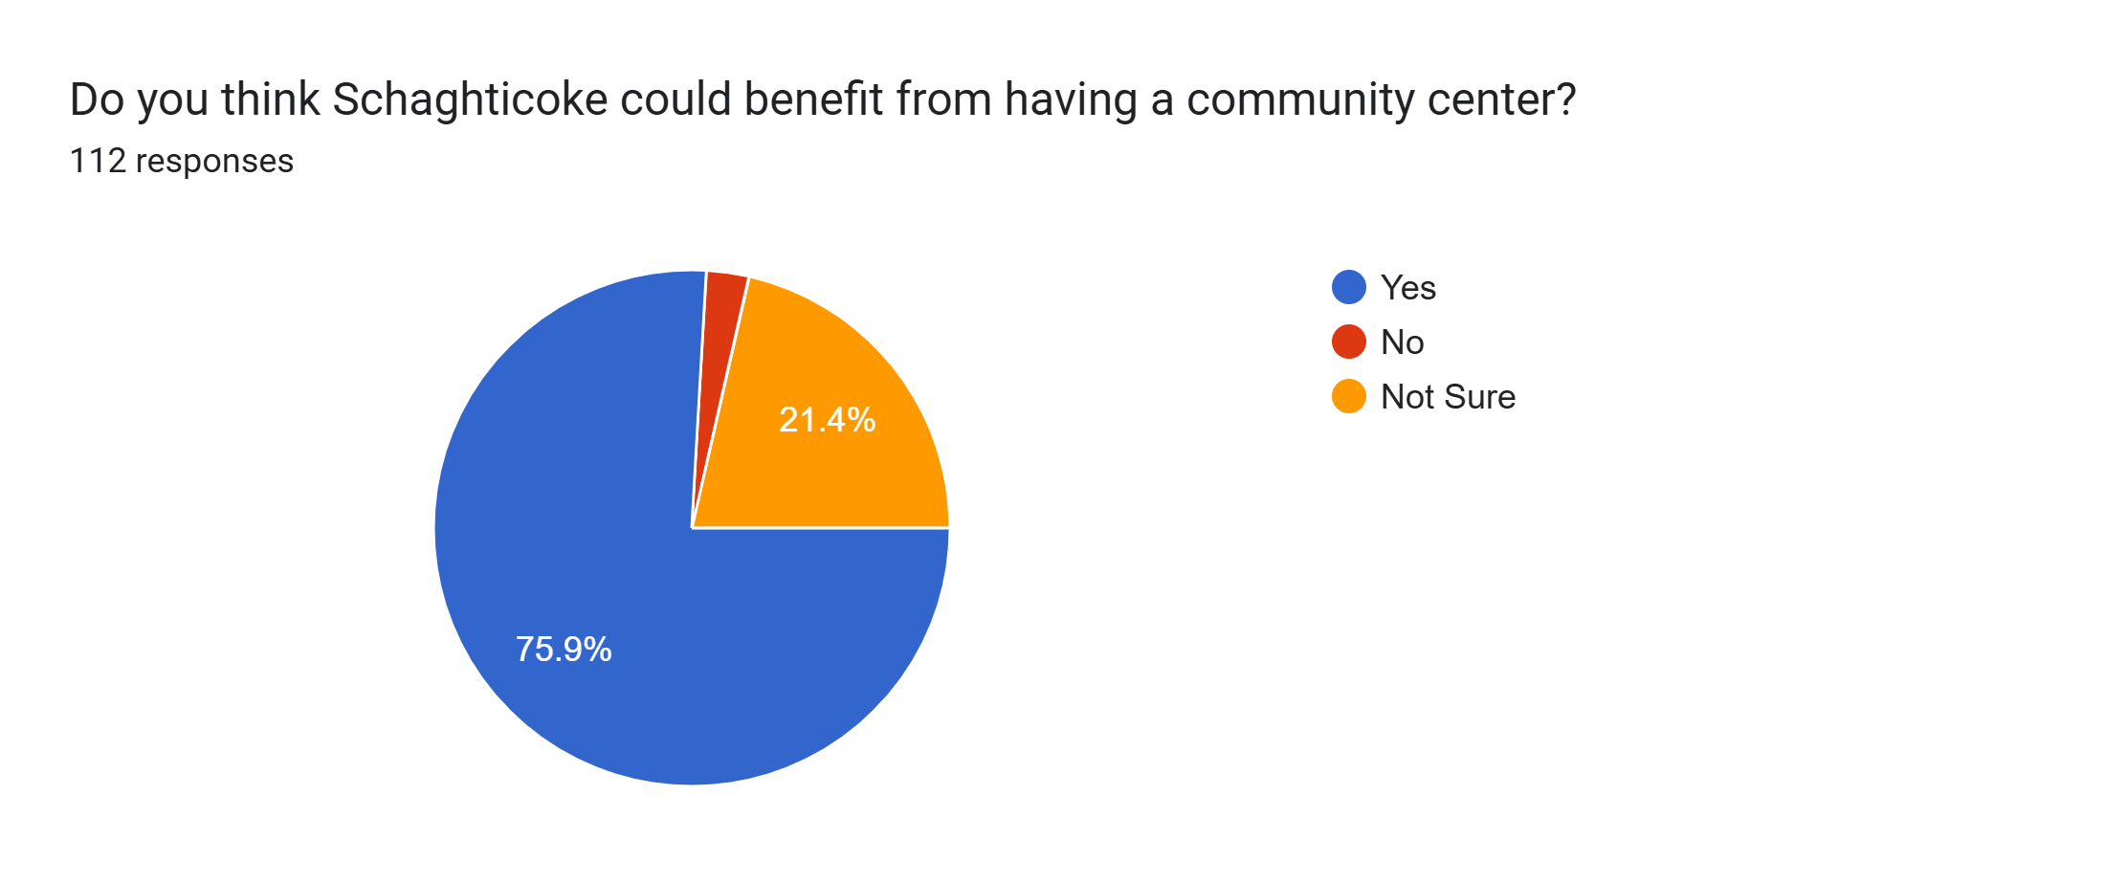  .  Upcoming Community Events and Opportunities:  We endeavor to support all groups and activities in and around our communities. Please feel free to send information of upcoming events to lenhardyny@gmail.com  Before the first of each month and they will be included in the newsletter.  Diver Library and Valley Falls Library are always very active in the summer- they have initiated a joint calendar of events that can be found: Valley Falls Library/ Diver Library Joint Community Calendar: valleyfallslibrary.org  Victor Lodge summer season is in full swing- with breakfasts and BBQ’s. Come out and enjoy community and support a worthwhile organization of men doing good for this and other communities. Check out their new electric sign.  Victor Lodge Chicken BBQ’s have resumed- and drive through event by registration only Second Saturday of the month- 4-6 pm. Wednesday is the last day to reserve your ticket. Call- 518-368-7228- or email Donnie Barton at donniebjv@aol.com-  Board members are available to come and share our work with your group. Please call on us especially if you are interested in small business support and or the concept of a community center in the future of the Greater Hoosic Valley area.  Interested in serving as a board member- we have several seats available and would love to have you join us. You can do this by contacting Liz Baker at 518-461-2155 or Lynne Hardy at 207-319-5307. Board members serve on teams that are geared to their skills and interests. We have 6 active teams: Events, Health and Wellness, Food Pantry, Community Center Initiative, Communications and Finances and Fundraising. Come share a bit of your time and talent with us- you will be glad you did and we will be eternally grateful as well as overjoyed to share our experiences with you.  Warm regards,  The Board of Community Life Support of Schaghticoke, NY 2019 Inc  Lynne Hardy, president; 207-319-5307; lenhardyny@gmail.com

