Fern Flower – Nature School will be closed on _____ due Truth and Reconciliation Day.

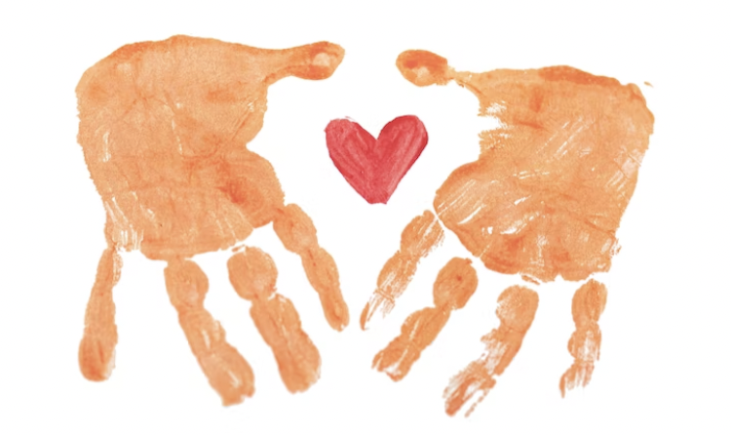

Listen.

Reflect.

Reconcile.