Fern Flower – Nature School will be closed from _____ to ______ due Summer Closure and Labor Day.

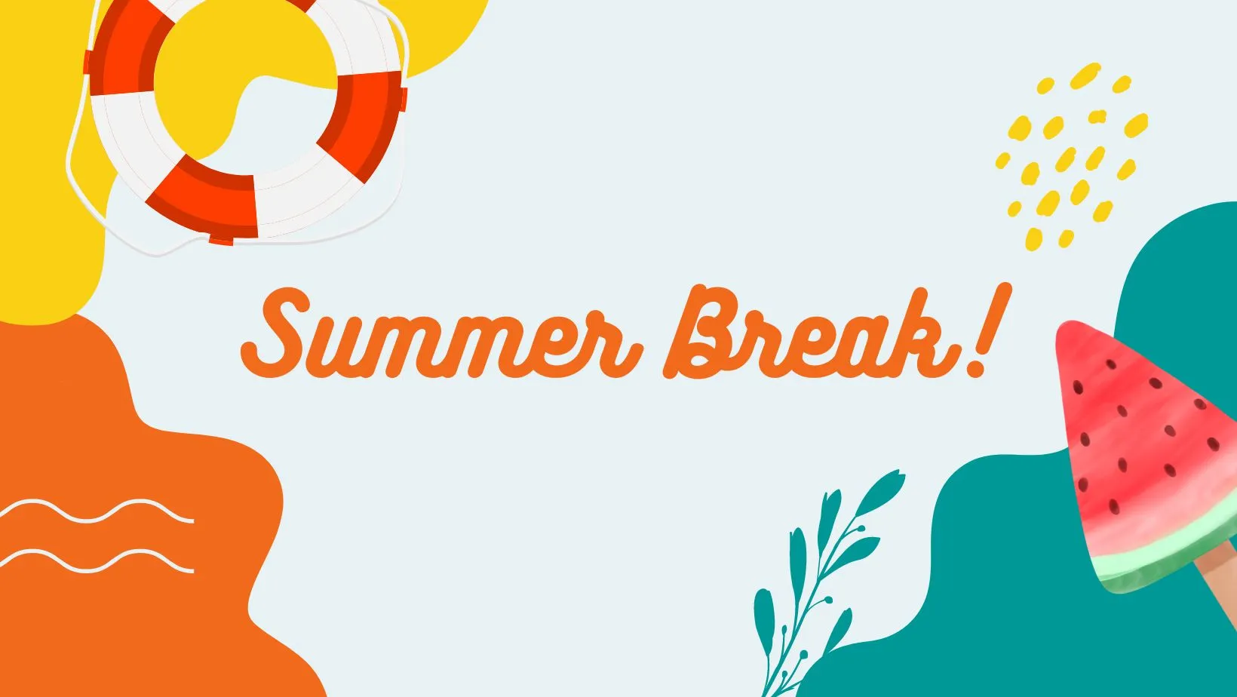

Enjoy your time with your family.

We will re-open on Tuesday _____.