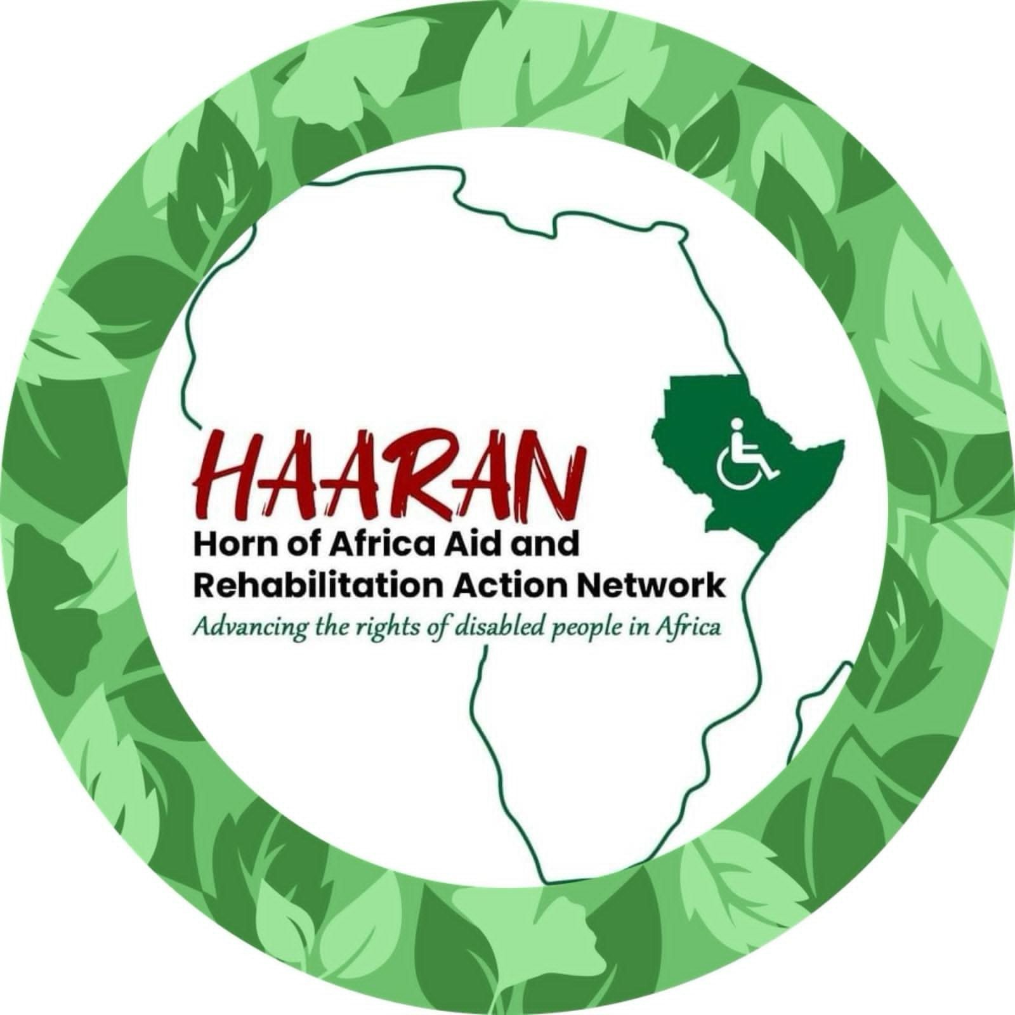

**HORN OF AFRICA AID AND REHABILITATION ACTION NETWORK (HAARAN)**

**ORGANIZATIONAL PROFILE 2024**

|  |  |
| --- | --- |
| **HAARAN-International** | **HAARAN-Kenya/Somalia** |
| 424 1/2 South Minnesota Avenue  Suite B, St Peter MN 56082  Phone: +1 507 9777106  Email: [haaranusa@gmail.com](mailto:haaranusa@gmail.com)  [info@haaran.org](mailto:info@haaran.org)  Phone: +1 507 9777106  Email: [haaranusa@gmail.com](mailto:haaranusa@gmail.com)  info@haaran.org | P.O. Box 85628 - 00200  Phone: +254 790 349 795  E-mail: [haarankenya@gmail.com](mailto:haarankenya@gmail.com) |

**Twitter (Xmedia)**: ………

**Facebook**:………..

I**nstagram**: ……….

**Website:** [www.haaran.org](http://www.haaran.org)

**OUR HISTORY**

Horn of Africa Aid and Rehabilitation Action Network (HAARAN) is a native, independent, disability -focused organization whose goal is to promote an inclusive society where persons with disabilities and other vulnerable individuals are respected and empowered to develop their potential to lead a quality life.

HAARAN was founded in the year 2008 by **Abdi Noor Matan** in state of Maine, United States of America to address the needs and challenges of Somali immigrants. Being a native of Somali community back in Horn of Africa, Abdi Soon realizing that many of the problems facing immigrants including those with disabilities in USA stemmed from back home, (AFRICA) and they included; high rate of jobless, youth migrating from Horn of Africa, violent extremism, poverty, discrimination, stigmatization and above all isolation on the ground of disability. Mr. Abdi expanded HAARAN’s activities to Horn of Africa, Kenya and Somalia in **2013** with a focus on strengthening capacity and broadening community coverage. HAARAN Kenya and HAARAN Somalia chapters were founded in 2**014** respectively to help scale down HAARAN mission in Northern Kenya and South West Somalia.

HAARAN is a registered as non-profit organization in **Kenya** with NGO board. It is also registered and has **501(c)3** non-profit organization status. Today, HAARAN works in both Kenya and Somalia with both PWDs and abled persons in need of help so as to transform their lives, one at a time, while responding to and building their resilience.

HAARAN believe and strongly uphold the fact that disability rights are human rights, there cannot be development in any country if persons with disabilities are still placed on the periphery of the mainstream development processes. Focusing on the most vulnerable we operate to reach and raise the voices of the often unheard at the national and international levels. We work for a society in which every person is equally valued. We believe persons with disabilities should have the freedom to live their lives the way they choose. To have the opportunity and support to live independently, to contribute and participate fully in society.

HAARAN’s main intervention approach is Community Based Inclusive Development (CBID) as a way of working that ensures persons with disabilities are respected and included in their communities on an equal basis in all areas of life. Through this approach we seek to realize the CRPD and to meet the Sustainable Development Goals (SDGs), in particular their “*Leaving No One Behind*” principle. Our approach is people- centred (Persons with disabilities having a choice and control over their own lives), community driven (a focus on community engagement and ownership) and human rights –based. In this we embrace diversity across multiple intersecting categories of identity, besides seeking to localize the SDGs.

**OUR VISION**

HAARAN envisions a society where the vulnerable persons have the right to an active, healthy and dignified life.

**OUR MISSION**

To work for the cause and care of disadvantaged disable persons, the aged and other vulnerable person by improving their quality of life.

**OUR OBJECTIVES**

* To promote disability inclusive development through Disability Inclusive Centered Community Development (DCCD) model.
* To enhance support to vulnerable children with a specific focus to children with disabilities and children in refugee set-ups.
* To enhance resource mobilization and technical expertise for efficiency, growth and sustainability of the organization.
* To capacity build local OPDs through institutional strengthening on the rights of persons with disabilities.

**OUR VALUES**

HAARAN’s values are guidelines for its employees and other stakeholders that govern the operations of the organization. To ensure nonpartisan/ neutral engagement, these values serve as our working norms and establish the organizational behavioral guidelines for successful organizational performance. These values are:

1. Transformative
2. Non-discrimination – disability, gender, faith and creed, age and race
3. Integrity
4. Accountability
5. Professionalism
6. Humanity
7. Partnerships

**HAARAN THEMATIC AREAS**

In our quest to improving quality of life of vulnerable persons, HAARAN pays attention to the following thematic areas:

1. Health and Rehabilitation.
2. Inclusive Education and Skills Development.
3. Economic empowerment and livelihoods.
4. Climate Change and Disaster management
5. Governance and Rights.

**OUR OPERATIONAL AREAS**

1. Garissa
2. Daadab Refugee Camp.
3. Liboi.
4. Wajir.
5. Mandera
6. Kismayo-Somalia.

**OUR STRATEGIES**

To ensure the realization of our development objectives, HAARAN has the following major developmental strategies that are identified to address the critical needs and rights of the people.

1. Policy influence and advocacy.
2. Capacity building.
3. Research and knowledge generation.
4. Networking and building partnerships.

**OUR KEY ACHIEVEMENTS**

* Participated in a global United Nations meeting in New York, South Africa, Kenya and Ethiopia on development of UNCRPD – toolkit for Africans nations.
* HAARAN is in frontline promoting inclusive learning in Daadab Refugee Camp.
* Submitted memoranda on several disability policies in Somalia to the Ministry of Education through our partners.
* Organized a youth with disabilities knowledge transfer summit in collaboration with EduCab and Garissa University using smart library approach.
* Received Gustavus Adolphus College 2018 Community Partner Presidents' Award for Civic Engagement in United States.
* Distributed assistive devices to persons with disabilities in horn of Africa.

**RESPONSIVE AND PARTICIPATORY PLANNING, MONITORING AND EVALUATION.**

The organization will closely monitor its; viability/sustainability and its programs/projects impact. This will encompasses, among others, the following:

* Tracking progress reports with board input.
* Review meetings.
* Reports from departments such as finance and programs, among others.

Monitoring will take the following dimensions:

* 1. **Performance monitoring** encompassing looking at the outputs, activities,indicators envisaged in the operational plan.

1. **Compliance Monitoring:** This generally tracks the implementation of thetargets and compliance with the systems and procedures established.

**MAINSTREAMING CROSS-CUTTING ISSUES**

The following Cross cutting priorities are key to HAARAN because they have relevance and should be mainstreamed as part of HAARAN’s programming across all sectors. The cross cutting themes includes;

1. **Gender justice:** The protection and promotion of the human rights of both women and men are fundamental to sustainable development. Unequal power relations between women and men often result in unequal distribution of wealth and access to opportunities. The centrality of women's role, not only in the family and community, but also in the process of development, necessitates a clear focus on the human rights of women and of girl children, and on equal participation of women. Part of our responsibility is to be deliberate in challenging gender inequality, in order not to reinforce patterns of injustice and exclusion for women.
2. **Child Protection:** Like women, children are also a vulnerable group. Suffering the most are children with disability and children in refugee camps. They are hidden from the public and very few of them access education and other essential services such as health. HAARAN will prioritize the special needs of children in all its programmatic work
3. **Youth Inclusion:** The youth in Kenya and Somalia form the bulk of the population. HAARAN will work with its partners to advocate for the mainstreaming of the youth with disabilities in all national programs. The organization will pay special attention to the unique needs of youth with disabilities.
4. **Climate change:** Sustainable development is only achieved when long-term human needs are satisfied without threatening or depleting the resource base on which future generations depend. This requires responsible management of the environment and natural resources. HAARAN is committed to incorporating concern for the environment. Climate change is resulting in increasing frequency of extreme weather events and climate-related disasters. It is contributing to increased competition and conflict over natural resources and, in some areas, forced migration of disaster-affected communities. Climate change adaptation is inextricably linked to protection and management of natural resources and will be a core aspect of our sustainable livelihoods.

**HAARAN PARTENERSHIPS AND NETWORKS**

|  |  |  |
| --- | --- | --- |
| **PROJECT TITTLE** | **SPONSOR**  **DONOR** | **PROJECT DETAILS AND STATUS** |
|  |  | |
| **TACKLING RELIGIOUS DRIVEN VIOLENCE AGAINST COMMUNITY IN SOMALIA PROJECT.** | KAICIID  International Dialogue Centre | The project provides a broad education & awareness centered campaign on community peace and religion topics relevant to the needs of residence. The goal of the Peace education is to enhance social transformation of the community to embrace peace and reconciliation. HAARAN pursues this goal through three dimensions of peace building process namely; The Structural dimension; The Relational & value systems dimension and personal dimension. |
| **INCLUSIVE EDUCATION PROJECT.** | ADRA Somalia with funding from NOARAD | The focus of this is that persons with disabilities claim their rights, access services and exert influence on matters that affect their lives. HAARAN works to allow CWDs to participate meaningfully in the decision-making processes. The project works towards expanding availability and accessibility to inclusive education services for children with disabilities as result of improved learning environment, advocacy, governance and evidence-based management of inclusive education at all levels (school, district, regional and national). |
| **SMART LIBRARY**  **PROJECT.** | EDUCAB  International | The project goal is to use library space combined  with community outreach and development activities to give community the skills and confidence they need to aim higher, achieve more and improve their lives. |
| **TECHNICAL**  **SUPPORT ON DISABILITY POLICY DEVELOPMENT** | ADRA Somalia and  Norad | HAARAN helped to develop a clear and  comprehensive statement of policy, with provisions specified in the national education document (Education Act or other relevant legal document) in order to provide a framework for developing minimum national standards for the inclusion of children with disabilities in national education systems. |

|  |  |  |
| --- | --- | --- |
| **CRPD TOOLKIT FOR AFRICA PROJECT** | UNDESA and UNDP Kenya | HAARAN together with partners under the lead of UNDESA developed a Toolkit on Disability designed for the African context and aimed to provide practical tools on various disability- related issues to government officials, members of parliament, civil and public servants at all levels, disabled persons organizations (DPOs) and all those with an interest in the inclusion of persons with disabilities in context of Somalia  and Kenya. |
|  |  |  |
| **DISABLITY RIGHTS & PROTECTION IN HIGHER EDUCATION PROJECT** | HAARAN USA &  Garissa University | HAARAN supports the university to set up a disability mainstreaming unit to help staff and students with disabilities through mobilizing resources to support activities of and for students with a disability within the college. |