
From Overwhelmed to Empowered:
Practical Advice for Navigating AI in Higher Ed


Chris Shaltry, Ph.D.
Education, Technology, and Innovation Specialist
College of Human Medicine
College of Osteopathic Medicine
shaltryc@msu.edu
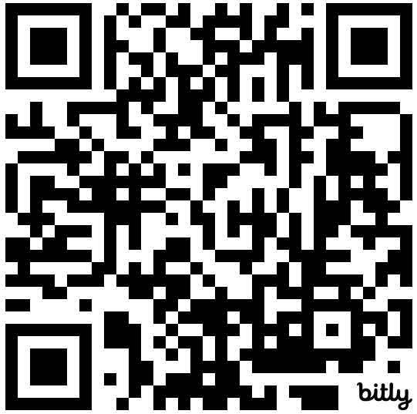 | bit.ly/mps-ai

Today’s Agenda:
- AI Tips and Advice
- My (current) Favorite AI Apps
- Apply: Rapid Content Prototyping Demo + Discussion
- gAImeshow Time…!

AI Tips and Advice
AI video is getting really good.
What does this mean for education?

Complement traditional idea generation with AI.
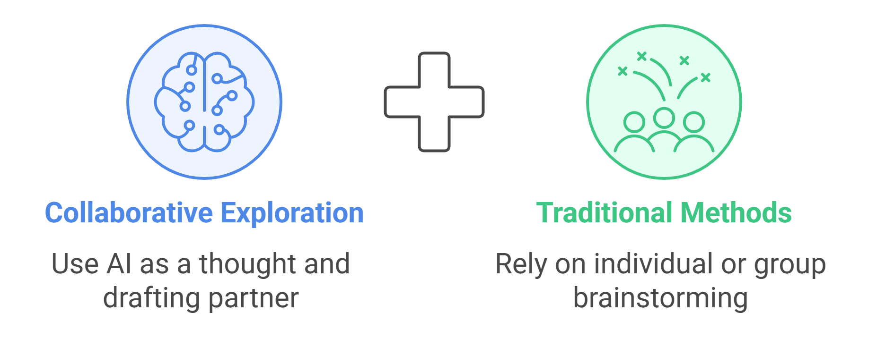

Be careful about generalizations regarding what “AI” can/can’t do.
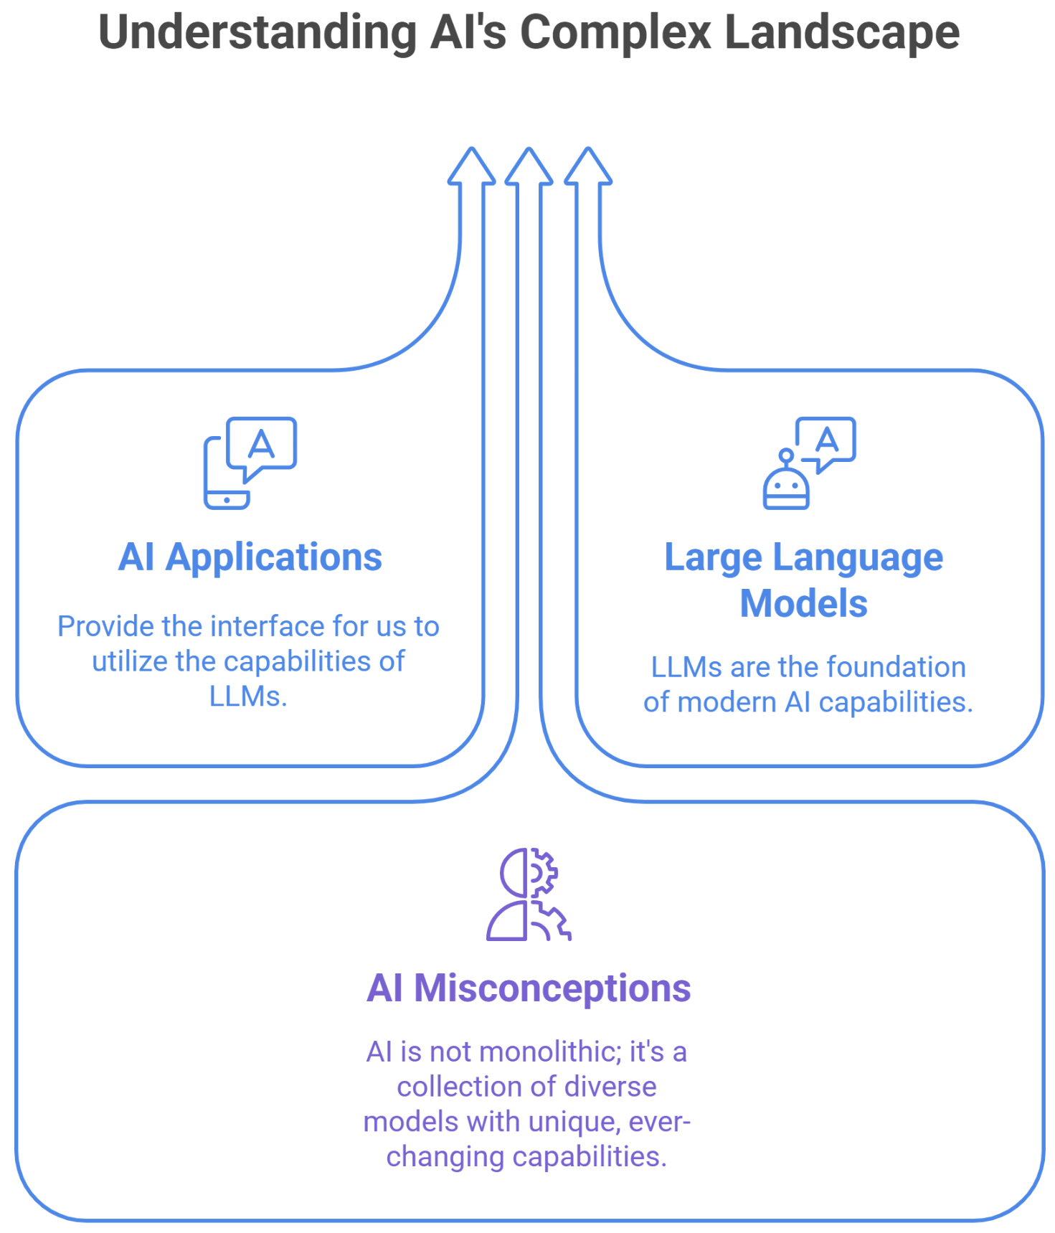

Promote mindful use.
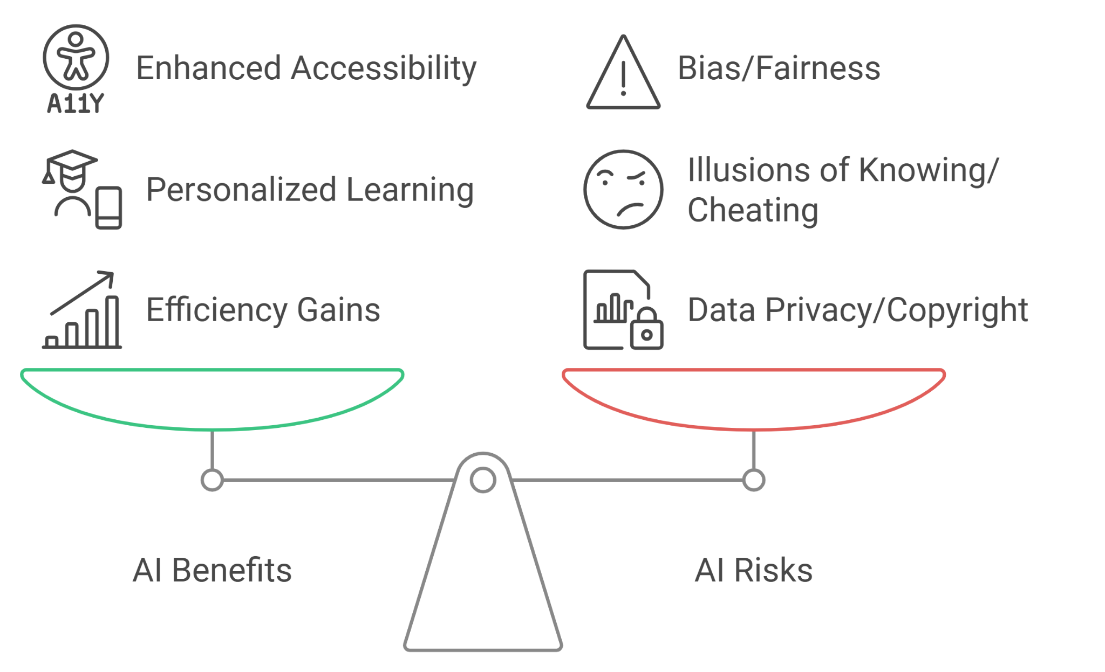

Consider the limitations of AI applications carefully before using them.
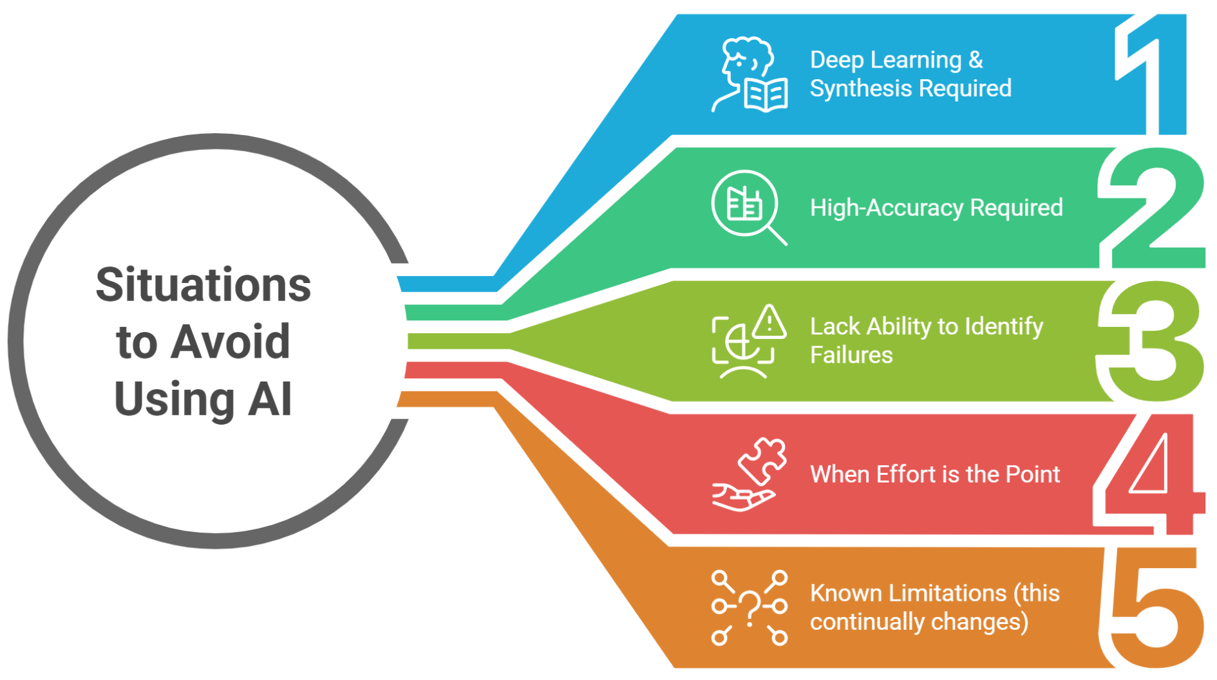

How can we ensure students are benefiting from work outside class?
Fewer students are benefiting from doing their homework: an eleven-year study
“So homework-copiers can perform as well as homework-generators on tasks not requiring long-term retention and both groups are equally capable of inferring the answer to a question on a just presented slide. Unfortunately, homework-copiers apparently adopt a strategy that increases the homework quiz score at the cost of a lower exam score. There is no reason to believe that the students are aware that their homework strategy lowers their exam score. Rather, it is more likely that they make the commonsense inference that any study strategy that raises their homework quiz score raises their exam score as well.”
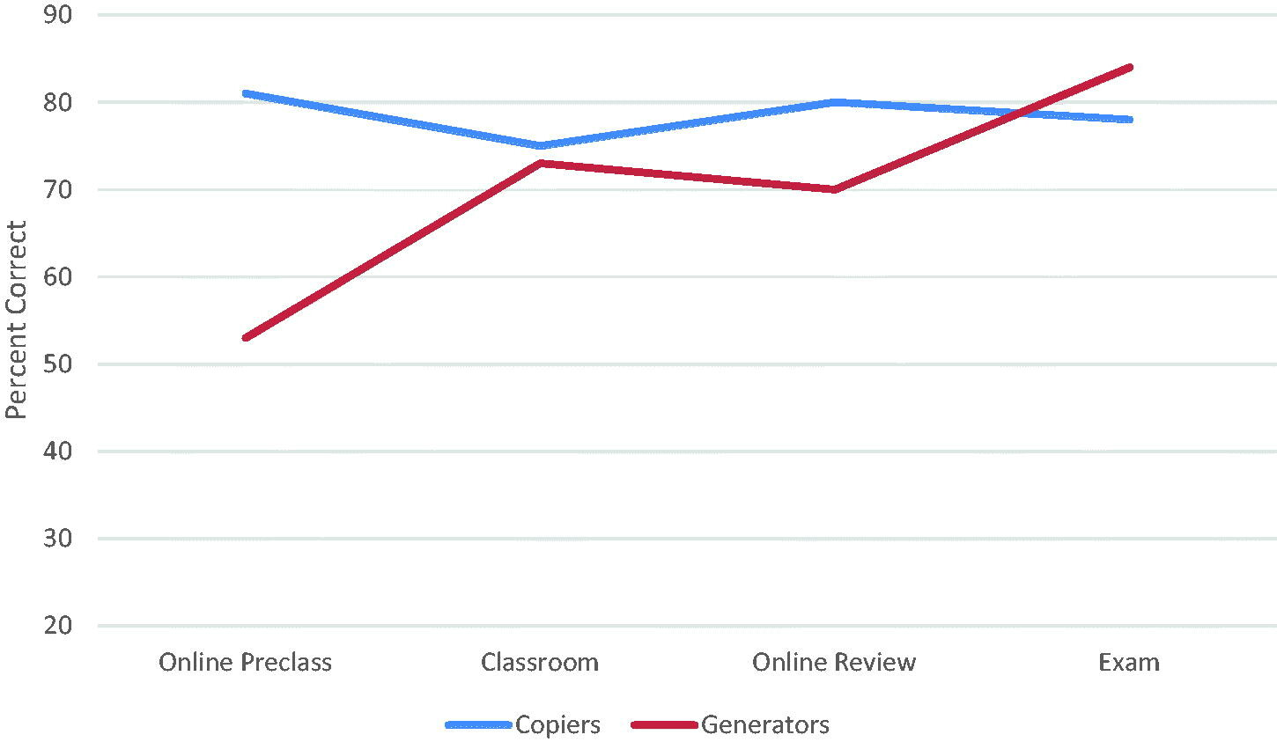

But, I’m Not A Prompt Engineer…
- Focus More on Problems, Less on Prompts
- Getting Started with AI: Good Enough Prompting
- Use AI to help you write and refine your prompts. For repeated tasks, consider a “GPT.”
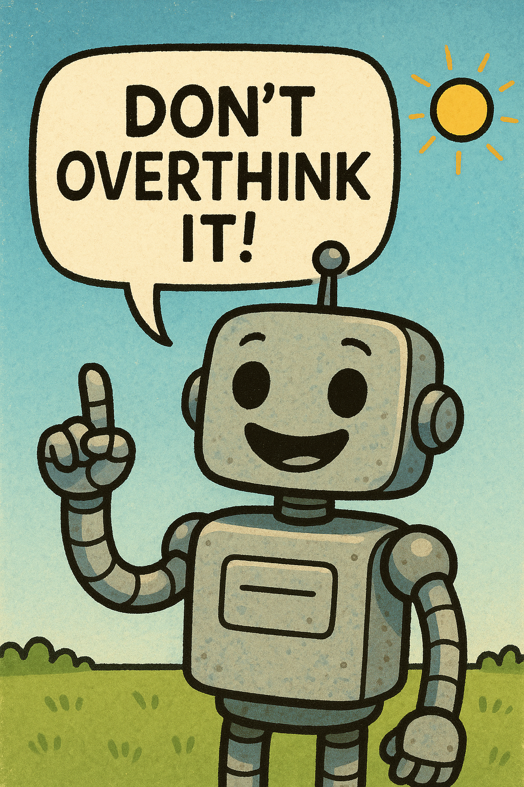

My (current) Favorite AI Apps [+2 great blog posts]
- Google NotebookLM
- Perplexity Search
- Napkin.ai
- Gamma.app
- Elicit
- Tim Dasey’s blog: AI & Intelligence, Critical Thinking

Rapid Content Prototyping Demo + Discussion
- AI 101 NotebookLM Resource (from AI 101 for Teachers)
  - How could you use this app with your students?
- Create your own!

BONUS CONTENT
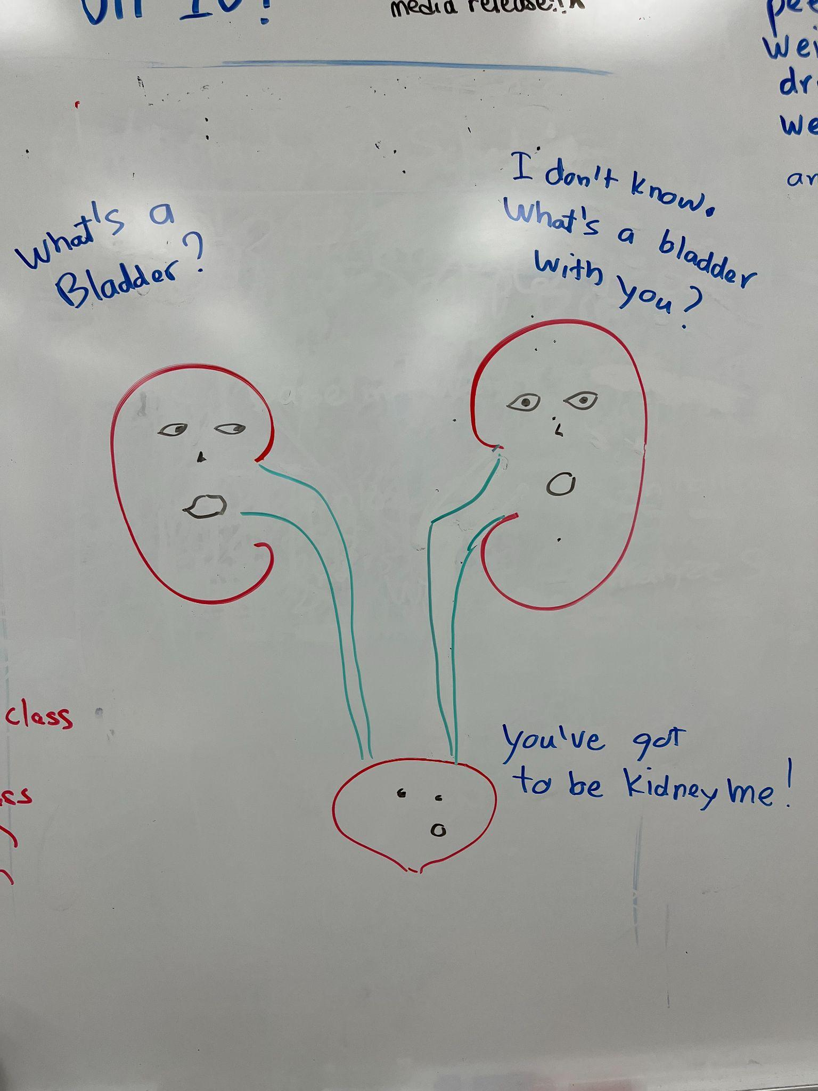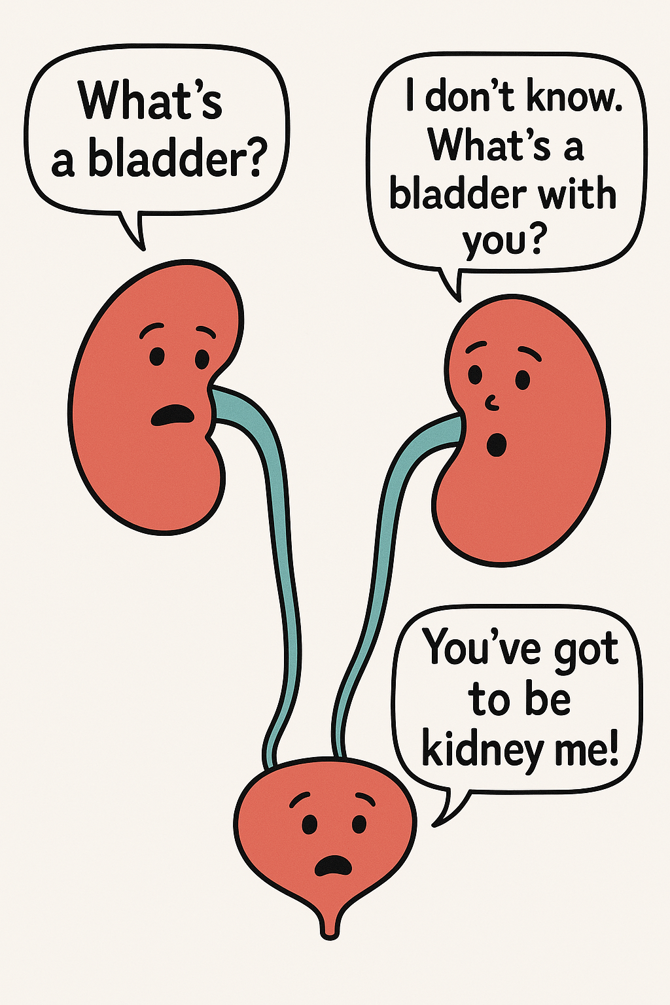What: Create custom digital concept diagrams for students that are copyright-free.
App Name: ChatGPT + iPhone
Details: Snap a photo of anything you draw, and ask ChatGPT to transform it into a diagram for student learning.
More from the John Zubek library…
