Ancient Africa Note Book

What is the largest country in Africa? _______________

What is the longest river? _________________________, it’s the longest river in the world.

The highest mountain in Africa is Mount _____________________________

Do your best approximation of drawing the different physical features of Africa on the map below (color the deserts orange, the savannahs yellow and the forests green… make sure to label the Sahara Desert, Kalahari Desert, and the Nile River)

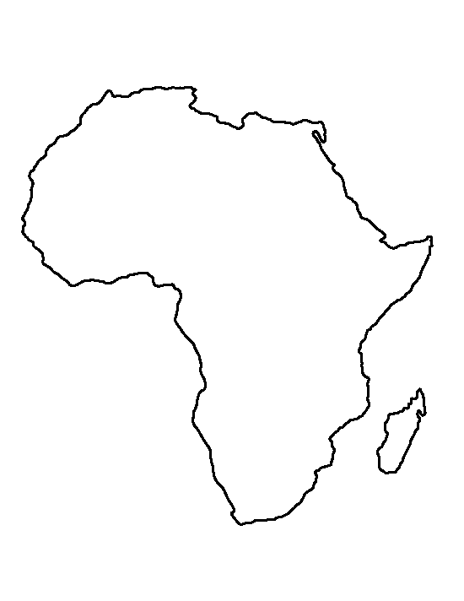

Because most of African history was passed down orally, we don’t have much for written records, but we do know a few ancient civilizations.

The ________________ had a large section of land in the east near Egypt.

The _____________________ of Aksum was would trade with Europe and the Far East.

The_________________ people are indigenous people of Africa who were located in central Africa and migrated throughout the continent.

The Kush people were very similar to ________________ in government, culture and religion.

Legend has it the Kingdom of Aksum was established by the son of King Solomon and the Queen of _________________.

Ghana means “__________________ king”.

Islam was important in the _____________ culture

Sunni Ali, the first leader of the Songhai Empire, was being held prisoner by the __________ Empire.

Why was Carthage important? _______________________________________________________________________________________________________________________________________________________________________________________________.