Here are detailed instructions to follow in getting registered and using the Classmarker.com site for exams:

1. On the internet, go to www.Classmarker.com

2. At the top of the page, click the “Register Free” link.



3. Next, on the page it brings you to, click the “All Test Takers register here” link.

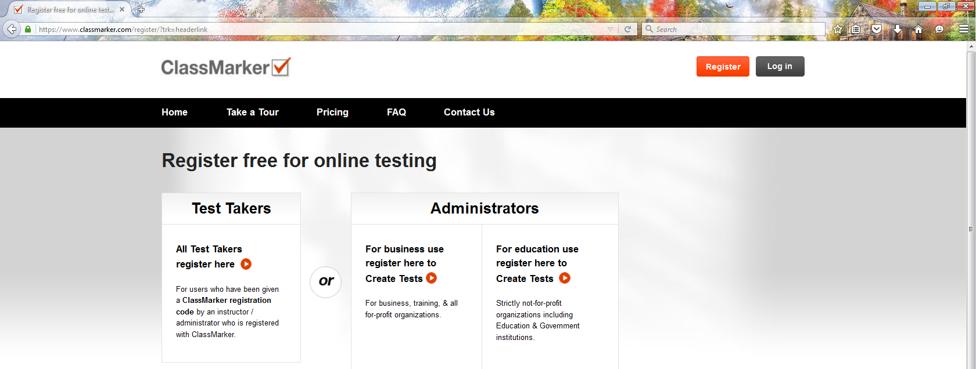


4. Next, on the page it brings you to, copy the Registration Code that I sent to you and then paste it in the box that states
“ Registration Code* ” If the code is rejected, please text me (509-429-8413) or email me.
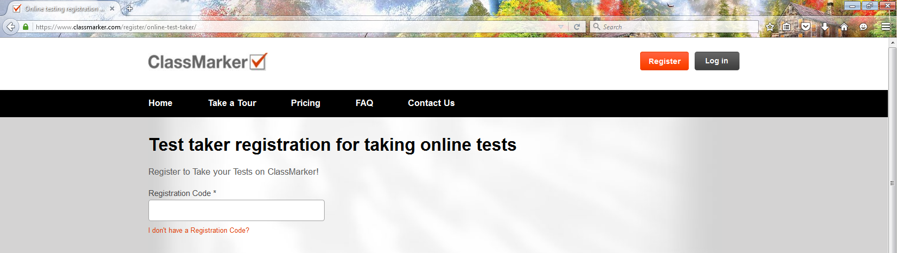


5. Also, on the same page, fill in the rest of the boxes. You get to choose your own ‘User Name’ and ‘Password’. Make sure to write down these two items and save them; you will use your chosen UserName and Password each time you log into Classmarker (note: you will never use the ‘registration code’ after this). Please put in your email address. Check the box that you agree with their ‘terms’. And, finally, click the “Register” button.

6. It will then take you to the main Exam page where all the exams for your program (Bachelor, Master, or Doctorate) will be listed in order by Year # and Semester #. Be very careful to select the correct exam ‘cycle’ in the Bachelor’s Program. We have started a new cycle of teaching (2015 cycle). The ‘Original Cycle’ was started in 2011. Make sure the exam’s cycle that you take matches with the same cycle of lecture notes and videos that you have been going over (either ‘Original Cycle (2011)’ or the ‘2015 Cycle’). If you are confused on this, please email me.
All you need to do to take an exam is to click the “Start” link located with the exam you are ready to take. Once you click ‘Start’ , the exam will begin and you will have only a certain amount of time to finish it (usually, 3 minutes per question). Please read over the ‘New Exam Taking Protocol’ link near the top of the “EXAMS” Home Page.

7. A common mistake new students make is trying to use their ‘Registration Code’ when getting ready to take another exam. The registration code is just for registering… it is a one time event. After registering, you will never need to use that code again. What you will use, though, is the username and password that you choose after registering. These credentials are what you will use each time you enter into Classmarker to take an exam.

