Stop Guessing, Start Testing: Food Intolerance Made Simple | FIT
Bloated? Tired? Skin breaking out? Discover how FIT Food Intolerance Testing helps you find your food triggers and transform your health without the guesswork.
Food Intolerance Testing: Because Feeling “Meh” Isn’t Normal
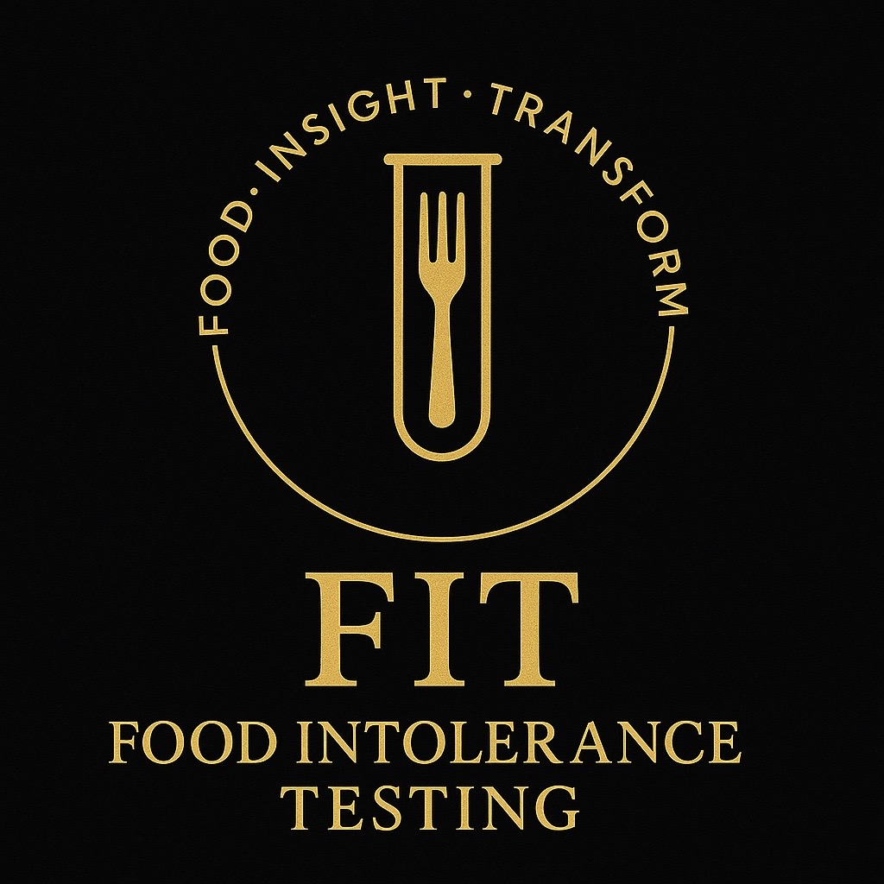

What’s the Deal with Food Intolerance?
Let’s be real: feeling bloated, sluggish, or battling random skin flare-ups isn’t just “adulting.” Sometimes, your body is straight-up saying: *“Hey, we don’t vibe with that food.”*
Unlike allergies, food intolerances won’t send you rushing to A&E — but they can totally wreck your daily energy, mood, and confidence. That’s where FIT Food Intolerance Testing steps in.
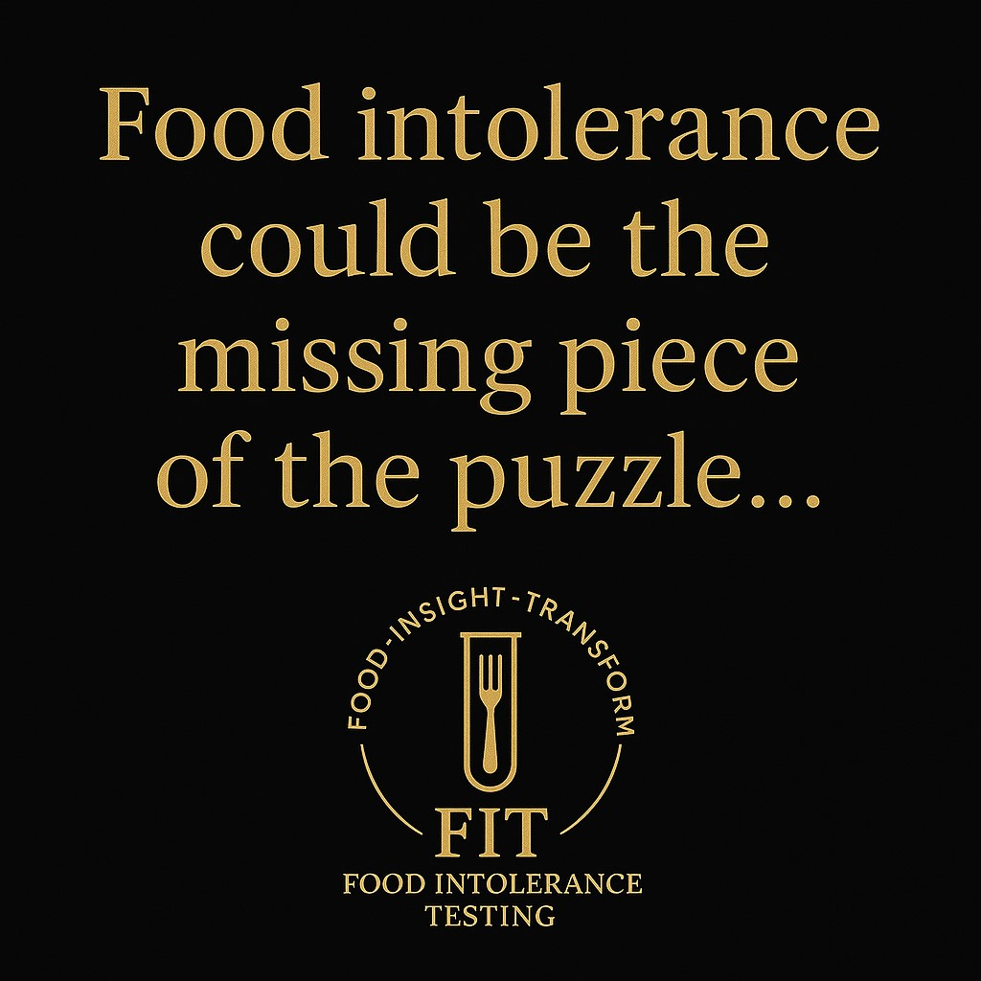

Why Bother Testing? (Spoiler: Because You Deserve to Feel Good)

If you’re constantly asking yourself why you feel:
✨ Bloated like a balloon
✨ Foggy-headed 24/7
✨ Snappy and tired for no reason
✨ Or breaking out like you’re back in high school
…then food intolerance could be the missing puzzle piece 🧩 (yep, pun intended).

Types of Food Intolerance Tests (And Why FIT Works)

You’ve probably heard of these:
- Elimination Diets → Old-school. Effective, but let’s be honest, it’s a faff.
- Breath Tests → Cool if you just want to test lactose. But what about everything else?
- Blood Tests (like FIT) → Pin-prick simple, checks over 200 foods/drinks. Science-acked. Zero drama.

What You Get with FIT

Think of it like a wellness glow-up, in 5 easy steps:
1️⃣ Free Chat – Quick call with Becki to spill your symptoms + goals.
2️⃣ Home Kit – Finger-prick, done in 2 minutes. (Promise, it’s easy.)
3️⃣ Lab Magic – 200+ foods tested in a trusted UK lab.
4️⃣ Results in 7 Days – Because no one has time to wait forever.
5️⃣ Personal Plan – 1:1 consult to decode results + build your roadmap.
💡 Common perks clients rave about: no more bloat, clearer skin, more energy, better mood. Basically, feeling human again.

But Wait — Is Testing Perfect?
No test is a magic wand ✨. Here’s the real talk:
- Some sensitivities (like caffeine) aren’t picked up.
- Stress, sleep, and lifestyle still matter.
- Results = a tool, not a life sentence.
That’s why FIT pairs testing with personal guidance — so you don’t just get results, you get solutions.

The FIT Promise
We’re not about scare tactics or fad diets. FIT is all about:
• Science you can trust ✅
• Support that feels like a cheerleader, not a drill sergeant 💁‍♀️
• Simple, doable steps that actually fit your life

Key Takeaways
• Food intolerances might be behind your everyday struggles.
• FIT Testing = quick, science-backed answers + personal support.
• Your energy, skin, and mood don’t have to suffer.
• Change can start with one test.


Ready for Your Glow-Up?
👉 Book your free consultation today. Stop Googling symptoms and start transforming your health — the FIT way.

Keywords
• food intolerance testing
• identify food sensitivities
• symptoms of food intolerance
• FIT Food Intolerance Testing
• bloating
• low energy
• digestion support

