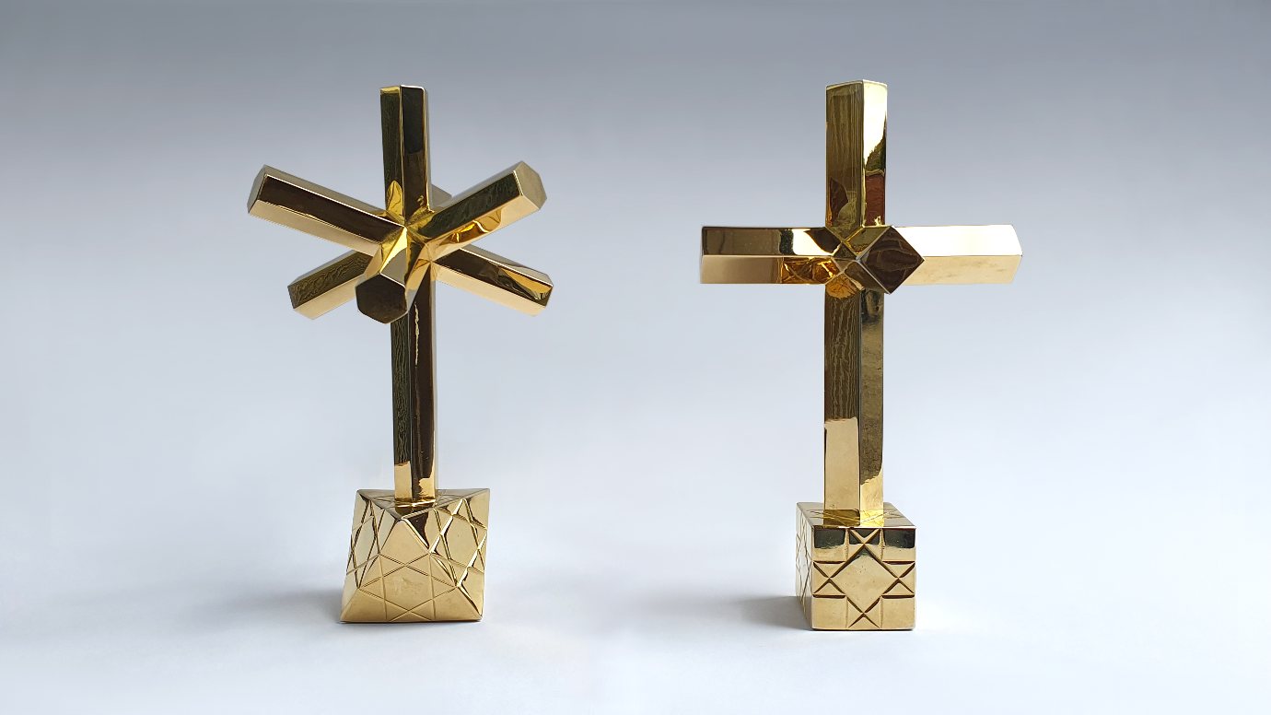
Free art exhibition lifts the lid on the lost culture of England
A brand new free art exhibition at The Minories, Colchester is set to completely rewrite our understanding of English culture and heritage.
Number in Time and Space: Exploring Plato’s Fifth Element reveals the forgotten meaning and significance of geometric shapes, motifs and proportions in British art and architecture spanning 2,000 years.
The product of six years of research, the artworks are the result of accidental discoveries by arts and heritage experts at Essex-based cultural history consultancy, Byrga Geniht.
The show features works made in collaboration with established and emerging British artists, including Jacob Chandler, Dave Shrimpton, Caroline Weidman, and Shay Shani.
The works combine modern craft with genuine antiquities and digital projection in media ranging from wood to glass, to bronze, and 24 carat gold to reconnect the public with a rich and living cultural inheritance.
“We hope this free exhibition in the heart of Colchester with its links to antiquity will help recent discoveries reach as many people as possible,” said James Wenn, Co-Founder of Byrga Geniht and the exhibition’s curator.
“The influence of symbolic geology on the formation and evolution of English culture is enormous and this art provides an accessible, enjoyable way to learn about this little-known part of our history,” he added.
Commenting on the research that underpins the exhibition, Marcus du Sautoy, Simonyi Professor for the Public Understanding of Science and Professor of Mathematics at the University of Oxford said: “The new insights into the role that mathematical geometry played in the art and architecture of Anglo Saxon Britain are absolutely fascinating. This feels like an intellectual version of the metal detectorists uncovering a treasure trove of wonders.”
He added that: “By tapping into people's passion for history and archaeology I am really excited by the power of this research to explain the way mathematical shapes have inspired such a range of creativity in this period (...) A truly original and exciting bit of research.”
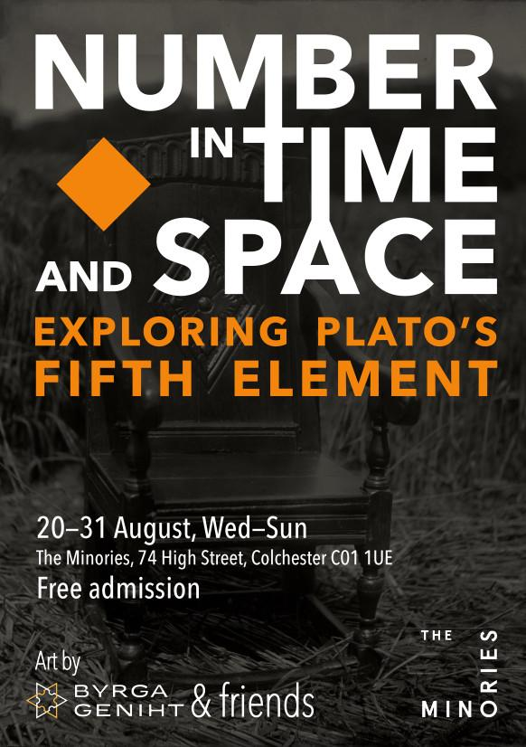
The exhibition is open
Wednesday 20 – Sunday 24 and Wednesday 27 – Sunday 31 August, 10:00-16:00. Admission is free.
Press are invited to attend the opening day of Wed 20 August, where representatives from Byrga Geniht will be in attendance to answer questions about the art and the research.
Nearest station: Colchester Town. Nearest car park: Greyfriars
The Minories, 74 High Street, Colchester CO1 1UE
Press contacts: James D. Wenn: 07481411395 / James Syrett: 07921374357
www.byrga.co.uk/preview

