PRESS RELEASE: Britain’s own “Da Vinci Code” — new research reveals the hidden message in our greatest architecture

A six year quest has revealed hidden messages in some of the UK’s favourite buildings and artworks.
These include Westminster Abbey, the Houses of Parliament, The Old Bailey, Oxford and Cambridge Universities, and scores of stately homes across the country.
For example, in Westminster Abbey, the ancient architecture is designed to transform the new monarch into a harmonious ruler. At the Houses of Parliament and the Old Bailey, geometric motifs serve as a reminder to conduct the work of the State with integrity.
Many of the most important buildings in the country are covered in geometric decoration. This was previously thought to be merely ornamental, but this new research proves otherwise. Central to the discovery is a shape called the rhombic dodecahedron. This 3D shape with 12 diamond-shaped sides is the form that garnet crystals adopt. It also fits the description of the shape of the universe, according to the Greek philosopher Plato.
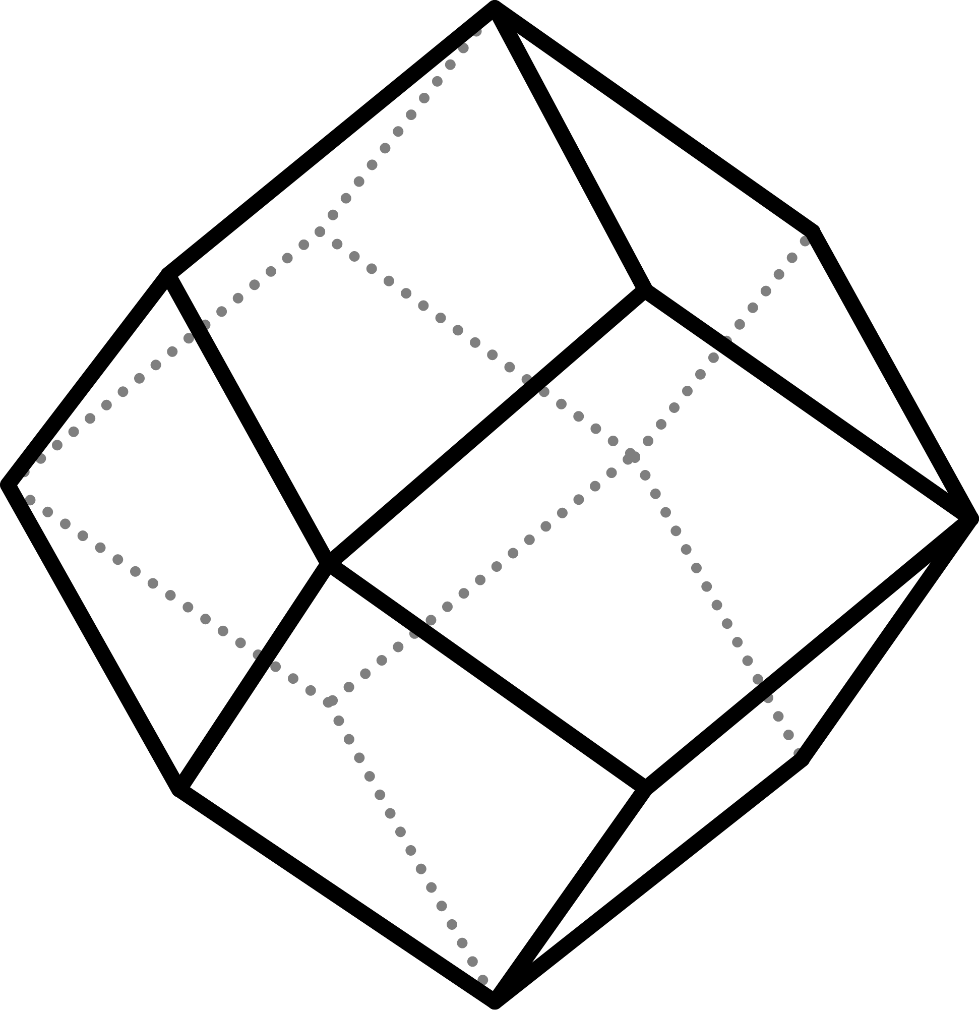
A rhombic dodecahedron (James Syrett, free for use without accreditation)
The discoveries were made by James Wenn and James Syrett, two independent researchers who work by combining their expertise. By far their biggest discovery is the meaning of the Coronation Pavement in Westminster Abbey. The spot where every monarch has been crowned for 700 years sits within a giant diagonal square — a slice through a rhombic dodecahedron. The intention is to envelop the new king or queen in an imaginary version of the 3D shape, transforming them into a harmonious ruler. James and James were asked to present their research to representatives of HM The King ahead of his coronation two years ago. Their work changed how the ceremony was conducted in order to make it correct.

The pair made their discoveries by accident. “The whole things started because I was explaining one of the greatest mysteries in the study of the Anglo-Saxons,” explains James Wenn. “Nobody knew why they used garnet for nearly all their jewellery. Then James showed me a garnet crystal fresh out of the ground, and there was an immediate light-bulb moment.”

It immediately explained the form of Anglo-Saxon church towers. Known as Rhenish helm roofs — they take the shape of half of a rhombic dodecahedron. A surviving example can be seen at Sompting in Sussex.

Because rhombic dodecahedra can fit together without gaps, they become a symbol of a harmonious society. The shape is also referenced by its various cross-sections and the patterns made when many of them fit together. These include diagonal squares, diamonds, hexagons, octagons, and much more. These shapes occur in British architecture for centuries after the Anglo-Saxons.

Another common motif is the eight-pointed star. This references a dance for eight people in which they trace out the shape of a rhombic dodecahedron in the air. The dance is associated with harmony and resurrection. By studying different versions of the star in stately architecture around the country, James and James are piecing together the choreography to reconstruct the dance.

The pair’s research has already attracted some notable supporters. Marcus du Sautoy, Professor of Mathematics at Oxford University, described it as “an intellectual version of the metal detectorists uncovering a treasure trove of wonders.” Roger Morris, Bishop of Colchester said of an exhibition of their work, that it “draws together science and art in a beautiful and harmonic relationship.”

The research is due to be featured on The Rest is History podcast this winter.

While this symbolism was known to the aristocracy for hundreds of years, the knowledge was lost around the time of the First World War.. The couple now want to work with heritage institutions across the country to bring this forgotten culture back to life. They are passionate about engaging the public with the discoveries, and say that the response has been fantastic.

“Our job involves traveling all over the country to stately homes, palaces and churches, looking for clues in the architecture. It reveals a continuous culture spanning thousands of years, driving for social cohesion. When we describe what we do, people always say, ‘that sounds like The Da Vinci Code!’”, says James Syrett. “We say we go one better, because it’s actually true!”

Contact:
James D. Wenn James Syrett
Phone: 07481411395 07921374357
Website: www.byrga.co.uk
Email: jdwenn@byrga.co.uk

James Syrett (left), and James Wenn (right). Credit: Byrga Geniht

Full quotations:
"The new insights into the role that mathematical geometry played in the art and architecture of Anglo Saxon Britain are absolutely fascinating. This feels like an intellectual version of the metal detectorists uncovering a treasure trove of wonders. By tapping into people's passion for history and archaeology I am really excited by the power of this research to explain the way mathematical shapes have inspired such a range of creativity in this period, one that traditionally has been thought to be a mathematical wasteland. Turns out this is far from the truth. A truly original and exciting bit of research.”
— Prof. Marcus du Sautoy, Simonyi Professor for the Public Understanding of Science; Professor of Mathematics at the University of Oxford; and author of Blueprints: How Mathematics Shapes Creativity

“I rejoice to see anything that draws together disciplines that the academy often holds apart - here history, mathematics, science and art come together in a beautiful and harmonic relationship - and point to a time when these disciplines inspired and informed our beliefs - as they still should. Brilliant.”
— Roger Morris, Bishop of Colchester
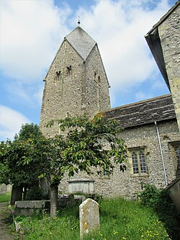
The tower of St. Mary’s church, Sompting (Wikimedia commons, no restrictions)


Natural garnet crystals showing rhombic dodecahedral shape. Credit: James Syrett

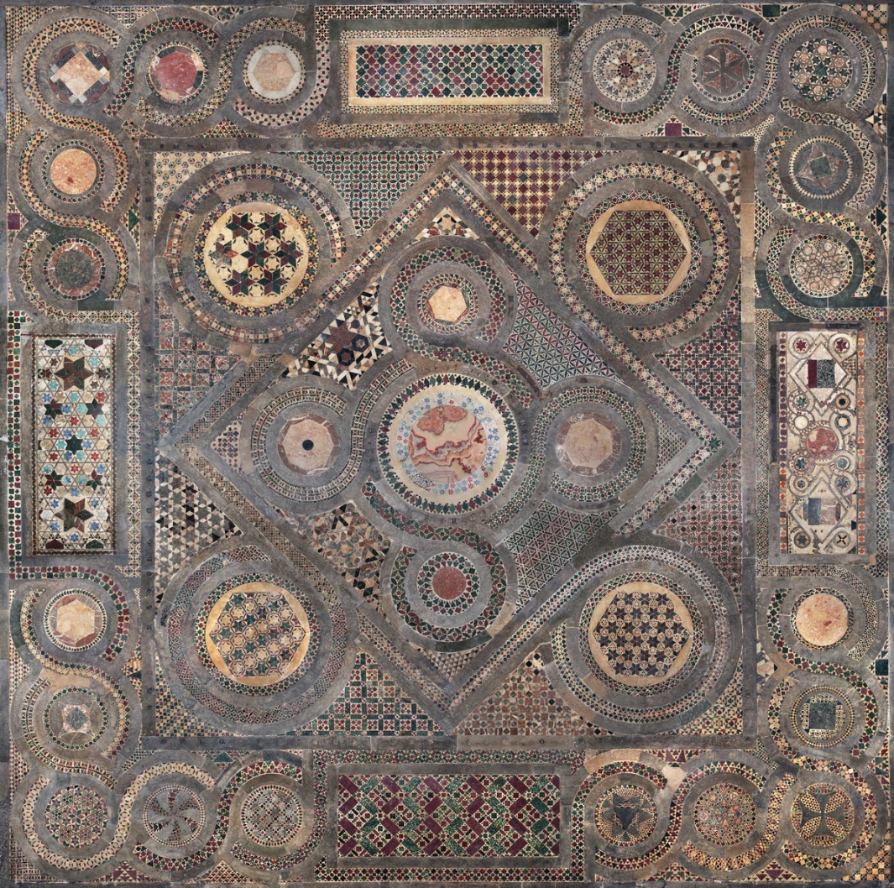
The Coronation Pavement, showing a large, central poised square. Credit: Westminster Abbey

