Teaching and Learning Sequence - Year 6 Lesson Plan Suggestion
Visible Learning and Feedback | Teaching and Learning Sequence | Resources
Students to understand different people experience the world differently and reduce barriers to participation. | Unit 1 – English  Focus question: How can we all join in? How can we help everyone participate?  Differentiated teaching and Links to areas of learning:  English – students will learn about difference and diversity in a positive and informed manner, building empathy for individual differences and also value the benefits different perspectives bring.  History – students will explore past attitudes towards difference such as disability exclusion, segregation and compare to contemporary inclusion concepts. Developing understanding of difference to increase inclusive participation. Students talk about people’s strengths and make a plan for their class/school to make sure everyone is included.  Creative Arts – students will be provided with opportunities to engage in role-play and dramatic representation. Opportunities to create art of their personal likes and dislikes.  PDHPE – students will build concepts of body structures and functions related to senses and how we experience the world (hearing, seeing, feeling -tactile and vestibular, taste) and different likes, dislikes and sensitivities.  Terms to research and discuss: For all openings: Neurodiversity, Autism, ADHD, Dyslexia.  Opening 9: Visual processing, Visual sensory seeking, Visual stimming, Self-soothing if anxious or Sensory overload  Opening 13: Communication differences and Neurodivergence, Differences in eye contact use, non-verbal communication | 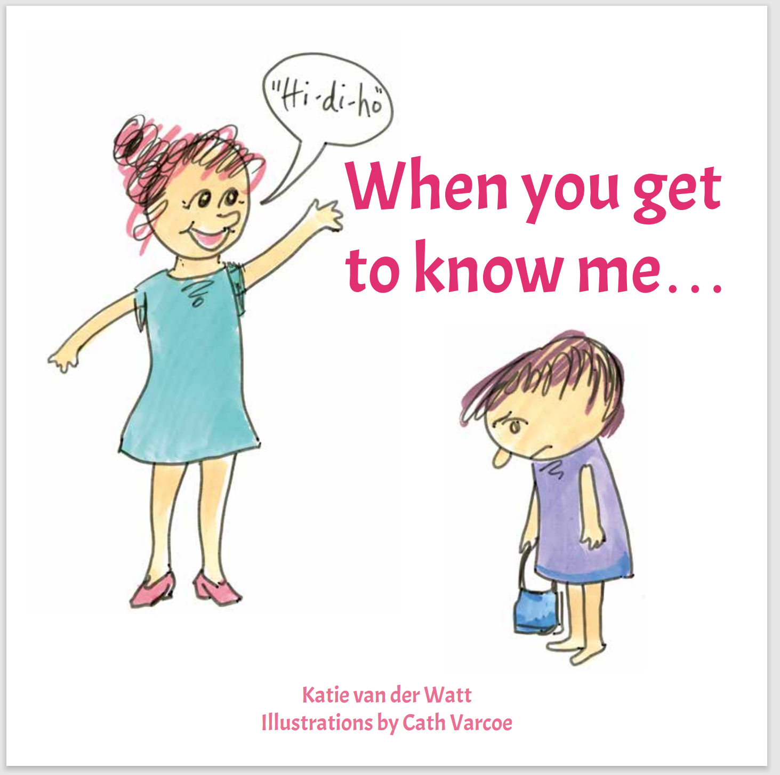  Title: When You Get To Know Me…  Author: Katie van der Watt/ Illustrator: Cath Varcoe  Electronic copy link: When You Get To Know Me...  Supplementary texts:  The Brain Forest – Sandhya Menon, Kushla Ross and Donita Richards  Gus The Asparagus – Ann-Marie Finn with Kaylene Hobson  List of more books: Community-Minded-Kids-Library
Learning Intention: We are thinking about why people may behave differently to me. We are learning that people can experience the world differently to me. We are looking at things from another angle. We are learning to ask people how they see things.  Success Criteria: I understand people have different perspectives and demonstrate this by finding different ways of doing things. I can recognise that there might be different ways to solve a problem. I understand there are differences in the way people experience the world.  Feedback: Modelling alternative solutions. Asking students to find differences. Praising different ways of approaching problems.  Praising suggestions for how to break down barriers to participation. | Activity: Read and discuss “When you get to know me…” opening 9 – “Do I explore things in a different way?” and opening 13 – “Do I communicate things in a different way?” (option to read additional pages/openings).  Opening 9: What is the child doing? Why doesn’t the child look at the prancing horse? What are some different ways we can share books? How can lights dance? Do I see things in a different way?  Opening 13: What is happening here? What is the child trying to do? Why is the child not using words? Is the child showing bad behaviour? Why is the child not pointing at the incident or looking at the adult? What are the different ways we can get a message across?  Questions related to all openings: What is happening? Is there a barrier or obstacle? Does this mean the child does not want to participate? Does this mean that the child cannot participate? What can we do so everyone can fully participate? What does this child miss out on when not participating fully? What does everyone miss out on when there are barriers that cause people difficulty participating? | Opening 9  The left picture shows a child taking a book off an adult who is encouraging the child to look at the picture (a prancing horse).  The right picture shows the child is more fascinated by the reflection of the light off the book than the picture they have been shown.  Opening 13  The left picture shows a child looking at a toy they are banging against a wall.  The right picture shows a child falling off a swing.  This opening shows that children can communicate in unexpected ways (this child is not looking at the adult or at the incident they are communicating about).
Evaluation
Where to next:

Adjustments made for:

Number of students in class:
Number of students demonstrating success criteria:

