Teaching and Learning Sequence - Year 2 Lesson Plan Suggestion
Visible Learning and Feedback | Teaching and Learning Sequence | Resources
Students to understand different people experience the world differently and reduce barriers to participation. | Unit 1 – English  Focus question: How can we all join in? How can we help everyone participate?  Differentiated teaching and Links to areas of learning:  English – students will learn about difference and diversity in a positive and informed manner, building empathy for individual differences and also value the benefits different perspectives bring.  History – students will explore past attitudes towards difference such as disability exclusion, segregation and compare to contemporary inclusion concepts. Developing understanding of difference to increase inclusive participation.  Creative Arts – students will be provided with opportunities to engage in role-play and dramatic representation. Opportunities to create art of their personal likes and dislikes.  PDHPE – students will build concepts of body structures and functions related to senses and how we experience the world (hearing, seeing, feeling -tactile and vestibular, taste) and different likes, dislikes and sensitivities.  Terms to research and discuss: For all openings: Neurodiversity, Autism, ADHD, Dyslexia.  Opening 5: Light sensitivity, Light avoidance, Sensory overload  Opening 11: Sensory avoiding, Auditory sensory processing, Sensory overload | 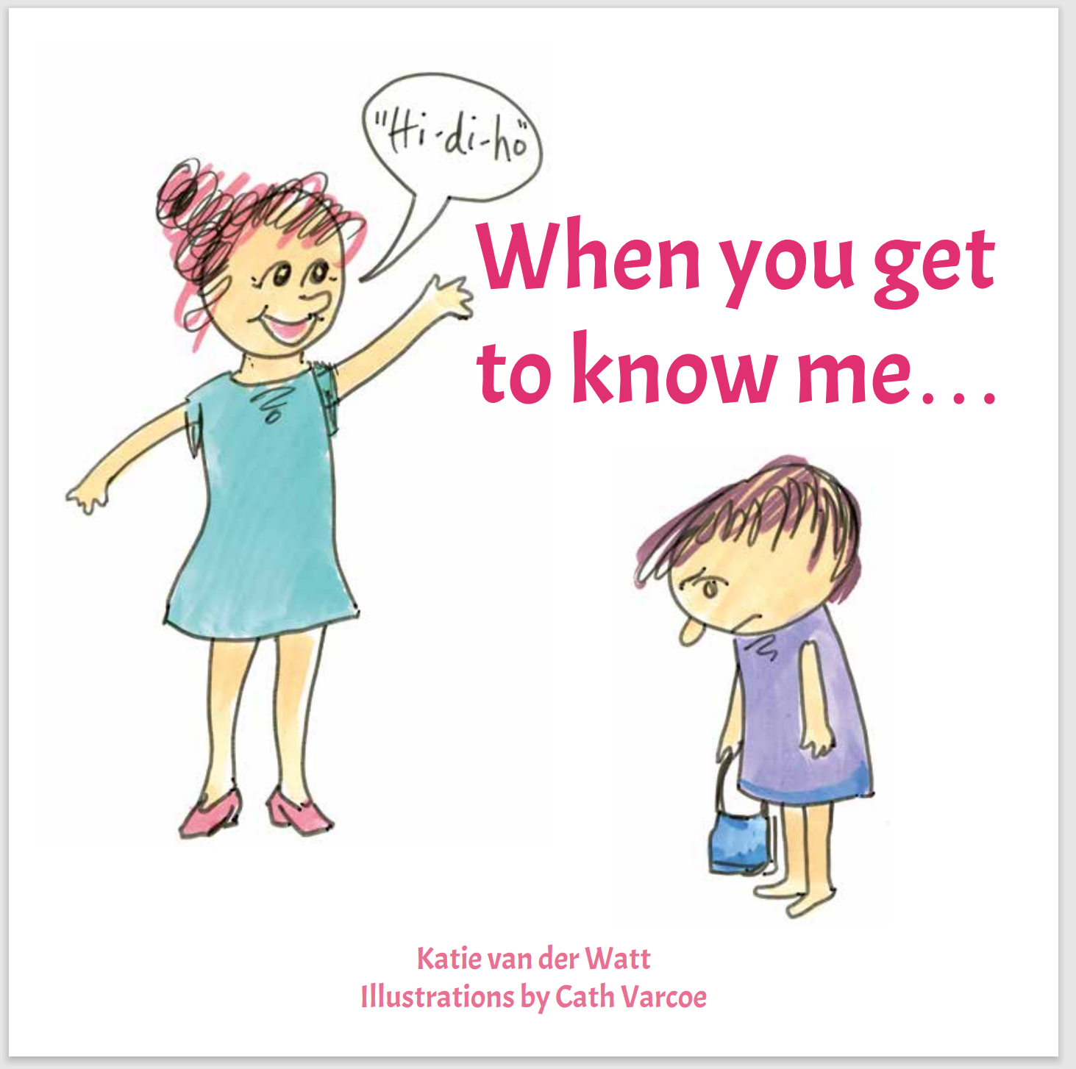  Title: When You Get To Know Me…  Author: Katie van der Watt/ Illustrator: Cath Varcoe  Electronic copy link: When You Get To Know Me...  Supplementary texts:  Ten Little Fingers and Ten Little Toes – Mem Fox  Gus The Asparagus – Ann-Marie Finn with Kaylene Hobson  List of more books: Community-Minded-Kids-Library
Learning Intention: We are thinking about why people may behave differently to me. We are learning that people can experience the world differently to me. We are looking at things from another angle. We are learning to ask people how they see things.  Success Criteria: I understand people have different perspectives and demonstrate this by finding different ways of doing things. I can recognise that there might be different ways to solve a problem. I understand there are differences in the way people experience the world.  Feedback: Modelling alternative solutions. Asking students to find differences. Praising different ways of approaching problems.  Praising suggestions for how to break down barriers to participation. | Activity: Read and discuss “When you get to know me…” opening 5 – “but look the sun’s too bright today” and opening 11 – “but I can only hear the sound of that train” (option to read additional pages/openings).  Opening 5: What is happening here? Why is the child wearing a hat inside? Do you think the other children are wearing hats? Why not? Should we wear a hat inside? If this child doesn’t wear the hat, what will happen? What can we do?  Opening 11: What is happening here? Why is this child not joining in? Do they want to join in? Why are the other children not bothered by the train? What can we do?  Questions related to all openings: What is happening? Is there a barrier or obstacle? Does this mean the child does not want to participate? Does this mean that the child cannot participate? What can we do so everyone can fully participate? What does this child miss out on when not participating fully? What does everyone miss out on when there are barriers that cause people difficulty participating? | Opening 5  Do I see things in a different way? The left picture shows a child wearing a hat indoors.  The right picture shows that, with the hat off, the sunlight shining through the window is too much for the child.  Opening 11  Do I hear things in a different way? The left picture shows a child moving away from children who are joining hands.  The right picture shows the child looking at a train out the window with a sad expression. The child cannot participate as they are overwhelmed by their experience of the train noise.
Evaluation
Where to next:

Adjustments made for:

Number of students in class:
Number of students demonstrating success criteria:

