

Manifest Me

Week 1 –Companion Guide

**Claire Boshoff**

**[Company Name]**

**Manifest Me – Week 1 Companion Guide**

**Description**

Week 1 introduces the foundational mindset of manifestation: the course is “all about you,” emphasizing the person you will become rather than the things you obtain. The session outlines the science–spirit partnership underlying manifestation, previews the 12 Universal Laws that govern the practice, and sets expectations for a supportive, action-oriented community using Zoom, WhatsApp, and Trello as collaboration tools.

**Key Lesson Points**

* Manifestation is identity-first, not thing-first. The journey centers on discovering one’s soul and aligning mind, body, and spirit.
* Heart–brain coherence accelerates results. When thoughts and feelings synchronize, manifestations “explode” in speed and scale.
* The 12 Universal Laws provide the rule-book. From Divine Oneness to Gender (masculine–feminine balance), each law offers a lens for diagnosing blocks and guiding action.
* 80% inner work, 20% aligned action. Internal beliefs, emotions, and subconscious re-programming drive outcomes more than sheer effort.
* Ease is a choice. If the process is expected to be easy, it becomes easy; resistance signals hidden “gremlins” to be cleared.
* Community & tools matter. Breakout rooms, chat, and shared Trello boards create accountability and collective momentum.

Action Steps for This Week

1. Download an aging app (e.g., Aging Booth). Generate a photo of yourself at 90 years old to serve as a daily accountability mirror.
2. Post the image on your Trello board or phone wallpaper. Make one solemn promise to your future self that you will honor throughout the course—review it each morning.
3. Rate your 2030 vision list for difficulty (1 = easy, 10 = impossible). Notice any mental push-back; that friction marks beliefs to rewire.
4. Introduce yourself actively in the WhatsApp group. Share why you joined and what you aim to manifest to strengthen group resonance.
5. Explore Zoom functions. Practice mute/unmute, focus view, and chat so tech never blocks engagement.

**Daily Practices**

* 90-Second Heart–Brain Sync: Close eyes, breathe slowly, and evoke gratitude until you feel warmth in the chest; hold that state before visualizing goals.
* Micro-Reflection Journal: Each evening, log one thought, one feeling, and one micro-action that felt most aligned that day.
* “Is my 90-year-old proud?” Check-in: Pause before key decisions—if the elder self smiles, proceed; if not, revise

Resources and Links:

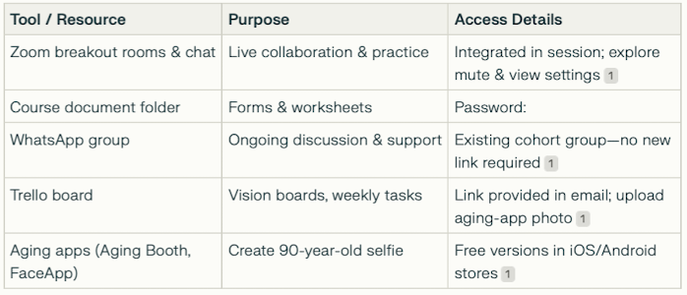

Notable Quotes & Highlights

* “Manifestation is not magic tricks or instant gratification; it is the co-creation process between you and your soul.”
* “If you can’t feel it in your heart, you won’t manifest it quickly.”
* “This time round, no matter what, you’re going to finish the course—even in the hard times, even in the easy times.”

FAQs & Challenges

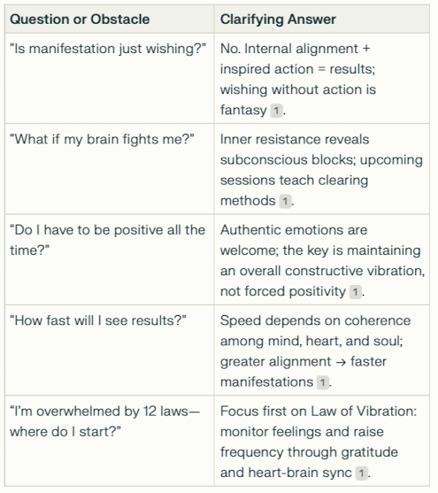

**Additional Insights**

* Science meets spirituality. References to CBT, NLP, neuroscience, and quantum physics frame manifestation as evidence-supported, not mere mysticism.
* Polarity as leverage. Extreme past struggles (e.g., financial hardship) can slingshot into equally extreme abundance once frequency flips.
* Rhythms & seasons. Expect ebbs and flows; manifestation honors natural cycles rather than linear progress.
* Community confidentiality. Honor group privacy to foster candid sharing and deeper breakthroughs.

Commit to the elder-self promise, engage daily, and watch aligned opportunities appear with increasing ease.