Core Stabilizing Progression
The program begins by tightening the abdominal muscles (specifically the internal and external obliques) to produce a neutral pain free spine position. Imagine gently pushing your belly button towards your spine to find the neutral position. While holding the neutral position, the trunk muscles tighten, the pelvis tilts and the curvature in the low back decreases. This position results in decreased pressure in the spine. The spine must be kept in this neutral position during all exercises. This is very difficult but extremely important.
After finding the neutral position, a series of exercises then follows which trains the body to move the arms and legs while maintaining the neutral position and therefore protecting the spine from injury. This program, if done 3 to 5 times per week, has proven to be successful in improving performance, preventing injuries, maintaining proper spine mechanics and prolonging careers in professional athletes.
To begin the program one should start with the beginner trunk. Do 3 to 5 sessions of this program with no problems and then advance to the next level (Intermediate). Do 7 to 10 sessions of the intermediate trunk program. If the program can be done with ease then move to the next level (Advanced). If the program cannot be done with ease then stay at this level.
Do 7 to 10 sessions of the advanced trunk program. If the program can be done with ease then add 1 exercise per session from the physio-ball or med-ball program. Continue this progression until you have a total of 5 exercises from the physio-ball or med-bal program combined with the advanced trunk program.
Beginning Position  Feet on wall or ground  Lateral abdominal muscles tightened  Neutral pain free position obtained  (Draw In Maneuver)(Pelvic Tilt)  **This position must be maintained with all exercises | 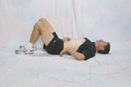
BEGINNER TRUNK

Pelvic Tilt / Draw In  *Feet on wall  *1 set of 10 reps  *Hold each rep 5 seconds | 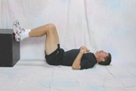

Bridging  *Feet on wall  *5 reps at 2” height  *5 reps at 4” height  *5 reps at 6” height  *Hold each rep 5 seconds | 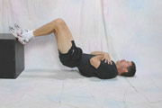

Dead Bug (A)  *Supported march, touch wall  *1 set of 1 minute  *Alternate feet every 10 seconds | 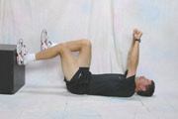 | Dead Bug (B)  *Supported march, push wall  *1 set of 1 minute  *Alternate feet every 10 sec.

Dead Bug  *Unsupported marching  *1 set of 1 minute  *Alternate feet every 10 seconds  *Light touch on wall only | 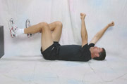

Prone Leg Lifts  *Straight leg lifts  *1 set of 10 reps each leg  *Hold each rep 3 seconds | 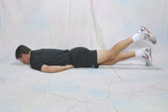

Partial Sit-ups  *Feet on wall with elbows up  *1 set of 10 reps  *Hold each rep 5 seconds | 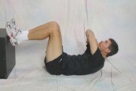

Prone Leg Lifts  *Bent leg lifts  *1 set of 10 reps each leg  *Hold each rep 3 seconds | 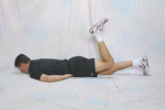

INTERMEDIATE TRUNK

Pelvic Tilt / Draw In  *Feet on floor  *1 set of 10 reps  *Hold each rep 5 seconds | 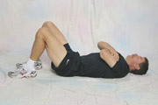

Bridging  *Double leg  *2 sets of 1 min. or 20 reps  with a 5 second hold on each  *Rest 30 sec. between sets | 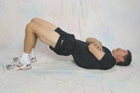

Dead Bug  *Unsupported single extremity  *L arm then L leg ; R arm then R leg  *1 set of 2 minutes  *Alternate one extremity at a time  *Hold each rep 5 seconds  *Modify with foor on wall if needed | 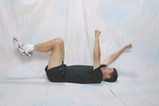 | 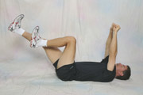

Prone Arm & Leg Lifts  *Lift straight R leg, hold then relax  *Then lift straight L leg and hold  *Then lift L arm and hold  *Then lift R arm and hold  *Hold each extremity for 5 seconds  *1 set of 5 reps for each extremity | 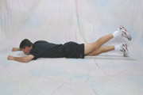 | 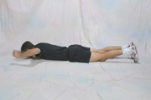

Partial Sit-ups  *Unsupported  *Feet up and elbows up  *1 set of 10 reps  *Hold each rep 5 seconds | 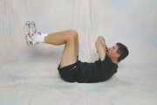

Prone Arm & Leg Lifts Bent  *Lift bent R leg and hold, relax  *Lift bent L leg and hold, relax  *Lift L arm and hold, relax  *Lift R arm and hold, relax  *Hold each extremity for 5 seconds  *1 set of 5 reps for each extremity | 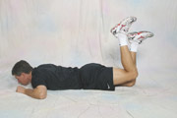 | 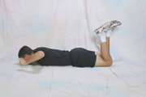

Partial Sit-ups  *Unsupported  *Feet up and elbows up  *1 set of 10 reps  *Hold each rep 5 seconds | 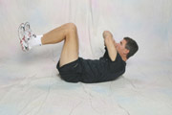

ADVANCED TRUNK

Bridging  *Feet on wall  *5 reps at 2” height  *5 reps at 4” height  *5 reps at 6” height  *Hold each rep 5 seconds | 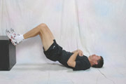

Dead Bug  *Unsupported; R Arm & L Leg  *Unsupported; L Arm & R Leg  *Alternate every 10 seconds  *2 sets of 2 minutes  *Modify with feet on wall, if needed  *Rest 30 seconds between sets | 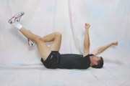

Bridging  *Single leg bridge feet on ground  *Alternate feet every 5 seconds  *1 set of 2 minutes or 20 reps | 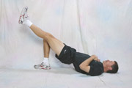

Partial Sit-ups  *Unsupported  *Feet up – Hands up  *1 set of 10 reps  *Hold each rep 5 seconds | 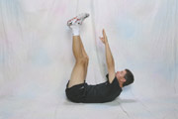

Prone Diagonals  *Lift R arm & Straight L leg  *Lift L arm & Straight R leg  *1 set of 10 reps each diagonal  *Hold each rep 5 seconds | 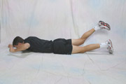

Partial Sit-ups  *Feet on wall w/rotation R & L  *5-10 lb weight on chest  *1 set of 5 reps each R & L  *Hold each rep 5 seconds | 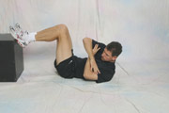 | 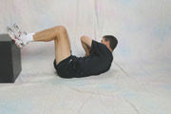

Prone Diagonals  *Lift R arm & Bent L leg  *Lift L arm & Bent R leg  *1 set of 10 reps each diagonal  *Hold each rep 5 seconds | 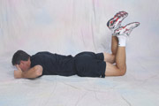

PHYSIO-BALL PROGRESSIONS

Bridging

*Double Leg w/ Back on ball  *1 set of 10 reps or  *1 set with a 1 minute hold | 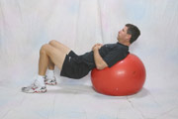 | 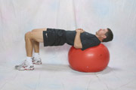

*Single Leg w/ Back on ball  *1 set of 10 reps or 1 set of 1 min.  *If you are unable to do this initially,  then do double leg up and single leg  down | 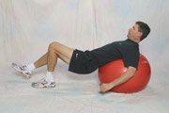 | 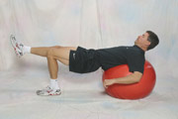

*Double Leg w/ Feet on ball  *1 set of 10 reps or  *1 set with a 1 minute hold | 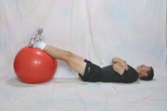 | 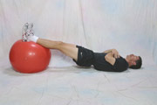

*Double Leg w/ Feet on ball Knees Bent  *1 set of 10 reps or  *1 set with a 1 minute hold | 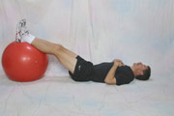 | 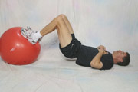

*Single Leg w/ Foot on ball  *1 set of 10 reps or  *1 set with a 1 minute hold | 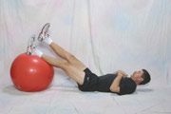 | 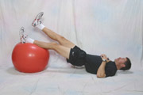

Prone *Exercises can be done with weights or tubing in hands

*Prone Flies  *1 set of 10 reps  *Hold each rep 3 seconds | 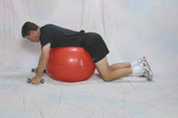 | 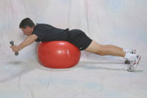

*Prone Swim  *1 set of 10 reps  *Hold each rep 3 seconds | 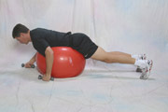 | 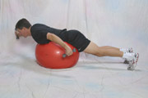

*Prone Superman  *1 set of 10 reps  *Hold each rep 3 seconds | 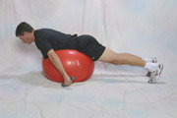 | 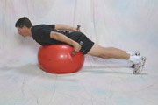

*Prone Arm & Leg  *1 set of 10 reps each diagonal  *Hold each rep 3 seconds | 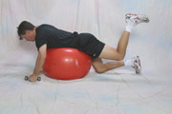

Abdominal Crunches *Weight resistance *Tube resistance

*Ab Crunches Forward  *1 set of 10 reps  *Hold each rep 5 seconds | 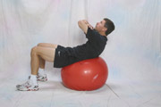 | 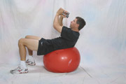 | 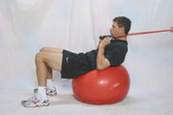

*Ab Crunches Right  *1 set of 10 reps  *Hold each rep 5 seconds | 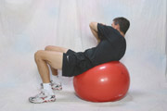 | 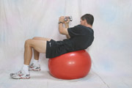 | 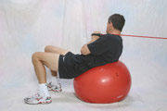

*Ab Crunches Left  *1 set of 10 reps  *Hold each rep 5 seconds | 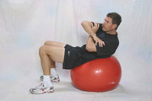 | 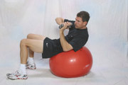 | 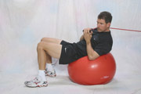

*Ab Crunch Diagonal R w/L leg lift  *1 set of 10 reps  *Hold each rep 1 second | 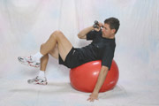 | 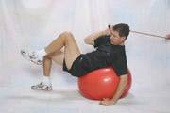

*Ab Crunch Diagonal L w/R leg lift  *1 set of 10 reps  *Hold each rep 1 second | 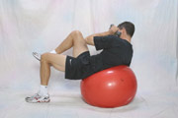 | 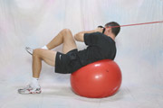

MED-BALL OR PLYO-BALL EXERCISES

*Diagonal Chops  *1 set of 10 reps each direction  *Chop may be to waist or knee | 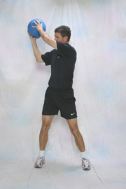 | 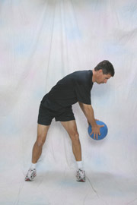

*Standing Twists  *1 set of 10 reps each direction | 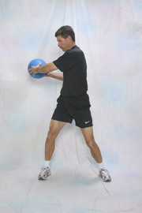 | 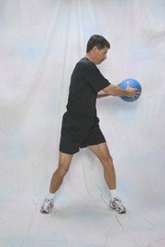

*Standing Twist with Throw  *1 set of 10 reps each direction | 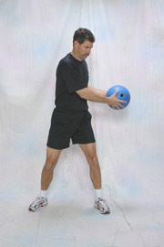 | 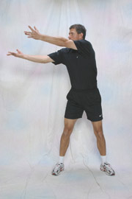

*Single Leg Chop  *1 set of 5 reps each direction  *1 set each leg | 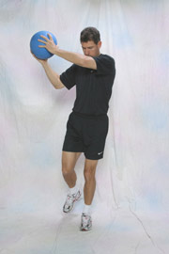 | 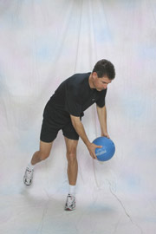

*Seated Throws  *1 set of 10 reps each direction | Bench  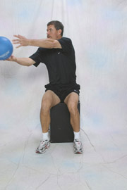 | Physio-ball  