**YAZEED ATIYA**

SENIOR UX/PRODUCT DESIGNER SPECIALIST

PROFILE

Senior UX/Product Designer with 16+ years of experience designing intuitive, scalable digital solutions across the FinTech and enterprise software sectors. Proven track record of leading high-performing design teams, streamlining complex systems, and delivering measurable business value. Expert in UX research, interaction design, accessibility, and prototyping—skilled at aligning cross-functional teams around human-centered design principles. Passionate about building design systems, optimizing workflows, and crafting seamless user experiences that drive engagement and retention.

WORK EXPERIENCE

**Lead Product Designer**

Bank of America Feb. 2024 - Present

* Rebuilt point-of-sale software templates using enterprise design systems, improving functionality and design consistency.
* Redesigned the merchant onboarding flow to simplify user experience and enhance associate comprehension, aligning with brand and accessibility standards.
* Led the migration from Sketch to Figma, improving file organization, version control, and cross-team accessibility.
* Built and maintained a scalable Figma-based style guide and component library, enhancing design consistency and development efficiency.
* Developed a dark mode strategy for associate-facing applications, applying Material Design principles and ensuring WCAG 2.2 compliance.
* Partnered with developers, content strategists, and product managers to ensure intuitive design across mobile and web apps.
* Created flowcharts, low-/high-fidelity wireframes, and interactive prototypes in Figma.

**Senior UX Designer Specialist**

Ally Financial Nov. 2008 - Dec. 2024

* Served as the first UX hire at Ally, playing a key role in building the UX team and establishing a human-centered design culture across the organization.
* Contributed to the creation and evolution of **TM Studio**, an internal innovation hub, by rapidly prototyping and testing new banking concepts. Helped shape strategic initiatives that unlocked in-house talent and positioned Ally at the forefront of innovation.
* Mentored junior designers to foster a culture of continuous learning and design excellence.
* Led the redesign of the **Ally Mobile app**, enhancing onboarding and feature discovery. These improvements resulted in a **25% increase in daily active usage** and a **30% boost in feature interaction.**
* Initiated and led the **One Click app redesign**, achieving a **32% uplift in user engagement.**
* Delivered measurable improvements in product usability and customer satisfaction, contributing to a **15% increase in customer retention.**

CONTACT

 980-621-1011

 yazeedzee@gmail.com

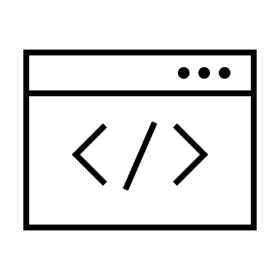 [https://yazeedux.com](https://yazeedux.com/)

 Charlotte, NC

SKILLS

* Design Leadership
* Strategic Thinking
* User Research & Analysis
* Wireframing & Prototyping
* Interaction Design
* Usability Testing
* Accessibility & Inclusivity
* Technical Understanding
* Responsive Design

TOOLBOX

* Figma
* Adobe Creative Suite
* Sketch
* InVision
* Keynote
* UserTesting
* Maze
* FigJam
* JIRA
* Slack
* Microsoft Office Suite

EDUCATION

Bachelor of Fine Arts and Technology

**University of Massachusetts**

While pursuing my degree, I worked as an assistant in the art department, supporting professors with gallery setups, maintaining photography equipment, and troubleshooting design software in computer labs.

I also helped onboard new students by sharing guidance on the curriculum and resources, and mentored peers by offering feedback, technical support, and design best practices.

**UX/UI Designer**

Wachovia Bank Dec. 2006 - Nov. 2008

* Delivered high-quality design outputs including wireframes, mockups, visual specs, prototypes, and graphical assets.
* Designed web and mobile interfaces emphasizing intuitive navigation, visual cohesion, and user engagement.
* Partnered with front-end developers, applying HTML and CSS to refine layouts and ensure pixel-perfect implementation.
* Established and maintained a design system and visual style guide to promote consistency across digital products.
* Conducted A/B testing and usability research to guide iterative improvements based on user feedback.