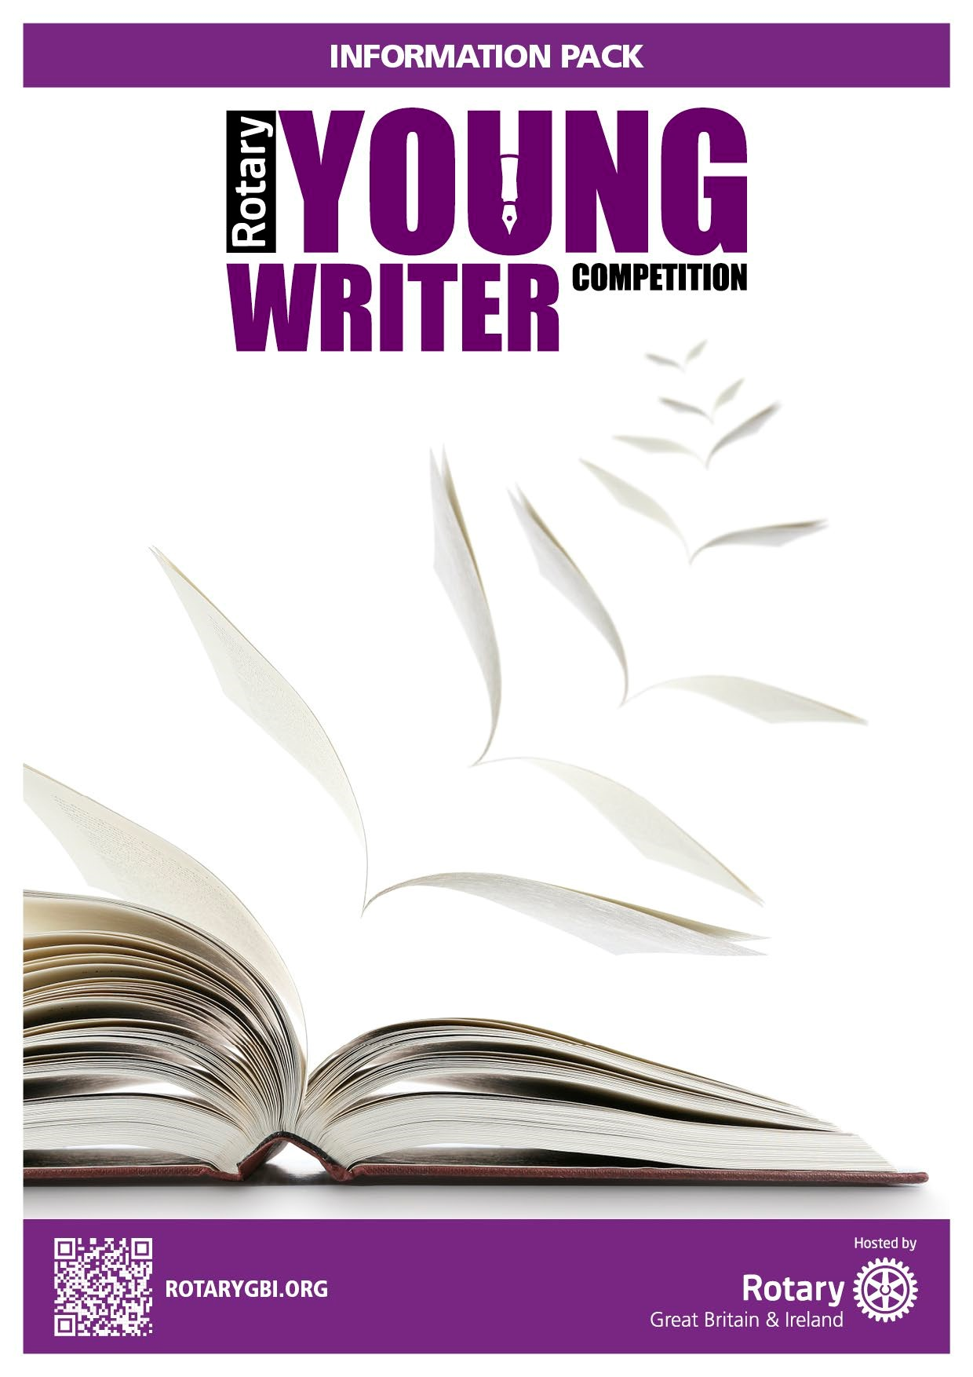
The Rotary Club of Caterham
2024
Information for Competitors

Young Writers
Information Pack 2026

THEME – ‘Space’

Introduction

The theme for our Young Writers competition is ‘Space’. This title will give young people the widest opportunity to share their creative talents in showing what the idea of ‘Space’ means to them.
The competition aims to encourage young people to
- Be creative.
- Use their writing skills.
- Write with imagination and creativity.
The task is to produce a typed or handwritten piece of writing entitled “Space”. It can be fiction or non-fiction and can be in prose or poetry. Handwriting and spelling will not be part of the judging criteria.

Who can take part?
This competition is open to all young people resident in or attending schools in the CR3 & CR6 area. Cash prizes and awards will be given in two age groups.
- KS2 (7-11 years)
- KS3 (11-14 years)

Important Notes:
The writing must be the original work of the entrant without assistance from parents/ guardians or carers or make use of artificial intelligence.
There should be only one submission per entrant.
Complete the Entry Form. (Unfortunately, entries received without a form cannot be included)
Competitors must include their age on the application form.
Send the Entry and Entry Form to: writing@caterhamrotary.org.uk , or delivery to Caterham Rotary, c/o Computer Solutions, 5b High Street, Caterham, CR3 5UE, by midnight 30th April 2026
The judges will not enter any discussion or correspondence regarding their decision; the decision of the judges will be final and not subject to any appeal.

Judging Criteria
Judges with appropriate skills, appointed by the Rotary Club of Caterham, who will look at the content and composition as well as imagination and style.
Judges will consider:
- imagination relative to the subject
- the ability to engage interest.
- the ability to be consistent in the power of argument.
The judges will not enter any discussion or correspondence regarding their decision; the decision of the judges will be final and not subject to any appeal.

Prizes
There will be cash prizes for the winner and 2 runners up in each of the age groups. Certificates of merit will also be awarded to other participants at the discretion of the Judges. All winners and runners –up will be notified by 15th May 2026
The prizes will be.
- 1st Prize £50
- 2nd Prize £30
- 3rd Prize £20
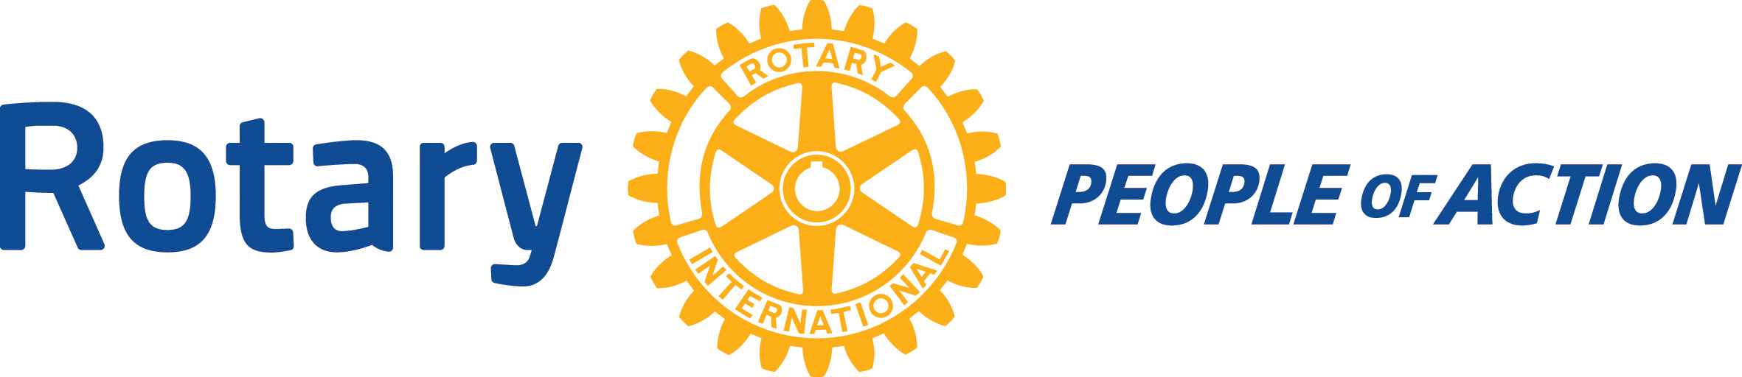

Young Writers
ENTRY FORM 2026

My Full Name | I am in Year
Age Category KS2 KS3 (please circle category)
Full Name of Parent/Guardian/Carer (Print):
Home Address (including Postcode) | Email of Parent/ Guardian/ Carer
Home Address (including Postcode) | Tel No of Parent/ Guardian/ Carer
Entrant’s signature (I declare that the entry is entirely my own work) | Date
I attend the following School.

SECTION TO BE COMPLETED BY PARENT/ GUARDIAN OR CARER
I have read and understood the information provided and agree to be bound by the rules of the competition and the terms set out below.
Signature |  | Date

TERMS:
You Give permission:
- For the named person to take part and be identified in the competition.
- For submissions to be used by Rotary International in Great Britain and Ireland (RIBI) for publicity purposes in printed, electronic and online formats.
- In signing this form the parent/guardian/carer allows permission for contact by the Rotary Club of Caterham Publicity Team

Working with Children Rotary International in Great Britain and Ireland has adopted this statement of policy in working with children, the vulnerable and those with disability:
“The needs and rights of the child, the elderly, the vulnerable and those with disability take priority. It is the duty of every Rotarian to safeguard to the best of their ability, the welfare of and prevent the physical, sexual or emotional abuse and neglect of all children, the elderly, persons with disability or otherwise vulnerable persons with whom they come into contact during their Rotarian duties.”
The Rotary Club of Caterham respects your rights and does not claim copyright for works you submit to this contest. You will retain full copyright in each entry. In addition, your moral rights are respected. Whenever your work is published by The Rotary Club of Caterham (and its partners), you will be credited. Failure to publish a credit due to error or oversight shall not be deemed a breach of this condition.
By entering this contest, you agree that any (winning or shortlisted) work you submit may be used by The Rotary Club of Caterham (and its partners) solely for marketing and promotional purposes of this contest or future contests and for no other purpose. These uses include:-
- judging the competition,
- displaying the entries on the Rotary website (and websites of partners),
- displaying the entries at public exhibitions to promote the competition,
- displaying the entries in a book, magazine, any newspaper or similar,
- publishing the entries on posters to promote the competition,
- publishing the entries on postcards to promote the competition,
- publishing the entries on a calendar to promote the competition,
- cropping and re-sizing the work as necessary to fit pre-defined formats to promote the competition,
- sub-licensing the entries to the press for reproduction in connection with the competition and any related exhibition,
- inclusion within any materials promoting the competition or any exhibition of works from this competition organised by The Rotary Club of Caterham.
You hereby grant The Rotary Club of Caterham a non-exclusive, irrevocable licence in each entry throughout the world in all media for the issues described above for 3 years following the date of announcement of the winners.
Please note that any publicity photographs of the winners, under 18 years old, must be accompanied by written permission from the parent, guardian or carer of the person/s photographed.

