
SKYKART STAND ASSEMBLY MANUAL
Models: FP1, FP2, FP3

⚠️ IMPORTANT SAFETY INFORMATION
READ ALL INSTRUCTIONS BEFORE ASSEMBLY
- Always wear safety glasses and gloves during assembly
- Keep children and pets away from assembly area
- Use caution when handling metal parts - edges may be sharp
- Ensure stand is on a flat, non-slippery, non-markable, stable surface during assembly
- A second person may be helpful for holding parts in place during assembly
CUSTOMER SUPPORT
Phone: 585.738.5907
Email: Alex@skykartstands.com
Website: www.skykartstands.com
Hours: Mon-Fri 8AM-6PM EST

INTRODUCTION
Thank you for purchasing your stand from SkyKart Stands! This heavy-duty, fully collapsible stand will make maintenance, transportation and storage of your go-kart safe and convenient.
Estimated Assembly Time: 30-45 minutes
Skill Level: Beginner
Number of People Required: 1-2 people (2 recommended)

Before You Begin
✓ Clear a workspace of at least 6 ft x 4 ft
✓ Verify all parts are included (see Parts List)
✓ Gather all required tools
✓ Read through all instructions before starting
✓ Dispose of packaging materials safely

PARTS INCLUDED

Main Components
Part Name | Quantity
Main Body | 1
Arm Body | 1
Front Arm | 1
Rear Arm | 1
Handle | 1
Front Axle | 1
Rear Axle | 1
Bumper Hooks | 2
Electric Winch (FP2 & FP3 models only) | 1
Hand Winch (FP1 model only) | 1
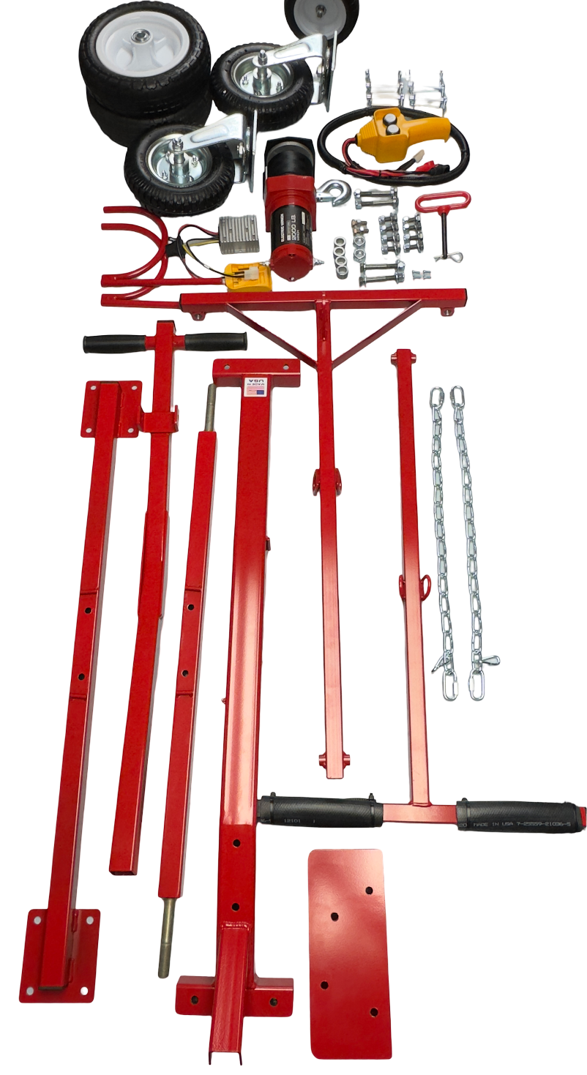

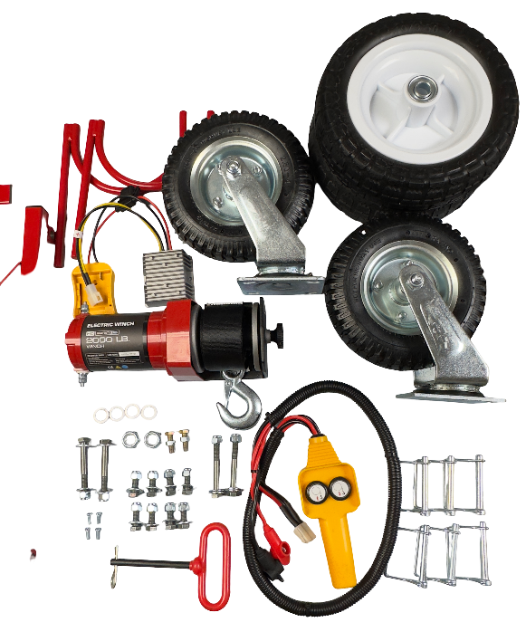
Hardware & Accessories
Description | Quantity | Notes
Front Wheels (non-swivel) | 2 | With 4 spacers
Rear Swivel Wheels | 2 | With mounting hardware
Locking Pins | 6 | For axle assembly
Bolts, Nuts, and Washers | Various | Pre-sorted by step

Parts Checklist: Check off each item as you verify it is included. If any parts are missing, contact customer support before beginning assembly.

TOOLS NEEDED

Essential Tools
- ✓ 15/16" Socket
- ✓ Two 9/16" Wrenches (or one 9/16" wrench and one 9/16" socket)
- ✓ 1/2" Wrench
- ✓ #2 Phillips Head Screwdriver

Recommended (Optional)
- Socket Wrench or Ratchet (speeds assembly)
- Work Gloves (for hand protection)
- Second Person (helpful for holding parts during assembly)

ASSEMBLY INSTRUCTIONS

STEP 1: Unbox and Organize the Parts
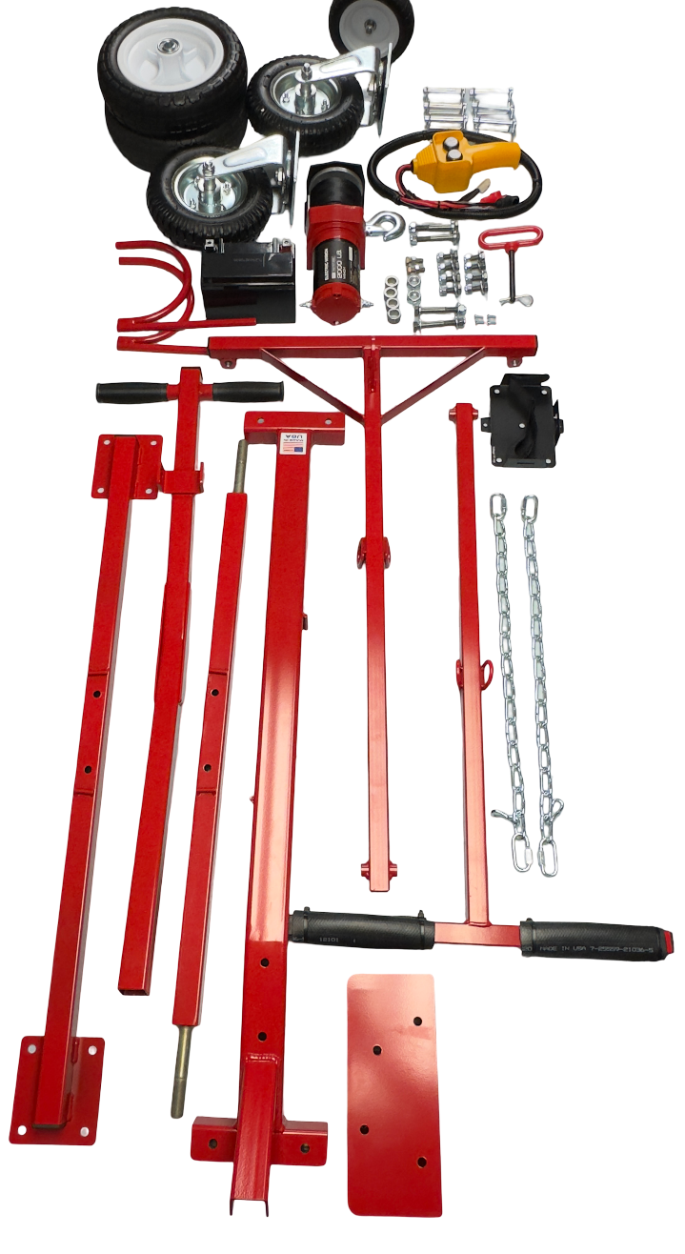
Tools Needed: None
- Open the box carefully and lay out all parts on a clean, flat surface
- Identify each component based on the parts list above
- Check for any missing pieces - ensure everything matches the list in this manual
- Organize hardware (bolts, nuts, washers, pins) in small containers to prevent loss
- Review the instruction manual thoroughly before proceeding

⚠️ IMPORTANT: Do not proceed with assembly if any parts are missing. Contact SkyKart Stands customer support immediately.

STEP 2: Assemble the Front Axle and Tires
Tools Needed: 15/16” Socket
- Identify the wheel mounting points on the front axle
- Take one front wheel (non-swivel) and locate the provided spacers
- Position one spacer on each side of the tire
- Ensure the long side of the wheel hub is facing toward the center of the stand
- Attach the wheel to the front axle using the provided nuts
- Tighten securely with 15/16” socket, ensuring spacers are snug
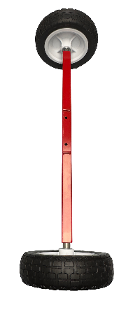
- Verify the wheel spins freely without wobbling
- Repeat this process for the second front wheel
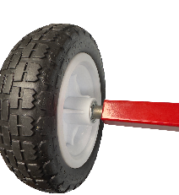
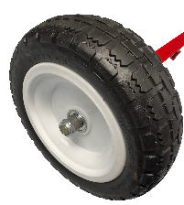
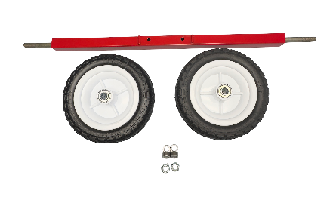

💡 TIP: The spacers should fit snugly against the tire. The wheel should spin freely but not have excessive side-to-side play.

STEP 3: Assemble the Rear Axle and Swivel Tires
Tools Needed: 9/16" wrenches or socket
- Identify the wheel mounting plates on the rear axle
- Take one swivel wheel assembly
- Place a washer on the bolt (washer should be on the bolt-head side)
- Insert the bolt from the bottom of the swivel tire upward through the axle plate
- Thread the nut onto the bolt (nut should be on top of the axle)
- Tighten securely using 9/16" wrenches, ensuring all hardware is snug
- Verify the swivel wheel moves freely in all directions
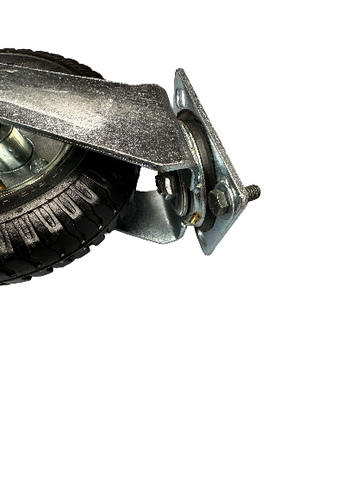
- Repeat this process for the second swivel wheel
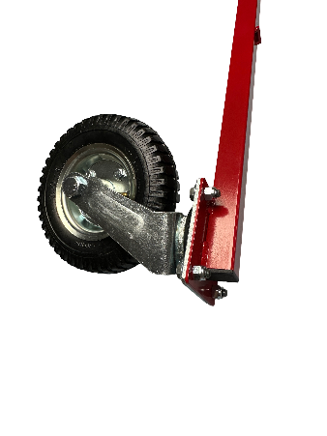
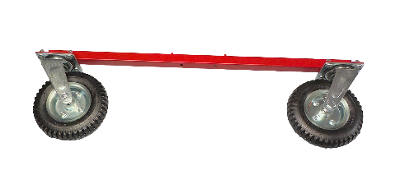
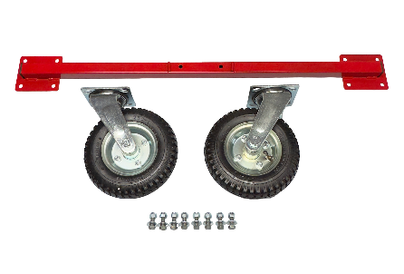
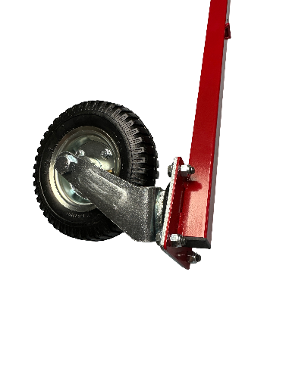

⚠️ IMPORTANT: Bolts must be inserted from the bottom of the swivel tire to the top of the axle plate. Washer goes on the bolt-head side.

STEP 4: Assemble Main Body
Tools Needed: None (hand assembly)
- Locate the front axle assembly (with non-swivel tires) from Step 2
- Identify the front of the main body (this is the non-handle side)
- Slide the front axle into the main body mounting points
- Orient the small alignment tabs so the open end faces up and toward the center of the stand
  - This orientation aids in perfect alignment of the locking pins
- Align the holes in the axle with the holes in the main body
- Insert 2 locking pins into the aligned holes
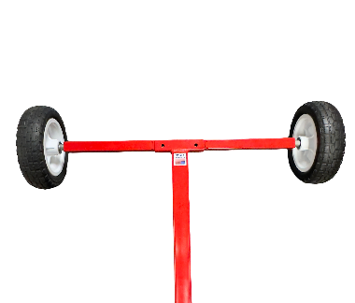
- Lock the pins in place using the locking mechanism
- Test that the axle is secure by gently pulling on it
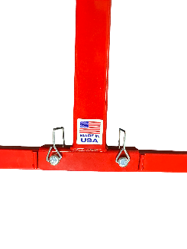

- Now locate the rear axle assembly (with swivel tires) from Step 3
- Slide the rear axle into the rear mounting points of the main body
- Ensure the alignment tabs are oriented properly (open end facing center of body)
- Insert 2 locking pins into the aligned holes
- Lock the pins in place
- Test that both axles are securely locked
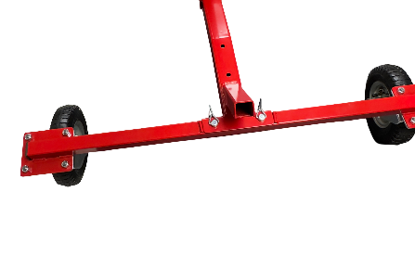

💡 TIP: The alignment tabs are critical for proper function. Take your time to ensure they're positioned correctly before inserting the locking pins. Holes will not line up if axle is backward.

STEP 5: Attach the Arm Body(and arms) to the Main Body
Tools Needed: None
- Locate the Arm Body component
- Position the Arm Body in the 'up' position (first picture):
- Align the Arm Body with the alignment tabs on the Main Body
- Insert Pins through the connection points
- Latch the pins closed
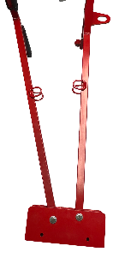
- Verify all connections are secure and stable
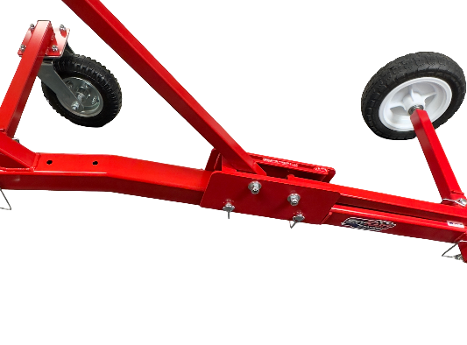
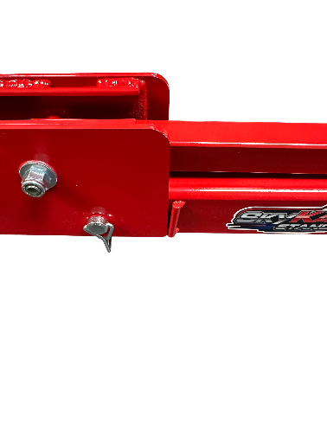

⚠️ WARNING: Ensure the Arm Body is in the correct 'up' position before placing pins. Do not drill out or change the holes as they have to be properly aligned to slide in. Incorrect orientation will prevent proper operation.

STEP 6: Install Chains
Tools Needed: None
- Locate the chains and quick links
- Connect the quick links to one side of the front and rear lift arms
- Maintaining congruent chain links (aligned and in the same direction) as this will make sure the chains are the same length
- Lock the quick links in place
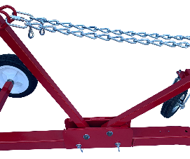
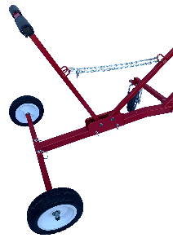

💡 NOTE: If you have to adjust the distance between arms for various size go-karts, move the quick links to a longer or shorter link on the chain maintaining the same number of links on both chains to maintain the same length.

STEP 7: Install Handle
Tools Needed: None
- Locate the Handle component
- Identify the handle mounting point on the rear of the body
- Align the handle with the mounting bracket
- Insert the handle all the way into the bottom of the handle slot
- Test the handle for stability by gently pulling on it
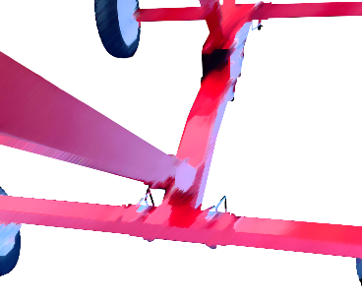

STEP 8: Attach Bumper Hooks
Tools Needed: 1/2" wrenches
- Locate the 2 Bumper Hooks
- Identify the bumper hook mounting points (on rear arms)
- Position one Bumper Hook into its designated location
- Insert bolts and tighten securely leaving 2.5” of the hook sticking out the bottom of the mounting slug(see picture)
- After tightening bolt, lock the jam-nut!
- Repeat for the second Bumper Hook
- Ensure both hooks are firmly attached and oriented correctly
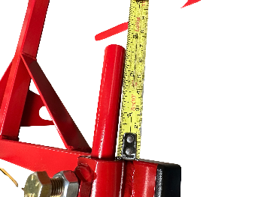
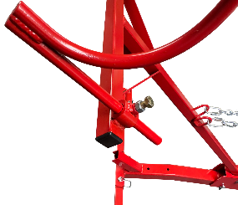
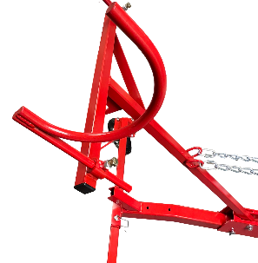

STEP 9: Install Electric Winch (FP2 & FP3 Models Only)
Tools Needed: #2 Phillips head screwdriver, 9/16" wrenches
- Locate the battery tray and battery
- Align the battery tray with the two holes on the main body
- Screw in the screws with the #2 Phillips head screwdriver
- Place battery on the tray
- Strap down the battery (front of stand to back of stand direction) and secure the battery
- Locate the Electric Winch and mounting hardware(pre installed in body)
- Identify the winch mounting location on the stand
- Position the winch at the mounting point
- Insert mounting bolts through the bottom of the main body up through winch base with washer on bolt head side
- Tighten securely using 9/16” wrenches
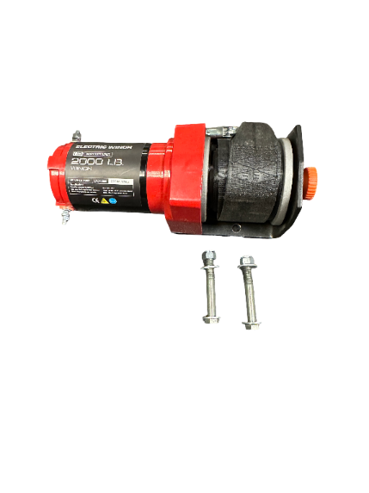
- Route the winch cable from the winch up through the handle roller to the lift arm hook
- Test winch operation before loading go-kart
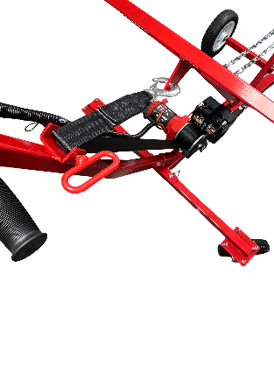
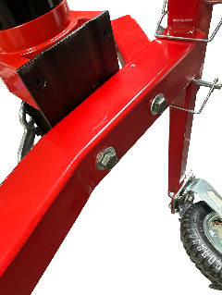
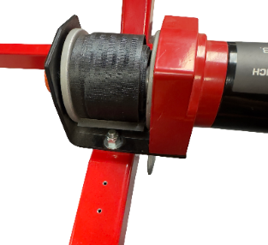

⚠️ IMPORTANT: Before lifting anything with this stand, validate and test that all mechanisms are working properly.
💡 NOTE: If you have a standard model without electric winch, skip this step.

STEP 9a: Install DeWalt Battery Connector (FP2 Only)
Tools Needed: #2 Phillips head screwdriver, 9/16" wrenches
- Locate the DeWalt connector and mounting hardware
- Identify the DeWalt and Step-down converter mounting location on the body
- Position the DeWalt battery connector (yellow) at the top “battery” mounting point on the main body
- Insert mounting screws through DeWalt connector into main body
- Tighten securely using the #2 Phillips head screwdriver
- Position the DeWalt Step-Down converter (silver) at the side mounting point
- Insert mounting screws
- Tighten securely using the #2 Phillips head screwdriver
- Route the winch cable from the winch up through the handle roller to the lift arm hook
- Test winch operation before loading go-kart
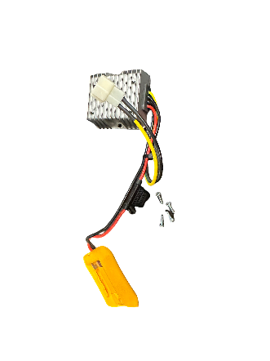
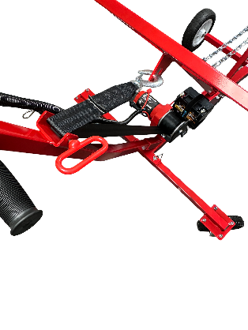
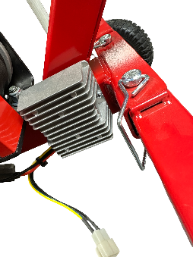
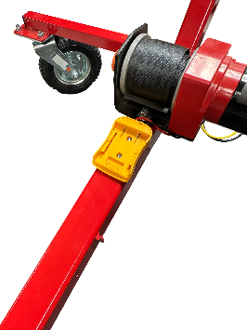

⚠️ IMPORTANT: Before lifting anything with this stand, validate and test that all mechanisms are working properly.
💡 NOTE: If you have a standard model without electric winch, skip this step.

STEP 9b: Install Manual Winch on Body (FP1 Only)
Tools Needed: 9/16" wrench
- Locate the Manual Winch and mounting hardware
- Identify the winch mounting location on the stand handle
- Position the winch at the mounting points, one long bolt and two short bolts
- Insert mounting bolts through the winch base and fasten washer and nuts
- Tighten securely using the 9/16” wrenches
- Route the winch cable from the winch up to the lift arm hook
- Test winch operation before loading go-kart
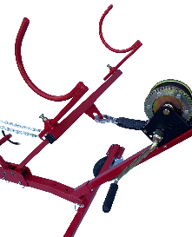
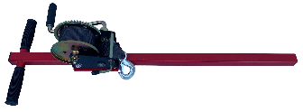

⚠️ IMPORTANT: Read the separate Electric Winch manual for detailed operation and safety instructions.
💡 NOTE: If you have a standard model without electric winch, skip this step.

FINAL INSPECTION & SAFETY CHECK
Before using your SkyKart Stand, complete this comprehensive checklist:

Assembly Verification
- [ ] All bolts and nuts are fully tightened
- [ ] No loose hardware or missing parts
- [ ] No wobbling when gentle pressure is applied
- [ ] Front wheels spin freely
- [ ] Rear swivel wheels move freely in all directions
- [ ] Locking pins are properly engaged on both axles
- [ ] Arm Body is in correct 'up' position (cut out on top)
- [ ] Front and Rear Axles are level and aligned
- [ ] Handle is securely attached
- [ ] Bumper Hooks are firmly in place
- [ ] Electric Winch is operational (FP2 & FP3 only)
- [ ] Rear tires are filled to appropriate PSI

Stability Test
- Place stand on flat, stable surface
- Gently push or shake the stand to verify stability
- Apply downward pressure to the support arms
- Check for any movement or instability
- Make any necessary adjustments if wobbling occurs
- Stand should remain firm and stable under pressure
If any issues are detected, review assembly steps and retighten all connections.

USING YOUR SKYKART STAND

Loading Your Go-Kart
- Position the stand near your go-kart on a flat, stable surface
- Use the handle to maneuver the stand into position
- If equipped with electric winch (FP2 & FP3), use the winch to lift the kart while simultaneously pushing the stand under the go kart while its being lifted
- For manual stands(FP1) this process is the same, insure the locking bolt is engaged and clicking Is heard while lifting go-kart
- Ensure the kart frame rests securely in both the Front and Rear Arms
- Verify the go-kart is balanced and stable before moving

Weight Distribution
- Always center the go-kart on the stand
- Maximum weight capacity: 250 lbs
- Do not sit on go-kart while on stand
- Ensure weight is evenly distributed across both support arms

Moving the Stand
- Use the handle to push or pull the stand
- Swivel rear wheels make maneuvering easy
- Always move slowly and carefully when go-kart is loaded
- Ensure path is clear of obstacles

MAINTENANCE & CARE

Regular Inspection
- Check all bolts and nuts monthly for tightness
- Inspect wheels for damage or excessive wear
- Verify locking pins are functioning properly
- Check support arms for any major damage
- Test electric winch operation regularly (FP2 & FP3)
- Clean stand with damp cloth - do not use harsh chemicals(NO BRAKE CLEANER!)
- Lubricate moving parts (arm pivot points,wheels, swivel mechanisms) as needed
- Store in dry location when not in use

Replacement Parts
Contact SkyKart Stands customer support for replacement parts. Have your model number ready when ordering.

TROUBLESHOOTING
Problem: Stand wobbles on flat surface
Solution: Check that all four wheels are making contact with the ground. Verify all bolts are tightened. Adjust wheel assemblies if necessary.
Problem: Wheels don't spin or swivel freely
Solution: Check that spacers and washers are correctly installed. Ensure nuts are tight but not over-tightened. Lubricate wheel bearings if needed.
Problem: Locking pins won't insert or engage
Solution: Verify alignment tabs are oriented correctly (open end up, facing center). Ensure axle is fully seated in mounting points. Check that holes are properly aligned.
Problem: Support arms not level
Solution: Loosen mounting bolts slightly. Adjust arm position until level. Retighten all bolts securely. Use a level tool for accuracy.
Problem: Go-kart doesn't sit securely on stand
Solution: Verify Front and Rear Arms are properly aligned and level. Ensure go-kart frame is centered on the stand. Adjust arm positions if needed. Use Bumper Hooks for additional security.
Problem: Electric winch not working (FP2 & FP3)
Solution: Check power connection. Verify winch is properly mounted. Contact a SkyKart stands rep for further assistance.

WARRANTY INFORMATION
Your SkyKart Stand is covered by a lifetime warranty on all welds & a 1-year limited warranty against other manufacturing defects. This warranty does not cover damage from misuse, modifications, or normal wear and tear.
For warranty claims or questions, contact SkyKart Stands customer support with your proof of purchase. Additional information may be required to file a warranty claim. SkyKart Stands reserves the right to honor or deny any claims.

CONTACT US
SkyKart Stands
6970 Warboys Road
Byron, NY 14422
Customer Support:
Phone: 585.738.5907
Email: Alex@skykartstands.com
Website: www.skykartstands.com
Hours:
Monday - Friday: 8:00 AM - 6:00 PM EST
Saturday: 9:00 AM - 3:00 PM EST
Sunday: Closed

TIPS AND WARNINGS

Assembly Tips
- Read the manual thoroughly before starting assembly
- Wear gloves to protect your hands while handling metal components
- A second person is helpful for holding parts in place during assembly
- Organize hardware in small containers to prevent loss
- Don't fully tighten bolts until all components are in place
- Take your time and double-check each step

Safety Warnings
- Always use stand on flat, stable surface
- Never exceed maximum weight capacity of 250 lbs
- Keep children away from stand during loading/unloading
- Ensure go-kart is properly secured before working on it
- Do not use stand if any components are damaged
- Inspect stand regularly for wear or damage

Thank you for choosing SkyKart Stands. Happy Racing!
Document Version 1.0 | Last Updated: February 2026

