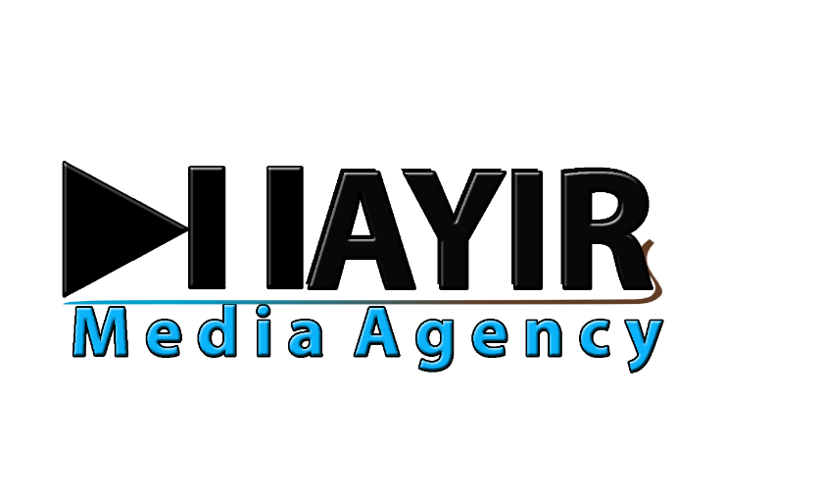

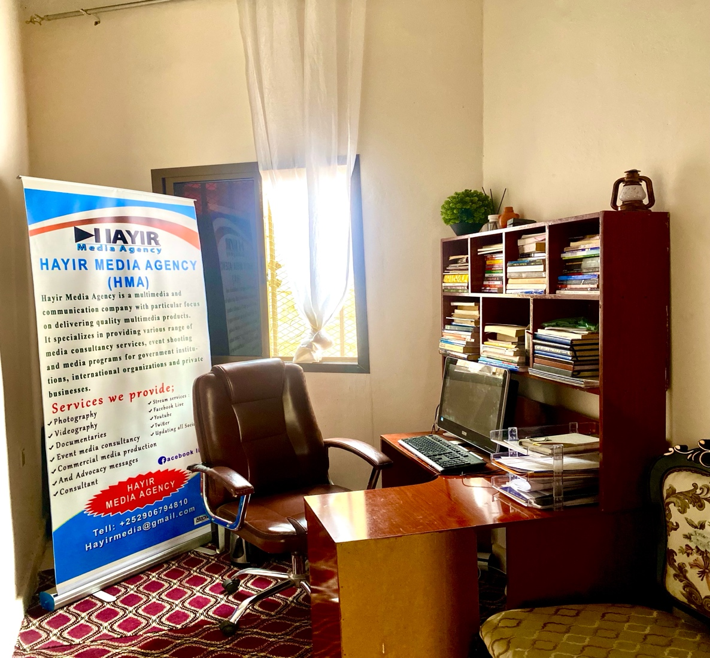

# Hayir

# Media Agency’s Profile

|  |  |
| --- | --- |
| Organization Name | Hayir Media Agency |
| Primary Contact | +252-90-6794810 |
| Reg. No | 15832 |
| Registration Type | Non-governmental Community Media Organization |
| Email | [hayirmedia@gmail.com](mailto:hayirmedia@gmail.com) |
| Address | Halgan, Main Streat, Garowe, Somalia |

Table of Contents

PART A: HMA BACKGROUND Error! Bookmark not defined.

1.0 About Hayir Media Agency: 2

Vision: - 2

Mission: - 2

Our Value: - 2

1.2. Organizational chart 2

1.3. Scope Work 3

1.4. Our Team 3

1.5. Our Main Services 3

Corporate videos 3

Publishing and print 3

Public relations 3

## About Hayir Media Agency:

Hayir Media Agency is a leading multimedia and communication company dedicated to delivering high-quality multimedia products to a diverse range of clients, including individuals, businesses, government agencies, and non-governmental organizations (NGOs). Operating locally and regionally across Somalia, we specialize in helping our clients promote, market, and sell their products, services, and messages. Whether you are a well-established corporation, a small business, a government institution, or an academic organization, Hayir Media is your trusted partner in strategic communication and media production.

We aim to elevate your brand presence and establish your footprint in Somalia’s rapidly growing market. We are committed to enhancing your image as a reliable and high-quality service provider while maximizing your reach and impact. With our headquarters in Garowe, the capital city of Puntland State, we are well-positioned to serve clients across the region.

### Vision: -

To provide exceptional multimedia and communication services while maintaining high standards of quality, innovation, and professionalism in a dynamic and engaging environment.

### Mission: -

We achieve our vision by fostering strong relationships with our clients, delivering high-quality products and services, and ensuring customer satisfaction through timely execution and strategic communication.

### Our Value: -

* Empower our team with clear business goals and objectives, ensuring they understand their roles and responsibilities.
* Persuade and influence our clients with innovative and impactful media solutions, building their confidence in our expertise.
* Uphold accountability and responsibility in every aspect of our work, ensuring excellence and integrity in our services.

## 1.2. Organizational chart

## 1.3. Scope Work

* News, reports, and entertainment tailored for Somali audiences.
* Professional video recording and documentary film production.
* Advocacy and social awareness campaigns.
* Behavioral change communication strategies.
* Coverage of humanitarian issues and development initiatives.

## 1.4. Our Team

Hayir Media Agency has an expert staff who possess excellent communication and interpersonal skills, their educational background and Intensive training has exposed them to good analytical skill, excellence in communication, and various aspects of media and communication whereby they have the ability to work in a multi-cultural environment. In addition to that they have good knowledge of the role of the media, communication, and advocacy and development initiatives in the region. They are culturally sensitive will treat people fairly and demonstrate an optimistic, beneficial attitude.

## 1.5. Our Main Services

### Corporate videos

* Promotional videos
* Video ads
* Documentary films for humanitarian works
* Commercial documentary films

### Publishing and print

* GMNEWS
* Business magazine
* Yearbooks

### Public relations

* Marketing strategies
* Community Outreach
* Publicity

With a passion for storytelling and a commitment to impactful media, Hayir Media Agency is a trusted partner in delivering compelling content that informs, engages, and drives meaningful change. Let’s work together to shape the future of media and communication in Somalia and beyond.

**THANK YOU FOR YOUR TIME**