Councilman-Elect Jon Morrow
Ward 1A – City of Sheffield Lake
856 Irving Park Blvd.
Sheffield Lake, OH 44054
Email: JonPaulMorrow@gmail.com
Phone:(419) 602-4425
November 22, 2025
President Rick Rosso
Sheffield Lake City Council
609 Harris Road
Sheffield Lake, OH 44054
RE: Urgent Council Action Required – Unauthorized Threats by the Mayor, Separation of Powers, and Exposure to Civil Liability
President Rosso and Members of City Council,
I want to state clearly for the record that I am not an attorney, and nothing in this letter should be interpreted as formal legal advice. I am sharing my perspective as a citizen and Councilman-Elect based on the facts before us, the plain language of Ohio law, and widely recognized constitutional principles.
Precisely because these matters carry serious legal consequences for the City, I respectfully urge Council to obtain independent legal guidance from counsel other than Mayor Rocky Radeff and Law Director David Hargraves, so that Council may evaluate these issues without conflict, intimidation, or executive interference.
My intent is not to substitute for legal counsel, but to ensure Council fully recognizes the gravity of the situation and seeks neutral, competent advice before further harm is done to the City or to the rights of its residents.
I write to you as Councilman-Elect for Ward 1, and as a citizen who has now been directly targeted by an unauthorized threat letter issued by Mayor Rocky Radeff on official City letterhead demanding that I “cease and desist” the operation of a political website. This was done without lawful authority, outside the scope of the Mayor’s office, and in a manner that is both absurd and preposterous for a constitutionally run city government.
This is not a minor procedural glitch. It is a serious offense against the lawful separation of powers within Sheffield Lake and against the First Amendment rights of residents. It also creates immediate and avoidable legal exposure for the City if Council fails to act.

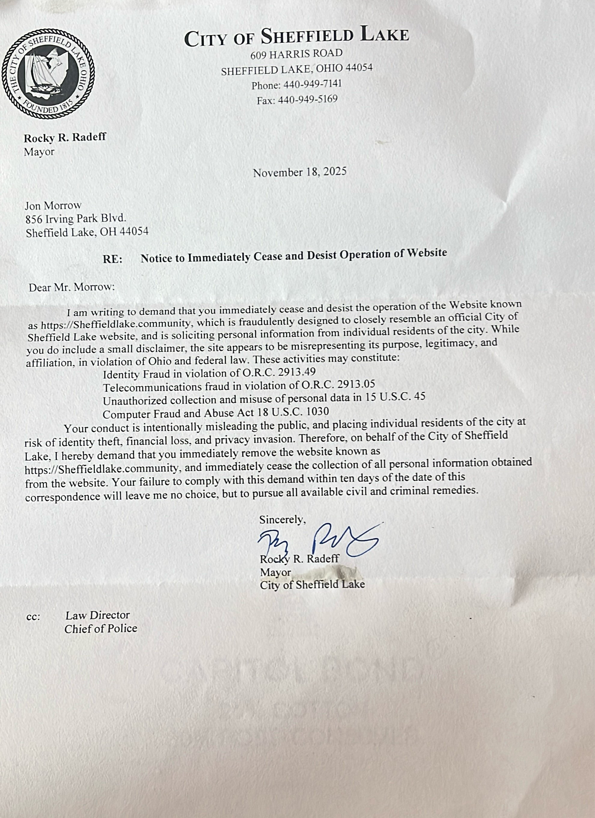

Factual Record on Website Legality and Absence of Wrongdoing
To ensure Council has a clear and accurate factual record, I want to address directly the Mayor’s public insinuation that my website was designed to “defraud” residents or unlawfully obtain private information. Those allegations are false on their face, unsupported by law, and contradicted by the website's features and disclosures.
First, the website has always displayed two prominent disclaimers, clearly visible to any visitor and not hidden in fine print or obscure links:
- That the site does not represent the government of the City of Sheffield Lake, is not affiliated with the City, and is not an official municipal page; and
- That the site is and has been my political campaign website for well over a year.

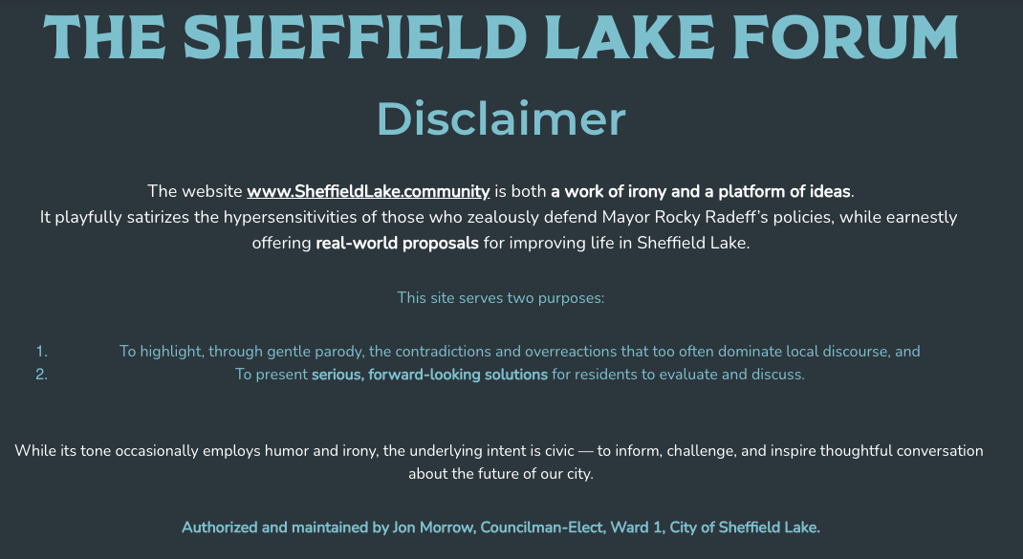
These disclaimers are placed in plain view for any ordinary user to see immediately upon arriving at the site. A fraud claim requires deception. Where clear disclaimers exist — and remain visible — the foundation for any allegation of misrepresentation collapses.
Second, the website has never solicited money of any kind.
There were no donations requested, no sales, no payment links, no commercial inducement, and no attempt to gain financial benefit from users. The absence of any financial transaction or request is fatal to the narrative that the site was a scheme to “steal” from residents.

Third, the information requested through the community poll was limited to standard demographic and residency-verification fields routinely used to validate surveys and ensure accuracy. The fields included:
- Name
- Postal address
- Email address
- Phone number
- Ethnicity
- Education
- Household income
- Age
This information is not sensitive identity-theft data, and much of it is already obtainable through commercially available datasets and public records, including the Ohio Secretary of State voter files. I did not request any of the categories that would even plausibly support an identity fraud theory:
- No credit card numbers
- No bank account numbers
- No Social Security numbers
- No photographs of IDs
- No driver’s license numbers
- No biometric or similarly protected data
In practical terms, the information requested was the minimum necessary to verify that respondents were genuine residents and to ensure the poll reflected the city’s demographics rather than outsiders or duplicate submissions. This is standard polling practice.
Fourth, there was never — at any point — criminal or civil wrongdoing on my part.
A lawful political campaign website, openly labeled as such, conducting a community survey with standard demographic questions and no financial solicitation does not constitute fraud, identity theft, telecommunications fraud, computer crime, or unlawful data collection. The Mayor’s accusations are therefore not only reckless; they are preposterous as a matter of law.


My above logo and seal do not look like the City’s website seal or logo, below, nor do the colors match -



Finally, it is well established that community organizations and citizen-led forums may lawfully use the name “City of Sheffield Lake” as a geographic descriptor and may adopt local logos or seals in an expressive or civic context. For example, a group calling itself the “City of Sheffield Lake Forum” — or using recognizable local imagery to indicate geographic relevance — is plainly lawful and does not amount to fraud or misrepresentation, so long as it does not falsely claim to be an official agency of municipal government. My website did not do so. The disclaimers removed any conceivable ambiguity.
Here are some examples below that are out on Facebook. We, the public, are told that there is only one official and authorized City of Sheffield Lake Facebook Page. - yet there are official-looking Sheffield Lake and Fire Department pages that are not referenced on the city’s website.
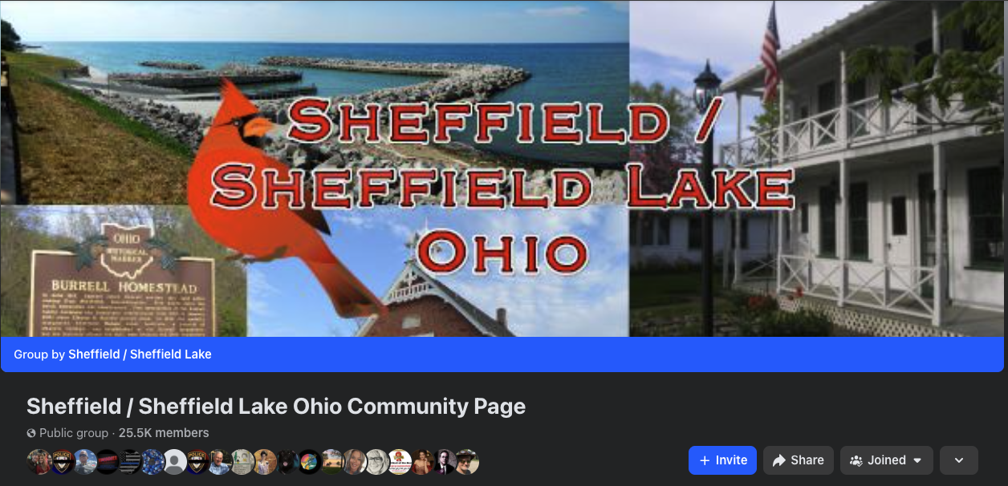
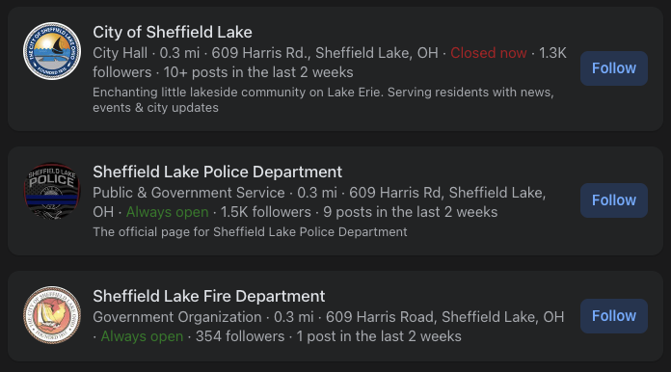
I want to be unequivocally clear with Council: I will not apologize for building a professional, attractive, and effective campaign website — a website that was instrumental in my victory and in motivating real civic engagement across Sheffield Lake.
Some have suggested that because the site looked polished, it must have been designed to “appear official.” That claim is both unfair and logically hollow. There is nothing unlawful about a campaign website being well-made. A citizen does not lose constitutional protection because he communicates with competence rather than clumsiness.
It is also important to state plainly: my website is not at all similar to the City of Sheffield Lake’s official website in design, layout, branding, or presentation. The City’s website is distinctly utilitarian in both structure and appearance. If I had copied city colors, matching fonts, identical design layouts, navigation structure, or any other distinctive elements, someone might attempt to make a colorable argument about confusion. I did not do that.
The claim being advanced here is essentially that a private citizen should be punished for producing a website that looks “too nice.” That is not a legal standard. It is a political grievance dressed up as one.
And frankly, if the City’s official website is so generic and utilitarian that any clean or practical layout is said to “look official,” then the problem is not the citizen’s speech — the problem is that the City is claiming ownership over a style no one can own. By that logic, any utilitarian civic website could be accused of impersonation, and the City could itself be accused of copying any person or group that uses a straightforward public-information format. That line of thinking collapses under its own absurdity.

In short:
- A professional campaign website is lawful.
- A polished aesthetic is not fraud.
- A generic utilitarian style cannot be monopolized by government.
- And the Constitution does not require political opponents to communicate poorly to avoid bruising the Mayor’s ego.
I built an effective platform for civic debate and community ideas. I stand by it fully.
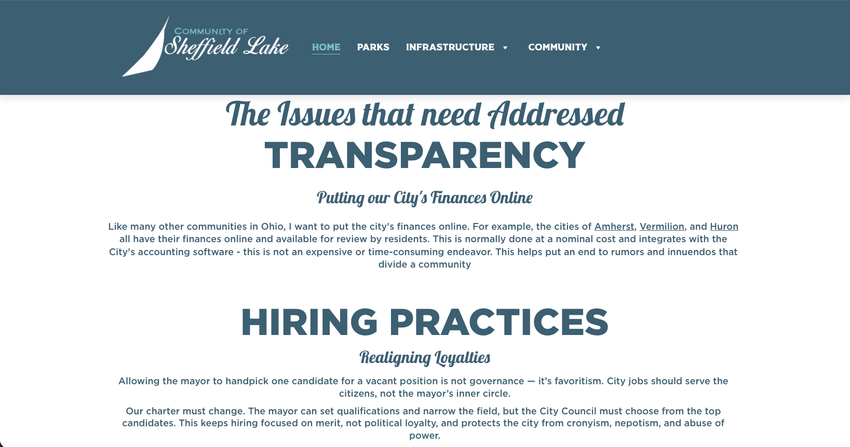
My Website
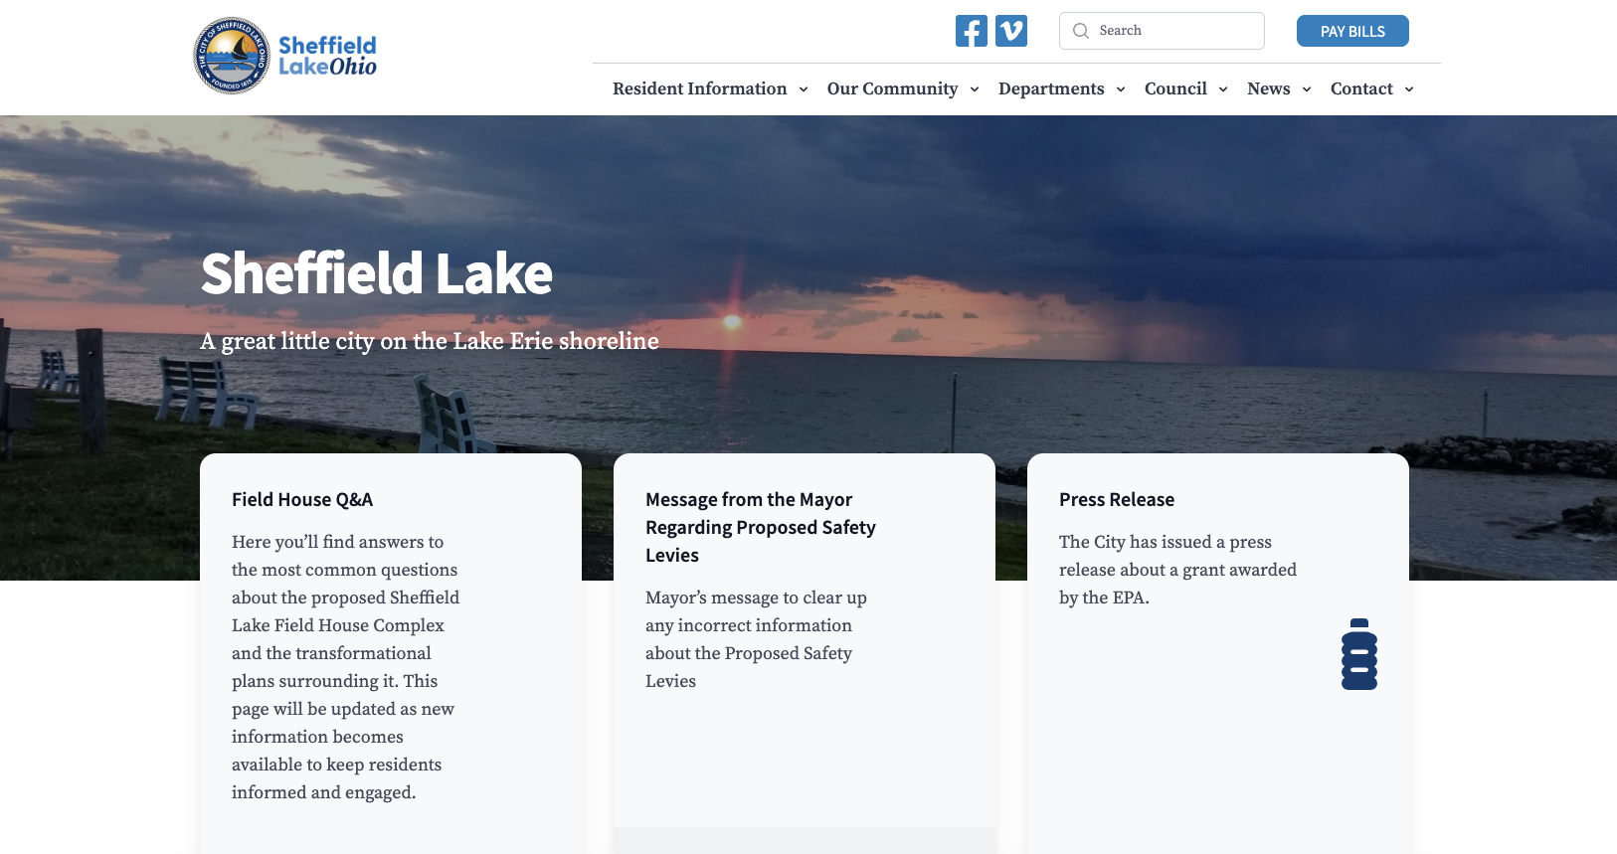
The City of Sheffield Lake’s Website
In sum:
The record shows transparency, not deception; civic engagement, not criminality. Any claim to the contrary is a political tactic dressed in legal costume. I ask Council to treat it as such and to respond accordingly, both to defend lawful public discourse and to prevent taxpayer exposure from unconstitutional, retaliatory misuse of City authority.

It is essential to understand that Ohio’s Ethics Laws do not limit “corruption” to cash bribes or gift bags. The statutory phrase “anything of value” is intentionally broad, and it includes non-financial advantages that a public official secures through misuse of office.
Under Ohio Revised Code 102.03(D) and (E), a public official may not use the authority or influence of office to obtain an improper benefit for themselves or to harm others. Ohio law defines “anything of value” expansively to include every valuable benefit, privilege, or advantage, not merely money. In practice, the Ohio Ethics Commission has consistently treated intangible but substantial benefits as “things of value” when secured through official power rather than for a lawful public purpose.
That matters here because political advantage is a real, substantial benefit to an elected executive. When a mayor uses city letterhead, the prestige of his title, or municipal legal machinery to intimidate, harass, or retaliate against political opponents, he is not performing neutral governance. He is attempting to secure a personal political benefit — namely:
- Silencing or chilling criticism of his administration,
- Weakening or discrediting challengers,
- Deterring civic opposition to his policies, and
- Protecting his political standing and future electoral prospects.
That advantage is not speculative. It is precisely the kind of “thing of value” Ethics Law is designed to prevent officials from extracting through public office. The test is not whether an official pocketed money, but whether he used public authority to obtain a substantial and improper benefit that a private citizen could not receive. Political retaliation fits that definition squarely.
Accordingly, any pattern of harassment or retaliation aimed at political enemies — mainly when carried out through official city channels or with legal counsel participation — raises a direct ethics concern. Council should treat such conduct as more than a political argument. It is a potential ethics violation involving the misuse of municipal power to obtain an improper “thing of value” in the form of political advantage.
There is a reason why you do not see other more seasoned Mayors retaliating against their political opponents with letters in their water bill after they were unable to get a levy on the ballot, with sending a threat letter to a council member because a forum sponsored by the city for civic engagement, held on city property, did not mention the Mayor in a positive light, and because a candidate won election by opposing Mayor Radeff’s policies.

The Mayor Is Not the City’s Legal Officer
Under Ohio municipal practice and the Sheffield Lake Charter, the Law Director is the City’s legal counsel. The Mayor is the City’s chief executive. These are separate offices for a reason: to prevent precisely this kind of unilateral intimidation or politicized enforcement.
A Mayor has no independent authority to:
- Issue cease-and-desist orders on behalf of the City,
- Threaten civil or criminal prosecution as the City’s lawyer,
- Direct legal action without proper process, or
- Impersonate the legal voice of the municipality.
When any Mayor undertakes those acts, he is not exercising executive power; he is manufacturing legal authority that does not belong to him.

Law Director's duties are non-transferable to the Mayor
Ohio law treats the Law Director as a separate executive officer from the Mayor. The director of law is the City’s legal counsel.
https://codes.ohio.gov/ohio-revised-code/section-733.51
Nothing in Title 7 gives a mayor authority to stand in the shoes of the Law Director or issue legal demands “on behalf of the City.”
Where the law does allow delegation, it’s narrow and specific:
- Law Director may designate assistants to prosecute in the mayor’s court only if the Council has authorized assistants, and even then, those assistants require legislative approval.
A Mayor is not an “assistant law director.” So the statutory delegation lane does not include him.
Bottom line:
The Law Director can’t deputize the Mayor to serve as the city lawyer just because he feels like it.

Council—not the Mayor—controls what cases the Law Director pursues
The Ohio Revised Code is blunt on this:
The Law Director, “when required to do so by resolution of the legislative authority, shall prosecute or defend on behalf of the city… and such other suits… as he is, by resolution or ordinance, directed to prosecute.”
https://codes.ohio.gov/ohio-revised-code/section-733.53
That means:
- The Law Director’s litigation agenda is not the Mayor’s private toy.
- Council can order suits to be brought or defended, and by implication can refuse to authorize ones it thinks are unlawful, retaliatory, or foolish.
So if the Mayor is pushing a harassment campaign through legal threats, the Council absolutely has standing to intervene.

If the Law Director “lets” the Mayor act anyway, what legal worms does that open?

A) Ultra vires acts (void on their face)
Anything the Mayor signs as “City legal action” without charter/statutory authority is ultra vires—outside power.
Ultra vires actions are typically void and unenforceable. That means the City can’t later pretend they were legitimate just because the Law Director winked at them.

B) Unbridled discretion + separation-of-powers violation
Letting the Mayor serve as both a political actor and a legal enforcer collapses the charter separation between executive policy and legal judgment. Ohio law treats the Law Director as an independent legal officer, not a mayoral mouthpiece.
Allowing this to stand is the kind of structure that invites selective enforcement and viewpoint retaliation.

C) Ethics exposure
If the Mayor uses the office to intimidate a political opponent and the Law Director enables it, that’s classic “use of influence for political benefit” territory.
The Ethics Commission has repeatedly said 102.03’s misuse-of-office prohibitions cover mayors and law directors.
https://ethics.ohio.gov/advice/opinions/96-001.pdf

D) First Amendment retaliation / §1983 liability
If the Mayor (with or without Law Director cover) threatens citizens for protected speech, it’s state action under color of law. That triggers:
- First Amendment retaliation claims
- 42 U.S.C. §1983 suits against the City and potentially individuals
Council’s failure to restrain this, once on notice, strengthens the claim that it’s a City policy/custom (Monell-style liability), not just a rogue tantrum.
What is a Monell-style liability?
Monell v. Department of Social Services, 436 U.S. 658 (1978), is the Supreme Court case that created the modern rule.
Monell says:
- Cities can be sued under §1983, but
- Not just because they employ a wrongdoer.
There is no automatic ‘employer liability’ (no respondeat superior) for cities in §1983 cases.
- Instead, a city is liable only when the constitutional violation was caused by:
  - an official policy,
  - a widespread custom or practice, or
  - a decision by an official who has final policymaking authority in that area.

What counts as “policy or custom”
A plaintiff must show the violation wasn’t just a random act. They need one of these:
- Written policy
Example: a formal rule that bans political speech in public facilities.
- Unwritten custom/practice
Example: city officials repeatedly intimidate critics, and everyone in government knows and tolerates it.
- Failure to train/supervise or discipline
Example: Council learns the Mayor is using city letterhead to threaten opponents and takes no corrective action.
Courts treat that as “deliberate indifference” to constitutional rights.
- Ratification by policymakers
Example: Council is told of the abuse, and instead of stopping it, lets it continue or publicly backs it.

Why Council inaction matters
Once Council is on notice that the Mayor (and potentially the Law Director) are using city authority to chill speech, Council has the power to:
- clarify roles,
- direct legal posture,
- Demand written opinions,
- Cut off funding for retaliatory actions,
- Investigate, and
- Pass corrective resolutions.
If Council does nothing, a court can infer:
“The City’s governing body knowingly allowed unconstitutional conduct to continue; therefore, it became a municipal custom/policy.”
That shifts liability from:
- “Mayor Radeff personally did something wrong.”
to
- “The City of Sheffield Lake, through its policymakers, allowed or adopted a retaliatory practice.”
And that’s Monell's liability.

What Monell-style liability would mean here?
If someone sues over retaliation/intimidation:
- Individual liability: the Mayor (and maybe Law Director) can be sued personally for acting under color of law.
- Monell municipal liability: the City can be sued and forced to pay damages/fees if the conduct is tied to City policy/custom or ratified by Council inaction.

E) Professional-responsibility / malpractice risk for the Law Director
Government lawyers owe duties to the municipal corporation, not to the Mayor personally. Allowing the Mayor to issue legal threats without basis can be viewed as:
- Failure to exercise independent legal judgment
- Aiding unlawful conduct
- Exposing the client (the City) to avoidable liability
Even if no bar complaint follows, it’s reputational dynamite.

F) Budget and authorization conflict
Litigation costs money. Council controls municipal appropriations. If the Law Director pursued—or pretended to authorize—the Mayor’s private crusade without Council buy-in, that’s a funding and authority collision waiting to explode.

City Council’s practical leverage point
Because of §733.53, Council can:
- Demand a written legal opinion from the Ohio Attorney General through the Lorain County Prosecutor on who may issue threats or take legal action for the City.
- Adopt a resolution stating no legal notices are valid unless signed/issued by the Law Director or properly retained special counsel.
- Refuse to authorize or fund any civil action rooted in political retaliation.
- Investigate maladministration if collusion is suspected.
You don’t need to “ask permission” to do oversight. Council is the permission structure.

Council Must Clarify Roles and the Chain of Legal Authority
City Council has a duty to protect the City’s lawful structure and the rights of its citizens. Therefore, I formally request that Council place on the agenda, and adopt, a resolution that:
- Affirms the distinct roles of Mayor and Law Director under the Charter;
- States clearly that only the Law Director may issue legal notices or threats in the name of the City, and only pursuant to lawful authority;
- Requires that any future legal warnings to citizens be reviewed and issued through the Law Director’s office, with a documented legal basis;
- Establishes that no official may employ City letterhead or City authority to pursue personal political disputes.
If Sheffield Lake does not draw this line in bright ink, we invite an executive drift into rule by intimidation.

Actionable Steps to Rein In an Out-of-Control Mayor
This Council must do more than express concern. I urge these concrete actions:
A. Council Inquiry and Formal Record
- Demand a written explanation from the Mayor and Law Director as to:
  - What authority was relied upon for the threat letter?
  - Whether the Law Director approved it,
  - And whether any investigation was actually opened in accordance with proper legal standards.
B. Request an Ohio Attorney General Opinion through the Lorain County Prosecutor
- Require the Law Director to request for an Ohio Attorney General Opinion through the Lorain County Prosecutor:
  - Confirming who may take legal action on behalf of the City,
  - And clarifying that political speech and parody are constitutionally protected.
  - And request a legal and ethical opinion on the actions of the Mayor and Law Director
C. Oversight Hearing
- Hold a public hearing on misuse of office and retaliatory enforcement.
D. Budgetary and Appointment Leverage
- Suppose the Law Director is enabling unlawful harassment. In that case, Council retains budgetary authority over legal services and may refuse to fund retaliatory actions or seek other legal counsel, where permitted by the Charter and ordinances.

Collusion to Harass Political Opponents Creates City Liability
Suppose Mayor Radeff and Law Director David Graves are collaborating—formally or informally—to intimidate a political opponent who openly disagrees with the Mayor’s policies. In that case, that is no longer a political spat. It becomes state action to suppress protected speech.
That exposes the City to civil litigation under:
- 42 U.S.C. § 1983 (civil rights violations under color of law),
- First Amendment retaliation doctrine, and
- Fourteenth Amendment equal-protection principles.
If a Law Director approves or participates in harassment, Council cannot hide behind the fiction of “executive independence.” The City itself becomes the defendant, and taxpayers bear the cost.
Council must understand the stakes plainly:
Suppose the Council does not act to restrain unlawful legal intimidation. In that case, the City is at risk of damages, injunctions, and attorneys' fees, and officials may face personal liability for violations of clearly established rights.
You cannot govern a free city by threatening its citizens for speaking. And you cannot protect taxpayers by standing idle while constitutional lines are crossed.

Council’s Power Over Civil and Criminal Direction
City Council is not a spectator in legal affairs. Council holds real, charter-based power:
- Civil action: Council controls authorization and funding for lawsuits brought in the City’s name. If the Council does not approve or fund a case, it generally cannot be pursued as municipal litigation.
- Criminal direction: While appropriate prosecutorial authorities bring prosecutions, the Council can:
  - Demand legal opinions,
  - Require lawful referral standards,
  - And restrain the misuse of City processes to trigger politically motivated “criminal” threats.
In short:
Council sets the boundaries for the City’s legal posture, and Council is the constitutional check on executive overreach.

HISTORY OF THREATS

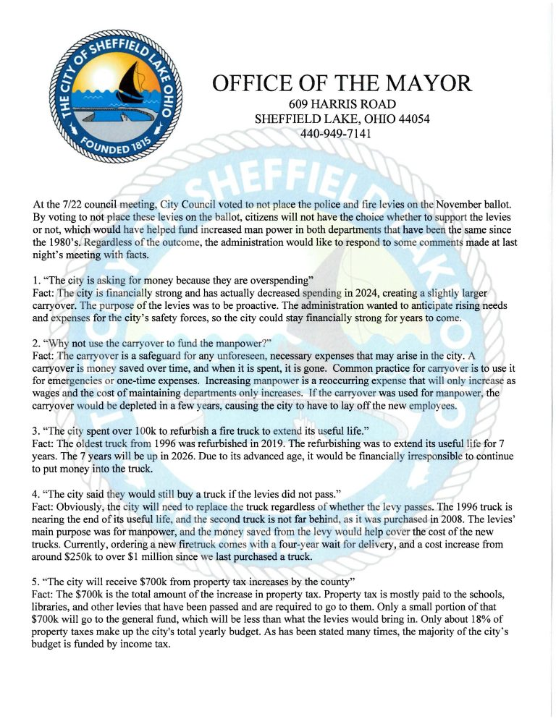

The Water Bill Notice
https://www.sheffieldlake.net/message-from-the-mayor-regarding-proposed-safety-levies/

Rocky’s letter to citizens is another prior example of the Mayor’s retaliatory nature and absolutely violates Ohio Revised Code 9.03.

What R.C. 9.03 actually forbids (and allows)
R.C. 9.03(C)(1)(e) prohibits a political subdivision from using public funds to publish or distribute information that supports or opposes the passage of a levy or bond issue.
But R.C. 9.03(B) and the AG say the city may spend money communicating about its plans, finances, and operations, so long as it’s not designed to influence an election/levy outcome.
The Auditor’s FAQs/guidance sharpen that line:
- “Factual information” is allowed.
- Advocacy that supports/opposes a levy outcome is not allowed, and that even applies to a tiny public cost amount.
So the legal test isn’t “did the mayor mention a levy?”
It’s “was public money used to advocate for one side?” and it does not matter that it is after the fact.

Applying that test to this Mayor’s letter
Mayor Radeff’s letter does three notable things:
- Frames Council’s vote as denying citizens a choice
“By voting to not place these levies on the ballot, citizens will not have the choice whether to support the levies…”
That’s not neutral accounting. It’s a persuasive framing that implies some of the Council acted against the public interest.
- Defends the levies as necessary
The “facts” are presented in a way that repeatedly justifies the levies and the administration’s position, not merely explains budgets.
- Responds point-by-point to criticism to change minds
The structure is classic campaign-style rebuttal: quote critics → “Fact:” → refute in a way that leads to a pro-levy conclusion.
That overall tone reads much closer to advocacy than to a neutral “here are the numbers” briefing.

So is it a 9.03 violation?
Yes, if public funds/resources were used to create or distribute it.
Because even if no levy was on the November ballot after the Council’s vote, the letter’s explicit purpose is to persuade residents, after the fact, toward the administration’s pro-levy position, and 9.03 is about publicly funded advocacy, not only before ballot-day campaigning.
And remember: there’s no minimum dollar threshold. Printing costs, staff time, use of official channels—any of that can trigger 9.03.
If the Mayor wrote this on his own time, paid for it personally, and distributed it through private campaign channels, that’s different.
But he used official letterhead and the “Office of the Mayor” platform, which is exactly the kind of thing 9.03 is meant to stop when used for persuasion.

Monday Morning Coffee with the Seniors

R.C. 9.03 Does Not Prohibit Incidental Political Discussion in Donated Civic Meetings
I contend that, on the surface, Mayor Radeff abused his power when Monday Morning Coffee with the Seniors turned into a political discussion that did not benefit him. Councilwoman Rosa Gee’s “Monday Morning Coffee with the Seniors” meeting very likely never violated the Ohio Revised Code 9.03 solely because of political discussion at the Recreation Center room that is provided without charge.

Text of the Statute
Ohio Revised Code 9.03(C)(2) provides a clear safe-harbor:
No political subdivision shall use public funds to compensate any employee for time spent on any activity to influence the outcome of an election…
This division does not prohibit the compensation of an employee or official to attend a public meeting to present information that is not designed to influence the outcome of an election, even though the election or issue is discussed or debated at the meeting.
This language explicitly anticipates civic meetings where topics may “be discussed or debated” incidentally. The legal test is intent to influence an election using public funds, not whether politics happens to arise in conversation.

Application to “Coffee with the Seniors”
In the Rosa Gee incident:
- The room was donated for general civic engagement, not campaign advocacy.
- There was no intent by Councilwoman Gee to influence an election, support/oppose a candidate, or advocate for a levy.
- The political discussion arose organically among attendees.
- No public employee was compensated to campaign, and no city resources were expended to produce advocacy materials.
Therefore, no element of a 9.03 violation is present. The statute regulates government spending for advocacy, not private discussion by citizens in a public forum.

Why the Mayor’s Interpretation Is Unlawful
The Mayor’s premise—that a free public room becomes a “politics-free zone” by operation of 9.03—is not supported by the statute and directly conflicts with its safe-harbor. If accepted, it would mean:
- Any citizen who mentions an election in a public building is “breaking the law,”
- Every incidental conversation at a city facility becomes a criminal risk, and
- City officials could suppress disfavored viewpoints by labeling them “political.”
That is not what 9.03 says, and such a reading would invite unconstitutional viewpoint discrimination.

Closing Demand
This letter is a formal warning and a civic appeal. The Mayor’s conduct is not merely wrong; it is an abuse of office that undermines public trust and risks legal consequences for the City of Sheffield Lake.
I respectfully demand that Council act immediately to:
- Clarify and reaffirm legal roles,
- Investigate the Mayor’s unauthorized threat,
- Direct the Law Director to cease any retaliatory enforcement, and
- Protect citizens' right to speak freely without fear of municipal intimidation.
I will pursue this matter publicly and legislatively upon taking office if corrective action is not taken now. Sheffield Lake deserves lawful government—not executive temper clothed as legal authority.
Respectfully submitted,
Jon Morrow
Councilman-Elect, Ward 1
City of Sheffield Lake

