Members’ Studio #6 15 May 2025
LEARN∞EXPLORE∞INNOVATE∞SHARE∞IMAGINE

- Preparing your artwork for marketing/viewing
- Composition
- Harmony, the Harmonic Armature

References & Links

COMMERCIAL/MARKETING information
https://paintersoftheflindersranges.org.au/artists/dennis-marshall/
https://josslynmartinart.com/

Packaging – cards, envelopes:
Packitin https://www.packitin.com.au/
Poppy Crafts: https://www.craftonline.com.au/

Frames and boards:
Crazy Roys https://www.facebook.com/crazyroys/
Big W https://www.bigw.com.au/search?text=picture+frames

Cataloguing & records apps:
Google sheets: https://docs.google.com/spreadsheets/u/0/

Creative apps:
Affinity software: https://affinityspotlight.com/

COMPOSITION Links & Refs

Thoughts on COMPOSITION (this is a straightforward look at unequal division in compositions)
John Taft
https://www.oilpaintersofamerica.com/2024/08/thoughts-on-composition-by-john-taft-opa/

What is composition and why does it matter so much in art?
Kaoula Chatt
https://theartandbeyond.com/a-beginners-guide-to-composition-in-art/

Harmonic Grid/Armature
Harmonic Armature for Beginners Part 1 James Cowman
https://www.youtube.com/watch?v=XlRIiNy7JSs
Classical Painting Atelier and the Harmonic Armature (6m50s)
“Diego Delacroix” Juliette Aristides
James Cowman
https://www.youtube.com/watch?v=-e2oR43w4kE
Vermeer and the Harmonic Armature (7m 56s)
James Cowman
https://www.youtube.com/watch?v=kG-uqB0SkZc

BOOK:
“Classical Painting Atelier” Juliette Aristides
https://www.aristidesarts.com/

A few good resources:
DYNAMIC SYMMETRY –And how I incorporate it into my plein air and studio and practice
https://www.oilpaintersofamerica.com/2022/03/dynamic-symmetry-and-how-i-incorporate-it-into-my-plein-air-and-studio-and-practice/
Michele Byrne

OIL PAINTERS OF AMERICA has HEAPS of very informative and interesting blog posts
https://www.oilpaintersofamerica.com/blog/
ART STUDIO LIFE has a great article with simply explained composition examples – but the ads are REALLY annoying!
Composition in Painting: How to Create Better Painting Compositions
https://artstudiolife.com/painting-composition/
Elisabeth Larson Koehler

Art Teacher Fusion – love this one!!
https://artteacherfusion.com/mastering-the-canvas-key-principles-of-composition-in-visual-arts-elements-of-art-principles-of-design/#google_vignette

HARMONIC ARMATURES: TOOLS
Michael Lynn Adams Adams has quite a few videos relating to Harmonic Armature
https://michaellynnadams.com/harmonic-symmetry/
https://www.youtube.com/watch?v=lqJjK33Iyh4

on Pinterest
https://au.pinterest.com/search/pins/?q=Composition%20art&rs=srs&b_id=BMR16yCfzBpsAAAAAAAAAACrOdGWV1iSxukXrGuPDcR3CCA9kkgyISViFATck4Q2Ri0Jx1qbBybsQy0OFZ9DZeY&source_id=SprpjlbI

ONLINE DIGITAL COMPOSITION TOOLS & APPS:
Customise this grid - GRIDMAKER
https://gridmaker.vercel.app/#grid-maker

Artist Assist App
https://app.artistassistapp.com/
(You might need to join via another app – Patreon)

Procreate
https://procreate.com/

WISE Photo app
Read about it here: App: https://karenhalbert.blogspot.com/2023/05/wise-photo-app-revisited.html

BOOKS:
IAN ROBERTS:
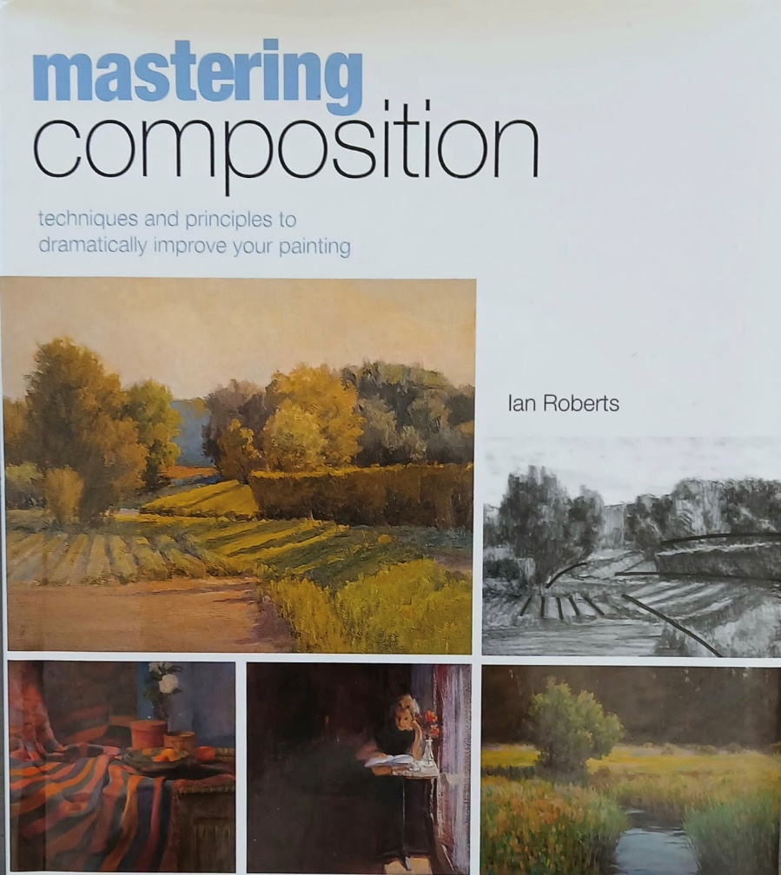

HARMONIC GRID/ARMATURE
V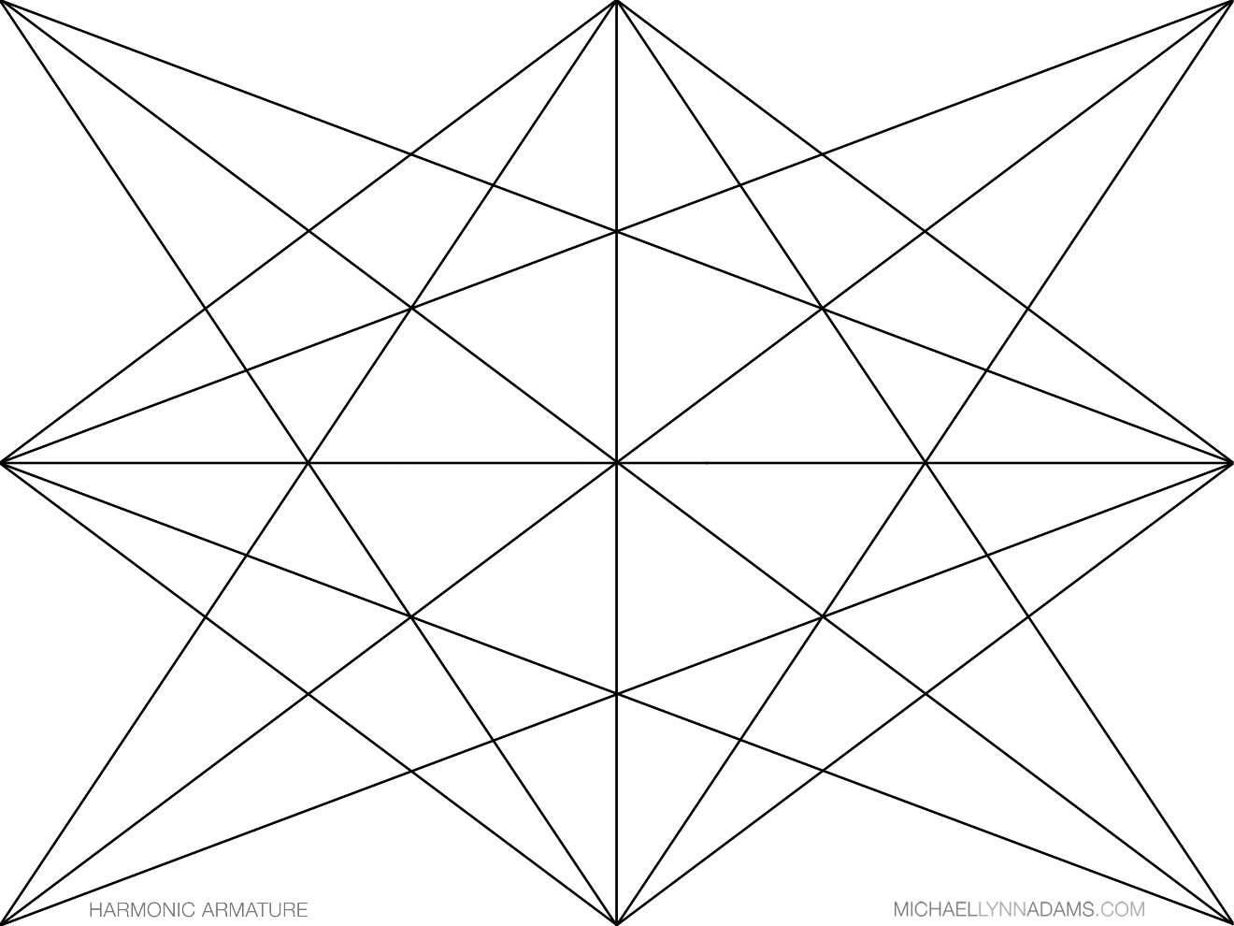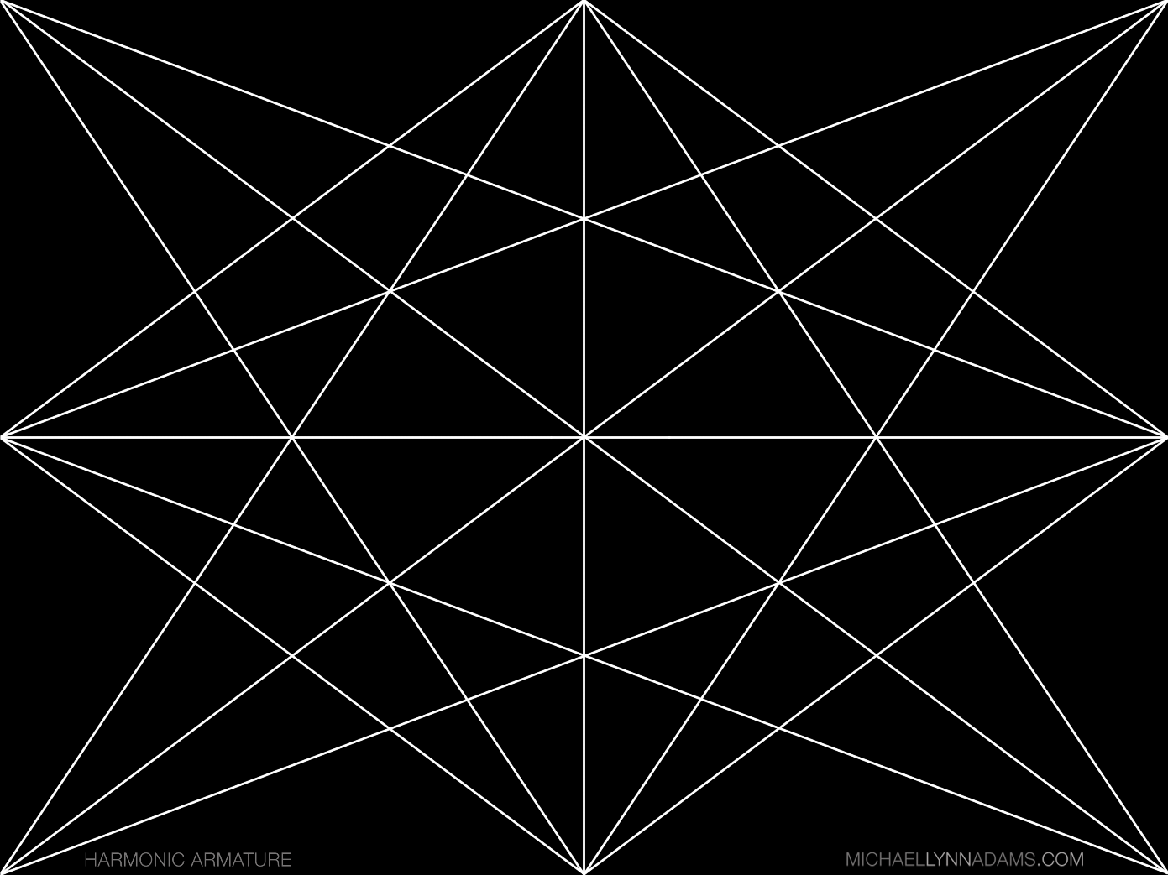

MAKE A VIEW FINDER – Extract from a very old book (Published 1903)
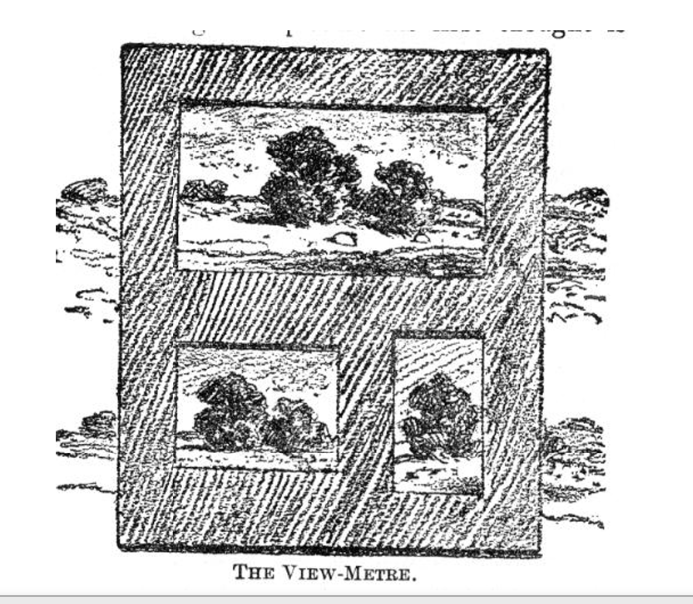
Many artists reduce all subjects to two or three sizes, which they habitually paint. The view-meter may in such cases be further simplified by using a stiff cardboard with such proportions cut out. By having them all on a single board a subject may be more rapidly tested than by the device of the collapsible sides. A light board( the thickness of a cigar-box cover,) 4×5 inches, and easily carried in the pocket, will enable one to land his subject in his canvas exactly as he wants it, and avoid the grievance of reconstruction later. By leaving a broad margin about the openings, one obtains the impression of a picture in its mat or frame, and may judge of it in nature as he will after regard it when completed and on exhibition.

‘Pictorial Composition and the Critical Judgment of Pictures A Handbook for Students and Lovers of Art”
By H. R. Poore 1903

A viewfinder with a square and/or with a 3:4 rectangle (9:12, 12:16).
Glue 2 pieces of card together, inserting a sheet of acetate marked in thirds with a permanent marker between the pieces of card. The size of the square is 2-1/4″ (6cm). (You can make it to your own preferred ratio or size)
The third viewfinder (available at www.pictureperfectviewfinder.com) has three rectangles with 1:2, 3:4 and 4:5 ratios divided into thirds. It also has red acetate, which is useful for determining value masses.
Sometimes when students first use a viewfinder, they feel limited by how much they can get into the frame. It doesn’t take much practice before they realize they can control how much to include or exclude by adjusting the distance from the viewfinder to the eye.
(excerpt from the book Mastering Composition (2008, North Light Books) by Ian Roberts.)

