Members’ Studio #5 1 May 2025
LEARN∞EXPLORE∞INNOVATE∞SHARE∞IMAGINE

References & Links
- Aesthetic
- Colour
- Composition
- Critiquing Artwork

AESTHETIC:
Ref: https://www.animatingdemocracy.org/aesthetic-perspectives

COLOUR
PAUL SMITH, ART PALETTE – A Google Tool Train your Eyes (video_
https://www.youtube.com/watch?v=VDQw70hYGrc Paul Smith, Train your eyes + Art Palette(Google) to find the colours

COMPOSITION
IAN ROBERTS – What makes a great composition? (video)
https://www.youtube.com/watch?v=sopLk4Czp6M
IAN ROBERTS – Mastering Composition –various videos on YouTube
https://www.youtube.com/@IanRobertsMasteringComposition

BASIC CONCEPTS OF COMPOSITION
Elements, Principles and Armatures
Ref: https://www.workovereasy.com/2019/06/13/a-beginners-guide-to-composition/ Natalie Harney

IAN ROBERTS:
“Movement and Structure create a coherent flow – shapes arranged and adjusted – the armature. The backbone of the painting. Armature is the most important dynamic.”
“Four most important compositional lines – the size and shape of your 2D shape e.g. canvas/paper – the proportion of width to height of the space – interacts with your composition, affects the dynamics of placement of the abstract shapes.”

8 Common Armatures
- S – commonly found in nature - landscapes
- L – centre of interest along one of the arms of the L – close to the intersection.
- Diagonal \ / - has the most dynamism in relation to the rectangular frame, Use with caution – needs to be DE-emphasized as it reaches each end of the diagonal / the edge of the composition/rectangle.
- Triangle – Perspective – centre of interest is near or on one of the angles of the triangle.
- Radiating Lines – one point perspective where everything converges to one point. Use with care not to draw the eye in immediately.
- Fulcrum – balancing the major masses, usually smaller against larger. If too close in size, they will create a static balance – less dynamic.
- O – 2 types – O is used as a framing device for the centre of interest OR
O leads the eye around the outside of the picture plane.
- Portrait – focal point is the object - be aware of negative shapes/spaces around the object of interest and how they impact the composition and the eye track.
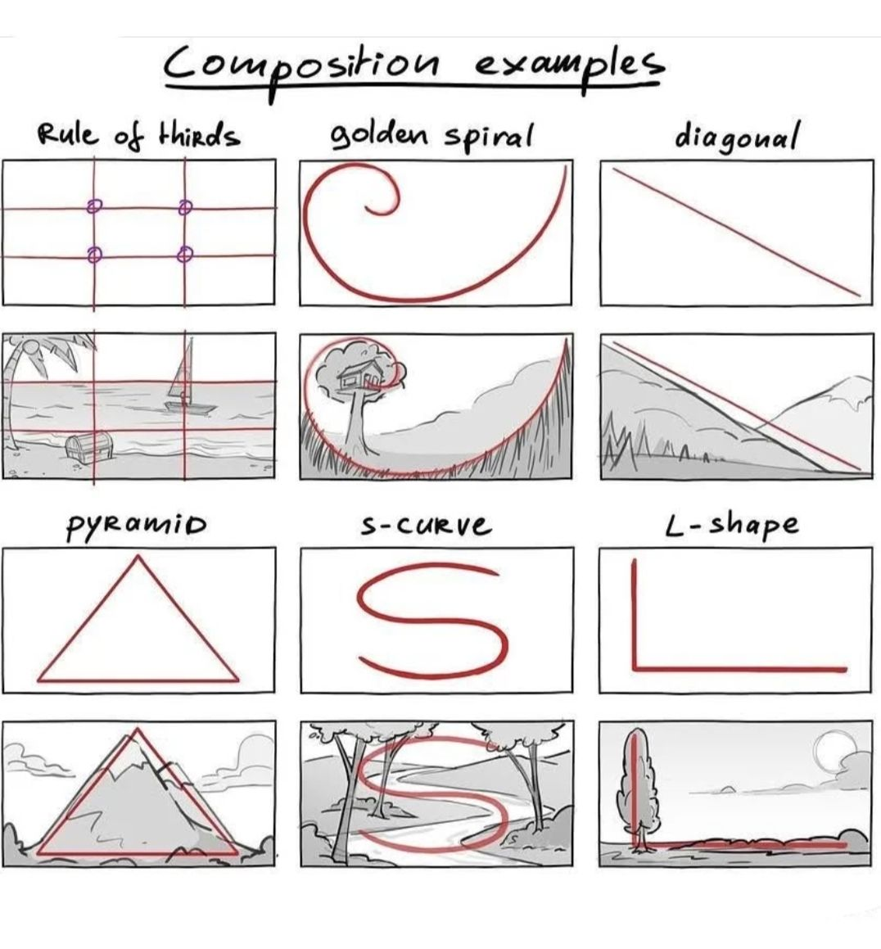

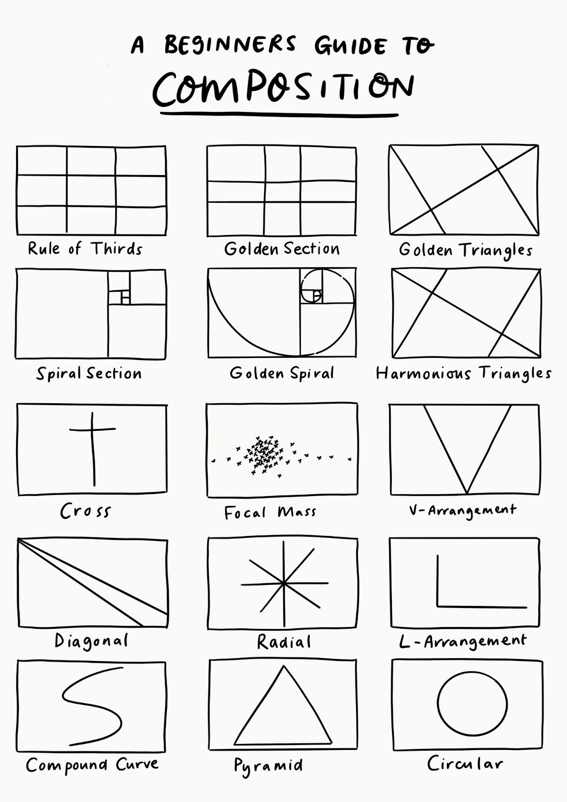
Ref: https://theartandbeyond.com/a-beginners-guide-to-composition-in-art/

CRITIQUE WORKSHEET – DESIGN
This is what we used to analyze the design of the 2 ads. It can be applied to all design.
https://sunywcc2ddesign.com/critique-worksheet

BOOKS:
IAN ROBERTS:
