Members’ Studio #7 5 June 2025
LEARN∞EXPLORE∞INNOVATE∞SHARE∞IMAGINE

- COLLAGE
- REVIEW OF COLOUR AND COMPOSITION
- A BRIEF LOOK AT PERSPECTIVE
_____________________________________________

Collage
Introduction and History – Lucie Davison
Collage is the technique of composing an artwork by gluing a range of materials to a surface. Art historians make technical differentiations between collage techniques:
• Decoupage, images glued to an object
• Assemblage, a three-dimensional accumulation of objects
• Photomontage. Photomontage can be either analog or digital.
• Digital photomontage means the work is created using computer software
• Analog, or cut paper collage, is composed entirely of images cut and glued by hand.
History
Collage upended the fine-art world when artists such as Georges Braque, Pablo Picasso Hannah Höch, Henri Matisse and Romare Bearden incorporated newspaper and wallpaper into their paintings, subverting traditional definitions of art.
Because collage often incorporates mass-produced images, the practice is inseparable from its historical, cultural and political context. The juxtapositions created by collage techniques means images take on new meanings in new contexts, multiplying and subverting the original purpose of the image, creating works that do not easily settle into single, fixed analyses.
Essay: Is Collage an Art or a Craft Activity? The 2023 Archibald Prize Says it is Art.
Sonia Jamieson
Collage is a French term, fait de coller, meaning the gluing or sticking of something on to a surface. So, the simple answer to the question above is that it can be both.
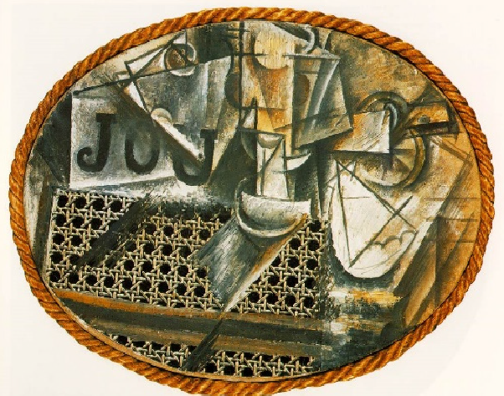
The first recorded recognised artist to use collage was Pablo Picasso. His early collages used newspaper and wallpapers. With his collage, “Still Life with Chair Caning”, created in 1912, he glued oil cloth that had a cane chair pattern on it to his canvas.
He then added newspaper. The finished art work had rope glued on as a frame. This has been called “Cubist Collage” and is considered to be Modern Art’s first collage. It opened up new possibilities for artists to express their individual style.

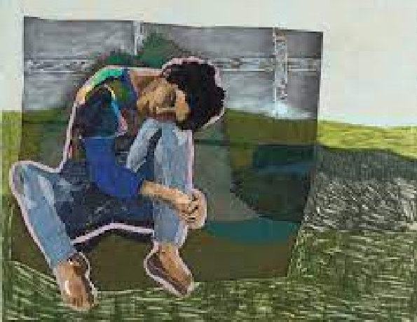
More recently the 2023 Archibald Prize winning entry “Head in the Sky, Feet on the Ground” by Julia Gutman, was oil and textile collage. In her work she uses recycled materials and, as a cute aside, in this work, she used a sleeve from an apron she wore while teaching art to small children. (theconversation.com)

What then does collage bring to a flat piece of artwork? It provides the opportunity to bring something more tactile and meaningful through familiar objects. It is both an art form and a technique.
As a pure collage artist, Jeannie Baker, also brings a social message to her illustrations and films.
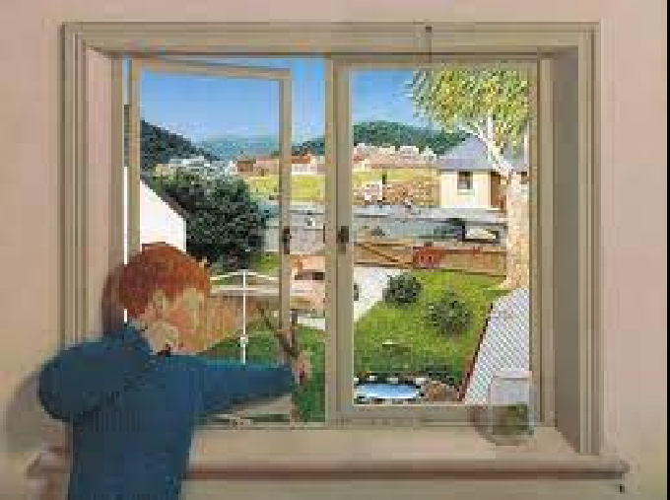
Through her work, collage definitely engages young people, exposing them to patterns, colours and shapes. It presents a way of expressing and expanding their basic knowledge of art apart from drawing and colouring in. It teaches children to explore and experiment, supporting the development of creativity from an early age.
As artists we are always open to new ideas and ways of expressing our feelings. As such, collage opens additional avenues for us to explore.

A QUICK REVIEW OF COLOUR & COMPOSITION

3 Colour Attributes
- Hue
- Saturation
- Brightness/Value

Colour Spectrum/Colour Wheel
Cool/Warm
Complementary
Contrasting
Analogous
Monochromatic
Achromatic

Colour Harmony

Harmonious groupings
- Complementary
- Split complementary
- Triad and analogous
- Saturation
- Proportions

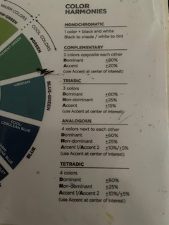

COMPOSITION

Design elements:
- Line
- Shape
- Colour
- Value
- Tone
- Texture
- Depth.

Design principles relevant to composition
- Proportion how do “things fit together and relate to each other in terms of size and scale; whether big or small, nearby or distant. This is the most obvious quality of composition
- Emphasis/focus – where is the viewer’s eye drawn? Creating contrast and playing with balance, rhythm or movement can make certain elements of a piece stand out and appear more important.
- Balance & unity – do all of the elements work together? Symmetrical compositions instil a sense of order and calm (think Wes Anderson) whereas asymmetrical ones create more dynamic and active pieces.
- Rhythm & movement – what is happening in the image and how does it draw your eye? Leading lines and underlying shapes/tones can direct the viewer to focus on certain elements of give a sense that a piece is going somewhere at a certain pace.
- Pattern – do elements of the composition repeat? Using repetition can give clear structure or draw certain parts of an image together.
- Contrast – how do elements of the piece appear different? Contrast may come in many forms including hue, tone or scale and can create dynamics within a piece.

COMPOSITION EXAMPLES - ARMATURES:
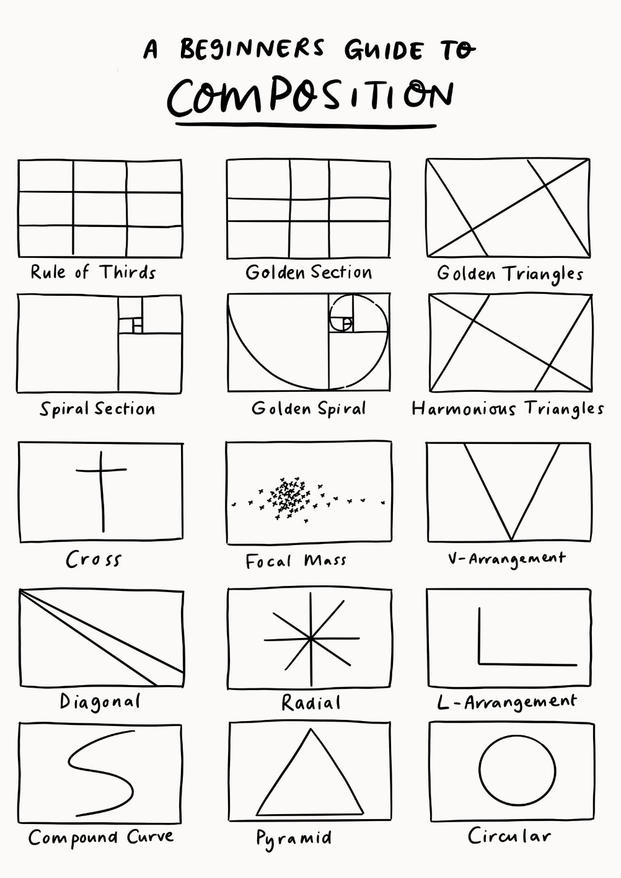

HARMONIC GRID
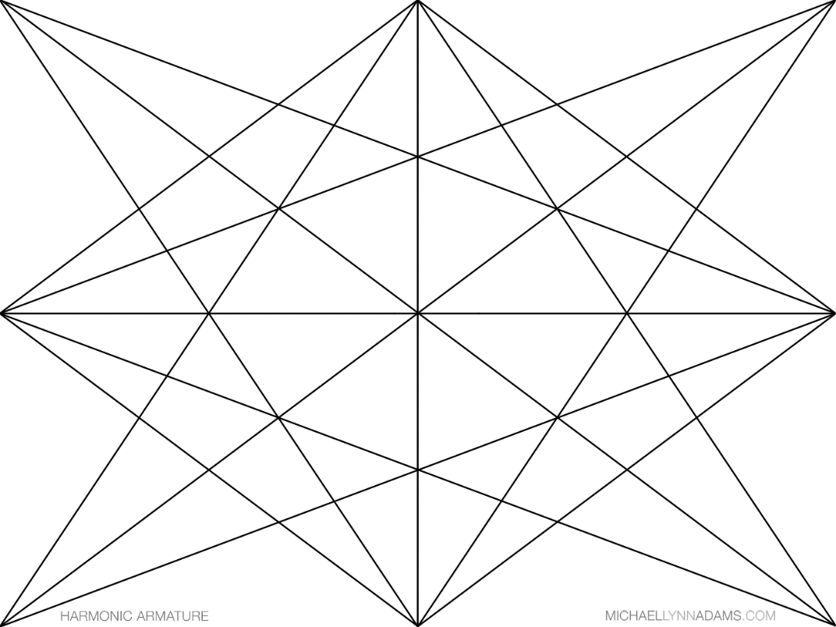

PERSPECTIVE:
Ref: https://www.studentartguide.com/articles/one-point-perspective-drawing
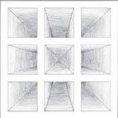

Key Principles of Perspective Drawing:
- Horizon Line: An imaginary line representing the eye level of the viewer.
- Vanishing Point: A point on the horizon line where parallel lines appear to converge.
- Convergence Lines: Lines that meet at the vanishing point, creating the illusion of receding depth.
- Linear Perspective: A system of drawing that utilizes lines to create the illusion of depth.

Ref: Bedroom at Arles Vincent Van Gogh
Key Points:
- Surfaces that face the viewer are drawn using their true shape
- Surfaces that travel away from the viewer converge towards a single vanishing point. This is a point that is located directly in front of the viewer’s eyes, on a ‘horizon line’ (also known as an ‘eye level line’).

LINKS:
Kurt Schwitters link
https://www.artic.edu/artists/36584/kurt-schwitters
Donna Watson link
https://www.donnawatsonart.com/
Lucie Davison link
https://www.gravisonart.com/lucie-davison

