Members’
Studio #11 7 August 2025
LEARN∞EXPLORE∞INNOVATE∞SHARE∞IMAGINE

Creating 3D shapes, Values, Shadows – Back to Basics
How do shadows feature in creative art forms – 2D or 3D (sculpture, papier mâché) and other forms?

Video 1 - Dorian Iten
“How to Separate Light and Shadow”
https://www.youtube.com/watch?v=yDVeNvphSvc

Video 2 - Jess Karp
“3 Tips on How to Shade”
https://youtu.be/FmsSbpsB5Vs?si=cONN_JBsA4uHW7-b

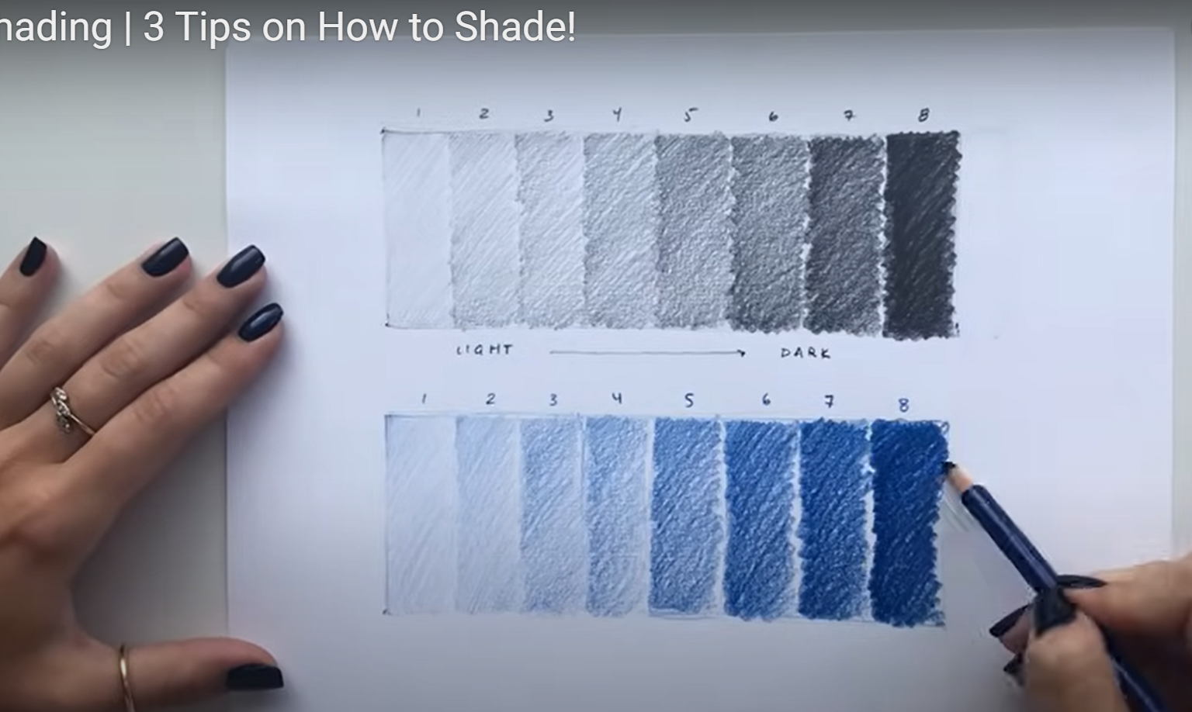

Video 3 – Dorian Iten (Proko)
“Mind-Blowing Realistic Shading Tricks”
https://youtu.be/6vapw6n6FyU?si=0uI_jCwo0syP9pk_
Compare with the value scale

Linear Values -vs- Lambert’s Emission Law
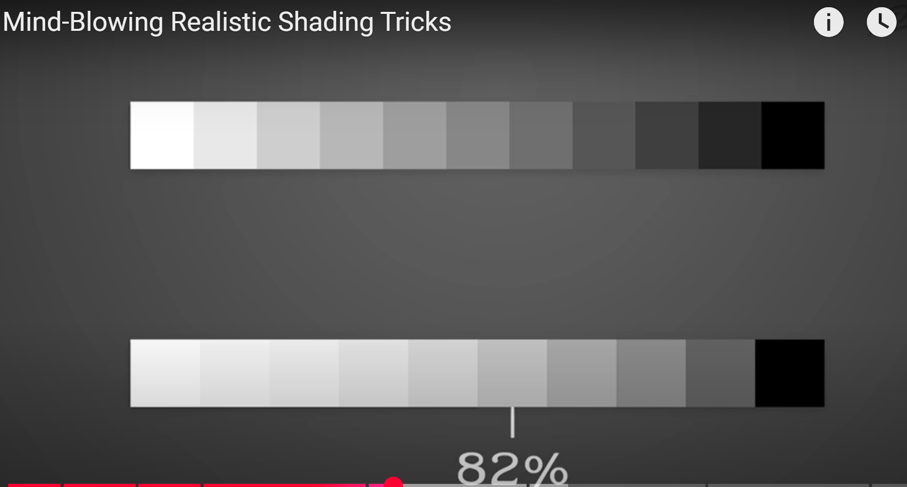

The Terminator
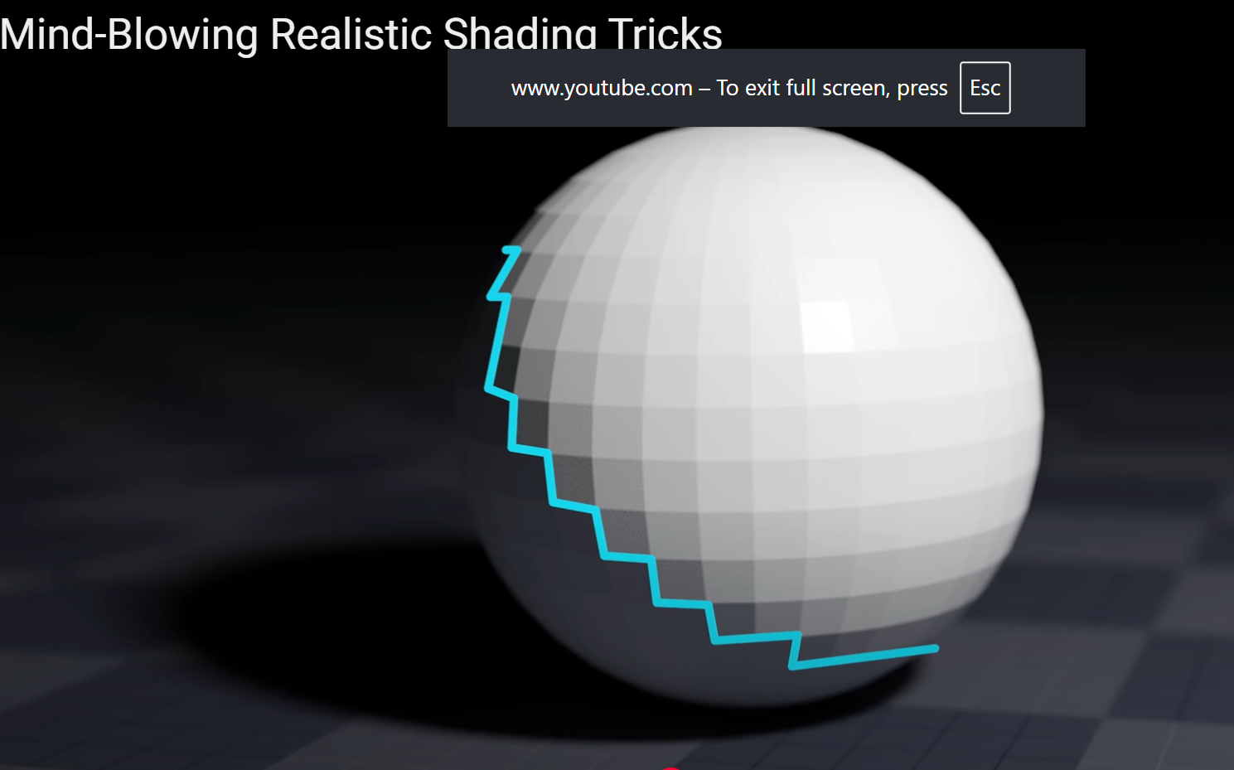
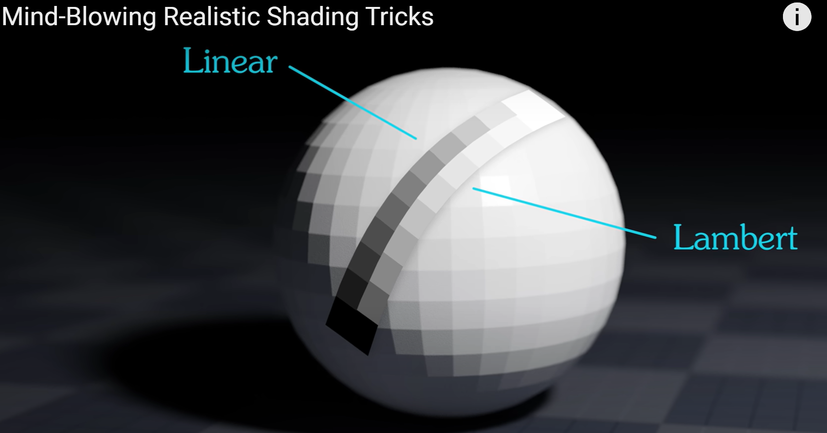

The Lightest Dark is darker than the Darkest Light
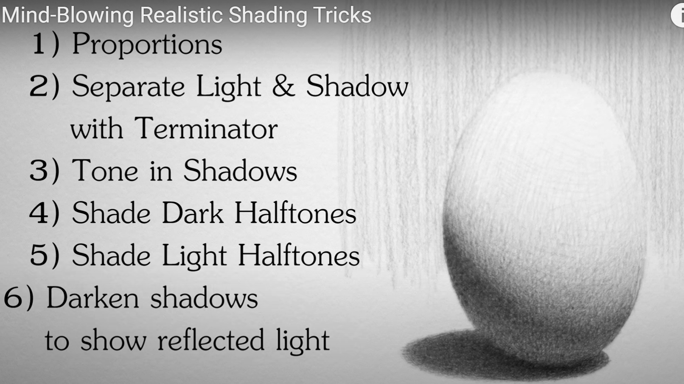
(Above screenshots from Dorian Iten video)
Links for Dorian Iten
Instagram –  / dorianvisuals
Facebook -  / dorianiten
Website - https://www.dorian-iten.com/

Other videos on shading:
Top 5 Shading Mistakes - • Top 5 Shading Mistakes
Shading Light and Form - Basics - • Shading Light and Form - Basics
How to Shade a Drawing - • How to Shade a Drawing
Live Shading Demo - Drawing Light on Form - • Live Shading Demo - Drawing Light on Form #shading #drawingdemo #howtodraw

