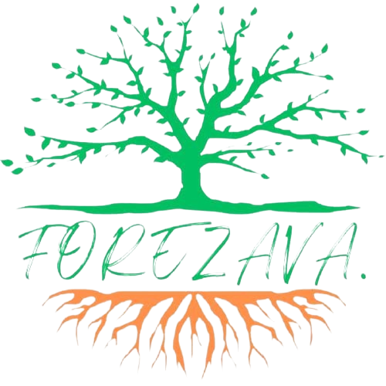

Forezava Farm Limited

Progress PYG038 Group Limited

Progressive Youth Group

Quarterly Report

1st January 2025 – 31st March 2025

**Reporting Period:** January – March 2025  
 **Reporting Organization:** Forezava  
 **Prepared by:** Laurelle Levin Adhiambo  
 **Date:** 15th April 2025

**1. Executive Summary**

The first quarter of 2025 has seen significant progress in Forezava’s mission to empower youth, protect riparian ecosystems, and foster community development in Vihiga County. Despite facing financing and capacity challenges, our team has remained committed and active across multiple focus areas—leadership training, sports for development, community engagement, and environmental conservation.

**2. Programmatic Highlights**

#### **A. Training and Capacity Building**

In January and February, we conducted a comprehensive training program for 30 youth drawn from across Vihiga County. The training focused on five key thematic areas:

* **Leadership, Governance & Gender Mainstreaming**
* **Financial Management**
* **Information Management & Record Keeping**
* **Communication for Development**
* **Value Chain Analysis & Business Plan Development**

The goal was to equip young community leaders with relevant skills to manage community initiatives, lead advocacy efforts, and support enterprise development. The training outcomes included increased awareness, improved planning capacity, and the formation of youth-led action plans targeting community transformation.

**B. Sports4Ezava**

Under our Sports4Ezava program, Forezava partnered with Lusengeli Secondary School and Vokoli High School to support handball activities. Both schools demonstrated remarkable performance, advancing to the **Western Regional Finals**.

Additionally, we **co-hosted the Turudi Grao Tournament**, a large-scale interschool handball event that engaged **over 30 schools**. This activity not only provided a platform for nurturing sports talent but also served as a powerful tool for youth mobilization and awareness creation on themes such as environmental conservation, gender equity, and peaceful coexistence.

**C. Community Engagement**

We expanded our grassroots reach through several community engagement initiatives:

* **Art for Social Change:** Participated in collaborative art programs focused on environmental protection and climate change.
* **School Outreach Programs:** Delivered guiding and counselling sessions in local schools, addressing personal development, mental health, and leadership.
* **Support for SRHR Initiatives:** Partnered with local health advocates to promote Sexual and Reproductive Health and Rights (SRHR) education and service access, especially among adolescents and young women.

These interventions have strengthened our community presence and built trust with institutions and families across the county.

**D. Seedling Production & Environmental Action**

Forezava’s environmental agenda remains active. During this quarter, work at our **community nurseries** has continued with momentum. We are currently on track to produce **at least 50,000 seedlings** by mid-2025. The seedlings include both indigenous and fruit-bearing species, which will be distributed to schools, households, and community groups in upcoming tree-planting campaigns aligned with our riparian land restoration objectives.

**3. Challenges**

#### **A. Financing Gaps**

The unexpected **cancellation of the USAID-YALI program**, which was one of our primary supporters, has left a significant funding gap. This has affected some of our planned activities for the quarter, including scaling our training programs and expanding outreach campaigns.

#### **B. Capacity and Organizational Limitations**

We continue to face challenges in building a **strong, consistent, and fully operational team**. Many of our activities are driven by volunteers and part-time staff, which limits our ability to maintain continuity and scale up successful initiatives. There’s a need for strategic investment in institutional strengthening, staffing, and systems development.

**4. Way Forward**

To sustain and build on the successes of Q1 2025, Forezava will:

* **Explore alternative funding sources**, including local and international partnerships, social enterprise models, and grant applications.
* **Strengthen institutional capacity** by investing in team development, internal systems, and volunteer management strategies.
* **Scale community engagement**, particularly focusing on school-based environmental clubs and youth enterprise support.
* **Leverage partnerships** with local government, civil society actors, and educational institutions to co-implement programs and share resources.

**5. Conclusion**

Despite a tough financial and organizational landscape, the passion and resilience of our team and community members continue to propel Forezava forward. The quarter has reinforced the relevance of our work and the urgent need for sustained support to amplify youth voices, protect our environment, and create lasting impact in Vihiga County.

**Appendix: Photos & Other Materials**

|  |  |  |
| --- | --- | --- |
|  |  |  |
|  |  |  |
|  |  |  |

**For further information, please contact:** Kevin Makova  
 Program Lead – Forezava  
 Email: official@forezava.org  
 Phone: +254786107106