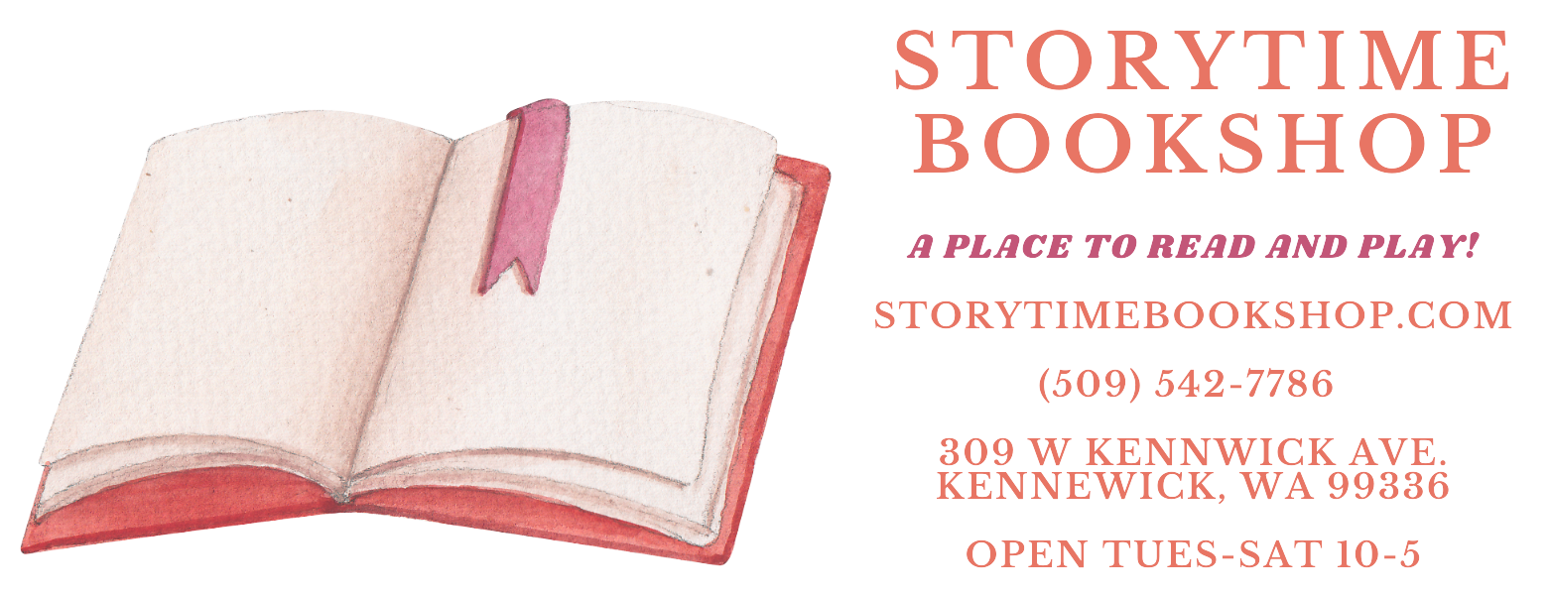

### **Storytime Bookshop One Sheet**

**Location:** 309 W Kennewick Ave, Kennewick, WA  
 **Founder:** Lorelei Kennedy, MS – Educator & Wolf Trap Teaching Artist  
 **Website:** [www.storytimebookshop.com](http://www.storytimebookshop.com) **Campaign Info:** [www.numarket.co](http://www.numarket.co)/fund/storytime-bookshop

### **About Storytime Bookshop**

Storytime Bookshop is a vibrant, literacy-fcused space for families in the heart of Historic Downtown Kennewick. As the **only children's bookstore within a 250+ mile radius**, we serve a wide range of communities across **Washington, Oregon, and Idaho**, including:

* **Rural and underserved populations**
* **Spanish-speaking families**, many from migrant farmworker backgrounds
* **Homeschool and public school families** seeking literacy resources

### **Why It Matters**

In a region where **over 50% of residents are Spanish-speaking**, Storytime Bookshop is a rare and vital hub. We provide inclusive access to books, creative learning, and enrichment programs that reflect and uplift our diverse community.

### 

### 

### **Our Programs**

* Weekly story times and book-themed activities
* Literacy-based classes and summer camps
* Wolf Trap artist residencies for early learners (through ArtsWA)
* Hands-on workshops and private events
* Curated collection of diverse children's books, toys, and games

### **Crowdfunding Opportunity**

We're thrilled to be the **first bookstore** participating in a groundbreaking pilot with **NuMarket**, **Main Street America**, and the **Historic Kennewick Downtown Partnership**.

**How it works:**You invest in Storytime Bookshop—and get a portion of your support back as 120 % **store credit**. It’s a powerful way to support literacy and earn perks while doing it. Credits can be used for books, bookmarks and bookish supplies, class tuition, Book Buddy visits, photography services and prints, and more.

### **Media Contact**

**Lorelei Kennedy, MS**Owner, Storytime Bookshop  
[info@storytimebookshop.com](mailto:info@storytimebookshop.com)   
Instagram: @storytimebookshoptc  
**Interviews Available Upon Request**