Alexandra Primary School Uniform Items
Alexandra PS – Polo Short Sleeve | Available from FCW | 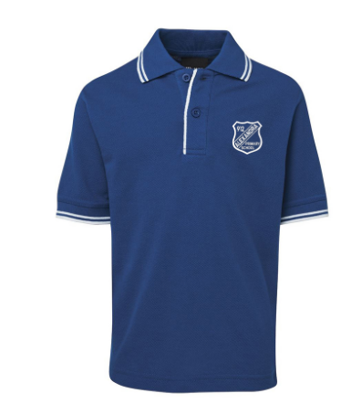
Alexandra PS – Half Zip Polar Fleece | Available from FCW | 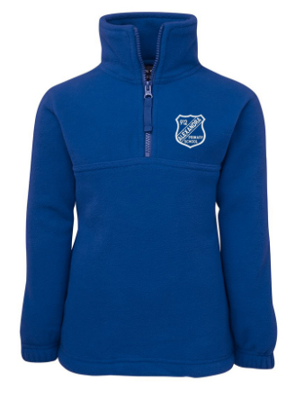
Blue check dress with white collar | Available from FCW and other generic stores. This item is not APS branded. | 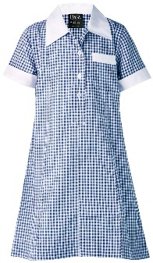
Grey skort | Available from FCW and other generic stores. This item is not APS branded. | 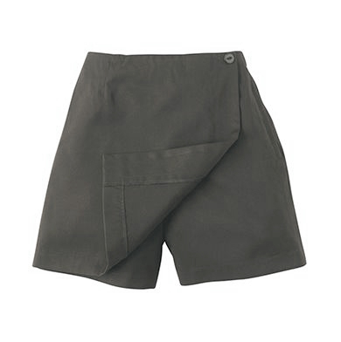
Grey shorts | Available from FCW and other generic stores. This item is not APS branded. | 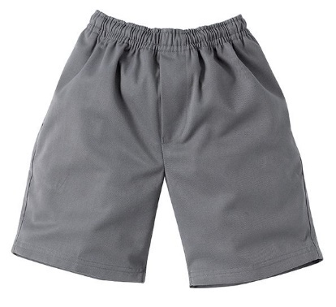
Grey pants | Available from FCW and other generic stores. This item is not APS branded. | 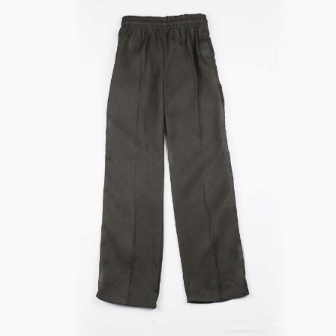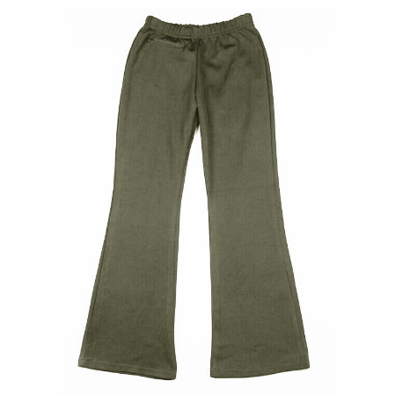
Alexandra PS Wide brim hat | Available for $12 from APS Office | 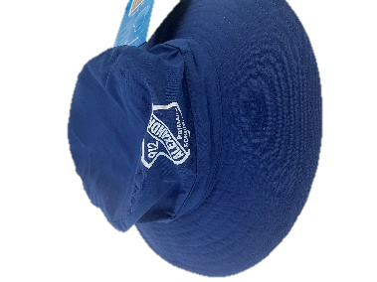

Additional Optional Items:
- White or blue skivvy underneath polo
- Grey tights under dresses
- APS branded beanie, available at the APS Office

- No leggings are permitted
- Hats are not to be worn inside
- Winter coats/jackets can be worn outside only
- Raincoats are welcome on rainy days for outside use only
- Safe and secure shoes are necessary for running and climbing. Runners are ideal.
- We welcome gumboots in rainy weather and slippers for inside.
- Thongs, open toed or slip on shoes are not permitted at school.

